SAC 1 Unit 4: Mystery molecule Total: 30 marks
Unless otherwise stated, assume the questions are all about the same mystery molecule.

A 4.400 g sample of an organic chemical is analysed and found to contain 0.600 g of hydrogen and 0.800 g of oxygen
1. a. What is the mass of carbon? _______________________________ 1 mark
b. Determine the empirical formula of the mystery molecule. 2 marks
__________________________________________________________________________

___________________________________________________________________________

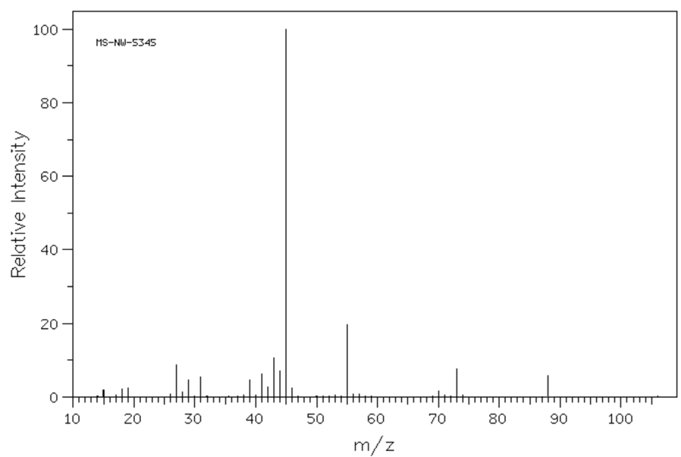
The mass spectrum of the mystery molecule is drawn below.

2. a. What is the molecular formula of the mystery molecule? ____________________________ 1 mark

b. Explain how you arrived at your answer. ___________________________________________

_____________________________________________________________________________1 mark

3. a. Suggest a fragment that might be causing the base peak. __________________________ 1 mark

b. What has been knocked off the molecule to form the peak at 73? ___________________ 1 mark

4. Draw and name 3 possible structural isomers with the molecular formula above. 4 marks

isomer 1 isomer 2 isomer 3
name: ___________________ name: _____________________ name: ___________________
The IR spectrum of the mystery molecule is shown below:

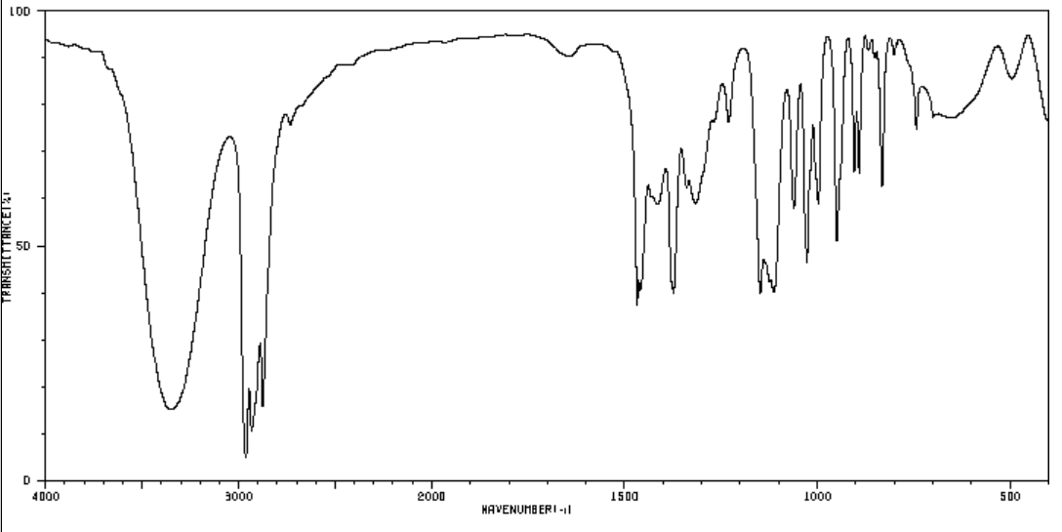
5. Refer to two possible absorbances to explain what conclusions you can draw from this spectrum about our
mystery molecule. 3 marks

___________________________________________________________________________________

___________________________________________________________________________________

___________________________________________________________________________________

___________________________________________________________________________________

The C-NMR of the mystery molecule is shown below
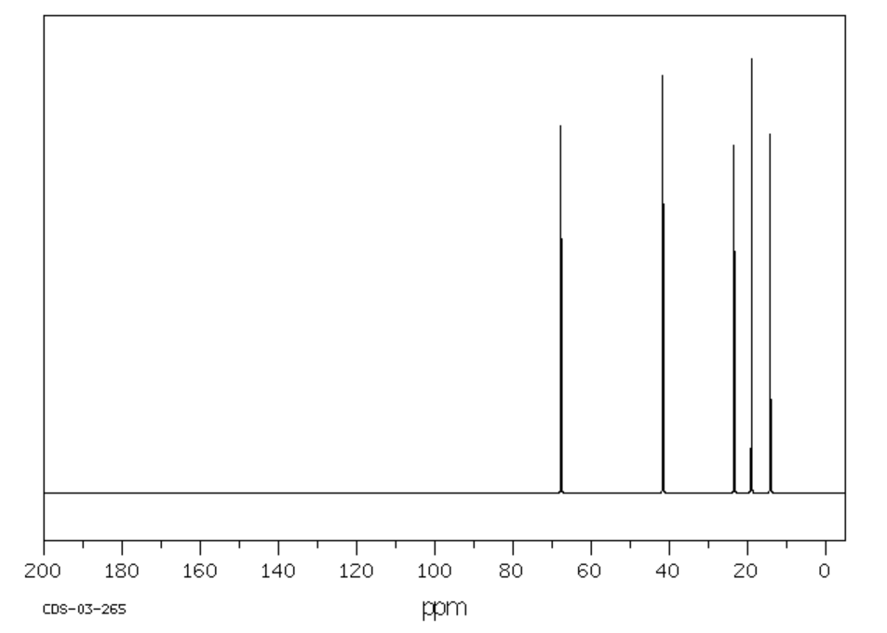
6. a. How many carbon environments does the molecule have? ___________________ 1 mark

b. Draw a molecule with the correct molecular formula that is ruled out as a possible alternative by this
C-NMR. Explain why it is ruled out. 2 marks

____________________________________________________________________________________

The H-NMR is shown below:
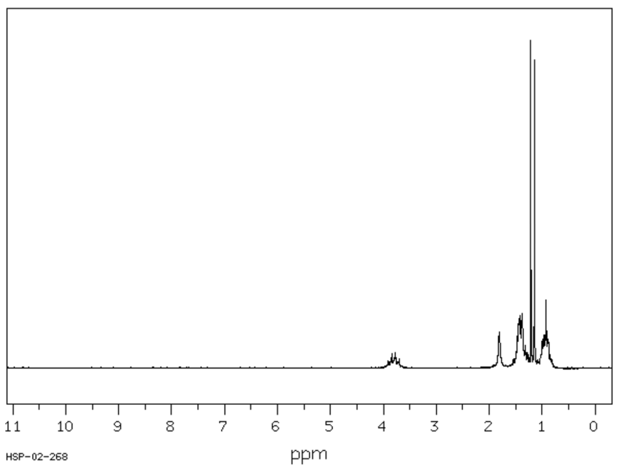
Splitting, from left to right:
sextet
singlet
quartet
sextet
doublet
triplet

7. Use this spectrum, and other information provided, to decide on the structure for the mystery molecule.
Outline clearly how you reached this conclusion. 4 marks

________________________________________________________________________________

________________________________________________________________________________

________________________________________________________________________________

________________________________________________________________________________

________________________________________________________________________________

________________________________________________________________________________

8. Outline how you could make this molecule from a suitable alkene. Include in your answer whether your
pathway produces molecules other than the mystery molecule. 4 marks

________________________________________________________________________________

________________________________________________________________________________

________________________________________________________________________________

________________________________________________________________________________

9. a. If the mystery molecule is reacted with K₂Cr₂O₇ in acid conditions, draw the molecule that will form.

1 mark
b. Write a balanced half-equation for the reaction of Cr₂O₇²⁻ to form Cr³⁺. 1 mark

_______________________________________________________________________________

c. What category of reaction is this? ________________________ 1 mark

10. If you are the one preparing the mystery molecule from the alkene, what preparation do you need to do to
comply with applicable safety guidelines? 2 marks

________________________________________________________________________________

________________________________________________________________________________

END OF TASK

