**SAC 1 Unit 4: Mystery molecule Total: 30 marks**

Unless otherwise stated, assume the questions are all about the same mystery molecule.

A 4.400 g sample of an organic chemical is analysed and found to contain 0.600 g of hydrogen and 0.800 g of oxygen

1. a. What is the mass of carbon? 4.4 – 0.6 – 0.8 = 3 g* 1 mark

b. Determine the empirical formula of the mystery molecule. 2 marks

$\frac{3}{12}$: $\frac{0.6}{1}:\frac{0.8}{16}$* = 0.25:0.6:0.05 = 3:12:1 = C5H12O*

The mass spectrum of the mystery molecule is drawn below. 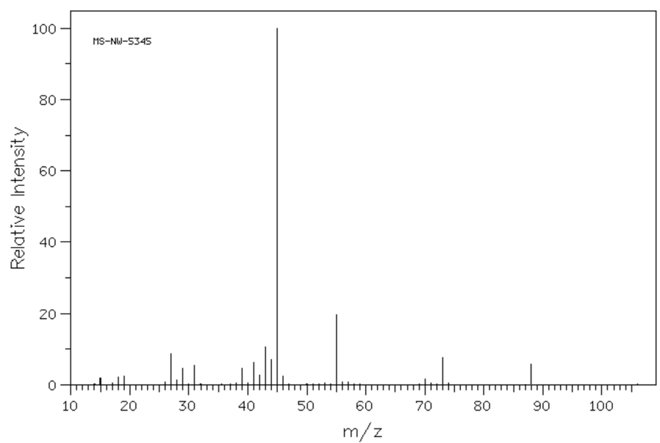

2. a. What is the molecular formula of the mystery molecule? C5H12O* 1 mark

b. Explain how you arrived at your answer. Parent molecular ion m/z = 74 = C5H12O* 1 mark

7

3. a. Suggest a fragment that might be causing the base peak. 45, C2H5O+ * 1 mark

b. What has been knocked off the molecule to form the peak at 73? CH3 1 mark

4. Draw and name 3 possible structural isomers with the molecular formula above. 4 marks



1 mark each isomer

isomer 1 isomer 2 isomer 3

name: pentan-1-ol name: pentan-2-ol name: pentan-3-ol 1 mark for all 3 names

The IR spectrum of the mystery molecule is shown below:

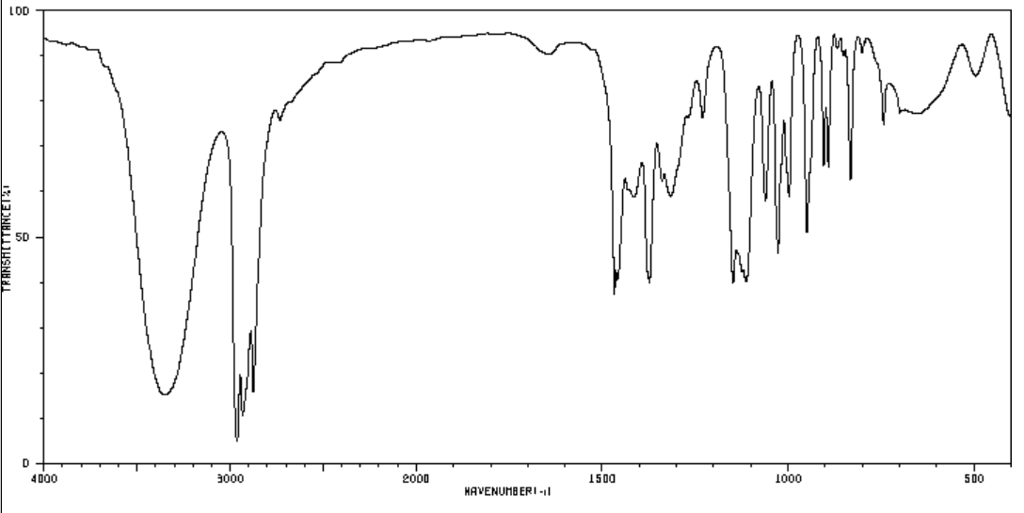

5. Refer to two possible absorbances to explain what conclusions you can draw from this spectrum about our

mystery molecule. 3 marks

-OH (alcohol) at 3300 * no peak at 1750 cm-1 => no C=O *

So could be an alcohol but not aldehyde or acid *

The C-NMR of the mystery molecule is shown below

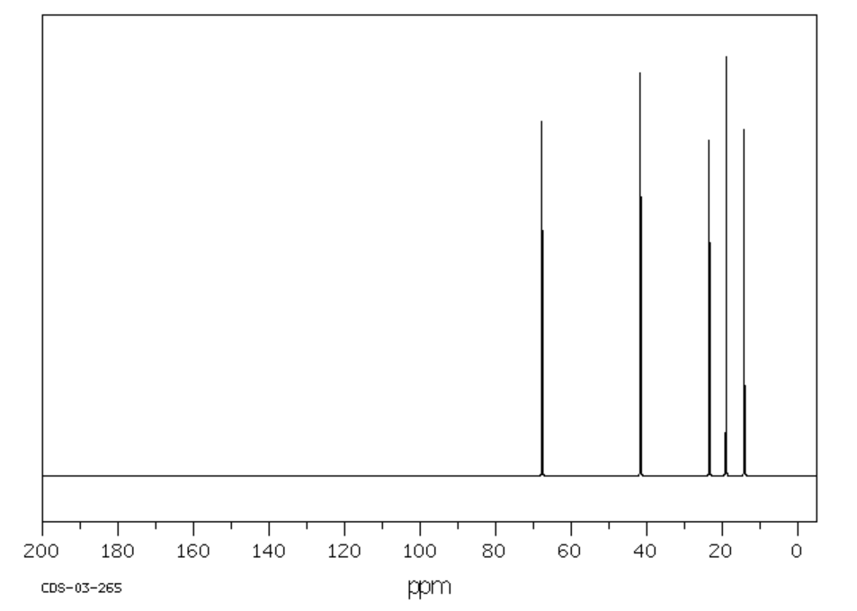

6. a. How many carbon environments does the molecule have? 5 1 mark

b. Draw a molecule with the correct molecular formula that is ruled out as a possible alternative by this

C-NMR. Explain why it is ruled out. 2 marks

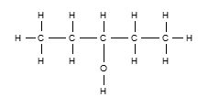 * this would have only 3 C environments *

The H-NMR is shown below:

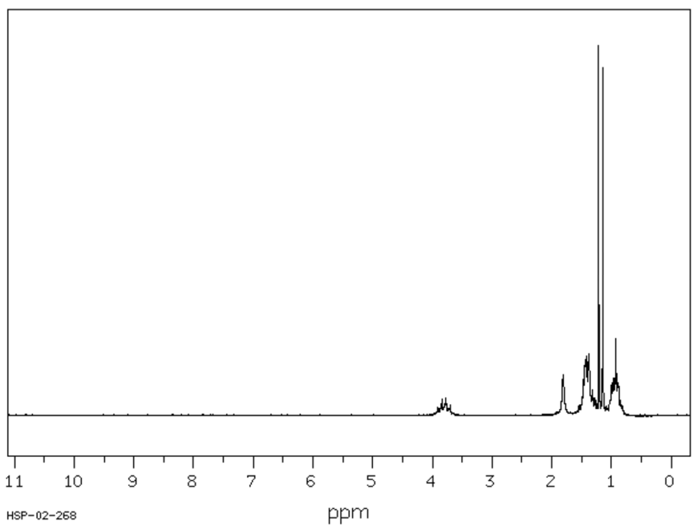

Splitting, from left to right:

quintet

singlet

quartet

sextet

doublet

triplet

7. Use this spectrum, and other information provided, to decide on the structure for the mystery molecule.

Outline clearly how you reached this conclusion. 4 marks

Molecule is pentan-2-ol*. 5 carbon environments and 5 H environments*

Splitting pattern matches but pentan-1-ol does not.*

triplet sextet quartet quintet singlet doublet **

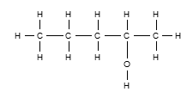

(multiplicity ignored here)

8. Outline how you could make this molecule from a suitable alkene. Include in your answer whether your

pathway produces molecules other than the mystery molecule. 4 marks

pent-1-ene (or pent-2-ene)* 🡪 H2O/H3PO4.* Would also produce pentan-1-ol * You would need to separate the two alcohols produced. No small molecules however from addition reactions*

9. a. If the mystery molecule is reacted with K2Cr2O7 in acid conditions, draw the molecule that will form.



1 mark

b. Cr2O72-+ 14H+(aq) + 6e 🡪 2Cr3+ + 7H2O(l)* 1 mark

c. What category of reaction is this? oxidation * 1 mark

10. If you are the one preparing the mystery molecule from the alkene, what preparation do you need to do to

comply with applicable safety guidelines? 2 marks

Prepare an MSDS sheet and follow the guidelines it contains, wearing appropriate PPE **

END OF TASK