**2021 Unit 1 Chemistry trial exam**

**Name**: ____________________ Total: ______/86

**Section A: Multiple Choice section**

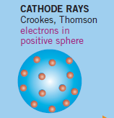**Question 1**

The diagram shows one of the early models of an atom, the plum pudding model. In this model,

**A**. the positive and negative particles were dispersed evenly through the atom.

**B**. the electrons were spaced through a positive medium.

**C**. the positive particles were spaced through a negative medium.

**D**. the electrons were dispersed through a neutral medium.

**Question 2**

Which element has the electron configuration 1s22s22p63s23p63d64s2?

**A**. calcium

**B**. titanium

**C**. nickel

**D**. iron

**Question 3**

A graph is shown below of the trend in a particular property plotted against the atomic number of the element.

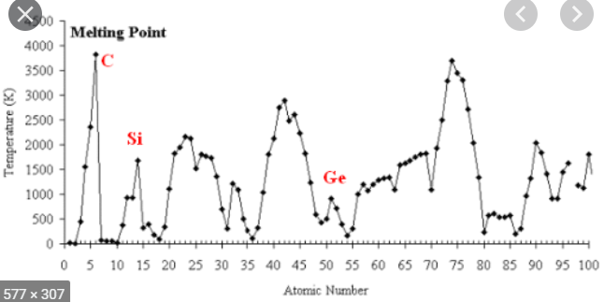

The property graphed is most likely to be

**A**. melting point.

**B**. atomic radius.

**C**. electronegativity.

**D**. first ionisation energy.

**Question 4**

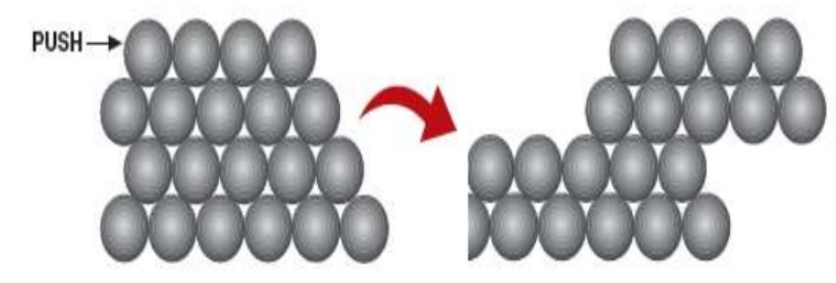

The diagram above can be used to illustrate

**A**. the electrical conductivity of metals.

**B**. the brittleness of diamond.

**C**. the malleability of metals.

**D**. ionic solids dissolving in water.

**Question 5**

When calcium reacts with chlorine,

**A**. one electron will be transferred from each calcium atom to each chlorine atom.

**B**. two electrons will be transferred from each calcium atom to two chlorine atoms.

**C**. each chlorine atom receives two electrons from each calcium atom.

**D**. one electron is transferred from each chlorine atom to a calcium atom.

**Question 6**

This element

* is a metal
* has an electrovalence of +2
* is more reactive than magnesium
* has 2 electrons in its outer shell
* does not have any electrons in d type orbitals.

The element is

**A**. beryllium

**B**. zinc

**C**. calcium

**D**. strontium

**Question 7**

A sample of a substance contains 1.204 x 1024 particles. The sample could be

**A**. 1 mole of He

**B**. 0.5 mole of MgCl2

**C**. 0.75 mole of AlCl3

**D**. 1 mole of NaCl

**Question 8**

A compound has the formula X2(SO4)3. X is likely to be

**A**. Na+

**B**. Mg2+

**C**. Ca2+

**D**. Al3+

**Question 9**

The relative atomic mass of magnesium is listed as 24.3. It is likely that

**A**. magnesium has no isotopes.

**B**. magnesium has three isotopes of equal abundance.

**C**. magnesium has three isotopes with 24Mg the most abundant.

**D**. magnesium has three isotopes with 26Mg the most abundant.

**Question 10**

Which one of the following will not conduct electricity?

**A**. barium

**B**. ethanol (C2H6O)

**C**. barium nitrate solution, Ba(NO3)2

**D**. graphite

**Question 11**

A molecule is found to be 87.5 % nitrogen. The only other component is hydrogen. The molecule could be

**A**. NH

**B**. N2H

**C**. NH3

**D**. N2H4

**Question 12**

Which of the following contains the highest mass of chlorine?

**A**. 2.5 mole of Cl2

**B**. 71 g of Cl2

**C**. 1.9 mole of AlCl3

**D**. 1.2 mole of CCl4

**Question 13**

A molecule is drawn below.

**X X**

X is most likely to be

**A**. hydrogen

**B**. chlorine

**C**. nitrogen

**D**. oxygen

**Question 14**

The formula of ammonia is NH3. In the outer shell of ammonia there will be

**A**. three bonding pairs of electrons and one non-bonding pair.

**B**. two bonding pairs of electrons and two non-bonding pairs.

**C**. one bonding pair of electrons and three non-bonding pairs.

**D**. four bonding pairs of electrons.

**Question 15**

The structure of CO2 is 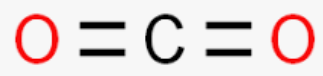

This molecule will

**A**. be ionic.

**B**. have no dipoles.

**C**. have dipoles but be non-polar.

**D**. be polar.

**Question 16**

Which of the following has the highest percentage of oxygen?

**A**. CO

**B**. CO2

**C**. H2O

**D**. SO3

**Question 17**

Which of the following is likely to have the highest boiling point?

**A**. ethanoic acid

**B**. propane

**C**. butane

**D**. methanol

**Question 18**

Which of the following is a structural isomer of hexane?

**A**. **B**.



**C**. **D**.



**Question 19**

The empirical formula of hexene is

**A**. CH

**B**. CH2

**C**. C6H12

**D**. C6H14

**Question 20**

A segment of a polymer is shown below.

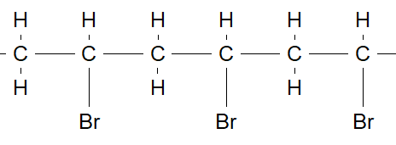

The monomer required for this polymer is

**A**. CH3CH2Br

**B**. CH2CH2Br

**C**. CH2CHBr

**D**. CHCHBr

**Section B: Short answer questions**

**Question 1** (9 marks)

A uranium atom is one of the heaviest atoms found in nature. It can be found in nature in two different forms and the notation below is used to simplify its structure.



**a. i**. What are the chemical names for the superscript and subscript in this notation? 2 marks

 _____________________________________

_______________________________________

**ii**. What is the chemical name for atoms of the same element that differ in this way? ______________ 1 mark

**iii**. What is the difference between these two types of uranium? 1 mark

____________________________________________________________________________________

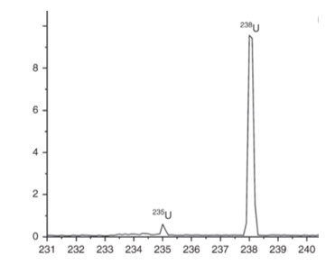

**b**. The diagram shown provides further information about uranium.

1 mark

**i**. What is this chart called? _______________________

**ii**. Explain how it is produced. 2 marks

____________________________________________________

____________________________________________________ m/z

________________________________________________________________________________________

**iii**. Use the data from the graph to estimate the relative atomic mass of a uranium atom. 2 marks

________________________________________________________________________________________

________________________________________________________________________________________

________________________________________________________________________________________

**c**. The atomic notation for argon and potassium is shown below.



The data for these two elements highlights an unusual feature that only 3 pairs of elements have.

What is it this feature and what causes it? 2 marks

________________________________________________________________________________________

**Question 2** (7 marks)

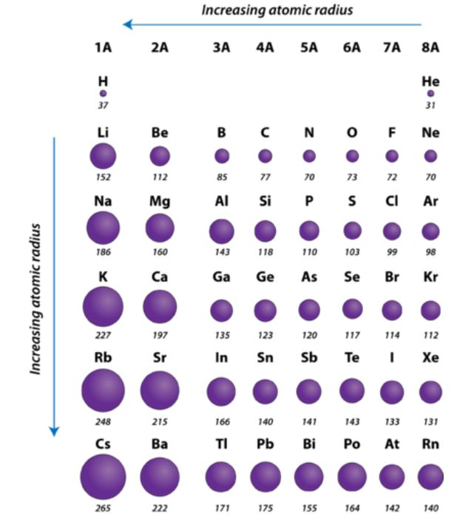**a**. The diagram below shows the atomic radius of the smaller elements on the periodic table.

**i**. What is the trend in atomic radius as you move across a period? 1 mark

______________________________________________________________________________

**ii**. Explain why atomic radius has this trend. 1 mark

______________________________________________________________________________

**iii**. What is the trend in atomic radius as you move down a group? 1 mark

______________________________________________________________________________

**iv**. Explain why atomic radius has this trend. 1 mark

______________________________________________________________________________

**b**. **i**. What is diagram below showing? 2 marks

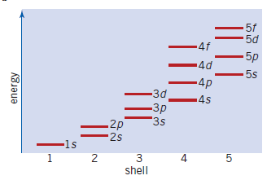

_________________________________________________________________________________

_________________________________________________________________________________

**ii**. Use the information in this diagram to write the electron configuration for a calcium atom. 1 mark

__________________________________________________________________________________

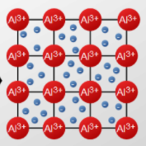**Question 3** (9 marks)

**a**. Use the diagram to explain the general structure of metals and the features of aluminium. 3 marks

_____________________________________________________________________________________

______________________________________________________________________________________

______________________________________________________________________________________

_______________________________________________________________________________________

**b**. A positive electrode is placed on the left side of the model above and a negative electrode is placed on the right

side. Describe what will happen to the metal. 2 marks

_____________________________________________________________________________________

______________________________________________________________________________________

**c**. **i**. Rank the following metals from least reactive to most reactive: 2 marks

zinc gold lithium calcium potassium

______________________________________________________________________________________

**ii**. Explain how you derived your ranking. 2 marks

_____________________________________________________________________________________

______________________________________________________________________________________

**Question 4** (11 marks)

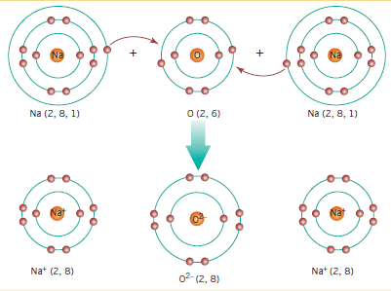

a. Explain carefully what the above diagram is illustrating. 3 marks

____________________________________________________________________________________

____________________________________________________________________________________

____________________________________________________________________________________

**b**. List three of the likely properties of the compound formed. 2 marks

_____________________________________________________________________________________

_____________________________________________________________________________________

**c**. Name the following compounds: 4 marks

**i**. Mg(OH)2 _____________________ **ii**. Li2CO3 ________________________________

**iii**. NH4NO3 _____________________ **iv**. Ag2O ________________________________

**d**. Write the formula of the following: 2 marks

**i**. iron(II) carbonate ___________ **ii**. aluminium sulfate ___________________

**Question 5** (11 marks)

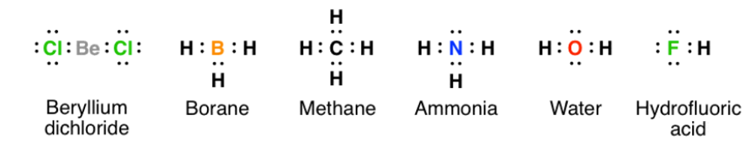Several electron dot diagrams are drawn below for you to refer to in this question.

**a**. Match the compound with the molecule shape given: 6 marks

V-shaped _________________ Tetrahedral ____________________________

Linear _________________ Linear ________________________________

Trigonal pyramid _____________ Trigonal planar _________________________

**b**. Select a molecule that will be polar and draw the dipoles on it. 2 marks

**c**. Select a molecule that will be non-polar. __________________ 1 mark

**d**. Select a molecule that belongs to a homologous series and name the next molecule in that series. 2 marks

______________________________________ ____________________________________

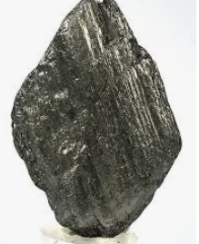**Question 6**  (8 marks)

The photos below are both of the same element.

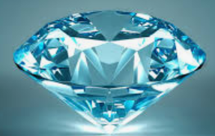

**a. i.** What is the term for an element that can have more than one form? ________________ 1 mark

**ii**. Describe the arrangement of atoms in the first structure (include a diagram in your answer) 2 marks

___________________________________________________________________________________

___________________________________________________________________________________

___________________________________________________________________________________

**iii**. Describe the arrangement of atoms in the second structure (include a diagram in your answer) 2 marks

___________________________________________________________________________________

___________________________________________________________________________________

___________________________________________________________________________________

**iv**. List two properties that will differ between the two structures above. 2 marks

____________________________________________________________________________________

**b**. The element in question has further possible structures. List one more structure. _____________ 1 mark

**Question 7**  (5 marks)

**a**. Calculate the relative formula mass of ammonium nitrate: NH4NO3 ________________________ 1 mark

**b**. What is the percentage mass of nitrogen in ammonium nitrate? 1 mark

____________________________________________________________________________________

**c**. Given 100 g of ammonium nitrate, calculate the number of mole of 3 marks

**i**. ammonium nitrate ________________________________________________________

**ii**. ammonium ions __________________________________________________________

**iii**. nitrogen atoms ___________________________________________________________

**Question 8** (6 marks)

**a.** Name the following molecules: 3 marks



________________ ___________________ ______________________

**b.** What is the molecular formula of propanoic acid? ______________________ 1 mark

**c**. Draw the ester ethyl ethanoate. 1 mark

**d**. Draw a structural isomer of pentane. 1 mark

**End of exam**

Section A: 20 marks

Section B: 66 marks