**2021 Unit 3_4 Chemistry trial exam**

**Name**: ____________________

**Section A: Multiple Choice section**

*Use the following information to answer Questions 1 and 2.*

A snippet from a student’s notes is shown below.

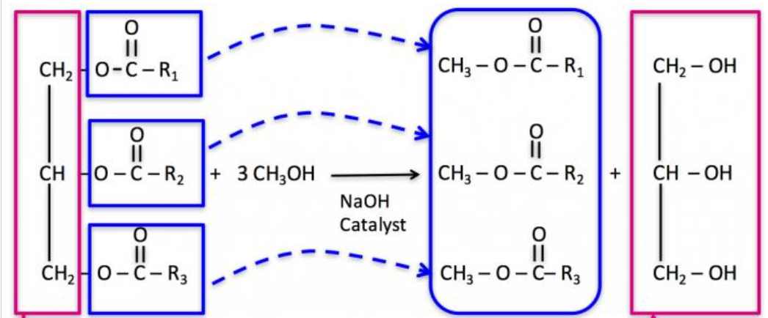

**Question 1**

The equation the diagram represents is

**A**. fatty acid + alcohol 🡪 3biodiesel + glycerol

**B**. fatty acid + 3alcohol 🡪 3biodiesel + glycerol

**C**. triglyceride + 3alcohol 🡪 3fatty acid + glycerol

**D**. triglyceride + 3alcohol 🡪 3biodiesel + glycerol

**Question 2**

The fuel formed

**A**. is non-renewable as the raw material is a component of crude oil.

**B**. has the highest energy density of any of the common fuels.

**C**. is considered renewable as crops required can be grown each year.

**D**. is good for the environment as it does not lead to the production of any CO2 emissions.

**Question 3**

The volume of oxygen required at SLC to react completely with 2 mol of ethane will be, in litres,

**A**. 49.6

**B**. 74.4

**C**. 99.2

**D**. 174

**Question 4**

Which one of the following statements about viscosity is correct?

**A**. The viscosity of biodiesel from stearic acid is higher than that of biodiesel from lauric acid.

**B**. The viscosity of biodiesel from linolenic acid is higher than that of biodiesel from stearic acid.

**C**. The viscosity of bioethanol is higher than that of biodiesel.

**D**. The viscosity of petrodiesel is usually higher than that of biodiesel.

**Question 5**

An energy profile diagram is shown below.

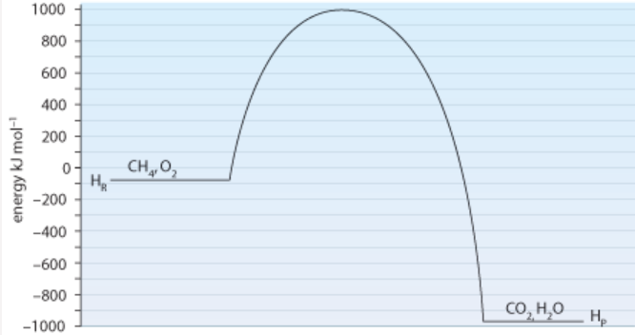

Which alternative correctly shows the activation energy and enthalpy change of the reverse reaction?

**A**. +1990 kJ mol-1 and -900 kJ mol-1

**B**. +1990 kJ mol-1 and +900 kJ mol-1

**C**. +1090 kJ mol-1 and -900 kJ mol-1

**D**. +1090 kJ mol-1 and +900 kJ mol-1

**Question 6**

The reaction between hydrogen and iodine gases is

H2(g) + I2(g) ⇄ 2HI(g)

A catalyst is added to an equilibrium mixture of the above gases. The catalyst

**A**. will not impact the rate as the system is at equilibrium.

**B**. will increase the rate of the forward reaction.

**C**. will lead to an increase in the value of *K*c.

**D**. will increase the rate of the forward reaction but not the back reaction.

*Use the following information to answer Questions 7 and 8*

The equation for the decomposition of ammonia is:

2NH3(g) ⇄ N2(g) + 3H2(g) *K*c = 3.4 x 106 at 700 0C ∆*H* = + 93 kJ mol-1

**Question 7**

A sample of ammonia is added to an empty reactor at 700 0C. When equilibrium is reached

**A**. [N2] = ½ [NH3]

**B**. [N2] = 3[H2]

**C**. [N2] > [NH3]

**D**. [NH3] > [N2]

**Question 8**

A change is made to a 1.0 L equilibrium mixture of the above gases. After equilibrium is re-established the amounts have changed by:

NH3 increased by 0.2 mol N2 increased by 0.02 mol H2 decreased by 0.3 mol

The change could have been

**A**. a decrease in temperature.

**B**. a decrease in volume.

**C**. an increase in volume.

**D**. an increase in the amount of nitrogen gas.

**Question 9**

The units for the equilibrium constant for a reversible reaction is M2. The equation could be

**A**. 2SO2(g) + O2(g) ⇄ 2SO3(g)

**B**. N2(g) + 3H2(g) ⇄ 2NH3(g)

**C**. H2(g) + I2(g) ⇄ 2HI(g)

**D**. CH4(g) + H2O(g) ⇄ CO(g) + 3H2(g)

*Use the following information to answer questions 10 and 11*

The diagram shows a cross section of a zinc, manganese dioxide cell that operates in alkaline conditions.

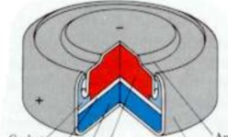

The MnO2 half equation occurring is

2MnO2(s) + H2O(l) + 2e- 🡪 Mn2O3(s) + 2OH-(aq)

**Question 10**

In this cell, the MnO2

**A**. is being reduced at the cathode.

**B**. is reducing zinc ions to zinc atoms.

**C**. is a catalyst for the reduction of hydrogen atoms.

**D**. is being oxidised at the anode.

**Question 11**

The overall equation in this cell will be

**A**. 2MnO2(s) + Zn(OH)2 🡪 Mn2O3(s) + Zn(s) + H2O(l)

**B**. 2MnO2(s) + Zn(s) 🡪 Mn2O3(s) + Zn(OH)2(s)

**C**. 2MnO2(s) + Zn(s) + H2O(l) 🡪 Mn2O3(s) + Zn(OH)2(s)

**D**. 2MnO2(s) + Zn(s) + 2OH-(aq) 🡪 Mn2O3(s) + H2O(l)

**Question 12**

Which of the following cells will produce the highest standard voltage?

**A**. Hydrogen half-cell connected to acidified oxygen gas half cell.

**B**. Magnesium half-cell connected to a solution of FeCl3

**C**. Acidified sulfur half-cell connected to a zinc half-cell.

**D**. Sodium half-cell connected to a lithium half cell.

**Question 13**

X, Y and Z represent three elements found on the electrochemical series.

X+(aq) + e- ⇄ X(s) +0.76 V

Y2(l) + 2e ⇄ 2Y-(aq) +0.66 V

Z2+(aq) + 2e- ⇄ Z(s) -0.62 V

**A**. Y2 could be formed by electrolysis of ZY.

**B**. X(s) is the strongest oxidant on this list.

**C**. Y2 could be formed when X is added to NaY.

**D**. A spontaneous reaction will occur when x is dropped into ZCl2.

**Question 14**

38600 Coulomb of charge is passed through an electrolytic cell. 11.9 g of tin is deposited at the negative electrode. The charge on the tin ion is

**A**. +1

**B**. +2

**C**. +3

**D**. +4

*Use the following diagram to answer Questions 15 and 16*

An electrolytic cell is constructed with two cells in the same circuit, one containing molten magnesium bromide and the other containing a solution of magnesium bromide.

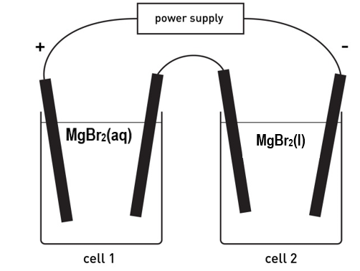

**Question 15**

The products formed will be

|  |  |  |  |  |
| --- | --- | --- | --- | --- |
|  | Cell 1 | | Cell 2 | |
|  | Anode | Cathode | Anode | Cathode |
| **A.** | magnesium | bromine | magnesium | bromine |
| **B.** | oxygen | hydrogen | bromine | magnesium |
| **C.** | bromine | hydrogen | bromine | magnesium |
| **D.** | bromine | magnesium | bromine | magnesium |

**Question 16**

A current of 965 amps is run through the circuit for 1 minute and 40 secs. The total mass of magnesium produced will be, in g,

**A**. 12.2

**B**. 24.3

**C**. 48.6

**D**. 97.2

**Question 17**

What is the IUPAC name for this compound?

**A**. but-2-en-3-ol

**B**. but-3-en-2-ol

**C**. 2-hydroxybutene

**D**. but-2-enol

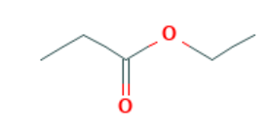**Question 18**

The skeletal structure shown is

**A**. hexan-3-oic acid

**B**. propyl propanoate

**C**. ethyl propanoate

**D**. propyl ethanoate

**Question 19**

Which of the following will have the highest boiling point?

**A**. ethane

**B**. chloroethane

**C**. ethanol

**D**. ethanoic acid

**Question 20**

Methane is heated with excess chlorine gas in the presence of UV light. The number of different products possible is

**A**. 2

**B**. 3

**C**. 4

**D**. 5

**Question 21**

Which of the following reactions will have the highest atom economy?

**A**. Reaction of ethane and chlorine gas.

**B**. Reaction of ethene and chlorine gas.

**C**. Reaction of chloroethane and ammonia.

**D**. Reaction of ethanol and ethanoic acid.

**Question 22**

The 1H NMR spectrum below could be for

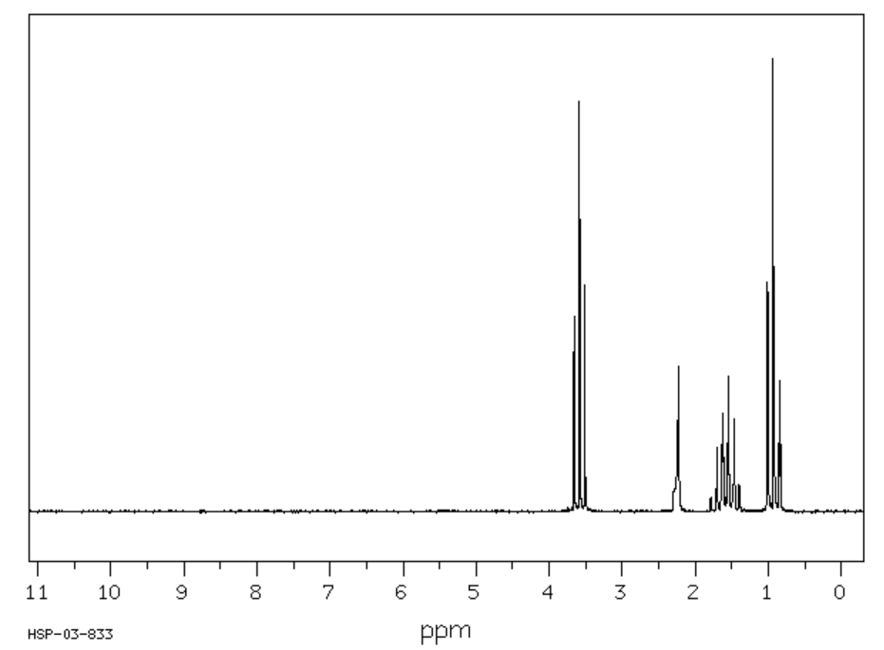

**A**. propan-1-ol

**B**. propan-2-ol

**C**. propanone

**D**. propanoic acid

**Question 23**

A HPLC chromatogram for a mixture of three fatty acids is shown below. A non-polar stationary phase was used.

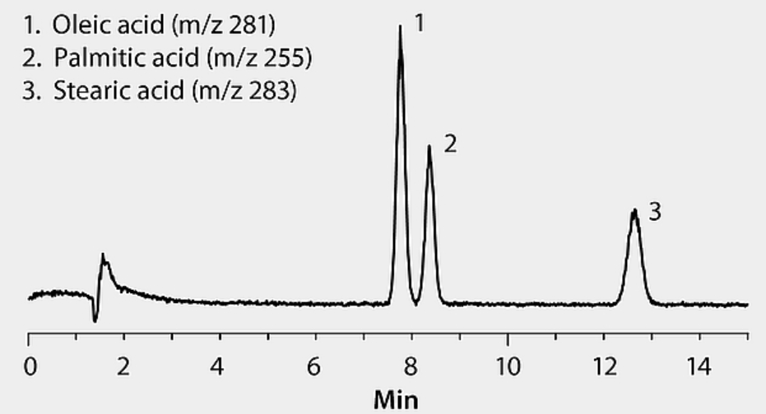

A valid conclusion from this chromatogram is

**A**. a non-polar stationary phase is not appropriate for fatty acids.

**B**. the concentration of palmitic acid is higher than that of stearic acid.

**C**. linolenic acid is likely to have a shorter retention time than the three fatty acids on the chromatogram.

**D**. retention time of fatty acids depends solely upon relative molecular mass.

**Question 24**

The molecular formula and molar mass of the methyl ester of linolenic acid will be, respectively,

**A**. C18H30O2 and 278 g mol-1

**B**. C18H32O2 and 280 g mol-1

**C**. C19H32O2 and 292 g mol-1

**D**. C19H34O2 and 294 g mol-1

**Question 25**

Which statement about coenzymes is correct?

**A**. Coenzymes can chemically react with a substrate.

**B**. Coenzymes can act with or without the presence of an enzyme.

**C**. Coenzymes are denatured by the addition of acid to a solution.

**D**. A coenzyme will work once only.

**Question 26**

A biomolecule is drawn below.

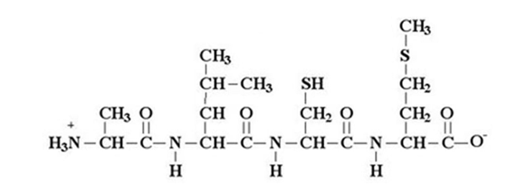

The diagram shows

**A**. a polypeptide formed from three amino acids.

**B**. a polypeptide formed from four amino acids.

**C**. a protein that has been denatured.

**D**. a segment of a protein molecule.

**Question 27**

Aspartame is often added to a food to provide a ‘diet’ alternative of that item.

**A**. The mass of aspartame required is far less than that of sugar.

**B**. Aspartame works because its level of sweetness is equivalent to that of sucrose.

**C**. Aspartame works because its energy density is over 100 times less than that of sucrose.

**D**. Aspartame works because the human body cannot metabolise it.

**Question 28**

2.22 g of biscuit is burnt under 80.0 g of water. The temperature change is 38.4 ºC. The heat of combustion of the biscuit is, in kJ g-1,

**A**. 3.84

**B**. 5.78

**C**. 12.8

**D**. 5780

*Use the following information to answer Questions 29 and 30*

A solution of 1.0 M CuSO4 is electrolysed for 3.0 minutes with a current of 2.0 amps. The copper electrodes are weighed before the current is switched on, then they are dried and reweighed after the current is turned off. Copper electrodes are used. The aim of the experiment is to investigate Faraday’s Laws.

**Question 29**

Which one of the following is likely to have little effect on the mass of copper obtained?

**A**. The surface area of the anode and cathode.

**B**. A student stirring the solution intermittently.

**C**. The conductivity of the solution decreasing as the experiment progresses.

**D**. The voltage from the power supply fluctuating.

**Question 30**

Which of the following will cause the mass change obtained to be higher than the predicted mass of copper?

**A**. The resistance of the solution increasing as the reaction proceeds.

**B**. The anode is not dried carefully.

**C**. The solution concentration gradually decreasing after many trials.

**D**. The cathode is not dried carefully.

**Section B: Short answer questions**

**Question 1** (11 marks)

Australia has three bioethanol plants, all located near wheat or sugar processing plants. They use the waste materials from these plants to ferment monosaccharides to ethanol.

An alternative, small scale trial is in place in Gippsland near a forestry plant that is using waste bark and wood trimmings as a raw material. An outline of the plant is shown in the diagram below.

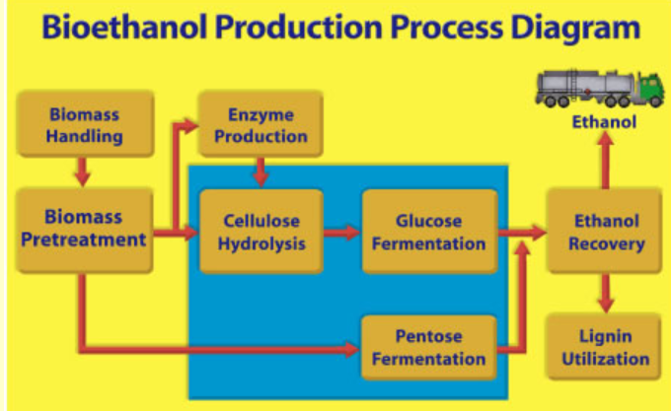

**a**. The volume of bioethanol produced in Australia is relatively low despite the high annual

production of both wheat and sugar.

Discuss reasons for this low production volume. 2 marks

_______________________________________________________________________________

_______________________________________________________________________________

**b**. The raw material for the production of bioethanol needs to be a form of carbohydrate.

What is the main form of carbohydrate in the bioethanol raw material from: 3 marks

**i**. wheat ____________________

**ii**. sugar cane ___________________

**iii**. forest waste? __________________

**c**. Suggest a reason why forest waste has not previously been used for bioethanol production.

1 mark

_______________________________________________________________________________

_______________________________________________________________________________

**d**. Write a balanced equation for the fermentation of glucose. 1 mark

____________________________________________________________________________

**e**. A 2.00 kg sample of ethanol undergoes complete combustion.

**i**. Calculate the energy released. 1 mark

______________________________________________________________________________

**ii**. The volume of CO2 released at 280 ºC and 120 kPa. 3 marks

_______________________________________________________________________________

_______________________________________________________________________________

**Question 2** (12 marks)

Ethyne, C2H2, is a gas used in industry to produce a high temperature flame. The flame is used to cut through metal. Ethyne can be produced from ethane in a reversible reaction.

C2H6(g) ⇄ C2H2(g) + 2H2(g) ∆*H* = + 355 kJ mol

a. If an ethyne plant is run at 600 ºC and 100 kPa pressure, the yield is found to be low.

What will be the impact on the yield of ethyne if

**i**. the temperature is increased (Justify your answer). 2 marks

_______________________________________________________________________________

_______________________________________________________________________________

**ii**. the pressure is increased. 2 marks

_______________________________________________________________________________

_______________________________________________________________________________

**b**. The graph below shows the concentration of ethane gas after a sample is added to an

empty reactor.

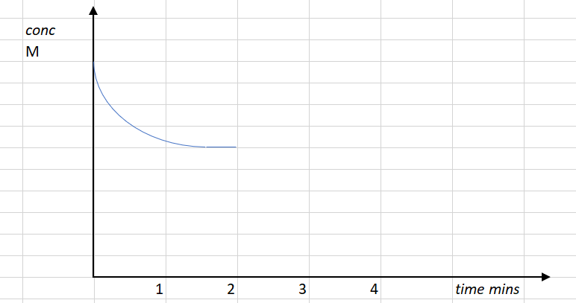

**i**. Draw on the graph the corresponding concentrations of ethyne and hydrogen gases. 2 marks

**ii**. At the two minute mark, the volume of the reactor is doubled. Draw, on the same graph, the

impact of this change on the ethane and show its likely response in returning to equilibrium.

2 marks

**iii**. Explain the impact of the volume change at the two minute mark on the rate of the forward

reaction. 2 marks

______________________________________________________________________________

______________________________________________________________________________

**c**. The other product in this reaction is hydrogen gas. Give an example of where society might use

hydrogen gas. Provide a balanced equation to support your answer. 2 marks

_______________________________________________________________________________

_______________________________________________________________________________

**Question 3** (11 marks)

Fuel cell technology is very advanced. One of the limitations with fuel cells however is finding a cheap source of the fuel itself. One of newer lines of research is with glycerol as a fuel. The energy density of glycerol is not as high as some other fuels but its abundance compensates for its energy density.

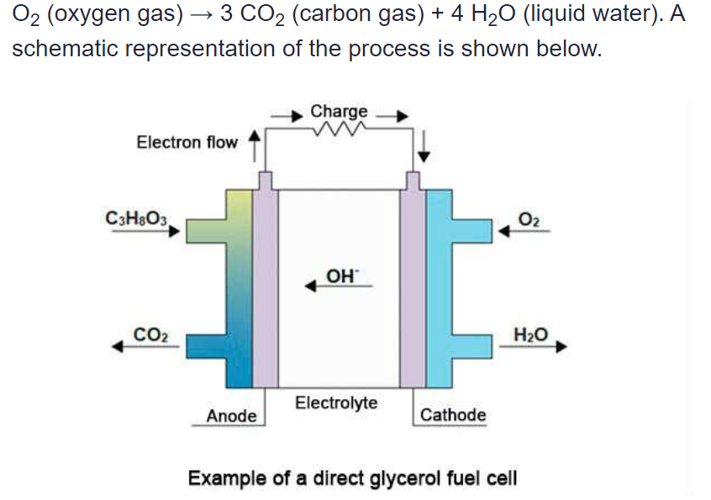Glycerol is a cheap raw material. A fuel cell designed to run on glycerol is shown below.

**a**. Name an industry that is likely to produce glycerol as a by-product and explain how it is formed.

3 marks

_______________________________________________________________________________

_______________________________________________________________________________

_______________________________________________________________________________

**b**. Use the template below to determine the equations occurring in this cell: 3 marks

Anode: ________________________________________________________________________

Cathode: ________________________________________________________________________

Overall equation: __________________________________________________________________

**c**. Discuss the environmental and sustainability impact of largescale use of this cell. 3 marks

_______________________________________________________________________________

_______________________________________________________________________________

_______________________________________________________________________________

**d**. Will glycerol be soluble in water? Justify your answer. 2 marks

_______________________________________________________________________________

_______________________________________________________________________________

**Question 4** (8 marks)

Fluorine gas is required for the polymer and pharmaceutical industries. As the gas is a dangerous gas to handle, it is often produced on-site using small electrolytic units. A sketch of a typical cell is shown below.

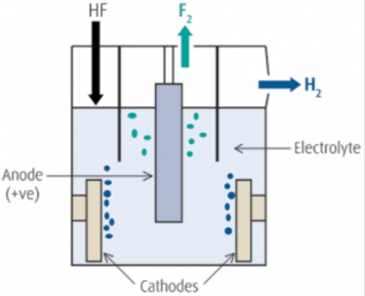

The electrolyte in this cell is hydrogen fluoride, HF, that is dissolved in molten KHF2 to make a conductive liquid. The anode in the cell is platinum and the cathode iron.

**a**. Use the headings below to write half-equations and an overall equation for the reactions

occurring. 3 marks

Anode: ________________________________________________________

Cathode: ________________________________________________________

Overall equation: ________________________________________________________

**b**. What is the minimum voltage required to power this cell? _________________ 1 mark

**c**. How will the mass of hydrogen gas formed in the cell compare to the mass of fluorine gas?

2 marks

___________________________________________________________________________

____________________________________________________________________________

**d**. List and justify two precautions the operators of this cell would need to take. 2 marks

___________________________________________________________________________

____________________________________________________________________________

**Question 5** (6 marks)

If you cut a banana into pieces and leave the pieces on the bench, they will gradually turn brown over the next few hours. This is a result of the reaction between the phenols in the banana and oxygen from the air. The phenols react to form polyphenols which are brown in colour. An enzyme called polyphenol oxidase in bananas acts as a catalyst for this reaction.

**a**. Should you cut the bananas into big or small pieces to limit browning? Discuss. 2 marks

____________________________________________________________________________

____________________________________________________________________________

**b**. A student’s mother suggests that the addition of fruit juice helps limit browning. A student tests

this be pouring 5 mL of the following fruit juices over similar pieces of cut bananas. This testing

results are summarised below.

|  |  |
| --- | --- |
| Juice | Ranking (least browning) |
| Grapefruit juice | 2 |
| Lemon juice | 1 |
| Orange juice | 3 |

Using your knowledge of chemistry, explain why the fruit juice limits browning and suggest why

lemon juice might be the most effective juice. 3 marks

_____________________________________________________________________________

_____________________________________________________________________________

______________________________________________________________________________

______________________________________________________________________________

**c**. Vitamin C solution is also effective in preserving the appearance of the bananas, but it works for a

different reason than the fruit juice in part b. Suggest a reason why vitamin C might prevent

browning of bananas. 1 mark

______________________________________________________________________________

**Question 6** (7 marks)

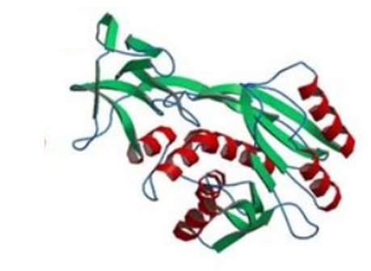A segment of a protein is pictured below.

**a**. Annotate this diagram to identify the two main types of secondary structure that occur in

proteins. Explain why proteins have a secondary structure. 2 marks

_______________________________________________________________________________

_______________________________________________________________________________

**b**. The tertiary structure of a protein is due to several bonding types between different parts of a

protein or between different protein molecules.

**i**. Name an amino acid that has an R-group that can form a covalent bond with itself.

Draw the covalent bond. 2 marks

_______________________________________________________________________________

_______________________________________________________________________________

**ii**. Name two amino acids that can have R-groups that can form an ionic bond.

Draw what that bond looks like. 2 marks

_______________________________________________________________________________

_______________________________________________________________________________

**iii**. Name two different amino acids that can form hydrogen bonds with each other. 1 mark

_______________________________________________________________________________

**Question 7** (11 marks)

A sample of an organic compound is tested to try and deduce its structure. It is known to contain carbon, hydrogen and oxygen only. The spectra in this question are provided to help you deduce the identity of the unknown compound.

**a**. The mass spectrum of the compound is shown below.

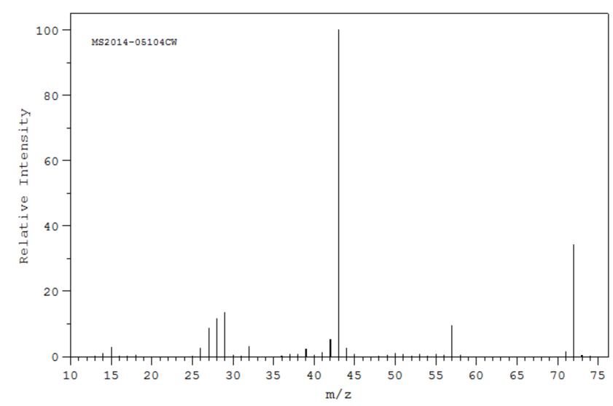

**i**. Suggest a fragment from this substance that might have produced the base peak shown

on the spectrum. _________________ 1 mark

**ii**. Use the space provided below to draw two molecules with a molecular formula consistent

with the parent molecular ion value. 2 marks

**b**. The infrared spectrum of the unknown compound is shown below.

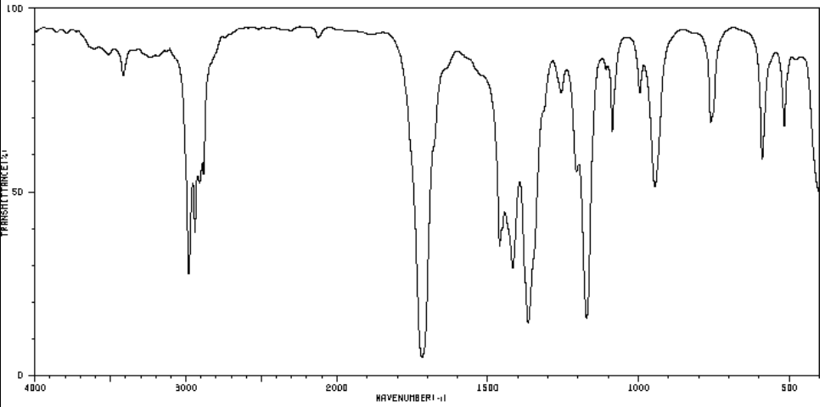

Suggest two useful conclusions that can be drawn from this spectrum. Justify each conclusion.

2 marks

___________________________________________________________________________

____________________________________________________________________________

**c**. The 1H-NMR and 13C-NMR spectra for the unknown compound are both shown below.

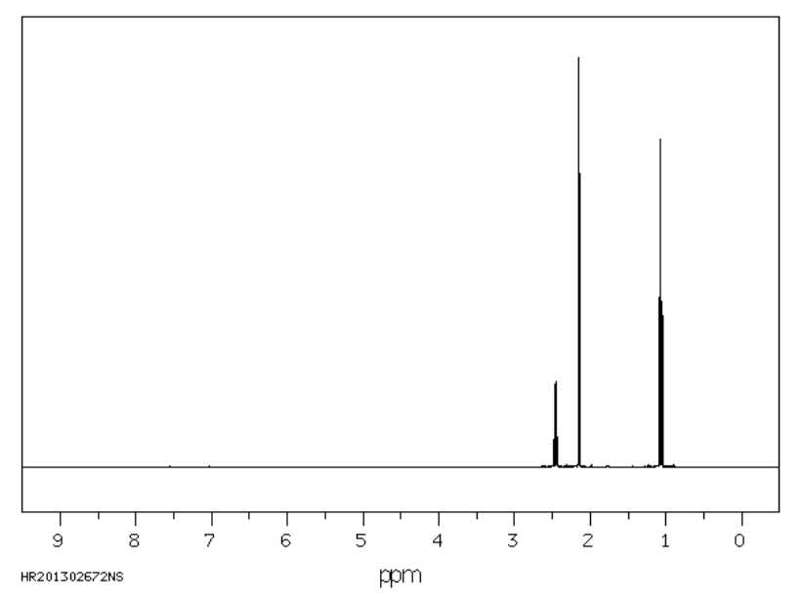

1H NMR: From left to right-

* quartet
* singlet
* triplet

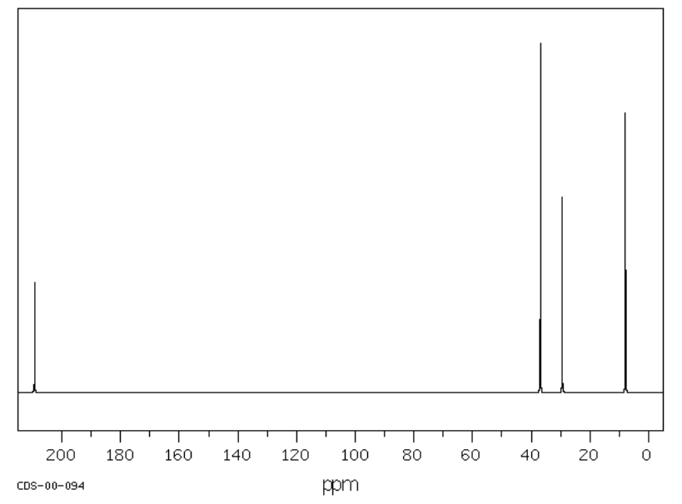

Combine all the data provided to draw the structure of the compound. Explain how the NMR

data supports your conclusion. 4 marks

__________________________________________________________________________

__________________________________________________________________________

__________________________________________________________________________

___________________________________________________________________________

____________________________________________________________________________

**d**. Use the boxes provided to draw the structure of a molecule that could be used to synthesise the

unknown compound. Also show the reagents required for this reaction. 2 marks

Other reagent(s)

Unknown compound

**Question 8**  (7 marks)

a. Propan-1-ol and propan-2-ol have very similar properties.

What chemical reaction could you use to distinguish between these alcohols and what different

outcomes would occur? 3 marks

_______________________________________________________________________________

_______________________________________________________________________________

_______________________________________________________________________________

_______________________________________________________________________________

**b**. Butanoic acid is an isomer of methyl propanoate. Both are colourless liquids.

How could you test a sample of one of these liquids, without a chemical reaction, to identify

which liquid it is? How will the outcomes differ depending upon the liquid? 2 marks

_______________________________________________________________________________

_______________________________________________________________________________

**c**. Two different labs produce separate samples of oleic acid. The sample from one laboratory has a

melting point 30 ºC higher than the sample from the other laboratory.

Suggest a structural reason for the differing melting points. 1 mark

_______________________________________________________________________________

_______________________________________________________________________________

**d**. Two separate samples of the molecule CH3CH2CHOHCl produce different effects on polarised

light. Explain why. 1 mark

_______________________________________________________________________________

_______________________________________________________________________________

**Question 9**  (8 marks)

A class is investigating different aspects of determining the heat of combustion of peanuts.

One of the students uses the setup shown below, where a peanut is held in a wire holder and burnt under a soft drink can containing 100 g of water. The student is investigating the impact of changing the distance between the flame and the can of water.

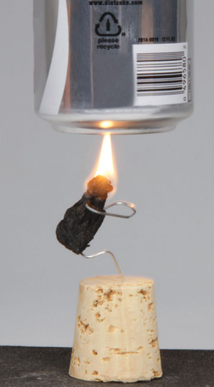

Some of the student’s notes are shown below.

**Hypothesis:** There will be an optimum distance between the nut and the can.

|  |  |  |
| --- | --- | --- |
| Experiment | Separation distance (cm) | ∆T ºC |
| 1 | 1.0 | 12.3 |
| 2 | 2.0 | 14.2 |
| 3 | 3.0 | 16.1 |
| 4 | 4.0 | 15.1 |
| 5 | 4.0 | 14.5 |
| 6 | 4.0 | 15.8 |
| 7 | 5.0 | 13.6 |
| 8 | 6.0 | 9.4 |

Experiment 3: Mass of peanut: 1.12 g

Final temperature: 38.6 ºC

Initial temperature 19.2 ºC

**a**. For this experiment, identify the 2 marks

- dependent variable ___________________________________________

- independent variable __________________________________________

**b**. Discuss the data obtained from experiments 4, 5 and 6 and relate your comments to the

experiment design. 2 marks

_______________________________________________________________________________

_______________________________________________________________________________

**c**. What conclusion do you think the student could draw from this experiment? 2 marks

_______________________________________________________________________________

_______________________________________________________________________________

**d.** The documented value for a peanut is 26.5 kJ g. 2 marks

Use the data from experiment 3 to determine the percentage efficiency of the student apparatus.

_______________________________________________________________________________

_______________________________________________________________________________

**Question 10** (9 marks)

The molecules drawn below are methanamine and ethanamine.



These two compounds are the first members of the homologous series of primary amines.

**a**. Use your knowledge of bonding to discuss some likely properties of methanamine, then use

amines as an example to explain

* what a homologous series is
* how a knowledge of what a homologous series is can be useful to a chemist.

Include in your answer discussion of likely trends in properties of the amine group.

4 marks

___________________________________________________________________________

___________________________________________________________________________

___________________________________________________________________________

___________________________________________________________________________

**b**. An acid-base titration can be used to determine the concentration of a strong solution of

ethanamine.

Outline in detail a procedure that could be used to determine the concentration of a solution of

ethanamine.

Include in your answer a discussion of other reagents required and a balanced equation for the

reaction occurring. 5 marks

___________________________________________________________________________

___________________________________________________________________________

___________________________________________________________________________

___________________________________________________________________________

___________________________________________________________________________

___________________________________________________________________________

___________________________________________________________________________

___________________________________________________________________________

End of Exam

Mark section A: /30

Mark section B: /90

Total: /120