2023 Unit 3 Chemistry trial exam

Name: ____________________ Total mark: 85

Section A: Multiple Choice section
Question 1
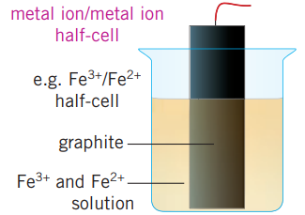
The diagram below shows a half-cell.

Select the correct statement about this half-cell.
A. This cell is constructed by dipping an iron electrode into a solution of FeCl₃(aq).
B. This electrode would be the positive electrode if the half-cell is connected to a Zn²⁺/Zn half-cell.
C. Iron metal will form at this electrode if the half-cell is connected to Ag⁺/Ag half-cell.
D. The use of carbon in graphite will enable the electrode to form CO₂ gas.

Question 2
An equation often referred to in relation to carbon monoxide poisoning is

Hb₄(aq) + 4CO(g) ⇌ Hb(CO)₄(aq)

Select the correct statement about CO poisoning.
A. The K value for this reaction is lower than the K value for the reaction between Hb₄ and oxygen.
B. CO poisoning will not occur if oxygen gas is present.
C. When oxygen is administered to a CO poisoning victim, the [Hb₄] in the blood will decrease.
D. When oxygen is administered to a CO poisoning victim, the K value for this reaction drops.

Question 3
Which of the following systems will have a K value with units of M?
A. N₂(g) + 3H₂(g) ⇌ 2NH₃(g)
B. 2NO₂(aq) ⇌ N₂O₄(g)
C. 2NH₃(aq) ⇌ N₂(g) + 3H₂(g)
D. 4NH₃(g) + 5O₂(g) ⇌ 4NO(g) + 6H₂O(g)

Question 4
A Maxwell-Boltzmann curve is drawn below.
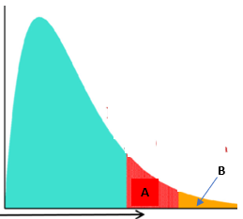
The proportion of particles with sufficient energy to react when a catalyst is used is represented by
A. Area B
B. Area A
C. Area A – Area B
D. Area A + Area B

Use the galvanic cell drawn below to answer Questions 5 and 6
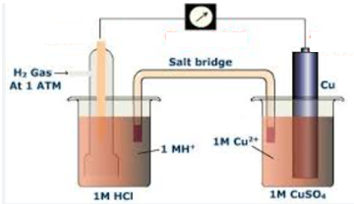
Question 5
When this cell is discharging,
A. the copper electrode will be the positive cathode.
B. the hydrogen electrode will be the negative cathode.
C. chlorine gas will be produced at the anode.
D. copper will form at the cathode and hydrogen gas at the anode.

Question 6
In this cell,
A. the hydrogen electrode receives electrons and the voltage should be 0.83 V.
B. the copper electrode receives electrons and the voltage should be 0.34 V.
C. the electrons will flow from the copper electrode to the hydrogen electrode.
D. the copper electrode receives electrons and the voltage should be 1.17 V

Question 7
Which of the following electrolytes will produce hydrogen gas at the cathode and oxygen gas at the anode?
A. 4.0 M NaCl
B. NaCl(l)
C. KCl(aq)
D. KI(aq)

Question 8
49.6 L of oxygen gas is produced at SLC from an electrolytic cell. Silver is deposited at the other electrode. The number of mole of silver deposited will be
A. 2
B. 4
C. 6
D. 8

Use the following diagram to answer Questions 9 and 10
A concentration time graph for a reversible reaction is shown below.
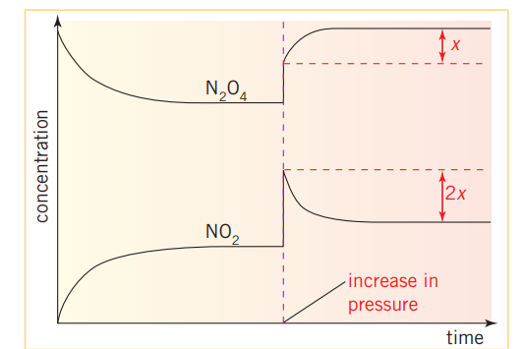

Question 9
The change to the equilibrium system shown in this graph is consistent with
A. an increase in pressure.
B. an increase in temperature.
C. a decrease in temperature.
D. an increase in volume

Question 10
After equilibrium is re-established, the
A. rate of reaction is unchanged and the value of K is unchanged.
B. rate of reaction is faster than before the change, but the value of K is unchanged.
C. the concentrations of all species are higher and the value of K is higher.
D. the concentration of one species is higher but the other is lower.

Question 11
The balanced half-equation for the conversion of NO₃⁻ ions to N₂ gas is

A. NO₃⁻(aq) + 3OH⁻(aq) 3H₂O(l) + N₂(g) + 4e
B. NO₃⁻(aq) + 6H⁺(aq) + 5e 3H₂O(l) + N₂(g)
C. 2NO₃⁻(aq) + 12H⁺(aq) + 10e 6H₂O(l) + N₂(g)
D. 2NO₃⁻(aq) + 12H⁺(aq) + 12e 6H₂O(l) + N₂(g)

Question 12
The equation for the reaction between sulfur dioxide and oxygen gases is
2SO₂(g) + O₂(g) ⇌ 2SO₃(g) K = 25 M⁻¹ at 220 ⁰C

The numerical value of K at 220 ⁰C for the reaction below will be

SO₃(g) ⇌ SO₂(g) + ½ O₂(g)

A. 0.04
B. 0.2
C. 5
D. -25

Question 13
The addition of an inert gas can change the concentrations of an equilibrium reaction if
A. the reactor is adjusted to keep the pressure constant.
B. a catalyst is also added.
C. the temperature of the reactor is held constant.
D. the total pressure in the reactor is increased.

Question 14
Which of the following statements is correct for both galvanic cells and electrolytic cells?
A. The cathode is the positive electrode.
B. The reactants should be separated to prevent spontaneous reactions.
C. The electrons will flow from the anode to the cathode.
D. The strongest oxidant will react with the weakest reductant.

Question 15
Which of the following fuels will have the lowest flashpoint?
A. biodiesel
B. petrodiesel
C. ethanol
D. ethane

Question 16
Which of the following is the correct comparison of the molar mass of a fatty acid and its methyl ester?
A. The methyl ester will be 14 g mol⁻¹ heavier than the fatty acid.
B. The methyl ester will be 15 g mol⁻¹ heavier than the fatty acid.
C. The methyl ester will be 31 g mol⁻¹ heavier than the fatty acid.
D. The methyl ester will be 32 g mol⁻¹ heavier than the fatty acid.

Question 17
Which of the following fuel samples releases the greatest amount of energy?
A. 1 mole of butane
B. 80 g of octane
C. 49.6 L of methane gas at SLC
D. 10 mol of hydrogen gas

Question 18
The diagram below is an energy profile diagram.
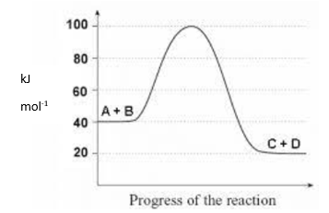

Determine the activation energy for the reaction

C + D A + B

A. -20 kJ mol⁻¹
B. -60 kJ mol⁻¹
C. 60 kJ mol⁻¹
D. 80 kJ mol⁻¹

Question 19
Select the correct statement about biogas.
A. Biogas is the same as natural gas but is sourced renewably.
B. The use of biogas makes no impact upon the environment.
C. Biogas usually contains a significant percentage of CO₂ gas.
D. Biogas does not produce emissions.

Question 20
Which of the following is likely to lead to a random error?
A. The burettes used for a titration have not been used or cleaned in the current year.
B. The balance used has not been calibrated for several years.
C. The temperature in the room is 3⁰ warmer than the setting indicates.
D. The concentration of a standard solution is 0.10 M higher than the label indicates.

Section A: 20 marks

Section B: 65 marks

Total: 85 marks

Section B: Short answer questions
Question 1 (8 marks)
The diagram below shows a flowchart for an electricity producing plant.
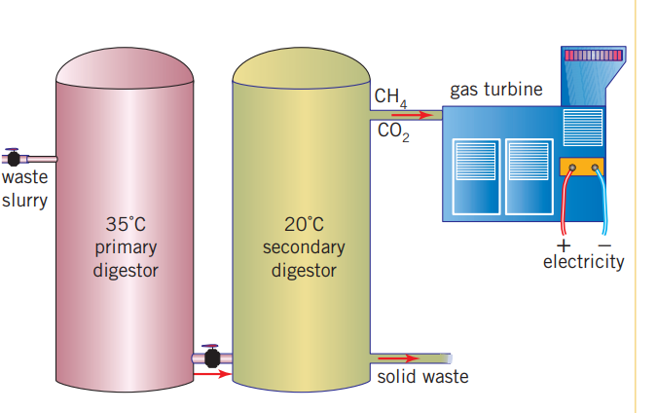

a. i. Name the fuel produced in this process: __________________ 1 mark

ii. Is this an example of a renewable fuel? Justify your answer. 2 marks

_______________________________________________________________________________

_______________________________________________________________________________

iii. Give an example of a source of waste slurry. __________________________ 1 mark

iv. The primary digester operates at a temperature of 35 ˚C. Suggest a reason for this choice of
temperature. 1 mark

b. Write a balanced equation for the complete combustion of the fuel. 1 mark

_______________________________________________________________________________

c. It is accepted that this process offers advantages over more conventional electrical generation plants.
List two likely advantages. 2 marks

_______________________________________________________________________________

_______________________________________________________________________________

_______________________________________________________________________________
Question 2 (14 marks)
In theory, a galvanic cell based on the reaction between lithium metal and S₈ sulfur molecules is an attractive proposition due to the high voltage and energy density resulting. In practice, the efficient design of this cell has been difficult. The diagram below shows one prototype that operates in non-aqueous conditions. This cell is a secondary cell. The discharge product formed is lithium sulfide. Li₂S.

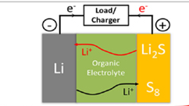

a. i. Use the headings below to write half-equations and an overall equation for the reactions occurring in
this cell during discharge. Also indicate on the diagram the polarity of the lithium electrode.
4 marks
Anode: _______________________________________________________

Cathode: _______________________________________________________

Overall: _______________________________________________________

ii. During recharge a flow of ions occurs through this cell. Identify the ions and the direction of their
flow. 2 marks

_________________________________________________________________________________

iii. What is the oxidation state change of sulfur atoms during discharge? _______________ 1 mark

iv. Organic electrolytes are expensive. Explain why one is used in this cell. 2 marks

_______________________________________________________________________________

_______________________________________________________________________________

b. Ammonia gas can be used as a fuel in the fuel cell shown below.
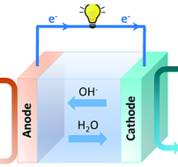

NH₃ O₂

The overall equation for this cell is 4NH₃(g) + 3O₂(g) 2N₂(g) + 6H₂O(g)
The cell operates in alkaline conditions.
i. Write balanced half-equations for the reactions occurring. 2 marks

Anode: _______________________________________________________

Cathode: _______________________________________________________

ii. Indicate on the diagram the polarity of the ammonia half-cell. 1 mark

iii. What is oxidation state change of the nitrogen atoms in this cell? _______________ 1 mark

iv. Is this cell rechargeable? Justify your answer. 1 mark

_____________________________________________________________________________

Question 3 (12 marks)
Three separate cells are connected in series and a current is passed through the circuit.
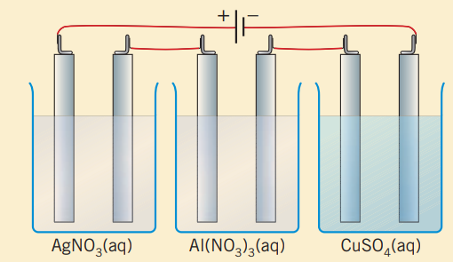

a. Use the circles provided to indicate the polarity of the two middle electrodes. 1 mark

b. Explain how the silver nitrate cell could be used to investigate Faraday’s First Law of electrolysis.
3 marks

_____________________________________________________________________________

_____________________________________________________________________________

_____________________________________________________________________________

_____________________________________________________________________________

c. Explain how the whole circuit could be used to demonstrate Faraday’s Second Law of electrolysis.
3 marks
_____________________________________________________________________________

_____________________________________________________________________________

_____________________________________________________________________________

_____________________________________________________________________________

d. A current of 1000 amps is passed through the circuit for 96.5 seconds.

- Determine the mass of metal that will be obtained in each of the three cells. 3 marks

_____________________________________________________________________________

_____________________________________________________________________________

_____________________________________________________________________________

_____________________________________________________________________________

ii. Determine the total number of mole of gas obtained from the circuit. 2 marks

_____________________________________________________________________________

_____________________________________________________________________________

_____________________________________________________________________________

Question 4 (9 marks)
The diagram shows an energy profile diagram for the reaction between ammonia gas and oxygen. The equation for the reaction is

2NH₃(g) + 3O₂(g) N₂(g) + 3H₂O(l)
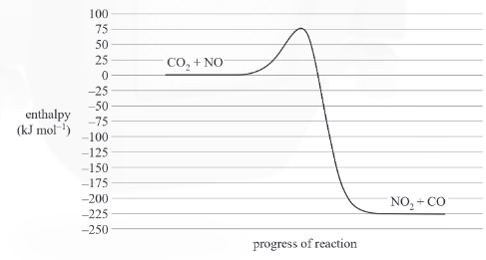
N₂, H₂O
NH₃, O₂
a. i. Write a thermochemical equation for this reaction. 1 mark

________________________________________________________________________________

ii. Determine the activation energy for the reverse reaction. 1 mark

________________________________________________________________________________

b. A catalyst is found for this reaction. Sketch on the graph the change to the reaction pathway that the
catalyst makes. 1 mark

________________________________________________________________________________

c. 1.00 kg of ammonia gas undergoes combustion.

i. Calculate the energy released, in kJ, from this combustion. 3 marks

________________________________________________________________________________

________________________________________________________________________________

________________________________________________________________________________

ii. Determine the volume of nitrogen formed at 320 ⁰C and 120 kPa from this combustion. 3 marks

________________________________________________________________________________

________________________________________________________________________________

________________________________________________________________________________
Question 5 (10 marks)
The reaction between hydrochloric acid and oxygen is a reversible, endothermic one. The equation for the reaction is

4HCl(g) + O₂(g) ⇌ 2Cl₂(g) + 2H₂O(g)

a. This reaction is a redox reaction. Explain how you could recognise this. 1 mark

________________________________________________________________________________

b. An equilibrium mixture of the above gases is formed.
Use the table below to indicate the impact of each change on the value of K_{c} and the concentration of
HCl. Use the terms increased, decreased or unchanged. 3 marks

Change made | Impact on K_{c} | Impact on [HCl] once equilibrium re-established
temperature increased

volume decreased

some H₂O removed

c. 4.0 mol of HCl and 1.0 mol of O₂ are added to a 10 L reactor. When equilibrium is reached, the amount
of Cl₂ is measured as 0.44 mol.
Determine the value of K_{c} at this temperature. 4 marks

________________________________________________________________________________

________________________________________________________________________________

________________________________________________________________________________

________________________________________________________________________________

________________________________________________________________________________

d. One possible change to an equilibrium system is an increase in temperature. For the reaction above,
state one advantage, and one disadvantage, of using a very high temperature. 2 marks

Advantage: ____________________________________________________________________

Disadvantage: _________________________________________________________________

Question 6 (12 marks)
Hydrogen peroxide, H₂O₂, decomposes to form water and oxygen gas. Manganese dioxide can be used as a catalyst for this reaction.

A student uses the equipment shown below to investigate the impact of temperature upon the rate of this reaction.
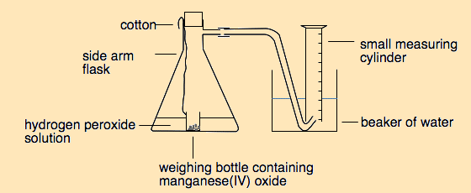

a. i. Write a balanced equation for the reaction occurring. 1 mark

______________________________________________________________________________

ii. Identify the reason for the use of string in this reaction. 1 mark
______________________________________________________________________________
______________________________________________________________________________

b. i. Write a procedure the student could follow to investigate the impact of temperature on rate of
this reaction. 3 marks

_______________________________________________________________________________

_______________________________________________________________________________

_______________________________________________________________________________

_______________________________________________________________________________

_______________________________________________________________________________

_______________________________________________________________________________

ii. identify the independent and dependent variables in your procedure. 2 marks

Independent variable: ________________________________________________________________

Dependent variable: __________________________________________________________________.

c. i. Explain why the rate changes with temperature? 2 marks
_______________________________________________________________________________

_______________________________________________________________________________

_______________________________________________________________________________

ii. Will the final volume of gas increase with temperature? Justify your answer. 2 marks
_______________________________________________________________________________

_______________________________________________________________________________

_______________________________________________________________________________

iii. Circle the one of the following that manganese dioxide impacts? 1 mark

enthalpy of the reaction the position of equilibrium the activation energy of the reaction

