Atomic theory teat: 50 Name: _____________
SECTION A – Multiple-choice questions

Instructions for Section A
Answer all questions.
Choose the response that is correct or best answers the question.
A correct answer scores 1, an incorrect answer scores 0.
No mark will be given if more than one answer is completed for any question.
Marks will not be deducted for incorrect answers.

Question 1
Which one of the following elements is considered to be ‘endangered’?
A. helium
B. carbon
C. oxygen
D. sodium

Question 2
A trend in Period 3 of the periodic table is shown below.
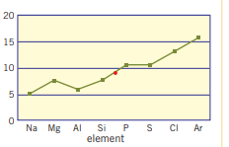
The property on the vertical axis is likely to be
A. electronegativity values
B. atomic radius
C. metallic nature
D. first ionisation energy

Question 3
In comparison to fluorine, iodine will have a
A. lower electronegativity but a higher first ionisation energy.
B. higher electronegativity and a lower first ionisation energy.
C. lower electronegativity and a lower first ionisation energy.
D. greater atomic radius and a higher chemical reactivity.

Question 4
Which element is found in Period 4 and Group 16?
A. sulfur
B. chlorine
C. selenium
D. tellurium

Question 5
The atomic notation for the element argon is shown below:
$${}_{18}^{40}{Ar}$$
This atom of argon will have with strontium, magnesium will have
A. 18 protons, 18 neutrons and 18 electrons
B. 18 protons, 22 neutrons and 18 electrons
C. 18 protons, 18 neutrons and 22 electrons
D. 18 protons, 22 neutrons and 22 electrons

Question 6
An electron orbital is best defined as a
A. shell in an atom that can hold several pairs of electrons.
B. region around a nucleus that contains two electrons.
C. region around a nucleus that can hold up to two electrons.
D. region around a nucleus that can hold up to eight electrons.

Question 7
The ground state electron configuration of 1s²2s²2p⁶3s²3p⁶ 3d⁸4s² represents
A. calcium
B. cobalt
C. nickel
D. strontium

Question 8
As you move down a group of the Periodic Table the electronegativity will
A. drop as the outer shell is more shielded from the nucleus.
B. decrease as the number of outer shell electrons has increased
C. increase as the core charge of the atom is increasing.
D. increase as the number of protons in the nucleus has increased.

Question 9
The number of orbitals containing electrons in an atom of chlorine will be
A. 3
B. 5
C. 6
D. 9

Question 10
An α-particles can be described as a nucleus of a helium atom. An α-particle will contain
A. 2 protons
B. 2 protons and 2 neutrons
C. 2 protons, 2 neutrons and 2 electrons
D. 4 protons

SECTION B- Short-answer questions

Instructions for Section B
Questions must be answered in the spaces provided in this book. To obtain full marks for your responses you should
- Give simplified answers with an appropriate number of significant figures to all numerical questions; unsimplified answers will not be given full marks.
- Show all workings in your answers to numerical questions. No credit will be given for an incorrect answer unless it is accompanied by details of the working.
Make sure chemical equations are balanced and that the formulas for individual substances include an indication of state; for example, H2(g); NaCl(s)

Question 1 (6 marks)
In Ernest Rutherford’s famous experiment, his team of researchers directed α-particles (alpha) at a thin film of gold foil. A representation of the experiment is shown below.
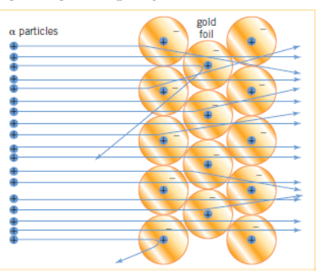

- One of the observations of the team was that most of the particles seemed to pass through the foil with a small deviation in their path.
i. What conclusion did Rutherford draw about the atom from the fact that most particles
passed through easily? 1 mark

______________________________________________________________________

_____________________________________________________________________

ii. What conclusion did Rutherford draw from the fact that the particles deviated slightly
in their path? 1 mark

_____________________________________________________________________

_____________________________________________________________________

- Another observation was that a very occasional particle rebounded strongly from the foil.
What conclusion did Rutherford draw from the observation that some of the particles rebounded strongly? 2 marks

_____________________________________________________________________

_____________________________________________________________________

- Make a sketch of how atoms were perceived after the release of Rutherford’s conclusions.
2 marks

Question 2 (7 marks)
A diagram from a chemistry text is shown below:
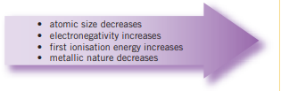

a. Explain what this diagram is summarizing. 2 marks

_____________________________________________________________________

_____________________________________________________________________

b. The term ‘electronegativity’ is used in the diagram.
i. What is electronegativity? 1 mark

_____________________________________________________________________

ii. Explain the trend is electronegativity shown. 2 marks

_____________________________________________________________________

_____________________________________________________________________

_____________________________________________________________________

c. Explain why the atomic size has the trend shown. 2 marks

_____________________________________________________________________

_____________________________________________________________________

Question 3 (6 marks)
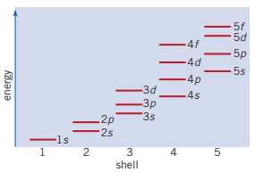
The diagram below can be a useful tool when studying atomic structure.

a. Explain what this diagram is showing. 2 marks

_____________________________________________________________________

_____________________________________________________________________

_____________________________________________________________________

b. i. Write the ground state electron configuration for the element scandium. 1 mark

_____________________________________________________________________

ii. Name the element with the electron configuration of 1s²2s²2p⁶3s²3p⁶4s² . 1 mark

_____________________________________________________________________

iii. Which subshell is being filled in the outer shell of Group 13 elements? 1 mark

_____________________________________________________________________

iv. Explain why there are 10 elements in each of the rows of transition metals. 1 mark

______________________________________________________________________

Question 4 (5 marks)
a. The atom copper has two forms ${}_{29}^{63}{Cu}$ or ${}_{29}^{65}{Cu}$.
i. What is the term used to describe elements with more than one form? _____________ 1 mark

ii. Explain how these two forms of copper are different. 2 marks

_____________________________________________________________________

_____________________________________________________________________

iii. Give an example of how this property of some atoms might be useful. 1 mark

_____________________________________________________________________

_____________________________________________________________________

b. Use atomic notation to represent an atom of fluorine. ______________________ 1 mark

Question 5 (10 marks)
An outline of the Periodic Table is drawn below with some letters to represent elements on it.
Refer to this diagram to answer the questions below.
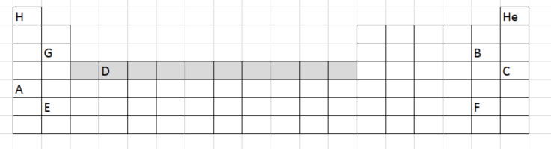
a. Identify the elements; 3 marks
i. A __________________
ii. C __________________
iii. D __________________

b. i. Element C is in Period ____ and Group ______. 1 mark

ii. Element G is in Period ____ and Group ______. 1 mark

c. i. What section of the Periodic Table is element D in? ________________________ 1 mark

ii. Which type of subshell is being filled in this section? ______________________ 1 mark

d. i. Which element on the table above is the most reactive metal? _________________ 1 mark

ii. Which element on the table above is the least reactive? _____________________ 1 mark

iii. List an element on the table above that is an alkali earth metal ________________ 1 mark

Question 6 (6 marks)

a. Croup 18 of the periodic table is often referred to the Noble gases.
Why is this term used and what is the reason for their behaviour? 2 marks

_____________________________________________________________________

_____________________________________________________________________

_____________________________________________________________________

b. The noble gases were discovered around the 1890 AD. Why did it take so long for scientists to identify
them? 2 marks

_____________________________________________________________________

_____________________________________________________________________

c. The electronegativity values of the Noble gases are often not listed. Explain why. 2 marks

_____________________________________________________________________

_____________________________________________________________________

End of test

Mark out of 50:

