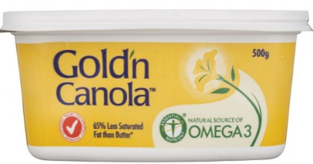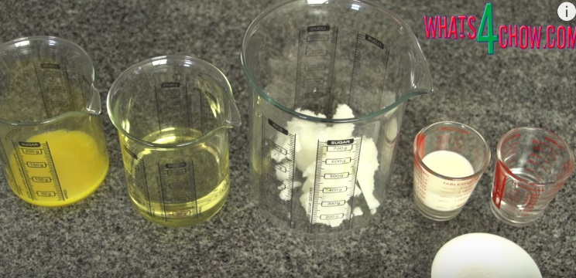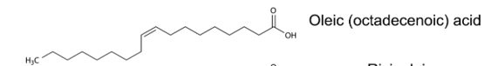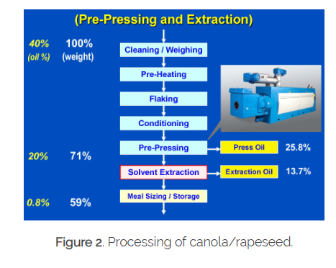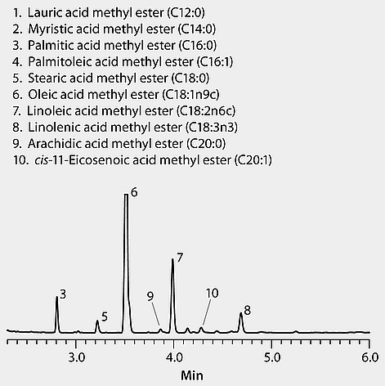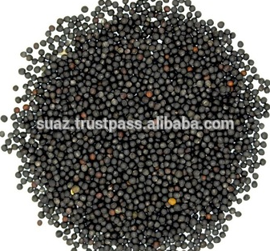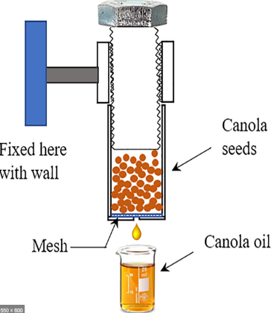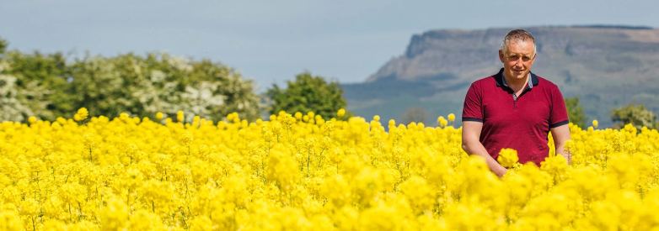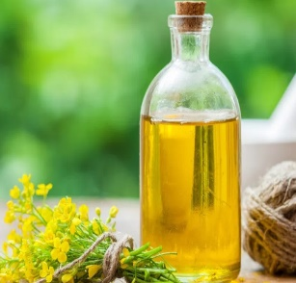

**Ingredients for margarine: canola, vegie oil, milk, lemon juice, egg (emulsifier) and salt.**

**The crushed seeds are soaked in hexane to extract remaining oil. Hexane is boiled off and reused. Remaining seed waste is made into pig food.**

**HPLC showing canola is a mix of fatty acids.**

Commercial margarine: Canola Oil (52%), Water, Vegetable Oils, Salt, Milk Solids, Emulsifiers (322 (From Soy), 471), Preservative (202), Food Acid (270), Colour (160a), Flavour, Vitamins A & D

**Oleic acid: about 60% of canola oil. (C18H34O2). Monounsaturated fatty acid**

**© POShea**

**Canola crops have small, black, oily seeds. The seeds are pressed in Numurkah to produce canola oil.**

**CANOLA OIL**