Chemistry Name: ________________
2018 Trial exam

SECTION A – Multiple-choice questions

Instructions for Section A
Answer all questions.
Choose the response that is correct or best answers the question.
A correct answer scores 1, an incorrect answer scores 0.
No mark will be given if more than one answer is completed for any question.
Marks will not be deducted for incorrect answers.

Question 1
The 2017 data below compares the energy production mix of South Australia with Victoria.
Units used are MW.

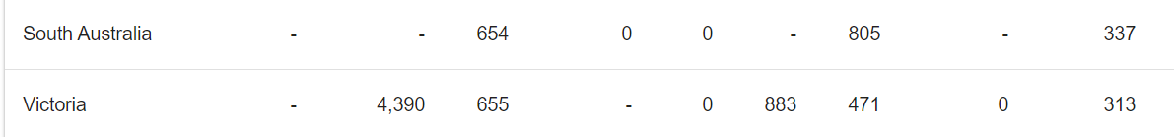

From these figures it can be concluded that in South Australia the
A. proportion of energy produced by solar is similar to that of Victoria.
B. overall energy mix is similar to that of Victoria.
C. use of renewable energy is less widespread than in Victoria.
D. use of fossil fuels is far less than that of Victoria.

Question 2
What mass of ethanol, in g, is required to produce the same amount of energy as 50.0 g of butane?
A. 29.6
B. 50.0
C. 72.1
D. 83.9

Question 3
In 2015 Australian energy production was 5980 PJ. (1 PJ = 10¹⁵ Joule)
The mass of natural gas (assume natural gas is 100% methane) required to produce that amount of energy would be, in kg,
A. 5.98 × 10¹³
B. 1.07 × 10¹⁴
C. 1.07 × 10¹⁷
D. 3.32 × 10²⁴

Question 4
Consider the following properties to answer this question.
I higher viscosity
II higher melting point
III higher solubility in water
IV longer shelf life
V higher energy density
Which of the above options apply to biodiesel compared to petrodiesel?
A. I and II only.
B. I, II and V only.
C. II, III and IV only
D. I, II and III only.

Question 5
A 90 g sample of fuel produces 149 L of CO₂ at SLC when it undergoes complete combustion. The fuel could be
A. ethanol
B. ethane
C. butane
D. octane

Use the following information to answer Questions 6 and 7
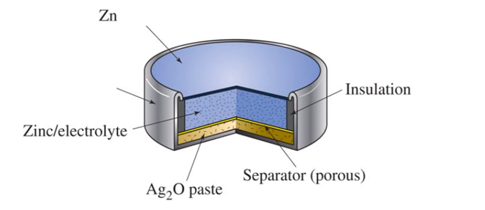

A common set of reactants in button batteries is zinc metal and silver oxide, Ag₂O. A typical cell is shown above. The overall equation for this cell is

Zn(s) + Ag₂O(s) ZnO(s) + 2Ag(s)

Question 6
In this cell,
A. zinc ions are reduced to zinc ions at the positive electrode.
B. zinc atoms are reduced to zinc ions at the positive electrode.
C. silver ions are reduced to silver metal at the anode.
D. silver ions are reduced to silver metal at the positive electrode.

Question 7
In this cell,
A. the products will have a greater level of chemical potential energy than the reactants.
B. electrons will flow from the zinc atoms to the silver ions.
C. the chemical potential energy is all converted to electrical energy.
D. the insulation is used to protect the cell from extreme temperature environments.

Question 8
In a hydrogen/oxygen fuel cell
A. the overall equation will be the same in acidic or alkaline environments.
B. the half-equations will be the same in acidic or alkaline environments.
C. the overall equation will be different from the equation for the combustion of hydrogen.
D. the volume of hydrogen used will be half the volume of oxygen used.

Question 9
Strong oxidants can be used to oxidise ethanol to ethanoic acid. A balanced half-equation for this reaction is
A. C₂H₆O(aq) + 4H⁺(aq) + 4e⁻ C₂H₄O₂(aq) + H₂O(l)
B. C₂H₆O(aq) + H₂(g) C₂H₄O(aq) + 2e⁻
C. C₂H₆O(aq) + H₂O(l) C₂H₄O₂(aq) + 4H⁺(aq) + 4e⁻
D. C₂H₄O₂(aq) + H₂O(l) C₂H₆O(aq) + 4H⁺(aq) + 4e⁻

Question 10
An energy profile diagram is drawn below.
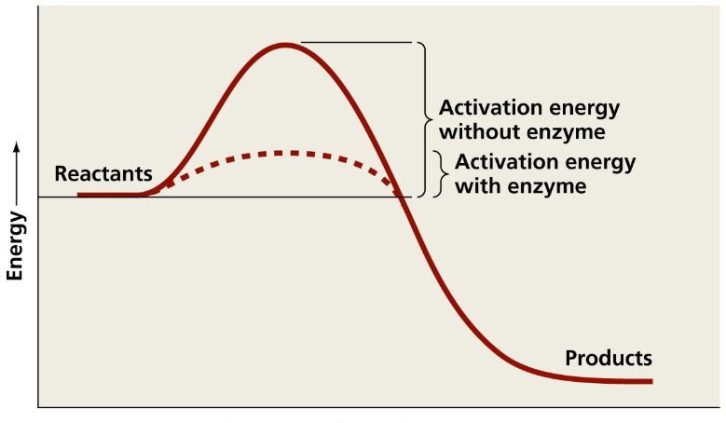

The diagram can be used to show that
A. an enzyme lowers the enthalpy change in a reaction.
B. an enzyme will only increase the rate of the forward reaction.
C. an enzyme lowers the activation energy required for a reaction to occur.
D. an enzyme increases the kinetic energy of the particles in a reaction.

Question 11
Exposure of humans to high levels of carbon monoxide can be fatal. Two relevant equations to the process of carbon monoxide poisoning are:

Reaction 1: Hb₄(aq) + 4O₂(g) ⇌ Hb₄O₈(aq) K₁
Reaction 2: Hb₄(aq) + 4CO(g) ⇌ Hb₄(CO)₄(aq) K₂

When a paramedic treats someone suffering from carbon monoxide poisoning they place an oxygen mask on the patient’s mouth. From an equilibrium point of view, this is serving to
A. increase the value of K₁ but lower the value of K₂.
B. favour the forward reaction in equation 1 and the back reaction in equation 2.
C. push both reactions in the forward direction.
D. increase the total amount of Hb₄ in the blood.

Use the following information to answer Questions 12 and 13
Dinitrogen tetroxide forms an equilibrium with nitrogen dioxide. The equation is

N₂O₄(g) ⇌ 2NO₂(g) ΔH = +ve

A 0.70 mol sample of dinitrogen tetroxide is added to an empty 1.0 L reactor. The concentration of N₂O₄ is monitored and displayed on the graph below.

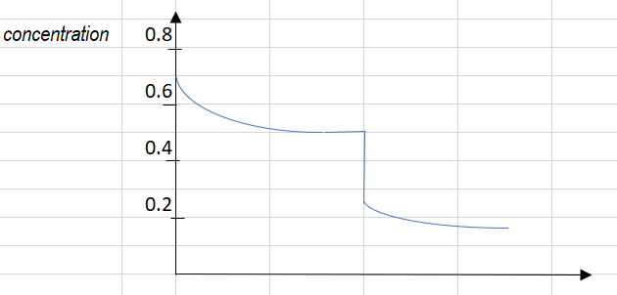time
t₁
Question 12
The amount of NO₂ present at equilibrium will be, in mol,
A. 0.2
B. 0.4
C. 0.5
D. 0.7

Question 13
The likely change that occurred at time t₁ is that
A. the volume of the container has been halved.
B. the temperature has been increased.
C. some N₂O₄ has been removed from the reactor.
D. the volume of the container has been doubled.

Use the following information to answer Questions 14 and 15
An electrolytic cell is constructed that uses copper electrodes in a CuSO₄ solution. A sketch of the cell is shown below.
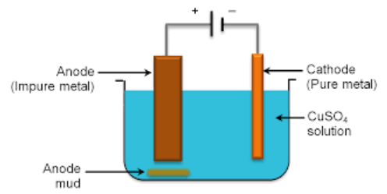

Question 14
The overall equation for the reaction occurring in the cell is
A. 2Cu²⁺(aq) + 2H₂O(l) O₂(g) + 4H⁺(aq) + 2Cu(s)
B. Cu(s) + 2H₂O(l) Cu²⁺(aq) + H₂(g) + 2OH⁻(aq)
C. 2H₂O(l) 2H₂(g) + O₂(g)
D. Cu(s) + Cu²⁺(aq) Cu²⁺(aq) + Cu(s)
Question 15
The cell runs operates for 5 minutes. During this time, the concentration of copper ions in the solution will
A. not change.
B. increase due to the formation of copper ions at the anode.
C. decrease as copper is deposited at each electrode.
D. decrease due to the formation of copper deposits on the cathode.

Question 16
What is the systematic name of this molecule?
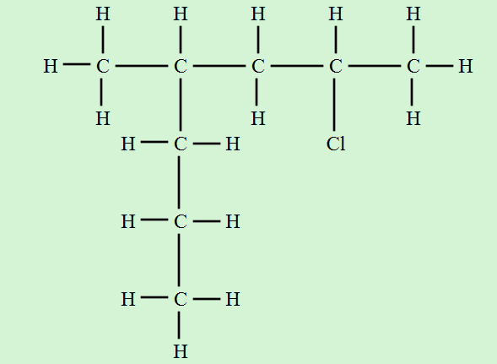
A. 4-chloro-2-propylpentane
B. 2-chloro-4-methylheptane
C. 2-propyl-4-chloropentane
D. 6-chloro-4-methylheptane

Question 17
Butan-2-ol could be formed from the
A. reaction of but-1-ene or but-2-ene with steam.
B. reaction of but-1-ene with oxygen.
C. reaction of but-2-ene with steam but not from but-1-ene with steam.
D. reaction of 1-chlorobutane with potassium hydroxide.

Question 18
Which option ranks the following molecules in order of boiling point? (lowest to highest)
A. propanal, propanol, pentane, butan-1-ol
B. propanal, propanol, butan-1-ol, pentane
C. pentane, propanal, propanol, butan-1-ol
D. butan-1-ol, propanol, pentane, propanol

Question 19
A mixture of liquids is passed through a HPLC. The solvent used is non-polar and the stationary phase is polar. The first two peaks to emerge from the column are, in order of retention time, hexane and octane. A third peak emerges. It could be
A. pentane.
B. heptane.
C. butan-1-ol.
D. but-2-ene.

Question 20
A student is performing a titration between ethanoic acid and ethanamine using phenolphthalein as an indicator. The ethanoic acid is in the burette. The student is frustrated that it is difficult to judge the endpoint of the titration as the colour change seems to occur over the addition of several mL from the burette.
Select the alternative that is a correct conclusion on this issue.
A. It is not good practice to titrate a weak acid and a weak base.
B. The student needs to change to a more suitable indicator for this acid/base combination.
C. The student is actually trying to titrate an acid with another acid instead of a base.
D. The use of extra indicator would help make the endpoint clearer.

Question 21
A proton-NMR is shown below.
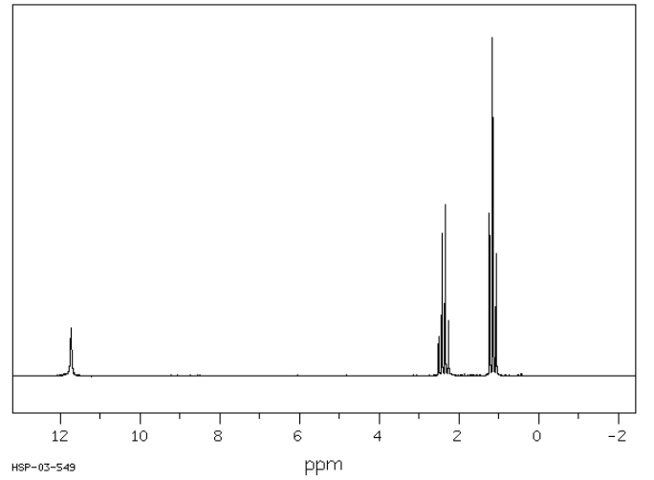
This molecule is likely to be
A. propan-1-ol.
B. propanal.
C. methyl ethanoate.
D. propanoic acid.

Question 22
A 10.0 mL sample of vinegar is diluted to 250 mL in a volumetric flask. The diluted vinegar is added to a burette and titrated against 20.0 mL aliquots of 0.120 M NaOH. The mean titre is determined to be 14.8 mL. The concentration of ethanoic acid in the undiluted vinegar will be, in M,
A. 0.203
B. 0.420
C. 0.840
D. 4.05

Question 23
The mass spectrum of a molecule is shown below.
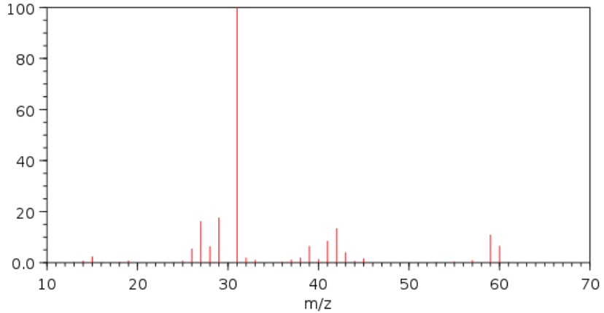
The molecule is likely to be
A. ethanoic acid
B. propan-1-ol
C. methyl ethanoate
D. butane

Question 24
A solution of ethanamine is added to a solution of hydrochloric acid. A product formed in the reaction will be
A. NH₃(aq)
B. CH₃CH₂Cl(aq)
C. CH₃CH₂NH₄(aq)
D. CH₃CH₂ NH₃Cl(aq)

Question 25
The diagram below shows a skeletal diagram of a tripeptide.
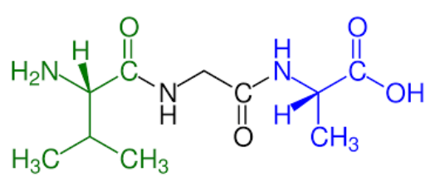
The amino acids in this structure are, from left to right,
A. valine, glycine and alanine.
B. alanine, glycine and alanine.
C. valine, alanine and leucine.
D. leucine, glycine and alanine.

Question 26
A student conducts a series of trials where the enzyme invertase (sucrase) is added to sucrose solutions at different temperatures. Invertase is a catalyst for the hydrolysis of sucrose. Benedict’s solution is added to each trial. It changes colour as hydrolysis occurs. The student has plotted his results on the graph shown but has not included the label on the vertical axis.

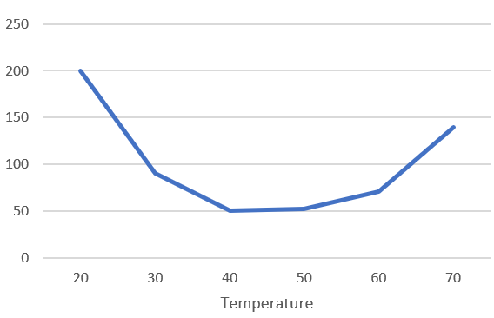
The quantity represented on the vertical axis could be
A. enzyme activity.
B. rate of reaction.
C. time taken for a colour change.
D. concentration of glucose.

Question 27
Starch is a polysaccharide formed from glucose. Which of the following is a general molecular formula for starch?
A. –(C₆H₁₀O₅)-_{n}
B. –(C₆H₁₀O₆)-_{n}
C. –(C₆H₁₂O₆)-_{n}
D. –(C₆H₁₁O₅)-_{n}

Question 28
The structures of vitamin A and folic acid (also a vitamin) are shown below.

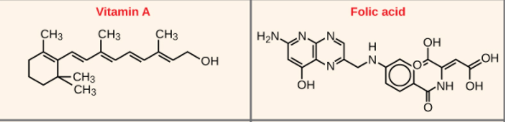

From examining their structures, it is likely that
A. both will be water soluble as they both contain at least one hydroxyl group.
B. vitamin A will be water soluble and folic acid fat soluble.
C. both will be water soluble as their structures are relatively linear.
D. folic acid will be water soluble and vitamin A fat soluble.

Question 29
The label on a packet of Savoy biscuits lists the energy per 30.0 g serve as 350 kJ. A sample of biscuit is burnt under a beaker containing 80.0 g of water. The mass of biscuit required to heat the water by 60.0⁰C will be, in g, (assuming 100% efficient energy transfer)
A. 0.057
B. 1.36
C. 1.72
D. 2.78

Question 30
A student conducts an electrolysis experiment to measure the amount of copper deposited from a copper sulfate solution. She sits the apparatus used in a shallow water bath set at 25⁰C. The circuit used includes a variable resistor, used to maintain the current at a set value. The student performs several trials of different duration and compares the masses of copper obtained in each trial. Which of the following is an independent variable?
A. The mass of copper obtained.
B. The current in the cell.
C. The duration of each trial.
D. The temperature of the cell.

Section A 30 marks ____
Total Section B 91 marks ____
Total exam 121 marks ____

SECTION B - Short-answer questions

Instructions for Section B
Questions must be answered in the spaces provided in this book.
To obtain full marks for your responses you should
- give simplified answers with an appropriate number of significant figures to all numerical questions; unsimplified answers will not be given full marks.
- show all workings in your answers to numerical questions. No credit will be given for an incorrect answer unless it is accompanied by details of the working.
- make sure chemical equations are balanced and that the formulas for individual substances include an indication of state; for example, H₂(g); NaCl(s)

Question 1 (11 marks)
The flowchart below outlines a process for bioethanol manufacture. The version shown is an experimental procedure that uses cellulose as a raw material rather than crops like sugar cane.

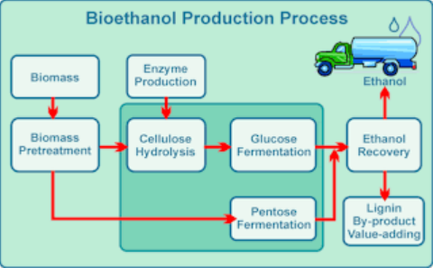

a. i. Write a balanced equation for the reaction of glucose to form ethanol. (1 mark)

_____________________________________________________________________

ii. The production and combustion of ethanol produces CO₂ emissions. Despite this, the
use of bioethanol as a fuel is put forward as a potential solution to greenhouse issues.
Explain why the use of bioethanol is considered to be environmentally preferable to
petrol. (2 marks)

______________________________________________________________________

______________________________________________________________________

b. i. One step on the flowchart shows the conversion of cellulose to form glucose. Use your
knowledge of carbohydrates to explain the chemical changes occurring during this
reaction and the conditions required for the reaction. (2 marks)

______________________________________________________________________

______________________________________________________________________

ii. The use of cellulose as raw material offers improvements in the sustainability of the
bioethanol industry over conventional sources of bioethanol. Suggest an advantage of
this change to cellulose. (1 mark)

___________________________________________________________________

____________________________________________________________________

c. i. Write a balanced equation for the complete combustion of ethanol in air. (1 mark)

____________________________________________________________________

ii. Calculate the volume of CO₂ that is produced from the combustion of 1.00 tonne of
ethanol at 480⁰C and 120 kPa. (3 marks)

______________________________________________________________________

______________________________________________________________________

______________________________________________________________________

iii. Calculate the amount of energy that is released from the complete combustion of 1.00
tonne of ethanol. (1 mark)

______________________________________________________________________

______________________________________________________________________

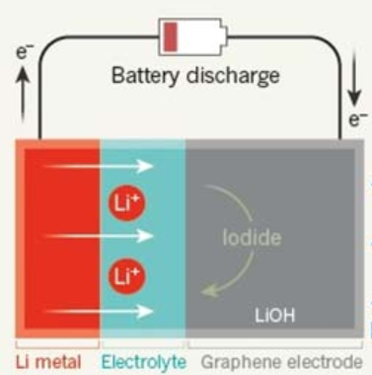
Question 2 (11 marks)
Cambridge University researchers are referring to the cell shown
as the ‘ultimate battery’. It has a high energy density, is over 90%
efficient and can be recharged over 2000 times.

The reactions in this cell are complex and do not occur in
aqueous solutions. The anode reaction can be taken from the
electrochemical series and the cathode half-equation is

cathode: 2Li⁺ + 2e⁻ + O₂ Li₂O₂

a. i. Write an overall equation for this cell discharging. (1 mark)

____________________________________________________________________

ii. What is the oxidation number of oxygen in Li₂O₂? ___________ (1 mark)

b. Write a half-equation for the reaction occurring at the anode when the cell is recharging.
(1 mark)
______________________________________________________________________

c. This cell is an expensive one to produce. Give two reasons for the expense. (2 marks)

______________________________________________________________________

______________________________________________________________________

d. The cell can operate with a voltage of 3.50 volts and the mass of lithium in the anode is
5.80 g. Calculate the energy produced in this cell if all the lithium reacts. (3 marks)

______________________________________________________________________

______________________________________________________________________

______________________________________________________________________

______________________________________________________________________

e. Lithium required for this cell can be manufactured by electrolysis of molten lithium
chloride solution. Use the template below to write the half-equations and overall equation
for the production of lithium from lithium chloride. (3 marks)

anode: _______________________________________________________

cathode: ______________________________________________________

overall: ______________________________________________________

Question 3 (9 marks)
The graph below shows the concentration curves of the reactants and products when a mixture of nitrogen and hydrogen gas are mixed in a reactor at 200⁰C.

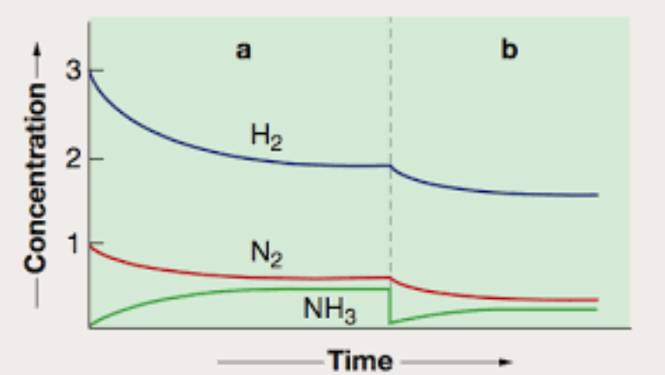
a. i. Write a balanced equation for the reaction occurring. (1 mark)

_________________________________________________________________

ii. Determine a value for the equilibrium constant in sector a of the graph. (3 marks)
(Note: Read the starting value and equilibrium values for H₂ and base the amounts of
the other two gases on the change in hydrogen.)

_________________________________________________________________

_________________________________________________________________

_________________________________________________________________

iii. What is the value of K for the reaction below at 200⁰C? (1 mark)

2NH₃(g) ⇌ N₂(g) + 3H₂(g)

______________________________________________________________

b. i. Describe the change made to the system at the start of sector b and explain the
response of the system to this change. (2 marks)

_________________________________________________________________

_________________________________________________________________

ii. Will the value of K for sector b equal that of sector a? Justify your answer. (2 marks)

_________________________________________________________________

_________________________________________________________________

Question 4 (8 marks)
1-chloropropane is a colourless, flammable gas with a pungent odour. It is an intermediate compound in the production of propan-1-ol.

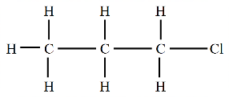

KOH

B

A

propyl ethanoate (pear flavour)
H⁺/ Cr₂O₇²⁻

C

a. i. Name two reactants that could be used to form 1-chloropropane. (2 marks)

_______________________________________________________________________

ii. Write a balanced chemical equation for the production of 1-chloropropane. (1 mark)

________________________________________________________________________

b. 1-chloropropane is reacted with KOH. Use the box provided on the template to draw the
structure of molecule A produced in this reaction. (1 mark)

c. A sample of molecule A is used to produce the ester propyl ethanoate. This molecule has
a distinctive pear flavour.
i. Draw the structure of propyl ethanoate in the box labelled B. (1 mark)

ii. Name the other reactant required to produce propyl ethanoate. (1 mark)

_______________________________

d. A sample of molecule A is heated very gently for a short period of time with an acidified
solution of potassium dichromate.
i. Use the box provided on the template to draw the structure of molecule C produced.
(1 mark)
ii. Write a balanced half-equation for the reaction of Cr₂O₇²⁻ ions to Cr³⁺ ions occurring
in this reaction. (1 mark)

_______________________________________________________________________
Question 5 (10 marks)
The diagram below is taken from an animation of the hydrolysis of the disaccharide, sucrose.
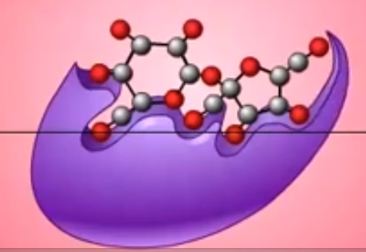
a. Describe what this diagram is illustrating. (3 marks)

___________________________________________________________________

___________________________________________________________________

___________________________________________________________________

b. i. What type of bond will be broken when the hydrolysis reaction occurs? (1 mark)

___________________________________________________________________

ii. What will the products of this hydrolysis reaction be? (1 mark)

___________________________________________________________________

iii. Will the purple object shown play any further part in this reaction?
Explain your answer. (1 mark)

___________________________________________________________________

___________________________________________________________________

c. The pH of the solution this reaction is conducted in is changed to pH 1. (2 marks)
Explain the impact of this change on the reaction occurring.

___________________________________________________________________

___________________________________________________________________

d. Food products containing high levels of sucrose are usually labelled ‘high GI’. What does
GI refer to and why is sucrose associated with high GI levels? (2 marks)

___________________________________________________________________

___________________________________________________________________

Question 6 (9 marks)
The structure of a triglyceride is shown below.
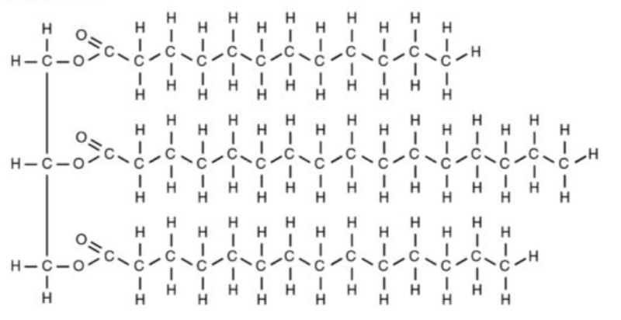
a. Potassium hydroxide is used to hydrolyse the triglyceride. Use the boxes provided to
write the molecular formulas of the four products of this hydrolysis. (4 marks)

b. What is the general form (the ratio of carbon atoms: hydrogen atoms: oxygen atoms) of a
saturated fatty acid? (1 mark)

_______________________________________________________________________

c. Hydrolysis of triglycerides is very limited in the human stomach. Use your knowledge of
chemical bonding to explain why this is the case. (2 marks)

_______________________________________________________________________

_______________________________________________________________________

d. The role of bile in the digestion of triglycerides is shown in the diagram below.
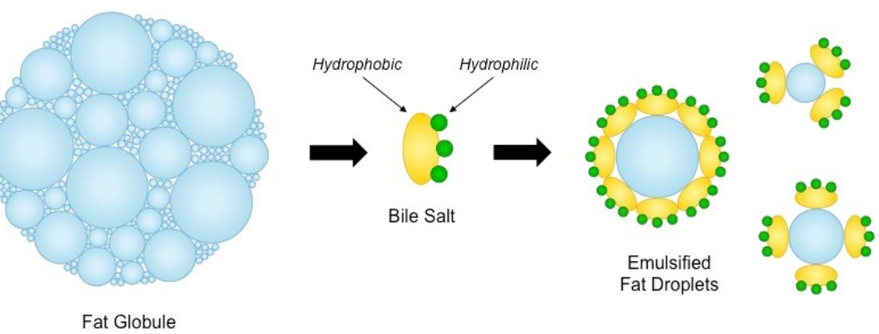
Use your knowledge of rates of reaction to explain how bile is facilitating the digestion of
fats. (2 marks)

_______________________________________________________________________

_______________________________________________________________________

Question 7 (8 marks)
An unidentified organic molecule has the molecular formula C₃H₆O₂.
a. Draw and name three possible structures of this molecule. (3 marks)

______________ ______________ ____________________
molecule 1 molecule 2 molecule 3

b. An infrared spectrum of the unidentified molecule is shown below.

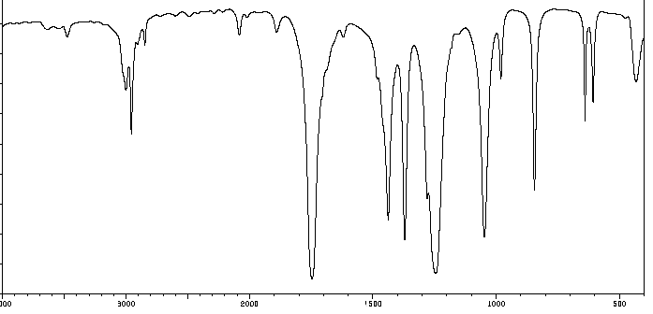
Explain how this spectrum can help deduce the structure of the unidentified molecule.
(2 marks)
___________________________________________________________________

___________________________________________________________________
c. A high resolution proton-NMR of the unidentified molecule is shown below.
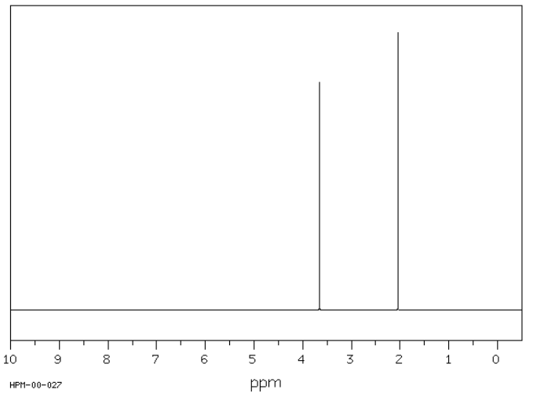

Use this spectrum to identify the molecule in question. Refer to the molecule structure to
justify your selection. (3 marks)

___________________________________________________________________

___________________________________________________________________

___________________________________________________________________

Question 8 (9 marks)
The chemical formula of the diprotic acid, oxalic acid is HOOCCOOH (C₂H₂O₄).

a. The concentration of a solution of oxalic acid can be determined by redox titration with
acidified potassium permanganate, KMnO₄.
i. Write a half-equation for the reaction of oxalic acid to CO₂. (1 mark)

______________________________________________________________________

ii. Write a half-equation for the reduction of MnO₄⁻ to Mn²⁺ ions in acid conditions.
(1 mark)

______________________________________________________________________

iii. Write an overall equation for the reaction between oxalic acid and potassium
permanganate solutions. (1 mark)

______________________________________________________________________

iv. 25.0 mL aliquots of 0.120 M KMnO₄ react exactly with 14.8 mL of oxalic acid
solution. What is the concentration of the oxalic acid solution? (2 marks)

b. The concentration of an oxalic acid solution can be determined by titration against
sodium hydroxide solution.
i. Write a balanced equation for the reaction between oxalic solution and sodium
hydroxide. (1 mark)

_____________________________________________________________________

ii. The same solution of oxalic as in part a. is titrated against 0.500 M NaOH. The
average titre of oxalic acid required to neutralise 20.0 mL aliquots of NaOH is
13.6 mL. Use this data to obtain a second estimate of the concentration of the oxalic
acid. (3 marks)

______________________________________________________________________

______________________________________________________________________

______________________________________________________________________

Question 9 (7 marks)
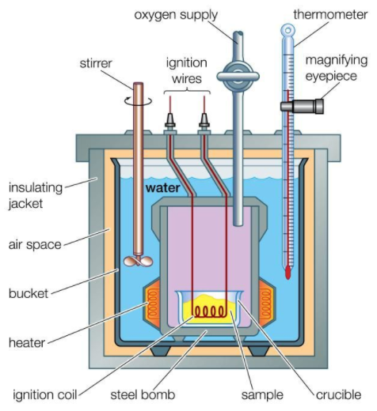
The diagram below is of a bomb calorimeter, frequently used to measure the energy content of food samples.

a. i. The calorimeter contains heating apparatus. Why
does it include heating apparatus? (1 mark)

_______________________________________

_______________________________________

ii. Oxygen can be added under pressure to the bomb
section. Explain why high pressure might be used?
(1 mark)
_______________________________________

_______________________________________

b. Why is a bomb calorimeter used instead of a solution calorimeter for foods? (1 mark)

______________________________________________________________________

The following data is obtained from experimentation using this calorimeter.

Initial temperature: 18.2⁰C

Current: 3.60 amps Voltage 4.42 volts Time: 4.00 minutes

Final temperature: 25.1⁰C
================================================================
0.873 g of biscuit added and ignited.

Initial temperature: 25.1⁰C Final temperature: 30.9⁰C

c. Use the data provided to
i. determine the calibration factor for the calorimeter. (2 marks)

______________________________________________________________________

______________________________________________________________________

ii. determine the energy content in kJ g⁻¹ of the biscuit. (2 marks)

______________________________________________________________________

______________________________________________________________________

Question 10 (9 marks)
A student conducts an investigation into the rate of a chemical reaction. The reaction she chooses to study is the reaction between magnesium metal and hydrochloric acid.

She uses a series of identical flasks, each containing 50 mL of HCl. She varies the mass of magnesium added to the hydrochloric acid in each flask and records the time taken for 80 mL of gas to be evolved. The apparatus used and the data recorded are shown below.

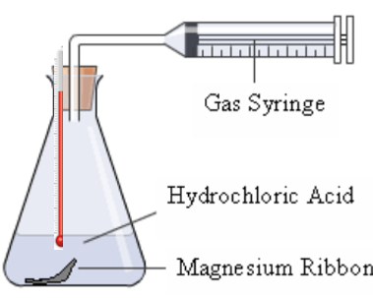
Hypothesis: that there is a linear relationship between mass of magnesium used and the rate of reaction

Exp. | Volume  2 M HCl mL | Mass Mg  g | Time  sec | Final T  ⁰C
1 | 50 | 0.1 | 521 | 29
2 | 50 | 0.2 | 200 | 32
3 | 50 | 0.3 | 46 | 36
4 | 50 | 0.4 | 12 | 41

Conclusion: The relationship between rate of reaction and mass of magnesium is a positive one but not linear.

a. In this experiment,
i. what is the independent variable? _________________ (1 mark)

ii. what is the dependent variable? __________________ (1 mark)

iii. list one controlled variable. _________________ (1 mark)

b. Use the grid provided to draw a graph of mass of magnesium against time taken.
(1 mark)

c. i. As the mass of magnesium increases, what happens to the time required to produce 80
mL of gas? (1 mark)

______________________________________________________________________

ii. Does this mean that the rate is dropping as the mass of magnesium increases? Explain
your answer. (1 mark)

_______________________________________________________________________

_______________________________________________________________________

d. The experiment design included the use of a thermometer. Discuss the temperature
readings obtained and their relevance to the conclusion made by the student. (3 marks)

_______________________________________________________________________

_______________________________________________________________________

_______________________________________________________________________

_______________________________________________________________________

