**Chemistry Name: ________________**

**2020 Trial exam**

**120 mark total: 30 + 90**

**SECTION A – Multiple-choice questions**

|  |
| --- |
| **Instructions for Section A**  Answer **all** questions.  Choose the response that is **correct** or **best answers** the question.  A correct answer scores 1, an incorrect answer scores 0.  No mark will be given if more than one answer is completed for any question.  Marks will **not** be deducted for incorrect answers. |

*Use the following information to answer Questions 1 and 2*

The diagram below is a representation of the processes occurring in the production of electrical energy from coal.

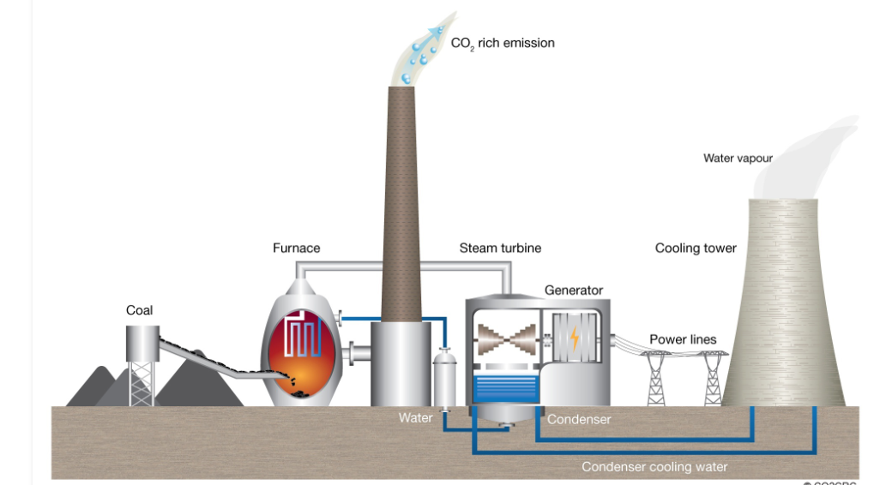

**Question 1**

The main energy producing reaction occurring in this power station is

**A**. CH4(g) + 2O2(g) 🡪 CO2(g) + 2H2O(l)

**B**. 2C(s) + O2(g) 🡪 2CO(g)

**C**. C(g) + O2(g) 🡪 CO2(g)

**D**. C(s) + O2(g) 🡪 CO2(g)

**Question 2**

The main pollutant producing reaction occurring in this power station is

**A**. CH4(g) + 2O4(g) 🡪 CO2(g) + 2H2O(l)

**B**. C(s) + O2(g) 🡪 CO2(g)

**C**. S(s) + O2(g) 🡪 SO2(g)

**D**. N2(g) + O2(g) 🡪 2NO(g)

**Question 3**

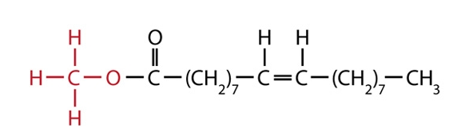

I fatty acid

II biodiesel

III ester

IV triglyceride

The molecule shown can be described as

**A**. I and III only.

**B**. II and IV only.

**C**. I and II only.

**D**. II and III only.

*Use the following information to answer Questions 4 and 5*

In 2019 Australia passed Qatar as the world’s largest exporter of LNG with a total export of 77.5 million tonnes (1 tonnes = 1000 kg). (Assume that LNG is 100% methane for this question)

**Question 4**

The amount of energy that could be produced from the complete combustion of this LNG is, in kJ,

**A**. 7.75×1013

**B**. 4.31×1012

**C**. 4.31×1015

**D**. 4.31×1018

**Question 5**

The volume of CO2 that could be produced at SLC from the complete combustion of this LNG is, in L,

**A**. 4.84×1012

**B**. 1.2 ×1011

**C**. 1.2 ×1014

**D**. 4.31×1015

**Question 6**

Select the alternative that **best** describes why the rate of a reaction increases with temperature.

**A**. A higher temperature means more collisions.

**B**. A higher temperature leads to less space between particles.

**C**. A higher temperature means a higher percentage of collisions are successful.

**D**. A higher temperature gives more collisions and a higher percentage of successful

collisions.

**Question 7**

The diagram below shows an energy profile diagram for a reaction with a two-stage catalyst.

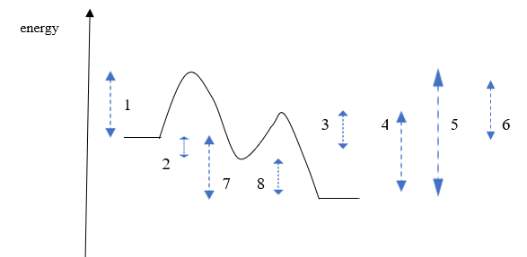

The respective values for the activation energy and enthalpy change for this reaction are

**A**. 1 and 7

**B**. 3 and 8

**C**. 5 and 7

**D**. 1 and 8

*Use the following information to answer Questions 8 and 9*

The diagram below shows a representation of a lithium/ manganese dioxide cell.

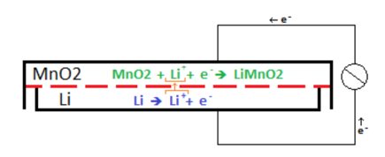

**Question 8**

In this cell,

**A**. electrons will flow from the cathode to the anode.

**B**. the lithium metal is the cathode and has a positive polarity.

**C**. lithium metal is oxidised and manganese ions reduced.

**D**. lithium ions are reduced and manganese ions oxidised.

**Question 9**

The overall reaction (simplified) for this cell will be

**A**. Li(s) + MnO2(s) 🡪 LiMnO2(s) + Li+

**B**. Li(s) + MnO2(s) 🡪 LiMnO2(s)

**C**. Li+ + MnO2(s) + Li(s) 🡪 Li+ + LiMnO2(s)

**D**. Li+ + MnO2(s) 🡪 LiMnO2(s)

**Question 10**

Which of these metals is the least reactive?

**A**. silver

**B**. tin

**C**. copper

**D**. lead

**Question 11**

Which of the following half-equations could be from the cathode of an alkaline fuel cell?

**A**. O2(g) + 2H2O(l) + 4e- 🡪 4OH-(aq)

**B**. CH4(g) + 2H2O(l) + 4e- 🡪 CO2(g) + 4OH-(aq)

**C**. H2(g) 🡪 2H+(aq) + 2e-

**D**. H2(g) + 2OH-(aq)  🡪 2H2O(l) + 2e-

*Use the following information to answer Questions 12 and 13*

Aluminium metal can be recycled by dissolving the aluminium in molten cryolite and electrolysing the liquid. The half equations for the process are shown on the diagram below.

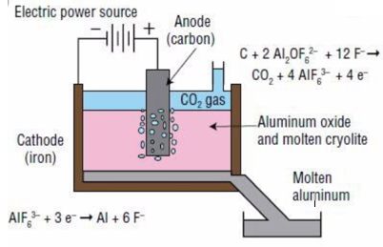

**Question 12**

In this cell

**A**. aluminium metal is formed at the anode and carbon dioxide at the cathode.

**B**. aluminium metal is formed at the cathode and carbon dioxide gas at the anode.

**C**. electrons will flow from the aluminium electrode to the carbon anode.

**D**. the energy released can be used to power other parts of the production process.

**Question 13**

A current of 10 amps runs through this cell for 10000 seconds. The volume of CO2 produced at SLC will be, in litres,

**A**. 0.0064

**B**. 2.0

**C**. 6.4

**D**. 13

**Question 14**

Electrolysis of a liquid produces hydrogen gas at the negative electrode and chlorine gas at the positive electrode. The liquid could be

**A**. a dilute solution of HCl.

**B**. a dilute solution of KCl.

**C**. KCl(l)

**D**. a concentrated solution of KCl.

*Use the following information to answer Questions 15 and 16*

Bromine and chlorine gases can react to form the compound BrCl. The equation for the reaction is

Br2(g) + Cl2(g) ⇌ 2BrCl(g) *K*c = 225 at 200 0C. Δ*H* = -ve

Bromine is dark brown in colour. Chlorine is a very light green and BrCl colourless.

**Question 15**

Given the above information, what is *K*c for the reaction BrCl(g) ⇌ ½ Br2(g) + ½ Cl2(g) at 200 0C?

**A**. 0.0044

**B**. 0.067

**C**. 15

**D**. -225

**Question 16**

A change is made to an equilibrium mixture of the above gases and the brown intensity is seen to increase as equilibrium is re-established. The change could have been

**A**. an increase in volume.

**B**. the addition of further chlorine gas.

**C**. an increase in temperature.

**D**. a decrease in temperature.

**Question 17**

What is the systematic name of this molecule?



**A**. 5-chloropentan-2-ol

**B**. 5-chloropentanol

**C**. 1-chloropentan-2-ol

**D**. 1-chloropentan-4-ol

**Question 18**



The molecule shown could be formed from the reaction between

**A**. ethanamine and propanoic acid.

**B**. methanamine and propan-1-ol.

**C**. butanol and ammonia.

**D**. propanoic acid and methanamine.

**Question 19**

A HPLC printout for a mixture of sugars is shown below. A non-polar stationary phase has been used. The left most peak is a standard included in all mixtures.

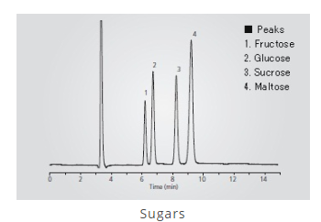

The chromatogram indicates that

**A**. disaccharides are more soluble than monosaccharides in the solvent used.

**B**. maltose is the least adsorbed on the stationary phase.

**C**. the concentrations of all sugars present are relatively similar.

**D**. monosaccharides have lower retention times than disaccharides.

**Question 20**



The molecule shown is tested in both proton-NMR and carbon-NMR. It will have

|  |  |  |
| --- | --- | --- |
|  | Hydrogen environments | Carbon environments |
| **A.** | 2 | 2 |
| **B.** | 3 | 2 |
| **C.** | 2 | 3 |
| **D.** | 3 | 3 |

**Question 21**

Oxalic acid is a diprotic acid. A 15 mL aliquot of oxalic acid is neutralised by 20 mL of 3.0 NaOH. The concentration of the oxalic acid is, in M,

**A**. 1.0

**B**. 1.5

**C**. 2.0

**D**. 4.0

**Question 22**

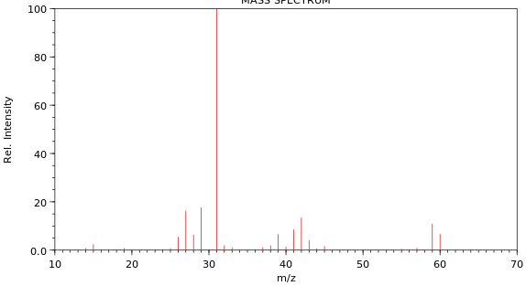

The mass spectrum shown is of

**A**. butane.

**B**. ethanoic acid.

**C**. propan-1-ol.

**D**. propan-2-ol.

**Question 23**

A high-resolution proton-NMR is shown below.

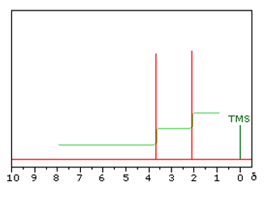

This molecule is likely to be

**A**. ethanol

**B**. propan-1-ol

**C**. methyl propanoate

**D**. methyl ethanoate

**Question 24**

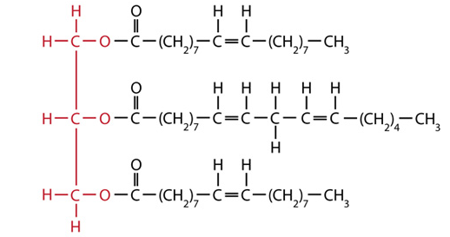

I polyunsaturated fatty acid

II monounsaturated fatty acid

III omega-3 fatty acid

IV omega-6 fatty acid

V saturated fatty acid

This triglyceride has been made from

**A**. I, II and III only.

**B**. II, IV and V only.

**C**. I, III and IV only.

**D**. I, II and IV only.

**Question 25**

The presence of the amino acid lysine in a protein is likely to lead to

**A**. dispersion forces in the tertiary structure.

**B**. ionic bonding in the tertiary structure.

**C**. covalent bonds in the tertiary structure.

**D**. dipole bonding in the tertiary structure.

**Question 26**



The molecule shown is

**A**. a dipeptide formed from threonine and serine.

**B**. an ester formed from two molecules of propan-1-ol.

**C**. a dipeptide formed from two molecules of serine.

**D**. a protein formed from threonine and serine.

**Question 27**

The diagram below outlines the stages in the metabolism in humans of triglycerides.

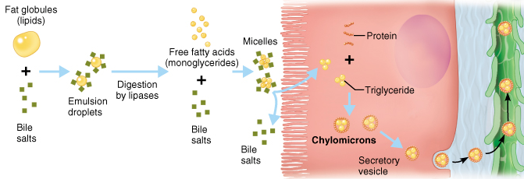

The sequence shown involves

**A**. fat blobs 🡪 emulsified drops 🡪 lipase induced hydrolysis 🡪 new triglycerides.

**B**. fat blobs 🡪 emulsified drops 🡪 glycerol and glycogen 🡪 fatty acids.

**C**. fat blobs 🡪 emulsified drops 🡪 lipase induced hydrolysis 🡪 protein.

**D**. fat blobs 🡪 emulsified drops 🡪 fatty acid 🡪 carbon dioxide and water.

**Question 28**

The molecule 2-amino-3-methylpentanoic acid is also known as

**A**. glycine.

**B**. isoleucine

**C**. leucine.

**D**. valine.

**Question 29**

A 0.64 g sample of almond is burnt under a can containing 60.0 g of water. The temperature of the water rises from 20.2 0C to 28.2 0C. The heat of combustion of the almond is, in kJ g-1,

**A**. 2.01

**B**. 3.14

**C**. 2010

**D**. 3140

**Question 30**

A student conducts a titration, rinsing a pipette with deionised water. She then uses the pipette to transfer a 20.0 mL aliquot of standard base solution to flask to place under a burette. The burette contains ethanoic acid that the is attempting to determine the concentration of. The impact of this poor technique is likely to be a

**A**. higher titre than expected causing the calculated concentration of the acid to be high.

**B**. higher titre than expected causing the calculated concentration of the acid to be low.

**C**. lower titre than expected causing the calculated concentration of the acid to be high.

**D**. lower titre than expected causing the calculated concentration of the acid to be low.

**SECTION B - Short-answer questions**

|  |
| --- |
| **Instructions for Section B**  Questions must be answered in the spaces provided in this book. To obtain full marks for your responses you should   * give simplified answers with an appropriate number of significant figures to all numerical questions; unsimplified answers will not be given full marks. * show all workings in your answers to numerical questions. No credit will be given for an incorrect answer unless it is accompanied by details of the working. * make sure chemical equations are balanced and that the formulas for individual substances include an indication of state; for example, H2(g); NaCl(s) |

**Question 1** (13 marks)

The flowchart below refers to the production of biodiesel. The structure of a triglyceride is also drawn for you. The alcohol used is methanol.

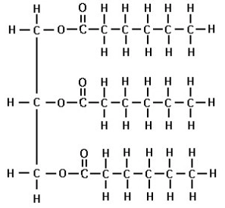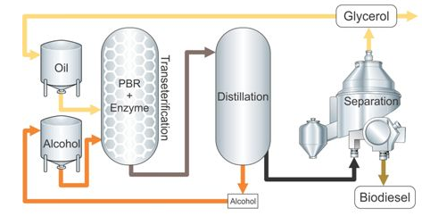

**a. i**. Draw the biodiesel molecule that could be formed from these raw materials. 2 marks

**ii**. This biodiesel molecule is a liquid at room temperature. List the two main factors

that determine the melting point of a biodiesel molecule. 2 marks

_______________________________________________________________________

_______________________________________________________________________

**iii**. The main reaction in this process is labelled ‘transesterification’. Explain what this

term means. 1 mark

_______________________________________________________________________

_______________________________________________________________________

**b**. The products of this process are biodiesel and glycerol. These molecules are both

liquids but they are easy to separate. Why are they easy to separate? 2 marks

_______________________________________________________________________

______________________________________________________________________

**c. i**. Write the molecular formula for the biodiesel formed ________________ 1 mark

**ii**. Write a balanced equation for the complete combustion of this fuel. 2 marks

_______________________________________________________________________

**d**. Complete the table below which is a general comparison between petrodiesel and

biodiesel. 3 marks

|  |  |
| --- | --- |
| **Property** | **Which is higher? Biodiesel or petrodiesel.** |
| Viscosity |  |
| Energy density |  |
| Melting point |  |

**Question 2** (11 marks)

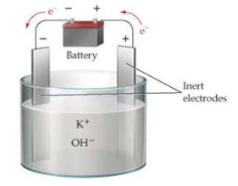British scientist, Sir Humphry Davy, was credited as the first person to isolate the metal potassium in 1807. To do this he electrolysed molten potassium hydroxide, KOH, as shown below.

**a**. Use the template below to write the half-equations, then the overall equation occurring

in this cell. (You may need to refer to your Data Book to answer this question) 3 marks

Anode: _____________________________________

Cathode: _____________________________________

Overall equation: _______________________________________________

**b**. Any attempt to operate a large-scale version of the above process is very dangerous

without modification of the cell design.

Why is this circuit dangerous? Include a chemical equation in your answer. 2 marks

_______________________________________________________________________

_______________________________________________________________________

**c**. Calculate the mass of potassium Davy would have isolated using a current of 0.23 amps

for 20 minutes. 3 marks

_______________________________________________________________________

_______________________________________________________________________

_______________________________________________________________________

**d**. If Davy had used a dilute solution of KOH, the products would not have been the same.

Complete the template for the half-equations and overall equation for the electrolysis of

KOH(aq). 3 marks

Anode: _____________________________________

Cathode: _____________________________________

Overall equation: _______________________________________________

**Question 3** (9 marks)

The empirical formula of a molecule is found to be C4H10O.

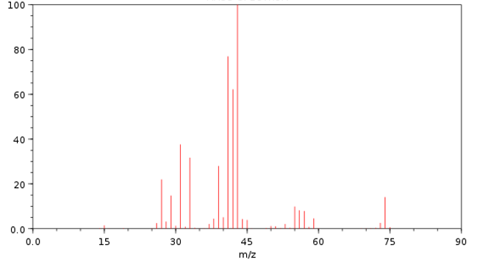

**a**. The mass spectrum of the molecule is shown above.

Use the mass spectrum to

**i**. determine the molecular formula of the molecule. ___________ 1 mark

**ii**. suggest a fragment that might have caused the base peak. ___________ 1 mark

**b**. The infrared spectrum of the molecule is shown below.

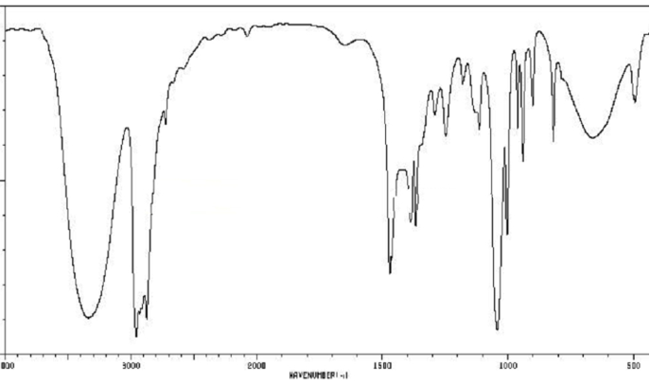

What conclusions can you draw from this spectrum? 2 marks

____________________________________________________________________

____________________________________________________________________

**c**. Draw two possible structures for this molecule. 2 marks

**d**. The carbon-NMR of the molecule is shown below.

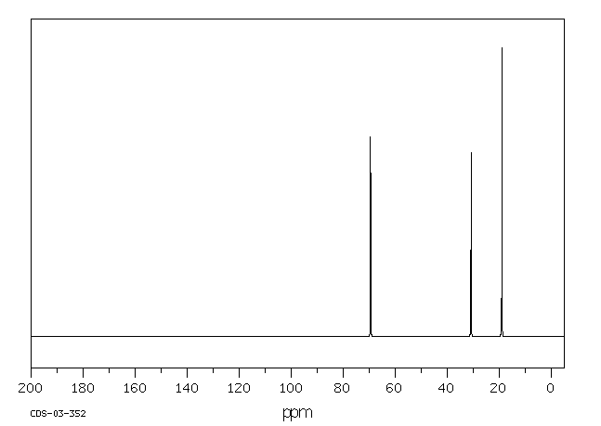

Use this spectrum to name the molecule in question. Explain how the carbon-NMR

structure provided is consistent with your choice. 3 marks

____________________________________________________________________

____________________________________________________________________

____________________________________________________________________

____________________________________________________________________

**Question 4** (8 marks)

The cell shown below is a fuel cell using ethanol solution and oxygen gas as reactants. The reaction produces CO2 gas which in turn forms carbonate ions in the solution. The half-equation and voltage for the reaction of the ethanol is

C2H5OH(aq) + 16OH-(aq) 🡪 2CO32-(aq) + 11H2O(l) + 12e-  -0.74 V

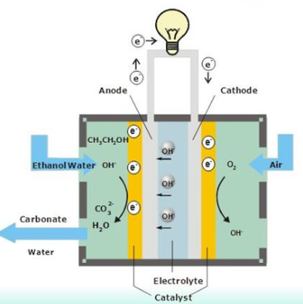

**a**. Use the circles provided to indicate the polarity of the electrodes. 1 mark

**b. i**. Use the template provided to write the oxygen half-equation and the overall equation

for this cell.

Oxygen half-equation: ___________________________________ 1 mark

Overall equation: ____________________________________ 1 mark

**ii**. What will be the cell voltage of this cell? __________________ 1 mark

**iii**. Calculate the energy is released by the reaction of 1 mol of ethanol? 2 marks

______________________________________________________________________

**c**. Energy can also be produced by the direct combustion of ethanol. 2 marks

List two advantages of the use of an ethanol fuel cell over direct combustion of ethanol.

_____________________________________________________________________

_____________________________________________________________________

**Question 5** (9 marks)

**a**. The two molecules shown are structural isomers. They are both colourless liquids.



___________________ _________________

**i**. Use the lines provided to name each molecule. 2 marks

**ii**. Describe a chemical test or reaction that could be used to distinguish between the two

liquids. Explain briefly how your test works. 2 marks

____________________________________________________________________

____________________________________________________________________

**iii**. Which spectrum should easily distinguish the two molecules? 1 mark

____________________________________________________________________

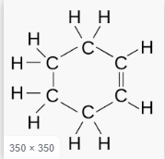**b**. The two molecules shown are both fuels and are both colourless liquids.

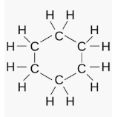

Describe carefully a chemical test that will distinguish the two liquids. Explain briefly

how your test works. 2 marks

____________________________________________________________________

____________________________________________________________________

**c**. The two molecules shown are both colourless liquids



Describe carefully a chemical test that will distinguish the two liquids. Explain briefly

how your test works. 2 marks

____________________________________________________________________

____________________________________________________________________

**Question 6** (8 marks)

Hydrogen and iodine gases react to form hydrogen iodide:

H2(g) + I2(g) ⇌ 2Hl(g) Δ*H* < 0

**a**. The volume of an equilibrium mixture of the above gases is decreased. Explain the

impact of this change on

**i**. the value of the equilibrium constant. 1 mark

_______________________________________________________________________

**ii**. the concentration of HI gas. 2 marks

________________________________________________________________________

________________________________________________________________________

**iii**. the amount of HI gas. 1 mark

________________________________________________________________________

_________________________________________________________________________

**iv**. the rate of the forward reaction 1 mark

________________________________________________________________________

_________________________________________________________________________

**b**. 0.60 mol of HI is added to an empty 2.0 L reactor at 80 0C. At equilibrium the amount of

hydrogen gas is found to be 0.15 mol.

Calculate the value of the equilibrium constant at 80 0C. 3 marks

________________________________________________________________________

_________________________________________________________________________

________________________________________________________________________

_________________________________________________________________________

**Question 7** (8 marks)

The apparatus below is used to determine the heat of combustion of an almond.

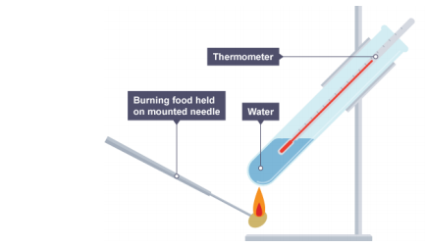

Mass of water: 80 g

Mass of almond: 0.42 g

Initial temperature water: 22 0C

Final temperature water: 48 0C

**a**. Use the data provided to calculate the per gram heat of combustion of the almond.

3 marks

_______________________________________________________________________

_______________________________________________________________________

_______________________________________________________________________

**b**. The experiment shown above usually results in low estimates for heats of combustion.

**i**. If the composition of the almond is assumed to be 70% oil and 30%carbohydrate what

would the theoretical heat of combustion be? 1 mark

_______________________________________________________________________

**ii**. Discuss reasons for the low results. 2 marks

_______________________________________________________________________

_______________________________________________________________________

**c**. Write a balanced equation for the complete combustion of glucose. 2 marks

________________________________________________________________________

**Question 8** (8 marks)

**a**. Many soft drinks offer a ‘normal’ version with sugar and an alternative ‘diet’ version

using artificial sweeteners. Discuss the chemistry of this marketing. 2 marks

______________________________________________________________________

_______________________________________________________________________

_______________________________________________________________________

**b**. Many biomolecules are large molecules. Complete the template below by

- identifying in the second column the smaller molecule(s) used to form the food.

- listing in the third column an enzyme that plays a role in the metabolism of that

biomolecule. 3 marks

|  |  |  |
| --- | --- | --- |
|  | Building block(s) | Enzyme aiding metabolism |
| Carbohydrate |  |  |
| Protein |  |  |
| Triglyceride |  |  |

**c. i**. What is a vitamin? 1 mark

____________________________________________________________________

**ii**. Vitamins are generally placed in two categories. Name the two categories and what

chemical feature is generally responsible for this categorisation? 2 marks

____________________________________________________________________

____________________________________________________________________

____________________________________________________________________

**Question 9** (8 marks)

When you cook eggs the egg white, albumin, turns white. The albumin is a protein and the heat used during cooking causes it to denature. The addition of vinegar aids the denaturing process.

A student conducts an investigation into this process. An outline of her experimental procedure is shown in italics below.

***Investigation****: To conduct an experiment where eggs are cooked at different temperatures and the time it takes for the eggs to cook is recorded and studied.*

*Hypothesis: The rate at which an egg cooks will increase with temperature up to a point but then will drop as the protein denatures.*

***Procedure***

*1. Prepare several beakers containing 50 mL of 1.0 M ethanoic acid.*

*2. Heat each beaker to a different temperature.*

*3. Add an egg to each beaker and record the time it takes for the outside of the egg to turn*

*completely white.*

***Results***

|  |  |
| --- | --- |
| ***Temperature 0C*** | ***Time to cook (secs)*** |
| *30* | *Over 10 minutes* |
| *40* | *812* |
| *50* | *420* |
| *60* | *250* |
| *70* | *146* |
| *80* | *88* |
| *90* | *52* |

***Conclusion***

*The denaturing of egg is not typical of normal enzymes – the rate does not slow at high temperatures.*

**a**. For the student’s experiment, state the

**i**. independent variable _____________________________ 1 mark

**ii**. dependent variable ______________________________ 1 mark

**iii**. a controlled variable. _____________________________ 1 mark

**b**. Suggest an important reason why multiple trials will improve the reliability of the results

obtained in this experiment. 1 mark

_______________________________________________________________________

**c**. Use your knowledge of proteins to explain what is happening to the bonding in egg white

as it is heated. 2 marks

_______________________________________________________________________

_______________________________________________________________________

_______________________________________________________________________

**d**. Discuss the student’s conclusion. 2 marks

_______________________________________________________________________

_______________________________________________________________________

**Question 10** (8 marks)

Many nutritionists consider hemp seeds to be a superfood. Hemp seeds come from the *Cannabis sativa* plant but they do not produce a mind-altering effect. They are a small, brown seed, rich in protein, fibre and fatty acids.

**a**. Hemp oil contains high proportions of essential fatty acids.

Use your knowledge of biomolecules to explain what essential fatty acids are and what

characteristics their structures have. 3 marks

___________________________________________________________________

___________________________________________________________________

___________________________________________________________________

___________________________________________________________________

___________________________________________________________________

___________________________________________________________________

**b**. Hemp seeds are one of the few foods considered to be a ‘complete source of protein’.

This means they provide all essential amino acids.

Use your knowledge of biomolecules to explain the significance of a food being

classified as ‘complete source of protein’. 3 marks

___________________________________________________________________

___________________________________________________________________

___________________________________________________________________

___________________________________________________________________

**c**. Hemp seeds are high in fibre. What is fibre and what happens to fibre when consumed by

humans? 2 marks

___________________________________________________________________

___________________________________________________________________

___________________________________________________________________

___________________________________________________________________

**Section A 30 marks ____**

**Total Section B 90 marks ____**

**Total exam 120 marks ____**

**END OF EXAM**