Trial SAC task: Instrumentation and pathways

Molecule A
The composition of a 2.820 g sample of an organic chemical is tested and found to contain 1.538 g of carbon and 0.256 g of hydrogen. The remainder is oxygen.

1. Complete the table below.

Element | Mass g
carbon
hydrogen
oxygen
1 mark

2. Use the above data to calculate the empirical formula of the compound.

______________________________________________________________________

_______________________________________________________________________
2 marks

3. a. The molar mass of this molecule is 44 g mol⁻¹. What is the molecular formula of the
molecule?
Explain how you arrived at your answer.

2 marks

b. Is this formula consistent with (explain your answer)

i. a typical alcohol ____________________________________________

ii. a typical carboxylic acid? _______________________________________
2 marks

4. Draw two possible structures for this substance. Provide the systemmatic name for the
substances you have drawn.(Molecule is not necessarily alkane based)

4 marks

The infrared spectrum of the molecule is provided below.

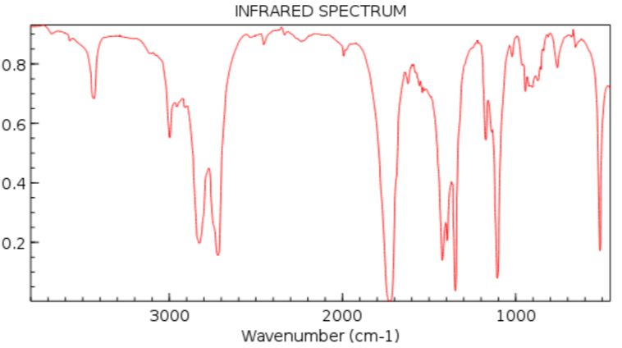

5. a. Select two absorptions on the spectrum that can help you identify the molecule you are
studying.

________________________________________________________________________

b. Sometimes the absence of an absorption can be as important as the presence of an
absorption. Use this spectrum to provide an example to support this statement.

________________________________________________________________________

c. What conclusion can you draw at this point about the identity of the substance?

_________________________________________________________________________
2 + 1 + 2 = 5 marks

The proton NMR is shown below.

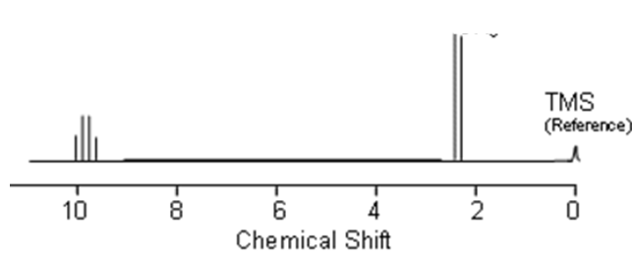

6. Explain clearly how this NMR can confirm the identity of the substance in question.

_______________________________________________________________________

_______________________________________________________________________
3 marks
The carbon NMR is shown below.

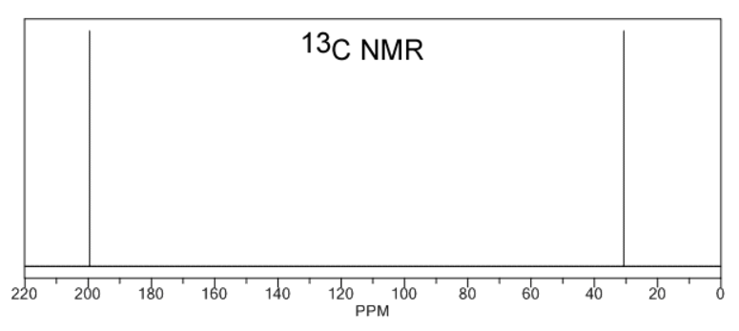
7. Explain clearly how this NMR can confirm the identity of the substance in question.

_______________________________________________________________________

_______________________________________________________________________
2 marks

8. Explain whether this molecule is likely to be soluble in water or not.

_______________________________________________________________________

_______________________________________________________________________
2 marks

9. This substance is flammable. Write a balanced equation for its complete combustion in air.

_______________________________________________________________________
1 mark

10. Explain how you would manufacture this substance from an appropriate alkene. Include
the name of all necessary reagents.

_______________________________________________________________________

_______________________________________________________________________
3 marks

11. If a sample of this molecule sits on a window sill in a beaker for a month it is slowly converted to a new substance.

- Draw the structure of the new product. 1 mark

- Write a balanced half-equation for the reaction occurring. 2 marks

_____________________________________________________________________

- What is the most significant change you would see on the infrared spectrum of the sample as the new product forms? 1 mark

_____________________________________________________________________

Molecule B
Data

The molecular formula of a molecule is C₃H₇Cl.
The infrared spectrum of the mystery molecule is shown below
1. a. There is no significant peak over 3000 cm⁻¹. What conclusion might this lead to?

____________________________________________________________________
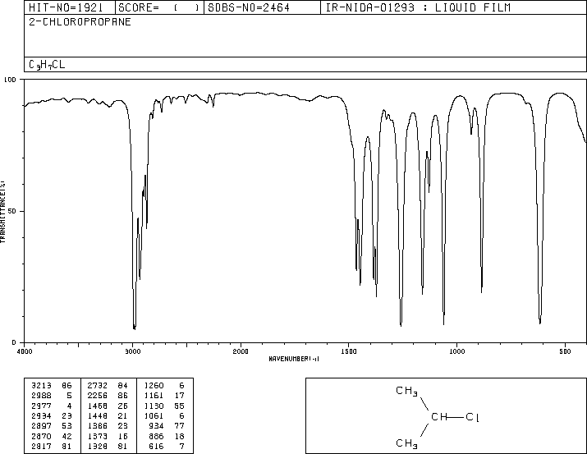
b. There is a significant peak at 3000 cm⁻¹. What conclusion might this lead to?

____________________________________________________________________

c. The infrared spectrum is a relatively plain one. What conclusion might this lead to?

____________________________________________________________________
1 + 1 + 1 = 3 marks

2. Draw and name two possible isomers with the molecular formula of this mystery
molecule.

2 marks
The ¹H NMR spectrum for the mystery molecule is drawn below

3. a. How many different hydrogen environments does this molecule have? ________

- What conclusion can you draw from the splitting on the left set of peaks?

____________________________________________________________________

- What conclusion would you draw from the splitting on the right set of peaks?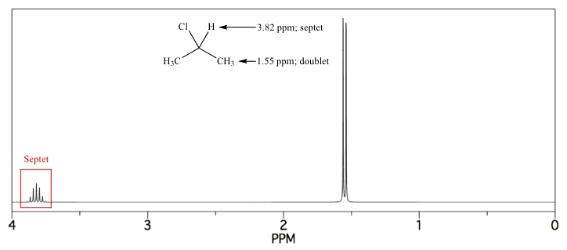

___________________________________________________________________

___________________________________________________________________
1 + 1 + 1 = 3 marks

4. Use the NMR to explain carefully which isomer is the correct one.

___________________________________________________________________________

___________________________________________________________________________

___________________________________________________________________________

___________________________________________________________________________
3 marks

5. a. How many different carbon environments does this molecule have? ________

b. Would you expect this molecule to be polar or non polar. Explain your answer.

_____________________________________________________________________

_____________________________________________________________________
1 + 1 = 2 marks

6. Write a balanced equation for the formation of this molecule from propane.

___________________________________________________________________________

