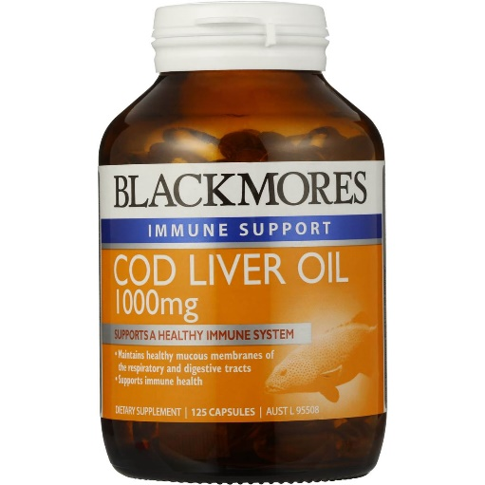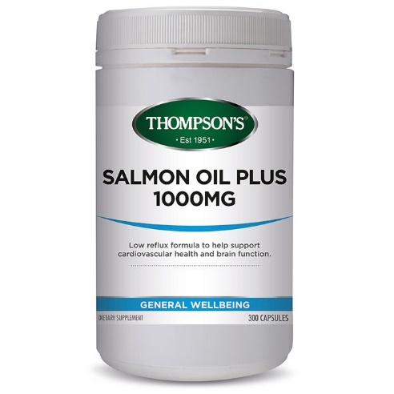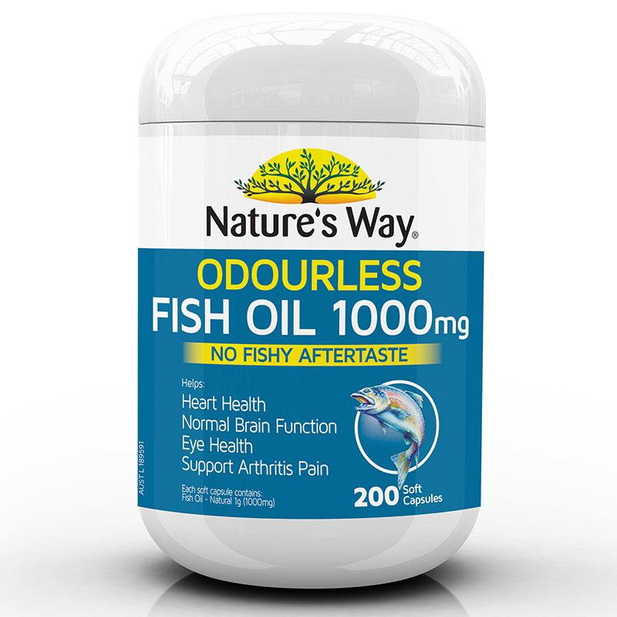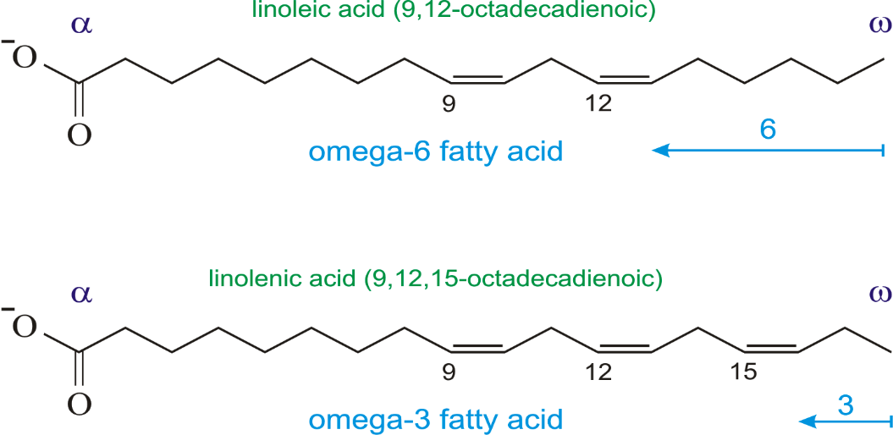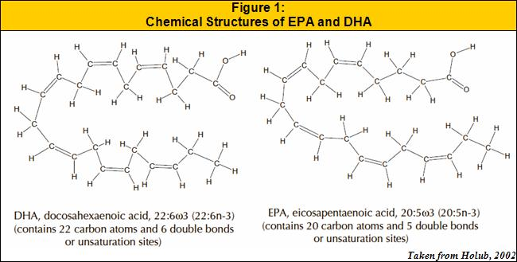Fish Oil

**By Sarah Harrington**

**What is fish oil?**It is a type of oil derived from the tissues of oily fish which contains the omega-3 fatty acids eicosapentaenoic acid (EPA) and docosahexaenoic acid (DHA).

**What is its chemical composition and how is it made?**

**Eicosapentaenoic acid (EPA)** – C20H30O2. This is an omega-3 fatty acid that can be obtained from eating oily fish and is also found in human breast milk. Fish can either synthesise EPA from fatty acid precursors found in the food they eat or obtain it from the algae they consume.

**Docosahexaenoic acid (DHA)** – C22H32O2. This omega-3 fatty acid can be synthesised from alpha-linolenic acid or obtained directly from maternal milk, fish oil, or algae oil. Most DHA in fish originates from photosynthetic and heterotrophic microalgae. It is commercially manufactured from microalgae.

**Omega -3 fatty acids**

Omega-3 fatty acids are types of fats that out bodies cannot produce. They are polyunsaturated, meaning that that they have several double bonds between carbon atoms in the chemical structure. They are named ‘omega’ due to the placement of double bonds on the fatty acid chain and the number indicates how many carbon atoms away from the omega end the first double bond is located. Omega – 3 fatty acids are anti-inflammatory and omega-6 fatty acids are pro-inflammatory, meaning a diet high in omega -6 fatty acids increases inflammatory (leading to diabetes, arthritis, heart disease etc.) whereas a balanced diet reduces inflammation. Many Westerners eat way too many omega-6 fatty acids with currently a ratio of 16 omega 6 fatty acids to 1 omega 3 fatty acid. A healthy ratio is between 4:1 and 1:4.

**What is fish oil used for?**

Fish oil is the most commonly taken supplement in Australia.It is most commonly used for conditions related to the heart or blood. It is suggested that fish oil prevents heart disease, stroke, clogging of arteries, chest pain, irregular heartbeat and high blood pressure. It is also used for many kidney related problems such as kidney disease and kidney failure. Fish oil also has many other uses such as helping the brain, eyes, digestive system, increasing exercise performance and diabetes.

**Do fish oil supplements really work?**

Studies have shown that taking fish oil supplements does not have the same benefits as eating real fish and they often have little or no effect on all-cause deaths and cardiovascular events. In one study, eating 2-4 serves of fish a week reduced stroke risk by 6% and eating more than 5 reduced it by 12%. However, those who regularly took fish oil supplements showed that stroke risk was not lowered.

**Where does fish oil come from?**

The majority of the world’s fish oil is a by-product of the animal feed industry. The oil comes from sardines, herring, mackerel or anchovies typically fished off the coasts of South America or North Africa. The fish meat gets ground into pellet food and the oil is multi-purposed. During this process, the oil is not typically well maintained, and in the resulting fish oil capsule, half the fats are saturated. Omega 3 fatty acid amount differs between different types of fish oil depending on what the fish are fed (factory farmed or wild) and what type of fish the oil is derived from.

**Types of fish oil**

* **Krill Oil –** Usually more expensive and people need to take almost twice the dosage to get the same benefits as fish oil. Much of the fatty acids in fish oil are stored as triglycerides, whilst in krill oil they are stored as phospholipids, which the body can use more easily.
* **Cod Liver Oil –** Oil extracted from the liver of Atlantic cod. It contains omega 3 fatty acids and high levels of Vitamin A and D. It has been used for medicinal purposes since the 1700’s.
* **Salmon Oil –** Typically has a DHA/EPA content of 8-16% and is more costly. It is often derived from factory farmed salmon.