Investigation: Conductometric titration of ethanoic acid
Hypothesis
The concentration of an ethanoic acid solution can be determined by monitoring electrical conductivity during a titration.
Aim: To investigate the procedure of using electrical conductivity to perform titrations.
Introduction
Provide students with
- a solution of vinegar that has been diluted about 1:10
- a 2.0 M solution of NaOH
- 0.2 M NaOH
- power supply, carbon electrodes and ammeter

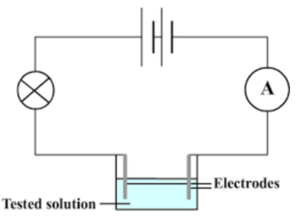
Connect a circuit from the power supply to an ammeter to two electrodes sitting in a beaker.
Demonstrate that NaOH conducts electricity and that ethanoic acid also conducts but to a much lower extent. This difference in conductivity can be used to monitor the progress of a titration.

Titration attempt 1
Add 20 mL of 0.2 M ethanoic acid to a beaker.
Add a few drops of phenolphthalein
Connect the same circuit as shown above, using a relatively high voltage.
Turn the circuit on – initially the current might be too low to read – no problem.
Add 4 mL of 0.2 M NaOH. Stir. Record the current.
Continue to add 4 mL increments of NaOH until you have added 32 mL of NaOH.
Plot your volume added vs conductivity graph.
Can you see any indication of the equivalence point?
Suggest changes to the design.

Titration attempt 2 (see diagram on page 2)
Fix the electrodes a set distance apart. ( use a retort or tape electrodes to a piece of wood)
Use AC current and an AC ammeter.
Add 40 mL of 0.2 M ethanoic acid to a beaker.
Complete your circuit and record the voltage.
Add 2.0 M NaOH 1 mL at a time, recording the current after each addition.
Stop adding after you have added 8 mL of NaOH
Plot your results.

Set-up
Electrodes are taped together and held in a retort. They are kept in the same depth of solution each time.
I have used AC current but with a voltage rectifier so that current can be measured using DC ammeter. Voltage rectifier is the black box shown.

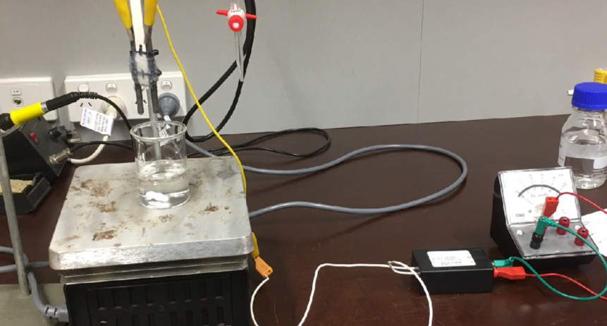

Theory
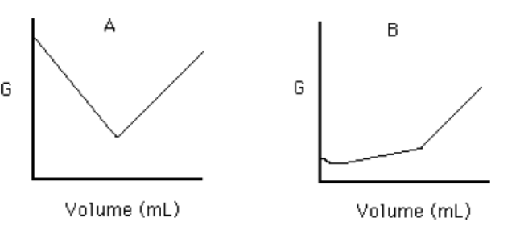
Graph A shows the conductivity change when a strong acid and base are titrated. Conductivity drops as water forms from ions during neutralisation.
You do not need to seek the endpoint as it only requires 2 readings to draw each straight line segment.
The concentration of the solution in the burette should be at least 10 times greater than that of the other solution, otherwise the change in volume during the titration will interfere.

Graph B shows the titration of a weak acid and a strong base. The low degree of ionisation of the acid makes the initial conductivity low. As ions are added the conductivity increases rapidly.
In theory it is also possible to monitor the titration of a weak acid and a weak base using electrical conductivity. The conductivity plateaus out after neutralisation.

