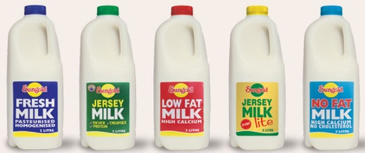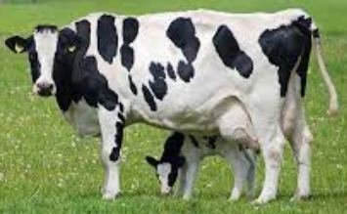

Dairy Industry

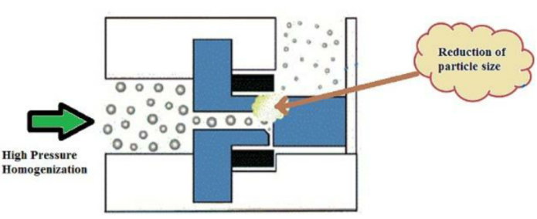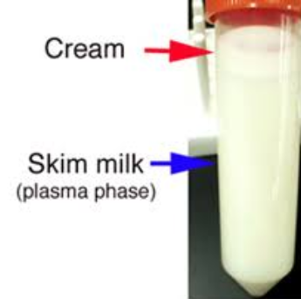

Milk can be centrifuged to separate cream from skim milk or homogenised, where the size of oil blobs is reduced.

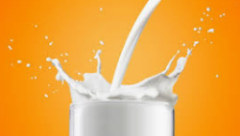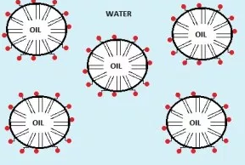

Milk is an **oil-in-water emulsion,** rather than a liquid. Globules of fat are spread through the watery phase of milk.

Milk contains lactose sugar, fats, proteins and minerals.

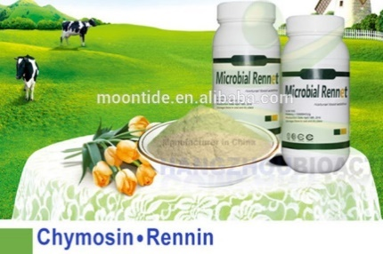

Cheese is formed by the addition of enzyme rennin from cow’s stomachs.

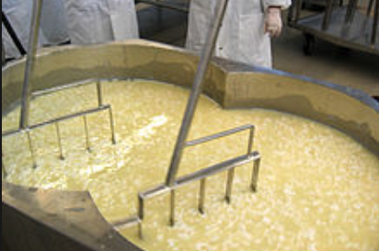

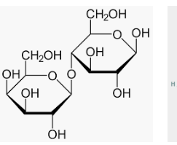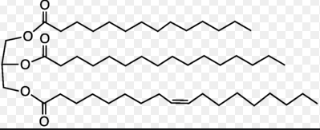

Live cultures (lactobacillus bulgaricus) added to milk lead to the formation of yoghurt.

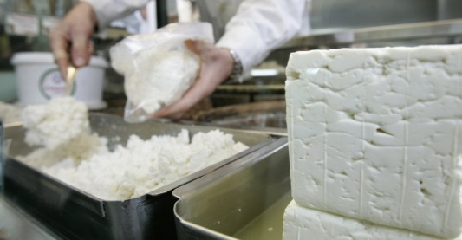

Lactose is a disaccharide from glucose and galactose. Water soluble and in the whey.

Butterfat contains high levels of butyric acid, stearic acid and oleic acid. Water insoluble and part of curds.

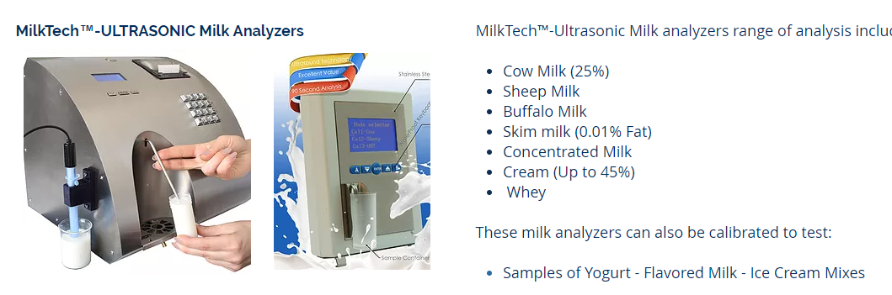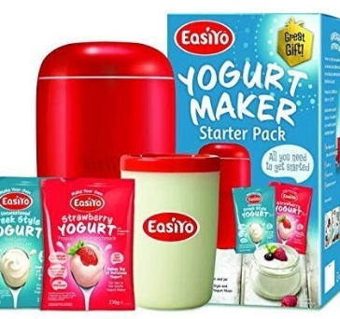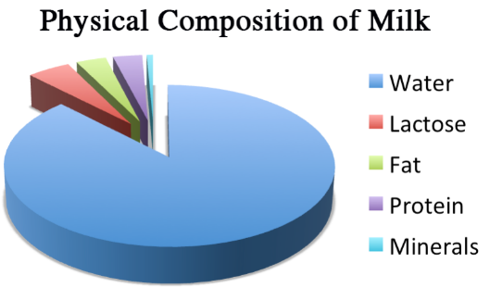

© POShea

Fetta and ricotta cheeses are made from sheep and goat’s milk. Ricotta is from the whey component and is lower fat.