Topic test 5: Unit 3 Electrolysis

SECTION A – Multiple-choice questions

Instructions for Section A
Answer all questions.
Choose the response that is correct or best answers the question.
A correct answer scores 1, an incorrect answer scores 0.
No mark will be given if more than one answer is completed for any question.
Marks will not be deducted for incorrect answers.

Question 1
Select the alternative that is a correct statement about electrolysis.
A. Chemical energy is released during electrolysis.
B. In electrolysis, the weakest oxidant reacts with the weakest reductant.
C. In electrolysis, the strongest oxidant reacts with the weakest reductant.
D. The electrons will flow from the positive anode to the negative cathode.

Use the following equation to answer Questions 2 and 3
The electrolytic cell shown below is set up to enable a series of items to be electroplated with silver.
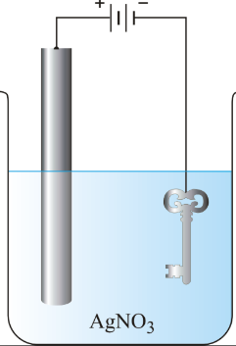

Question 2
Select the alternative that is a correct statement about electroplating.
A. The anode needs to be made from an inert metal.
B. The anode is often made from the same metal that is being plated.
C. The item to be plated will always be the positive cathode.
D. The polarity of the item to be plated will depend upon the reactivity of the metal.

Question 3
A current of 193 amps runs for 1000 secs. The mass of silver plated will be, in g,
A. 2
B. 54
C. 108
D. 216

Question 4
Electrolysis of an aqueous solution of MgI₂ produces
A. iodine at the anode and hydrogen gas at the cathode.
B. iodine at the anode and magnesium at the cathode.
C. oxygen gas at the anode and magnesium at the cathode.
D. hydrogen gas at the anode and iodine at the cathode.

Question 5
The products of an electrolytic cell are observed to be aluminium and oxygen gas. The electrolyte could be
A. Al₂O₃(aq)
B. Al₂O₃(l)
C. Al(OH)₃(aq)
D. Al₂(SO₄)₃(aq)

Question 6
Electrolysis of concentrated NaCl solution will provide a different outcome from electrolysis of dilute NaCl. The main difference will be that, with the concentrated solution,
A. sodium metal will be produced at the cathode.
B. oxygen gas will be produced at the cathode.
C. chlorine gas will be produced at the anode.
D. oxygen gas will be produced at the anode.

Question 7
During the commercial production of aluminium the overall equation is

2Al₂O₃(l) + 3C(s) 4Al(l) + 3CO₂(g)

The half-equation for the reaction at the anode will be
A. Al³⁺(l) + 3e⁻ Al(l)
B. C(s) + 2O²⁻(l) CO₂(g) + 4e⁻
C. C(s) + O²⁻(l) CO₂(g) + 2e⁻
D. O²⁻(l) O₂(g) + 4e⁻

Question 8
The overall equation in a particular electrolytic cell is

2H₂O(g) 2H₂(g) + O₂(g)

The electrolyte could be
A. CuCl₂(aq)
B. MgBr₂(aq)
C. KCl(aq)
D. AgNO₃(aq)

Question 9
The metals that cannot be obtained from electrolysis of aqueous solutions are
A. the transition metals.
B. the metals that are stronger reductants than hydrogen in alkaline conditions.
C. the metals that are more reactive than copper.
D. the metals that are stronger oxidants than water.

Question 10
The graph below plots the number of mole of 3 different metals produced as the amount of charge is increased.
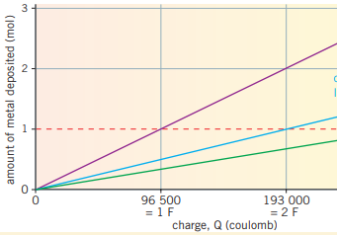
Solution 1

Solution 2
Solution 3

The solutions could be
 | Solution 1 | Solution 2 | Solution 3
A. | KNO₃(aq) | CuCl₂(aq) | AlCl₃(aq)
B. | AgNO₃(aq) | MgCl₂(aq) | AlCl₃(aq)
C. | AgNO₃(aq) | CuCl₂(aq) | AlCl₃(l)
D. | AgNO₃(aq) | CuCl₂(l) | AlCl₃(aq)

SECTION B- Short-answer questions

Instructions for Section B
Questions must be answered in the spaces provided in this book.
To obtain full marks for your responses you should
- Give simplified answers with an appropriate number of significant figures to all numerical questions; unsimplified answers will not be given full marks.
- Show all workings in your answers to numerical questions. No credit will be given for an incorrect answer unless it is accompanied by details of the working.
Make sure chemical equations are balanced and that the formulas for individual substances include an indication of state; for example, H₂(g); NaCl(s)

Question 1 (9 marks)
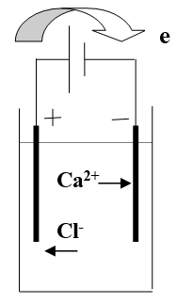
The diagram shown is of a cell used for the electrolysis of

molten calcium chloride.

a. Use the template below to show the reactions which will occur.
3 marks
Anode: _________________________________________

Cathode: ________________________________________

Overall equation: _________________________________

b. Give two reasons why this process is a costly one. 2 marks

________________________________________________________________________

________________________________________________________________________

c. Identify all products at each electrode if an aqueous solution of CaCl₂ was used. 4 marks

Anode: __________________________________________________

Cathode: __________________________________________________

Question 2 (13 marks)
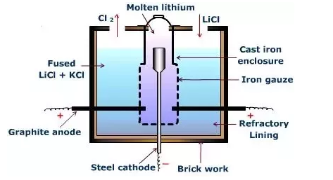
Lithium metal is produced from the electrolysis of molten lithium chloride. A sketch of the cell used is shown below.

a. Use the template provided to show the reactions occurring in this cell. 3 marks

Anode: _______________________________________________

Cathode: ______________________________________________

Overall equation: ________________________________________

b. i. Suggest a reason why the anode is not made of steel to match the cathode. 2 marks

_____________________________________________________________________________

_____________________________________________________________________________

ii. Suggest a reason why some KCl is added to the LiCl. 1 mark

______________________________________________________________________________

iii. If a voltage of 2.0 V is used in this cell, no reaction occurs. Explain why. 1 mark

_______________________________________________________________________________

________________________________________________________________________________

c. i. Calculate the mass of lithium that will be produced if a current of 3550 amps is passed through this cell
for a day. 3 marks

_______________________________________________________________________________

________________________________________________________________________________

ii. Calculate the volume of chlorine gas produced if it is stored at 20.0 ⁰C and 225 kPa pressure. 3 marks

_________________________________________________________________________________

_________________________________________________________________________________

_________________________________________________________________________________

Question 3 (10 marks)
Three cells are connected in series, as shown below.
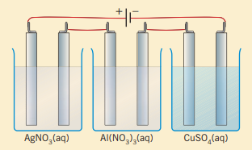

3 marks
a. 30 mole of electrons is passed through the cell. Calculate the number of mole of each metal that will form.

Silver: _________________________________________________________

Aluminium: _______________________________________________________

Copper: ________________________________________________________

b. How many mole of gas would be produced if 30 mole of electrons is passed through the circuit?
3 marks
______________________________________________________________________________

_______________________________________________________________________________

c. Use your answers to part a. to explain what Faraday’s Laws for electrolysis are. 4 marks

Faraday’s first law: _____________________________________________________________

________________________________________________________________________________

Faraday’s second law: _____________________________________________________________

________________________________________________________________________________

Question 4 (8 marks)
A galvanic cell constructed from copper and silver half-cells is shown on the left below. If a power supply is added to the circuit, electrolysis of the same two cells can occur.
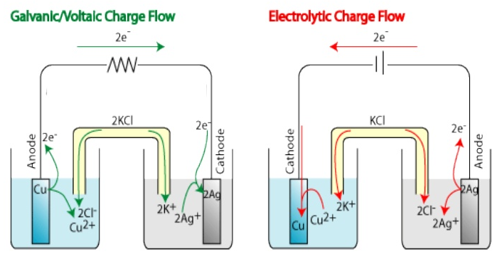

a. Write an overall equation for the: 2 marks

galvanic reaction on the left cell: _________________________________________________

electrolysis reaction on the right cell. ________________________________________________

b. Use the table provided to list 2 similarities and 2 differences between the cells. 2 marks

Similarities | Differences

c. i. What is the minimum voltage required for electrolysis to occur? ________________ 1 mark

ii. Identify the strongest reductant in the cells above. ____________________ 1 mark

iii. There is a limit to how long the electrolytic cell can operate continuously. Explain why the time of
functioning is limited. 1 mark

________________________________________________________________________________

iv. Is the mass change at the silver electrode double the mass change at the copper electrode in the
electrolytic cell? Justify your answer. 1 mark

_______________________________________________________________________________

_______________________________________________________________________________

