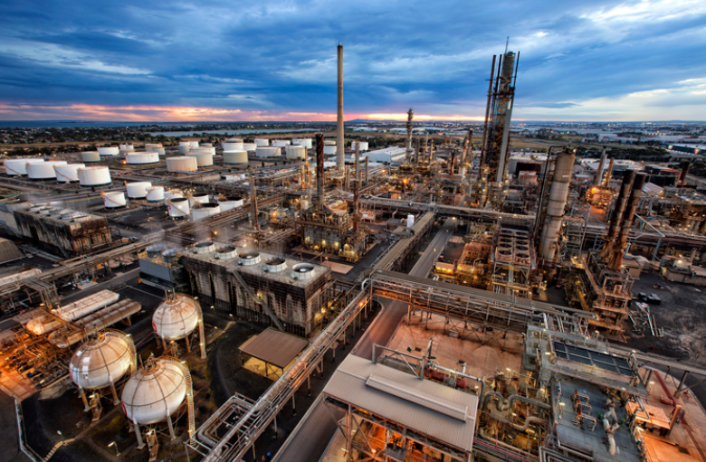
ExxonMobil: Altona Refinery

Receives crude oil from Gippsland or from imports
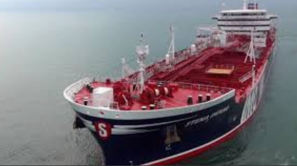
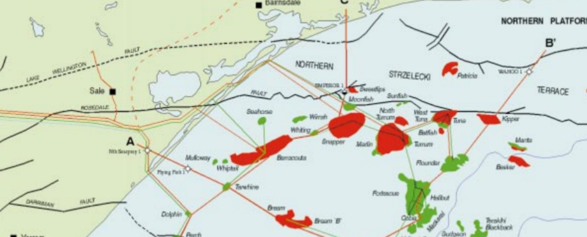

The oil is fractionated in the refinery’s towers.

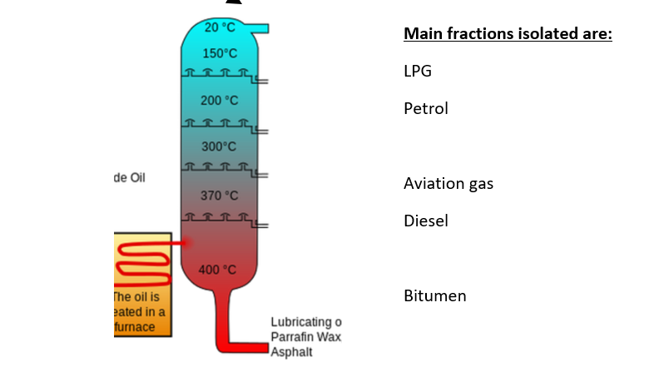
Qenos

Somerton (Tullamarine)

25.5 million litres of fractions per day.
What happens to the fractions?
Aviation gas piped directly to Somerton for use at Tullamarine airport.
Other fuels are piped directly to the Yarraville storage facility for distribution to petrol stations.
LPG can be used for transport or sent directly to Qenos where ethane and propane are isolated.
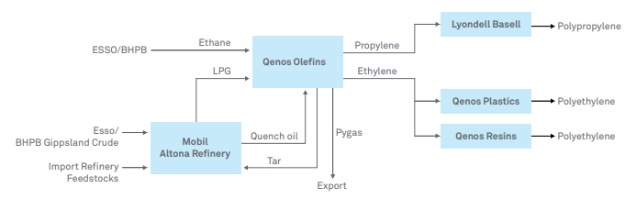

Quality Control
The composition of each fraction is tested frequently using gas chromatography.

