Fermentation to form bioethanol
Many possibilities
A: Just ferment a carbohydrate to study fermentation
Chop a ripe pear or apple or other fruit into small pieces.
Add the pieces to a flask.
Cover in water.
Add a spatula of dried yeast.
Put a single holed stopper in flask and hose leading into a beaker of water. (This is to direct CO₂ evolved into the water as evidence of gas evolution.)
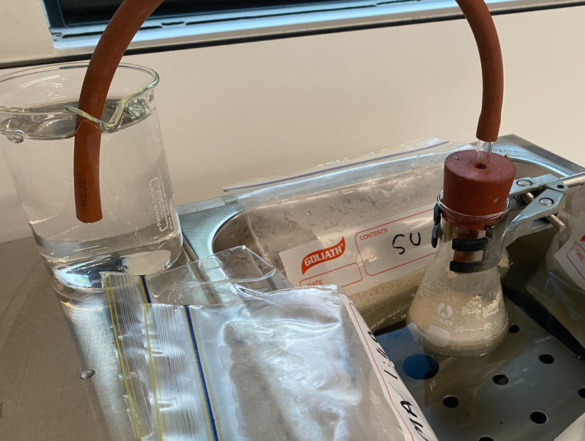
Sit flask on window sill or in water bath set on 35 ⁰C. See diagram.

B: distil the liquid to demonstrate distillation and to obtain a sample of ethanol.
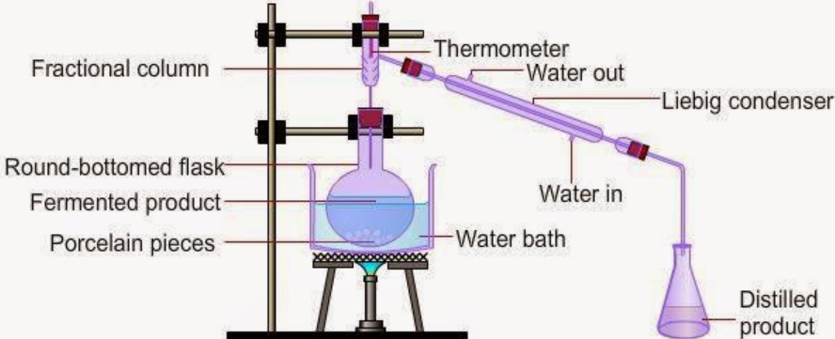
C: Make this an investigation
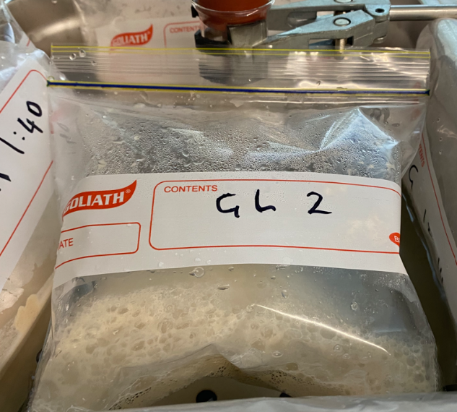
Compare the rate of fermentation of different sugars eg same procedure but try sucrose, maltose, lactose, paper and cellulase etc
Can be done in a bag – see below

D: Try varying the temperature, concentrations etc
Can can the rate of bubbling to compare reaction rates.
