SAC: Response to stimulus material
1. The three molecules shown are the first three α-amino acids listed in your Data Book. 7 marks
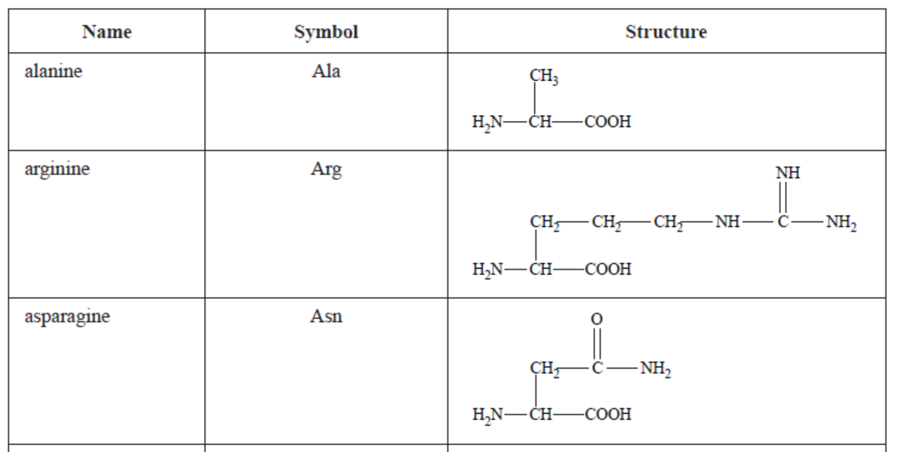
- Explain what the characteristics of an α-amino acid are.
- Which of the three molecules will be the least soluble? Explain your answer.
- Arginine can act as a weak base. Explain why.
- i. Draw one of the possible products formed when alanine reacts with asparagine.
ii. Circle and name the functional group formed in the reaction.
iii. How many possible products are there? (1 + 2 + 1 + 3 = 7 marks)
2. A segment of a protein molecule is shown below. (8 marks)
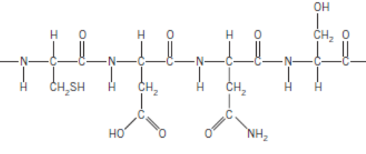
- How many different amino acids are in this segment?
- Annotate on this diagram to explain why proteins have a secondary structure.
- This molecule could form a covalent bond with a neighbouring molecule. Explain how this might happen.
- Name an enzyme that could hydrolyse this molecule.
- What happens to the amino acids formed in your body as a result of hydrolysis? (1 + 2 + 2 + 1 + 2 = 8 marks)

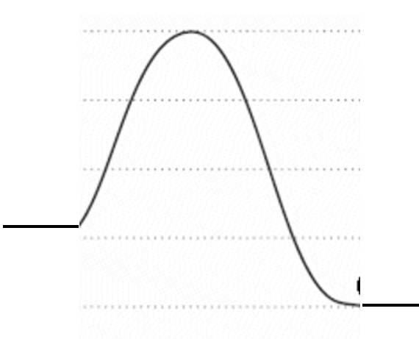
Q.3 An energy profile diagram for a digestion reaction is drawn
below. (5 marks)
An enzyme is an example of a biological catalyst.

- Show on this diagram how the energy profile is changed if a catalyst is added to the reaction.
- Label on the diagram, the ∆H for the reaction
- Label on the diagram, the activation energy for the catalysed reaction.
- If the enzyme is added to NaOH solution it loses its ability to catalyse this process. Explain how the structure of the enzyme has been changed. (1 + 1 + 1 + 2 = 5 marks)
4. A triglyceride is drawn below. (8 marks)
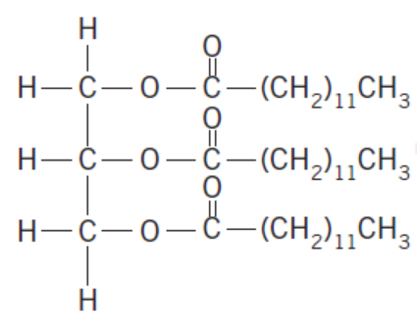
- i. Draw the products of hydrolysis of this triglyceride.
ii. What type of bond is broken when the hydrolysis occurs?
- Draw the biodiesel molecule that will form from the reaction between the fatty acid formed and methanol.
- Write a balanced equation for the complete combustion of the fatty acid.
- Name an enzyme that might assist with the hydrolysis of this triglyceride.
- What happens to the fatty acid and glycerol in your body one they are formed from hydrolysis?
((2+1) + 1 + 2 + 1 + 1 = 8 marks)
5. A reaction between biomolecules is shown below. (5 marks)
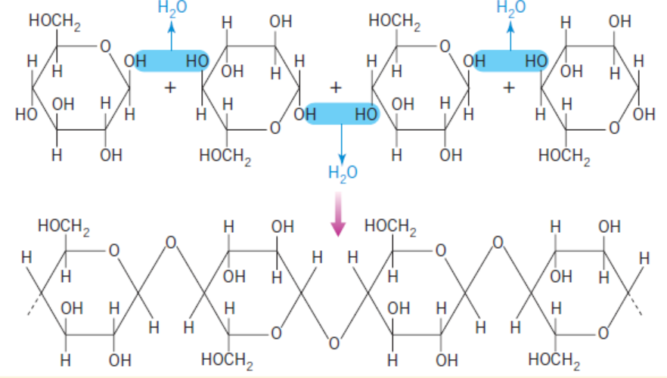
- What type of bond is formed in this reaction?
- i. Name the monomer in this reaction.
ii. Name the product of this reaction.
- Explain how this product is digested in different animals. ( 1 + 2 + 2 = 5 marks)

6. The diagram below is of two different vitamins. (5 marks)
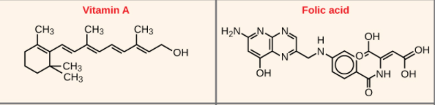

- The structures of these two molecules are quite different. Why are they described as vitamins?
- i. How will the solubility in water of these two molecules compare?
ii. Where will vitamin A be stored in the body?
iii. Would a person need to consume vitamin A regularly? ( 1 + 2 + 1 + 1 = 5 marks)

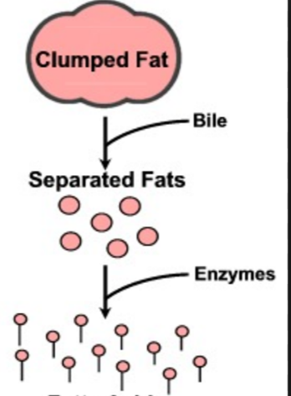
7. a. Explain clearly what the diagram on the right is illustrating. (6 marks)
b. Where in the body is this reaction likely to occur?
c. What are the final products of this reaction?
d. Name the likely enzyme causing this reaction. (3 + 1 + 1 + 1 = 6 marks)

8. A complex reaction is outlined below. (6 marks) 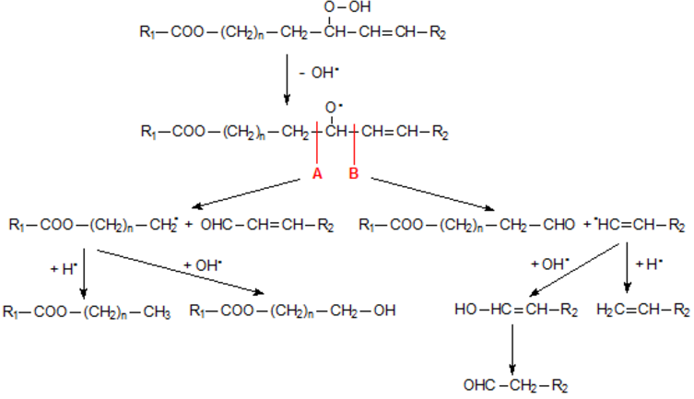
- What type of molecule is the long molecule at the top of the diagram?
- What process is this sketch an outline of?
- How can you predict where the long molecule will break?
- i. What type of molecule is formed in the bottom right of the diagram?
ii. What do you know about the properties of this molecule?
- How can you prevent this reaction process occurring? (1 + 1 + 1 + (1 +1) + 1 = 6 marks)

