Outcome 1 Unit 3 Prac report
Heats of combustion
Hypothesis: The heat of combustion of alcohols will increase with molar mass.
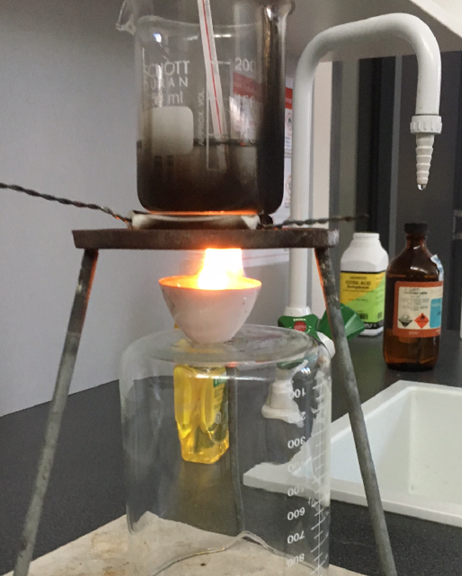
Aim: To refine the procedure for determining the heat of combustion of fuels and to use this procedure to compare the heat of combustion of common alcohols.

Procedure
Use the photo to set up a sample of ethanol to burn
Under a beaker of water.
Use a Bunsen mat rather than a pipe clay triangle.

Add a sample of ethanol to the crucible, weigh the
crucible and light the sample.
Allow the ethanol to burn for 1.0 minute and measure
the temperature change.
Reweigh the crucible

Ask students to use their results to determine the
molar heat of combustion for ethanol.

Discussion
The value obtained will be very low. Discuss ways of improving the energy transfer.
Ask each student group to identify one aspect of the experiment design to investigate.

(Possibilities – lid, pipe clay triangle, wind shield, metal can, alcohol burner)

Students conduct an experiment to test their design modification.

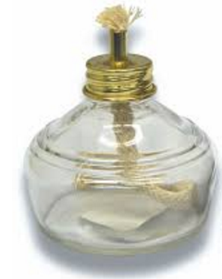
Design improvements
Students to pool results of their experimentation.
Class to repeat experiment with ethanol using an alcohol burner.
Compare the class results to see if precision has improved.
Compare the mean value to that of the Data Book to calculate the efficiency
of combustion in your experiment.

Part B
Heats of combustion of various alcohols

Use any design improvements to determine the heat of combustion of methanol, ethanol. propan-1-ol and pentan-1-ol.
Graph results for heat of combustion per gram vs molar mass.
SAC Report
As a result of your experimenting you should have

- Part A: Experimental data 1 mark
- Calculations of ∆H g⁻¹ and mol⁻¹ 3 marks
- Part B: Data 2 marks
- Calculations of ∆H g⁻¹ and mol⁻¹ 5 marks
- Graph of molar mass vs ∆H 4 marks

Questions
1. The results from part A will be well below accepted values.
a. Give reasons why the results from part A are poor.
b. Explain how you attempted to modify the experiment design in part B to improve results.
(2 + 2 =4 marks)
2. a. What conclusions can you draw from the graph?
b. Can you suggest reasons for the trends evident in your graph?
(2 + 2 = 4 marks)
3. For this experiment, identify
a. the independent variable
b. the dependent variable
c. any controlled variable(s) (1 + 1 + 1 = 3 marks)
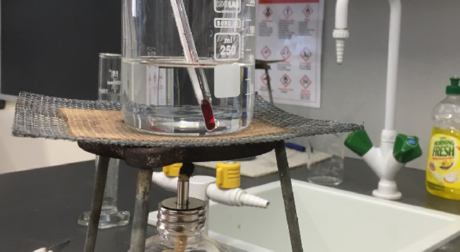
4. One group used a mat in place of a pipe clay triangle,
as shown in the diagram. What impact do you think
this would have on
- The ∆H values obtained
- The graph drawn? (1 + 2 = 3 marks)

5. a. Explain the difference in structure between propan-1-ol and propan-2-ol.
b. How would you expect their ∆H values to compare? Explain your answer.
(2 + 2 = 4 marks)
6. Write a balanced equation for
a. the complete combustion of butan-1-ol
b. the incomplete combustion of butan-1-ol (2 + 2 = 4 marks)

7. Ethanol can be obtained from biomolecules.
a. Name the process used to produce bioethanol
b. Write a balanced equation for the reaction occurring. (1 + 1 = 2 marks)
8. a. Does the combustion of bioethanol solve problems associated with fuel combustion?
Explain your answer.
b. Are the emissions produced by the combustion of ethanol the same as those of pentan-1-ol?
Explain
(2 + 2 = 4 marks)
9. List two safety precautions taken during this experiment. 2 marks

10. The combustion of 1 mole of ethanol should produce 1364 kJ of energy. Knowing this figure, calculate the percentage energy loss occurring when you burnt ethanol
If you were to now test hexan-1-ol, how could you use the result of part a of this question to improve your estimate of ∆H?
(3 + 2 = 5 marks)

