From alchemy to atomic bombs

The History of Chemistry
- an extraordinary journey!

Alchemy
Western science
Life of a scientist
Otto van Guericke
Hennig Brand
Johann Baptista van Helmont
Glass
Robert Boyle
Karl Scheele
Joseph Priestley
Henry Cavendish
Antoine Lavoisier
Humphry Davy
The battery
John Dalton
Jons Berzelius
Periodic Table
Chemical names
The scientists
Joseph Gay- Lussac
Amadeo Avogadro
Friedrich Wohler
Stanislao Cannizaro
Dmitri Mendeleev
More tools
J.J. Thomson
William Ramsay and Lord Rayleigh
Wilhelm Roentgen
Maria Sklodowska (Marie Curie)
Competing the Periodic Table
Ernest Rutherford
Neils Bohr
More tools
Females in science
Frederick Soddy
James Chadwick
Lisa Meitner
German nuclear research
Manhattan project
Marcus Oliphant
Post World War II
Synchrotron
Glossary

(Fig. 1 double page timeline before any text)
Ancient History – alchemy.

Alchemists 3000 BC - 1600 AD

Chemistry is generally believed to have had its origins in alchemy. Note the similarity of the two words, alchemy and chemistry. The origins of alchemy itself were probably in ancient Egypt, where it was called khemeia. As these pursuits moved to the Arab world in the first centuries AD, the name changed to al-khemeia, then alchemy. Many Arab words start with the prefix ‘al’ i.e. algebra, algorithm and alcohol.

The early chemists were involved in industry. They discovered metal smelting, brewing and preserving. They had little knowledge of the changes taking place to the atoms involved but they had mastered a number of industrial processes.

Alchemy in Egypt

The Egyptians were skilled metallurgists. Their ability, with heat and smoke, to convert seemingly useless rocks into shiny metals probably explains why khemeia attracted a mystique that was later often viewed as sorcery or dark arts.
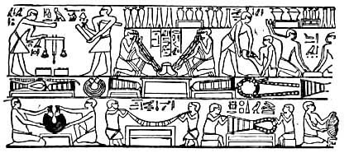
Fig. 2 Egyptian metallurgy www.touregypt.net/science.htm

Some of the skills of the Egyptians included
- the extraction copper from copper ore as early as 3400 BC. The ore was mined in Egypt itself.
- the alloying of copper and tin to form bronze. They knew that a ratio of 10% tin led to the hardest possible weapon.
- the mixing of mortar. The quicklime, calcium oxide, needed for mortar was made by heating limestone in a furnace. CaCO₃(s) → CaO(s) + CO₂(g)
- the use of iron weapons from around 1000 BC. The Egyptians did not invent iron but they were skilled in working it.
- the manufacture of gold ornaments. Egypt received gold tribute from many countries but it also mined significant quantities of gold itself. Many gold artifacts have been recovered from the pyramids and other sites.
- glass blowing. The manufacture of clear and coloured glass was an Egyptian discovery. Glass furnaces have been found that date back to at least 1400 BC. Sodium carbonate and lead oxide are two common substances used by the Egyptians for glass.
- embalming. The process of mummification involves more than wrapping a body up in cloth. The body organs were removed, the brain was pulled from the head through a narrow opening near the nose and the body was coated in chemicals.
- dyes. The Egyptian fabrics and inks found are often complex mixtures of substances. Red pigment for example was a mixture of clay, iron oxide and haematite.
- brewing! Beer was a popular drink five thousand years ago in Babylon and Egypt. Brewing and bread making have gone hand in hand in society as both can use the grinding of a cereal and the addition of water as a first step. The Egyptians also pressed grapes for wine.

The list above is an impressive list of achievements from an empire that ruled the world for a long period of time.

Fig. 3 Egyptian mummy 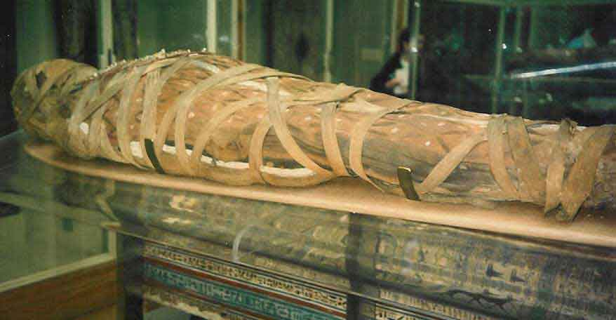
http://historylink101.net/egypt_1/rf-k-egyptian-mummy.htm

Chinese alchemy

Alchemy in China followed a different path, the use of herbs for medicinal purposes and for food handling being typical examples.

Gunpowder: Gun powder may have existed around 700 AD in China. It was obviously not known as gunpowder. Why? Because guns had not been invented! Its early Western names were ‘serpentine’ and ‘black powder’. In the early centuries the mixture used probably only burn vigorously without exploding. As improvements were made in the refining of saltpeter, the explosive power increased. The three ingredients are saltpeter (potassium nitrate), sulfur and carbon. The ratio used around 1800 by the French was 76% saltpeter, 9% sulfur and 15% charcoal.

Extension
A typical equation for gunpowder reacting is
Note that the reaction produces two gases. This is what an explosive does- it produces gas so quickly that the gas shoots out from the source of the reaction doing damage as it goes.

Fig. 3.b principle of an explosive

Ink: As early as 2500 BC fine grains of carbon were suspended in liquids to make ink. This was a Chinese or Indian invention. When the liquid dries, the pigment, carbon in this case, remains in the shape of the writing or drawing. Water alone is not suitable as a solvent as the carbon would sediment out. Plant juices or gum Arabic were found to keep the pigment suspended much more successfully.
One of the successes of Chinese alchemy was the invention of ‘black powder’ or gunpowder as it came to be known. Gunpowder was used in fireworks in China during the tenth century. By the thirteenth century it was used in cannons and its use gradually spread to the West. The advent of cannons to warfare was a massive escalation in destructive potential.

Other industries

Food preservation. Without fridges and freezers, how do you keep food available all year round? The methods used have varied with the climate. Countries in warm climates often relied on drying fruits, meat and herbs. In colder climates, smoking was common. Smoking dries the food and breaks down fats that would have been prone to rancidity. Salting and pickling were other methods developed.
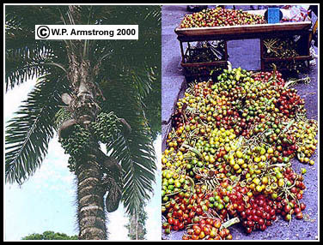
Fig. 4 Dates being dried in the sun (any picture of drying or preserving fruit)

Rubber. Here is a discovery from a different origin – Central and South America, with the Mayans and Aztecs. The Indians knew how to tap sap from rubber trees and to coagulate it into crude items.

Soap. Soap was known to the Sumerians and the Phoenicians over five thousand years ago. It was made from animal fat and alkali just as modern soap is. This discovery bypassed the Romans however, and was not taken up in Europe until well into the Renaissance period. Life without soap in medieval Europe – something to contemplate!

Arab alchemy

As the Egyptian, then the Roman empire, fell into disarray, alchemy was kept alive in the Arab world. It was here that it moved from industrial application to more dubious and ‘darker’ science. The secrecy increased and the goals of magic elixirs, potions and transmutations came to the fore. Over the course of many centuries however, the alchemists maintained a pursuit of chemical processes. They searched to uncover the ‘principles’ that must be present when substances react with each other. The focus of Western alchemy was in two main directions
- Transmutation. Converting ordinary metals into the more valuable metal gold.
- Elixir of life. The secret of living forever.

While the alchemists never succeeded in these objectives, the knowledge of substances and their properties was to prove the launching pad for the emergence of real chemistry.

Perhaps the most famous alchemist was Jabir ibn-Hayyan, born around 760 AD, later known as Geber. He brought science to alchemy, heating metals, sulfur and other substances. Gold did not form but at least a range of properties of substances became apparent.

The writings of the alchemists described equipment and processes that they knew – sublimation, distillation, solution, calcinations –powdering of solids. Their substances were often categorized as metals, stones salts, spirits. For many years the strongest natural acid available for experiments was acetic acid. In the 1300’s, a Spanish monk called the False Geber discovered oil of vitriol. He extracted this from the leaves of the vitriol plant. This is sulfuric acid and it was a huge breakthrough. It provided a liquid that could dissolve a wide range of other materials. It could also be used to manufacture nitric and hydrochloric acid.

Fig. 5 Arabic sketches of the distillation process http://levity.com/alchemy/greek-im.html

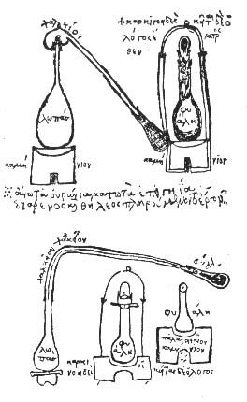

Questions
Q.1 Why did the alchemists know some substances and not others?
Q.2 Is it now possible to change elements into other elements?
Q.3 Why were the alchemists useful to the progress of chemistry?
Q.4 What is distillation?
Q.5 Can you give a chemical formula for alcohol, acetic acid and sulfuric acid?
Q.6 Can you give an example of a reaction of sulfuric acid?

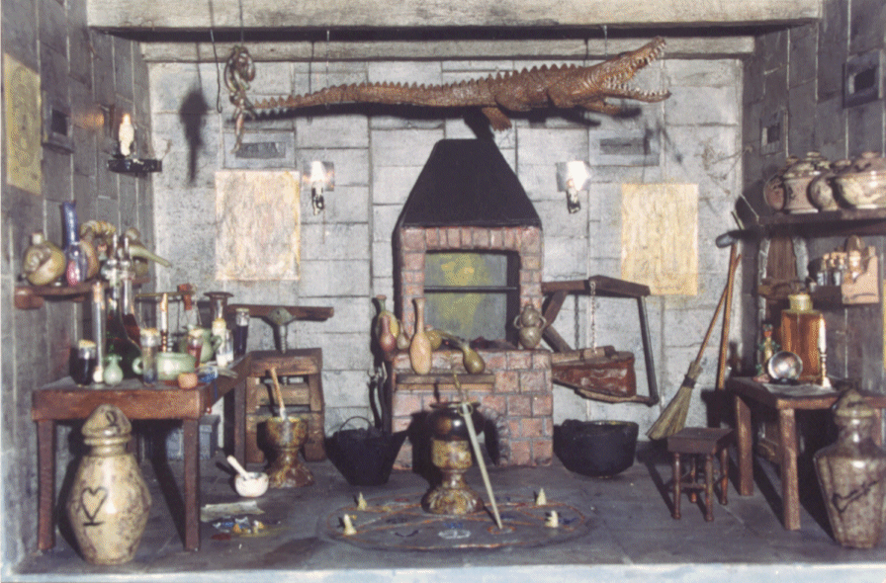
Fig. 6 An artist’s impression of an alchemy laboratory.
www.levity.com/alchemy/alchlab.html
Extension:
Three important chemicals found by the arab alchemists –

Acetic acid 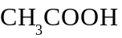 known as vinegar. This was the strongest available acid for centuries before sulfuric acid was found.

Sulfuric acid 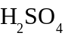 known as oil of vitriol. Its ability to cause reactions changed the face of chemical reactions.

Ethanol 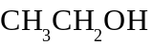 known as aqua vitae. A powerful alternative solvent to water.

Distillation – separation of a mixture of liquids by heating the liquids until each evaporates. Gases evolved are trapped. When alcohol is fermented from sugar to form beverages like wine, the alcohol content is about 12%. If the alcohol, water mixture is heated, the alcohol boils first and is condensed in a separate container. Its concentration is now much greater and it is referred to as a ‘spirit’. Whisky is an example and the term ‘distillery’ explains where spirits are produced.

Experiment: Making chemicals
A challenge for students – what substances could you isolate using natural substances?
This was the challenge faced by the early chemists. Can I do something to common materials to try and produce new materials? Some examples that students could try are given below;

Salt: Seawater tastes different from water. The extra ingredient is salt.
Add seawater to a tray and sit it on a window sill. Leave it for the water to evaporate.
Harvest the salt!
Where in Australia is salt produced and is this method used? Table salt - NaCl
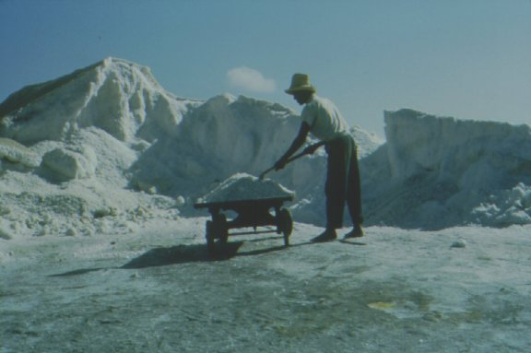
Fig. 7
Raking of salt in a third world salt plant
www.temuseum.org/gallery/image/salt_worker_in_the_1960s/
Chlorophyll: Cut some spinach (or grass) into small pieces and add to a flask. Cover with a 50:50 mixture of methylated spirits and water.
Heat on a hot plate until the liquid turns very green.
The liquid is green because it contains chlorophyll.
What role does chlorophyll perform in plants?
Add some of the green liquid to a test tube, depth about one cm.
Cut a strip of chromatography paper and sit it in the test tube.
The green liquid moves up the paper but it does separate into some different layers – chlorophyll is not a pure substance. It has a very complex formula.

Ethanol: Cut some potato or ripe fruit like grapes into pieces and add to a flask. Cover with water, add a teaspoon of sugar and a sprinkle of dried yeast. Put a single holed stopper into the flask with hose to a water trap. Sit the flask in a warm spot for about 10 days. Distill the liquid after 10 days to produce some ethanol.
What fruits or vegetables have been used in different countries to produce ethanol?
What can ethanol be used for, besides drinking?!

Copper: Sit a large steel nail in a solution of copper sulfate. Leave the nail for 15 minutes.
Remove the nail. It should be covered with a layer of pure copper.

Fig. 8 Nail sitting in a copper sulfate solution.

Hydrogen: Cut a sausage at one end and squeeze the sausage meat out. Wash the sausage skin in detergent ( intestine ) to clean it. ( Turn it inside out)
Place a piece of zinc in a test tube. Add some 1 M hydrochloric acid and place the sausage skin over the test tube. Collect the gas in the sausage.
Early scientists found it difficult to find containers for gases, so animal stomachs and intestines were often used. Even painters stored their paints in animal stomachs to keep them moist.
Place a lighted match near the pen end of the test tube to see if it pops.

Rubber: Add 20 mL of latex solution to a beaker. Add 20 mL of 1M hydrochloric acid.
Stir with a glass rod.
Wash the product.
Test its elasticity.

Western Science Emergence

From 1500 AD the story of chemistry moves predominantly to Western Europe. After almost a thousand years of intellectual stagnation, through the Dark Ages, then the Middle Ages, Western Europe was about to embark on a 400 year journey of discovery. The beginnings were slow and haphazard but the pace of change and discovery was to escalate all the time.

What caused the change? Probably no single factor but a combination of the following:
- Renaissance and Reformation. The Renaissance in art and culture extended to science and education. The Reformation also led to a questioning of accepted truths like that of Creation and the structure of the Universe.
- The fall of Constantinople and the acceptance of Arab education. Greek and other scholars were fleeing to the West with Eastern documents.
- Printing press. As the quality of print and the ease of reproduction improved, new discoveries spread much faster than ever.
- Technology in general. The Industrial Revolution demanded much larger supplies of materials and machines. Science was involved in meeting this demand.

One of the leading European alchemists was Frenchman Nicholas Flamel, 1330 - 1418. This is the same Nicholas Flamel as mentioned in the first book in the Harry Potter series, 'Harry Potter and the Philosopher's Stone'. The story refers to a special stone in the possession of an alchemist named Nicolas Flamel, the Philosopher's Stone. The Stone can of course turn lead into gold but it is also an elixir of life. Nicholas Flamel did in fact exist; he was a noted alchemist and he did become a very rich man. Whether the riches were from sales of gold is not known!

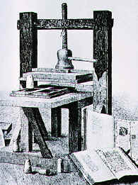

German, Johannes Gutenberg ( c.1398 – 1468) is credited with the first printing press. Gutenberg was a metal worker, hence his ability to make mirror-image dies of each letter of the alphabet.

Fig. 8 b. printing press

http://www.historyguide.org/intellect/press.html

Life as a Scientist

What was life like as a scientist around 1600? Very different from today, that’s for sure! Look around your school laboratory at the equipment that you have and then consider these problems faced by early scientists.

Females. If you were female, you did not exist. How many famous female scientists can you name? If you have clutched at Marie Curie, keep in mind that she was 1900, not 1600 and even she was restricted to working in a shed at the rear of laboratory and not allowed in the main laboratory. Access to education was limited to mainly rich people and more particularly rich males. Tertiary education was a completely male domain. Women were not even allowed to work as laboratory assistants. They were not accepted as members of the Royal Societies that European countries formed to promote science. Rumour suggests that the great Isaac Newton went missing from university for a few months because he could not cope with the presence of a female assistant. Many scientists vowed never to marry in case their attention to their studies might suffer.

Politics and religion: In ancient Greece, the great philosopher Socrates was executed by the state for ‘corrupting youth’. Nothing had changed in Europe as science emerged.
Astronomer Johannes Kepler: had to interrupt his studies on several occasions to represent his mother who was being tried for witchcraft. The penalty for being found guilty was not attractive.
Italian physicist Galileo Galilei was forced to swear that the Earth was the centre of the universe, not the Sun. He faced execution if he said anything else and he was placed under house arrest until he died to ensure that he did not make any contrary pronouncements.
English chemist Joseph Priestley emigrated to the United States in 1794 because he had made many enemies due to his support of the French revolution.
Brilliant French chemist Antoine Lavoisier was guillotined after the French revolution because of his past as a tax collector.
English botanist Charles Darwin waited over twenty years before publishing his theories on evolution because he was concerned about the furore it would cause with the various church authorities.


Fig. 8. c guillotine – a heavy blade dropped due to gravity onto the neck of the victim http://www.metaphor.dk/guillotine/Pages/Gallery.html

Medicine: Sometimes the challenge was not making a discovery but rather staying alive. Bubonic plague, smallpox and other diseases regularly swept through Europe killing up to a quarter of the population. Average life expectancy was over twenty years less than today. Universities were evacuated for up to 3 months at a time as everyone moved to the country to try and escape the current disease.

An eerie common feature of many famous scientists is that they lost one or both parents at a very young age.

The unknown. If you are an astronomer studying the skies, why not include the sun in your studies? Swiss mathematician Leonhard Euler studied the sun, with the naked eye! Needless to say he went blind at an early age.

Perhaps snow could be used to preserve meat. This thought occurred to Francis Bacon as he traveled through the snow. To test this, he stopped his carriage and stuffed a chook with snow. He himself caught pneumonia from the cold and died!

Naturally the best way to test a new gas was to inhale it! Early chemists Karl Scheele and Humphrey Davy certainly thought so. Scheele inhaled chlorine and hydrogen cyanide at different times. Hydrogen cyanide is a potent poison. He survived these encounters but, not surprisingly, died at an early age. Davy tested carbon monoxide. He fainted but fortunately dropped the gas mouthpiece and eventually revived. He had more luck sampling the nitrous oxide that he isolated. This produced a high that rapidly became a popular practice with the aristocracy of the time. On another occasion, an explosion blinded Davy for some time and he was forced to employ an assistant, Michael Faraday. Faraday became a famous scientist in his own right.

Surely there is no harm in using radiation to take X-rays of one’s self. We now know that radiation can pose very serious threats but the first nuclear scientists did not know this. Marie Curie, husband and children all died of radiation related problems. Husband Pierre stumbled and fell under a wagon, probably dizzy from radiation sickness.

Nor was it safe to be an animal in this era. Once chemists acknowledged the dangers of gases, it did not immediately occur to them to use mice or rats. Cats were a common choice and many a poor moggy was the first to sample a new gas.

Tools. These scientists did not have electronic balances, mass spectrometers and gas syringes. They had forges for heating, animal intestines for gases and pan balances for mass readings.

Lavoisier had a special 1 metre lens constructed to establish a melting point, or sublimation point, of over 3500 ⁰C for diamond.

Fig. 9 Lavoisier’s lens
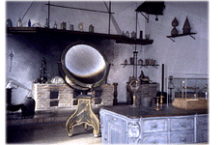
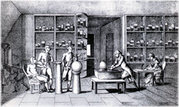
Fig. 10
Lavoisier’s laboratory and study of respiration.

http://chem.ch.huji.ac.il
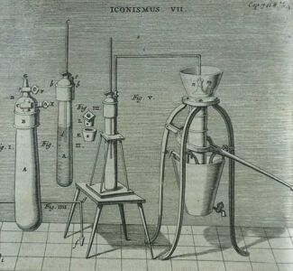

Fig. 11
Early vacuum pump

Q.1 How do we produce high temperatures in the laboratory?
Q.2 Are animals still used for testing in laboratories?
Q.3 How would you test the properties of a new gas?
Q.4 What does ‘sublime’ mean? ( in a chemical sense )

Otto van Guericke

Name: Otto van Guericke Birth/Death: 1602- 1686

Country: German

Background: Physicist, inventor and showman! Europe was just starting to emerge from the Dark Ages at this time. Formal science experimenting was still not happening.

Contribution to science: Invention of the vacuum pump, including spectacular demonstrations of its uses. He also invented a device for generating static electricity.

Impact of discovery: The vacuum pump still has many uses. Television tubes and science instruments are two examples. With space travel scientists now have the opportunity to experiment in the ultimate vacuum – space! Performers like Guericke helped generate an interest in science.

Otto van Guericke invented the vacuum pump. A vacuum pump can empty a container of the air in it. It is very difficult to remove the air completely from a container. He put this invention to a spectacular use in 1654 when he placed two hollow copper hemisphere bowls together to make a 35 cm sphere. The bowls fitted neatly into each other but they were not bolted in any way. He used his pump to remove the air from inside the copper sphere. The bowls were held together by the ‘suction’ caused. (The suction is caused by the air pressure being much greater outside the bowls.) He attached a team of eight horses to each bowl and they pulled in opposite directions. The air pressure held the bowls together despite the pulling power of sixteen horses! As soon as Guericke allowed air to flow back into the spheres, they just fell apart. This made a spectacular demonstration for the emperors and rulers of the time. He toured Europe repeating this display in major cities.

Fig. 12 Differences in air pressure.

Guericke also invented a forerunner of the Van der Graff generator, a device that he used to charge a ball of sulfur to the point where it glowed. This is called electroluminescence.
http://chem.ch.huji.ac.il
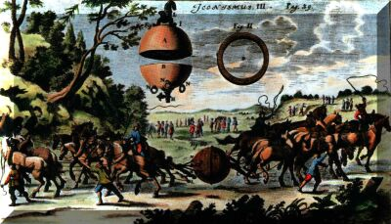
Fig. 13 Van Guericke’s demonstration

Q Can you think of any modern devices that require a vacuum?
Q How does motion change in a vacuum?

Hennig Brand

Name: Hennig Brand Birth/Death: c.1630 - c.1710

Country: German

Background: Not known with certainty. Well known alchemist.

Contribution to chemistry: Brand was the first to isolate phosphorous. He made spectacular demonstrations of its explosiveness.

Anecdote: The source of phosphorous was large volumes of urine!

Impact of discovery: The impressive demonstrations of the properties of phosphorous led to a renewed interest in chemistry.

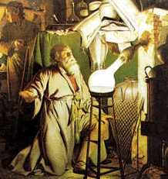

Brand chose urine as a material to study to look for new substances. He collected and stored vast quantities of urine. The urine fermented and evaporated with time to form a black paste. When this paste was heated in a retort, Brand was able to collect a waxy material under water. This material glowed in the dark and ignited spontaneously. He demonstrated this new material across Germany. Not surprisingly, the preparation remained a secret process for many years. Brand named the new material phosphorous, Greek for ‘light bringing’.

Fig. 14 Brand preparing phosphorous
http://en.wikipedia.org/wiki/Hennig_Brand

Extension
Brand’s recipe! Just in case you want to repeat the work of Brand, here is his recipe
Boil urine to reduce it to a thick syrup.
Heat until a red oil distills up from it, and draw that off.
Allow the remainder to cool, where it consists of a black spongy upper part and a salty lower part.
Discard the salt, mix the red oil back into the black material.
Heat that mixture strongly for 16 hours.
First white fumes come off, then an oil, then phosphorous.
The phosphorous may be passed into cold water to solidify.

What Brand was unwittingly doing was breaking down the phosphate in urine. Urine contains phosphate ions, 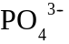. Carbon removes oxygen from the phosphate to form carbon monoxide, leaving phosphorous to come off as a gas. Phosphorous turns to a solid at 44 ⁰C. It is luminescent.

Scientific Method 1600AD

Does this type of format for writing up an experiment look familiar?
Name: Partner:
Aim:

Method:

Results:

One of the reasons science made rapid progress after 1600 was that scientists adopted formal procedures for experimenting. As obvious as this sounds, the Greek philosophers were content to theorise about a topic without actually testing it. It was scientists like van Helmont, Isaac Newton and Robert Hooke that introduced the notion of formal testing of a hypothesis. They realized that careful measurement of masses and volumes were important. The potential of the equipment that they used was often improved as the demand for more accuracy increased.

The thermometer can be used as an example of equipment that was regularly upgraded.
Scientists like Galileo designed early models of thermometers that relied on air being trapped in a partial vacuum. A disadvantage of this was that air pressure affected the reading as well as temperature. In 1709 Gabriel Fahrenheit piloted alcohol thermometers and in 1714 he replaced the alcohol with mercury. The expansion of mercury with heat makes it a very suitable material. It also has a higher boiling point than alcohol.

Modern scientists have digital temperature probes routinely capable of reading temperatures to two or three significant figures.

Experiment: Building a thermometer

Aim: To make and calibrate a simple thermometer.

Materials
250 mL conical flask with stopper.
narrow diameter glass tubing, about 20 cm long. Fig. 15 An early thermometer
thermometer
http://inventors.about.com/library/inventors/blthermometer.htm
Method
Fill the flask with water that has several drops of green food dye in it.
Drill a hole in the stopper to match the diameter of the glass tubing.
Push the glass tubing through the stopper so that it will reach about ½ way to the bottom of the flask.
Put the stopper into the flask, so that the tube has a few cm of green fluid protruding above the stopper. Fiddle with the water volumes until you have an appropriate water level.
Use the real thermometer to calibrate your own thermometer. Mark the glass tubing with the corresponding temperature.

Q.1 Is your scale linear?
Q.2 What impact does the glass diameter have?
Q.3 Research other equipment like a balance or Bunsen.
Q.4 What is the highest temperature ever recorded in Australia?

Johann Baptista van Helmont
Name: Johann Baptista van Helmont Birth/Death: 1579-1644

Country: Belgian

Contribution to chemistry: van Helmont pioneered many new experimental ideas. These included
- the use of careful mass measurements to understand a chemical process.
- the study of gases. All gases are not the same.
- the expansion of gases when heated.
- the study of phase changes; perhaps water and steam were related.

Quote: . “I call this spirit, unknown hitherto, the new name ‘gas’ ”

Impact of discovery: Scientists followed his lead of careful measurement and the investigation of new gases.

Van Helmont brought careful measurement to a number of common processes that no-one had previously thought to investigate. He weighed a tree carefully, and the water added to it, for over 5 years. He noticed that the mass gain of the tree was related to the amount of water absorbed. This was close to an example of conservation of mass. Van Helmont’s experiments are amazing for the era that he belonged to, around 1570.

Fig. 16 a van Helmont weighed a plant for over 5 years
b If a closed container is heated, eventually the gas particles inside move so fast that they cause the container to explode.

Some examples of van Helmont’s experiments and his recorded conclusions are given below.

Example 1: Mass change in plants
Take one plant. Weigh it. Dry the earth around it. Weigh that. Cover the plant. Water the plant with distilled water for 5 years. Reweigh the earth and the plants.

Note the systematic measuring and the emphasis on purity. Never mind van Helmont’s conclusion – water was converted to plant material!

Example 2: Investigating air. Van Helmont was the first to use the word ‘gas’.
“Suppose thou, that 62 pounds of oaken coal, one pound of ashes is composed: Therefore the 61 remaining pounds are the ‘wild spirit’ which, also being fired cannot depart, the vessel being shut. I call this spirit, unknown hitherto, the new name ‘gas’ ”…

A translation of the above might be …
Burn 62lb of charcoal and catch the gas formed. Test the gas. A candle does not burn in it. He named the gas ‘spiritus sylvester’ or the spirit of wood. Like many other chemicals, carbon dioxide was to have several other names before its modern name was accepted. Same as the gas formed during fermentation. Were there other gases?
This time the conclusion was better – that not all air is the same.

Example 3: Gases can cause explosions!
“If nitric acid is poured on sal ammoniac in a glass vessel which is closed, the vessel is filled with plentiful exhalation (yet an invisible one) and however it may be feigned to be stronger than iron, yet it straightaway dangerously leapeth asunder into broken pieces.”
Translation: If you mix nitric acid and sal ammoniac in a sealed glass container, it explodes!

Example 4: Condensation
“gas is composed of invisible atoms which can come together by intense cold and condense into minute liquid drops”
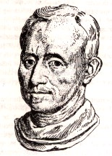
Translation: gases can condense into liquids; a very new idea and one of the first contemplations of phase changes.

Other gases van Helmont studied
Burning charcoal
Fermentation
Belches
Burning sulfur
Silver plus nitric acid
Fig. 17 Johann van Helmont

Q.1 What proof could you offer for the existence of gases?
Q.2 How could you prove that not all gases are the same?
Q.3 What would we call the gases above?
Q.4 How would you capture these gases?
Q.5 Explain, in terms of particle theory, why the flask exploded in Example 3.
Q.6 If you had two gases in separate containers, what tests might you conduct to try and identify the gases?
Q.7 How could you obtain a sample of carbon dioxide quickly? Would your sample be pure?

The experiments, techniques and range of ideas evident in van Helmont’s work is remarkable, all coming while science was in an era still dominated by Aristotle's conclusions.

http://mattson.creighton.edu/History_Gas_Chemistry

Experiment: Distinguishing gases. Is air always the same?

Supply your students with some unlabelled gas jars. Students are asked to test if the jars contain air or other gases.
A student group could be given oxygen in one gas jar, air in another and carbon dioxide in a third. Burning, match, limewater are examples of methods for distinguishing the gases.

Extension
Equation for example 2 above: C(s) + 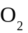(g) → C (g)

Testing for gases:
Hydrogen ‘pops’ when a lit match is placed near it 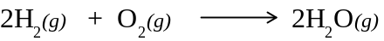
Carbon dioxide extinguishes matches and it turns lime water milky.
Matches etc burn very vigorously in oxygen. Glowing steel wool burns very brightly.

Glass – The Greatest Invention of all?

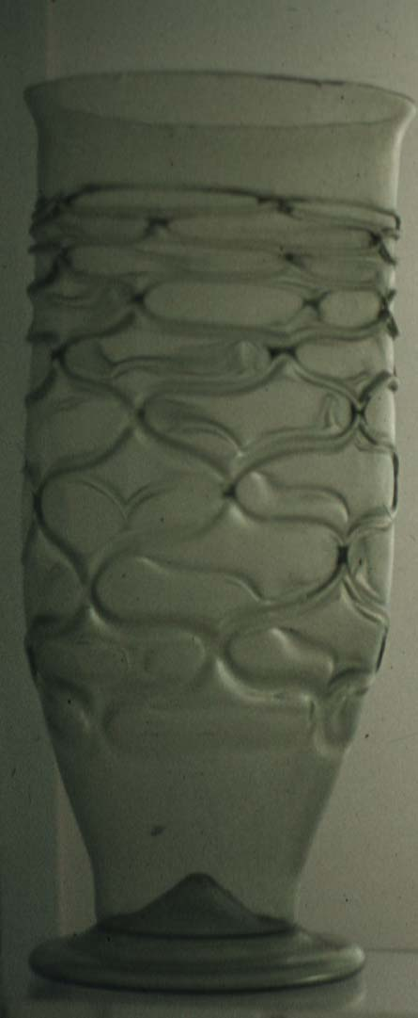
Glass was evident in the containers of the ancient Egyptians and Romans. It was probably discovered in the campfires of traders using fires in sandy, beach areas. Early uses included jewellery, glazing and drinking vessels. The Venetians were famed for their glassblowing skills but the use of glass was still limited to specialist uses.

The use of glass for windows was a practice that did not become widespread before the 18th century but, once it was introduced, look at the impact it had. The working day could be increased because light could now penetrate houses. Houses were warmer and the better lighting led to better hygiene and better health. As well as home windows it was used for shop windows and display cabinets. Even in old Australian homes, glass with small bubbles or uneven thickness can often be seen.

Fig.18 An early glass from Roman times
www.unc.edu/courses/rometech/public/contents/arts_and_crafts/Susan_Hampton
http://www.cas.muohio.edu/~mbi-ws/microscopes/fathers.html
http://www.cartage.org.lb/en/themes/Sciences/Physics/Optics/OpticalInstruments/Microscope/Leeuwenhoeks/Leeuwenhoeks.htm

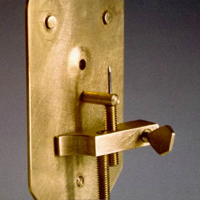
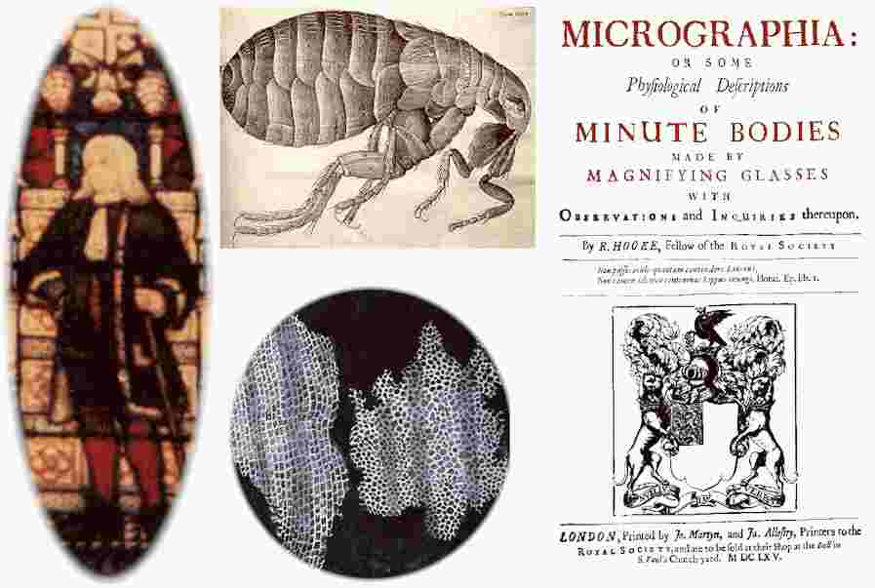

Fig. 19 Diagrams from Robert Hooke

Fig. 20 van Leeuwenhoek’s microscope
An early microscope used by Dutchman Anthony van Leeuwenhoek. It was van Leeuwenhoek skill in meticulously grinding lenses that enabled him to make such breakthroughs.

Robert Hooke used a lens and a microscope to open up the whole field of biology. Pasteurization, bacteriology and vaccination all followed the use of microscopes. Astronomers pointed their glass lenses to the heavens to revolutionize our knowledge of astronomy.
Galileo – ‘As I stinted neither pains nor pence, I was so successful that I obtained an excellent instrument that enabled me to see objects a thousand times as large and only one thirtieth of the distance in comparison to the naked eye’

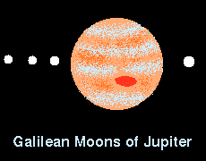
Fig. 21 Galileo’s picture of Jupiter. The red spot is recorded but Jupiter has several more moons than this.

Chemists introduced laboratory glassware and glass instruments like thermometers, manometers and barometers. Progress in art is also related to the use of glass in art. It is interesting that Western civilization accepted glass windows and drinking vessels far more readily than Islamic and Asian countries. Glass could be used for street lamps, hot houses and bottles.

Q.1 Explain how the lens has been of significance to science.
Q.2 List the glass equipment that you have used in science this year.
Q.3 Laboratory flasks could be made from pottery. Why is glass usually preferred?
Q.4 Did Roman houses have glass windows?!

Extension
Cheap glass is often referred to as soda glass. It contains sand (silica - SiO₂), lime (CaO) and baking soda (Na₂CO₃). It can be brittle and it has a low melting point. As the silica content increases, so does the quality of the glass. Crystal glass has lead oxide added to it.

Robert Boyle

Name: Robert Boyle Birth/Death: 1627 - 1691

Country: English (his family acquired large tracts of land in Ireland and lived there at different times)

Background: England was an unstable environment at this time. Frequent civil war occurred between supporters of the monarchy and supporters of Parliament. Rebellion in Ireland, where Robert Boyle was a landowner, was also common. Boyle was the youngest son in a family of fifteen children. His mother died when he was 4 years old. The land owned by his family made him a wealthy man.

Contribution to chemistry: Boyle’s discoveries include the match and acid/base indicators. He documented the unusual increase in density that occurs when water condenses to a liquid. He is remembered through ‘Boyle’s Law’ – The volume of a gas is inversely proportional to its pressure.

Fig. 22 Gases are made from particles that have significant space between them. It is easy to change the amount of space, the volume, between particles.

Anecdote: Boyle was an ‘all-rounder’! He published several books on theology and wrote several fictional novels. He was a humble and modest man, turning down many positions offered to him.

Impact of discovery: Boyle initiated discussion of phase changes in materials. Particle theory is still taught in junior science today.

After a period of education and travel, Boyle moved to Oxford at the age of 27 and began experimenting. His most famous books were ‘The Spring of the Air’ and ‘The Sceptical Chymist’. Boyle’s wealth made it much easier for him than many other scientists. He could pay for his own publishing and for his own
laboratory and for assistants.

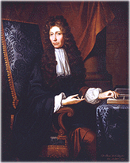

Fig. 23 Boyle’s book

Fig. 24 Robert Boyle

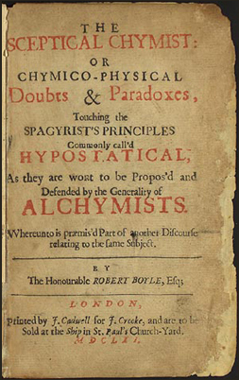

http://www-groups.dcs.st-and.ac.uk/~history/Mathematicians/Boyle.html
Boyles Law: Boyle bent a long piece of glass tubing into a J shape and sealed one end. He added mercury to the tubing, trapping a sample of air in the J. As he added more mercury, increasing the pressure on the air, the volume of the air decreased. Not only did it decrease but it did so in proportion to the pressure increase.
http://en.wikipedia.org/wiki/The_Sceptical_Chymist
Fig. 25 a Air trapped by mercury in a sealed J tube.
b. When the pressure on the trapped gas is increased, its volume decreases.
c. When the pressure is returned to the initial value, the volume also returns to the original value.

From these observations, Boyle concluded that air contains particles with space between them. Prior to this gas was assumed to be like a mist. The particles can be pushed closer together without changing the particles themselves. The origin of his book ‘The Spring of the Air’ is obvious from this experiment. Boyle also noted the inverse connection between volume and pressure and this is still referred to as Boyle’s Law – The volume of a gas is inversely proportional to the pressure. Another way of phrasing this is that the volume a gas will decrease if the pressure on it is increased.

Phase changes: Boyle made other conclusions from experiments like the one above. If a gas could be compressed then it must consist of particles. When compressed these particles are pushed closer together. If steam is water as a gas, then other gases must have a liquid and solid phase. Liquids and solids must also contain discrete particles, also with some space between them. Boyle was one of the first scientists to contemplate particle theory. The notion of atoms and elements was to flow from this line of reasoning.

Boyle’s experimenting also led him to the following discoveries
- the density of water is greater than the density of ice. The majority of liquids contract when they freeze – the unusual structure of ice causes it to be an exception to this.
- the extract from the petals of violets can be used to distinguish acids from alkalis. It has a different colour in each. This was the first recorded use of chemical indicators.
- the match. The action of friction on phosphorous could provide an instant flame.

Fig. 26. photo of a bottle bursting after coming from a freezer.

Use this liquid to classify a range of common liquids as acid or base. Your liquids could include fruit juices, milk, cleaning agents etc.

Q.1 What methods do you know of that will distinguish between acids and bases?
Q.2 Knowing that gases consist of individual particles, can you explain why Boyle’s Law works?
Q.3 List some ways in which the expansion of water when it freezes is significant in nature.
Q.4 Research other materials or substances that act as chemical indicators.
Q.5 If the volume of a gas is 25 litres at a pressure of 60000 Pa., what will the volume be at 180000 Pa?
Q.6 Use the points plotted in the Extension to see if the pressure value multiplied by the volume value does in fact come out as a constant?

Extension
The density of most substances increases as the liquid freezes. The particles pack together more closely as a solid. Water freezing to ice is an exception because of the unusual packing arrangement of water molecules.

Indicators: Many plants contain pigments that change colour in acids compared to bases. Most flower petals, beetroot juice and tea are examples. Indicators are weak acids, the conjugate acid and base pair having a different colour. Phenolphthalein and methyl orange are commonly used in chemistry classes for this but any flower petal can be used.

where the indicator is shown as HIn
red orange

The action of an indicator can be shown by the general equation above. When the indicator, HIn, loses its hydrogen it forms a negative ion, In. The In⁻ ion has a different colour to the HIn. The substance must be a weak acid for this to work.

Boyle’s Law: V α 1/P or V=k/P where k is a constant or PV = k
Volume is inversely proportional to pressure or ‘As the pressure increase the volume will decrease.’
A gas with a volume of 100 and a pressure of 20, will have a volume of 50 if the pressure is increased to 40. The graph below shows the inverse relationship. If pressure and volume values are multiplied together, they will equal the same value each time.

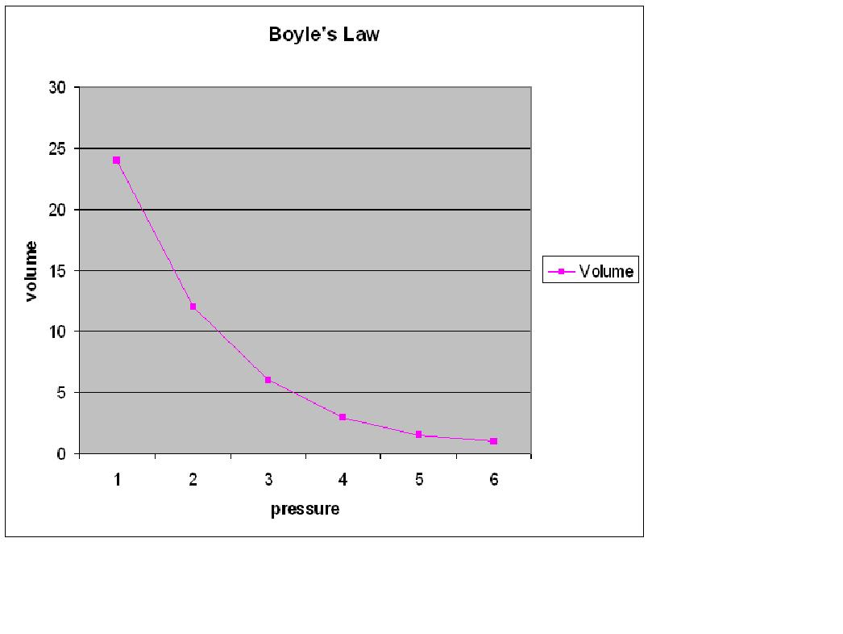
Experiment: Volume of water compared to ice.

Aim: To compare the density of ice and water.

Materials
10 mL measuring cylinders.
Balance
Refrigerator

Method
Weigh a measuring cylinder
Fill a 10 mL measuring cylinder to a volume of 8 mL. Use a dropper to get the volume exact.
Weigh the measuring cylinder again.
Place the measuring cylinder in a freezer, ensuring that it is vertical.
Record the volume once the contents have frozen.
What do you notice?
Is this the expected result?
density = mass/volume or d= m/v

Calculate the density of ice.

Calculate the density of the water.

Which is denser, ice or water?
Give some examples of how nature puts this unusual property of water to use.

Experiment: Acid/base indicators

Aim: To extract a pigment from plant petals that can indicate acid or base.

Materials
100 mL flask
hot plate
50:50 mixture of methylated spirits and water
Flower petals. Do not mix petals from different flowers.
test tubes

Method

Pick some petals from a flower.
Add the petals to a 100 ml flask with about 30 mL of a 50:50 mixture of methylated spirits and water.
Heat on a hot plate until the dye from the petals has been extracted into the liquid.
Decant or filter some of the liquid into two test tubes
Add lemon juice or acid to one.
Add lime water or sodium hydroxide to the other.

What colour changes did you observe?
Do all petals produce the same result?
Try purple cabbage.

Karl Scheele

Karl Scheele and his laboratory. www.chem.yale.edu/~chem125/125/history99/2Pre1800/Scheele/Scheele.html
Fig. 27 Scheele and his laboratory
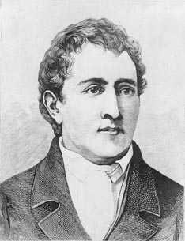
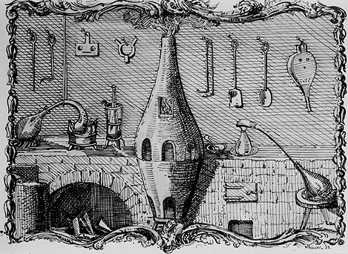
Name: Karl Scheele Birth/Death: 1742 - 1786

Country: Swedish

Background: Pharmacist (apocathery). Scheele was a modest and humble man. He turned down many offers of university and public positions. He shared his knowledge readily and often allowed others to publish his ideas as their own.

Contribution to chemistry: Scheele’s experimenting led to the discovery of at least seven new elements and a range of compounds. He is not credited with the discovery of any of these elements.

Anecdote: Scheele was the first to isolate hydrogen cyanide. Unfortunately, he also tested the gas on himself! Hydrogen cyanide is a lethal poison. Is relatively early death at the age of 44 is attributed to his poor safety practices.

Impact of discovery: Very few scientists could lay claim to the involvement in the discovery of so many new elements. These elements have many practical uses between them all.

Odd Spot: Scheele invented a popular green pigment called Scheele’s green. It was later found that the copper arsenite used was poisonous.

Scheele was a pharmacist and a keen chemist. He sourced unusual ores and managed to isolate many new gases and compounds from these ores. If a gas was produced from an experiment, he tested the gas, usually on himself, to see if it was a new gas.

During his lifetime Scheele isolated up to seven new elements ( nitrogen, oxygen, chlorine, manganese, molybdenum, barium, tungsten - probably a record) and many new compounds. The new compounds included crystallizing organic acids like lactic, tartaric, uric, oxalic and citric acids. Many of his discoveries were not acknowledged until his laboratory notes were inspected after his death. He published one book only – Experiments in Fire and Air.

Chlorine: Scheele produced chlorine in 1770 but he had no way of knowing that it was an element and not a compound. He reacted manganese dioxide with hydrochloric acid to make the chlorine. He new the element was hydrochloric acid minus the hydrogen but he did not know the formula of hydrochloric acid. The name chlorine was supplied thirty years later by Sir Humphry Davy.

Oxygen and nitrogen: Scheele proved by burning objects in sealed containers that air had at least two components, one that supported combustion, ‘fire air’, and one that did not, ‘spoiled air’ i.e. oxygen and nitrogen. Nitrogen had been produced four years earlier however by a Scottish scientist and Scheele did not publish his work on oxygen until after Priestley did.

Fig. 28 Scheele concluded that air was a mixture of two gases in the proportions 4:1. He called these components ‘spoiled air’ (nitrogen) and ‘fire air’ (oxygen).

Barium hydroxide: Scheele isolated barium hydroxide as the first known barium compound. Davy electrolysed this to produce barium.

Molybdenum and manganese. Scheele passed these ores onto other scientists who promptly produced the elements. Tungsten was also isolated from a substance that Scheele produced and named tungstic acid.

Q.1 Explain what ‘fire air’ and ‘spoiled air’ were and why Scheele might have named them as such.
Q.2 How might Scheele have obtained crystals of citric acid?

Experiment: Production and testing of oxygen

Aim: To collect oxygen gas and to test its properties.

Materials
test tube and single hole stopper to fit
rubber tubing to collect the gas from the test tube
pneumatic trough or 4 litre ice cream container
gas jar or large beaker to collect gas in
potassium permanganate
hydrogen peroxide (20 volume)
manganese dioxide

Method

Scheele was the first to collect samples of pure oxygen. There are several possible ways of doing this. Scheele had to work out a way of testing for oxygen. One that he tried was to breathe it himself. It was also common to use cats or mice for testing.

Three quarter fill the ice cream container with water.
Fill the gas jar with water and invert it in the pneumatic trough.
Add 2 spatulas of potassium permanganate to a test tube. Stopper the test tube and direct the rubber tubing into the inverted gas jar in the pneumatic trough.
Heat the potassium permanganate and catch the gas evolved.

Does the gas have a colour?
Is it distinguishable from air?
Hold some steel wool in a Bunsen flame until it burns.
Plunge it into a gas jar of oxygen.
What happens?
Plunge a glowing ice cream stick into a different jar of oxygen.
What happens?
How do you test for oxygen?

Oxygen can also be generated by placing hydrogen peroxide in a test tube and putting a spatula of manganese dioxide into the test tube. Pieces of liver will also work!
Henry Cavendish

Name: Henry Cavendish Birth/Death: 1731 – 1810

Country: English

Background: The most eccentric of all eccentrics! Cavendish was close to the richest man in Britain but he had absolutely no interest at all in money. He wore the same shabby suit every day. He avoided all conversation and interaction. He communicated with his staff by leaving them notes. He dined on roast mutton every night. Despite all this, he loved science and spend his entire life experimenting.

Contribution to chemistry: Cavendish was respected for the accuracy of his experimenting. He was the first scientist to make water from hydrogen and oxygen. This led him to predict its formula was 2 parts hydrogen to 1 part oxygen. Cavendish also predicted that air contained some other gas besides nitrogen and oxygen.

Fig. 29. Water is made from dephlogisticated air, oxygen, and inflammable air, hydrogen, in a set ratio that is close to 2:1.

Quote: ‘Cavendish probably uttered fewer words in the course of his life than any man who lived to fourscore years.’ – Lord Brougham

Impact of discovery: The formula of water was confirmed by later scientists.

Odd spot: Cavendish weighed the Earth, and he did so very accurately! He designed an apparatus with a large metal sphere. He measured the gravitational interaction between the sphere and the Earth to obtain his estimate of the Earth’s mass.

Cavendish was another scientist whose mother died when he was young. His voice was squeaky and he stuttered. He was immensely shy, never spoke to women and rarely to men

Cavendish experimented with many different gases. He calculated their densities, something that scientists had not been very concerned with. Te density of a gas was an aid to its identity. His best experiments were with the production of water.

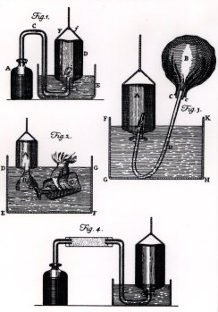
Fig. 31 Gas equipment
Fig. 30
Cavendish weighing the Earth.
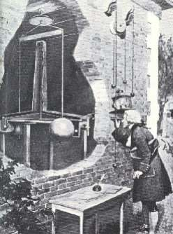

http://mattson.creighton.edu/History_Gas_Chemistry/Cavendish.html

Water: Cavendish unwrapped many of the secrets of water even though hydrogen and oxygen had not been identified. He wrote
‘..on applying the lighted match to the mouth of the bottle, with 3 parts of inflammable air to 7 of common air, there was a very loud noise.’ He did not realize it, but what he called inflammable air was hydrogen and it was reacting with oxygen in the air.
‘.. almost all of the inflammable air and near one-fifth of the common air lose their elasticity, and are condensed into dew.’
Cavendish continued experimenting to establish the ratio between the hydrogen and oxygen in water

dephlogisticated air + inflammable air gives water
ratio 1000 : 423

Note the way this equation is written – chemical symbols were yet to be used. Nor did he see the need for an exact ratio.
Cavendish had made water; water could not be an element as Aristotle had assumed.

Note also the ratio of dephlogisticated air to inflammable air. As air is about 1/5 oxygen (20.8% figure used by Cavendish), Cavendish found the ratio of oxygen to hydrogen was 208 : 423, remarkably close to the correct 1:2 of H₂O. Cavendish did not see any reason to round this ratio off.

Air: The meticulous experimenting of Cavendish is evident in the extraordinary accuracy of his experiments with air. He determined the composition of air to be 79.167% phlogisticated air and 20.95% dephlogisticated air. He even correctly suggested a small percentage of a third gas in air – identified as argon 100 years later.

Q.1 How do we now represent the equation given for forming water?
Q.2 What do we know the following gases as?
dephlogisticated air inflammable air phlogisticated air
Q.3 Why was Cavendish unable to identify argon?
Q.4 What is the significance of Cavendish not trying to round off his ratio of hydrogen to oxygen?

Experiment

If your school has a Hoffman voltammeter, the ratio of hydrogen to oxygen can be investigated easily. Even without one, the apparatus can be simulated with two carbon rods inside inverted test tubes.

The Hoffman voltammeter uses a salt solution in an apparatus that has two long burette-like arms for collecting gases from the separate electrodes. The electrodes are connected to a power supply. When the power supply is switched on, a current passes through the salt solution, breaking the water up into hydrogen and oxygen. More hydrogen is trapped than oxygen because the formula is H₂O. This apparatus is a safe way of stopping the hydrogen and oxygen from combining explosively.

The ratio of gases rarely meets the hoped for 2:1 because of the varying solubility in water of hydrogen and oxygen.

Joseph Priestley
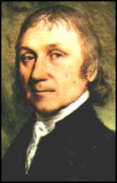
Name: Joseph Priestley Birth/Death: 1733-1804
Fig. 32 Priestley www.chemheritage.org/EducationalServices/chemach/fore/jp.html

Country: English

Background: Middle class family involved in textiles. Priestley’s mother died soon after the birth of her sixth child. Priestley was sent to live with an aunt. He had a pronounced stammer. He became a minister after completing his studies at a nonconformist academy.

Contribution to chemistry: Priestley is best remembered for his research into gases, oxygen included. As an aside he is also credited with the marketing of soda water.

Fig. 33 Animals need to breathe a component of air. This air can be prepared from chemicals.

Anecdote: At the age of 61, Priestley was forced to migrate from Britain because of his political views. His laboratory and house were burnt by a mob prior to this in 1791.

Quote: ‘the injury which is continually done to the atmosphere by the respiration of such a large number of animals…is, in part at least, repaired by the vegetable creation.’

Impact of discovery: Priestley was a good experimenter but a lousy academic. Many scientists like Lavoisier benefited from his experimental results but he was not able to provide correct chemical explanations of these experiments.

Soda Water: Some of Priestley’s earliest experiments were with fixed air (carbon dioxide). He lived beside a brewery, an excellent source of fixed air. He collected carbon dioxide in water, noted its pleasant taste, the result being an early version of soda water. This proved a hit with the upper classes of the time. Priestley established that sulfuric acid and chalk also produced the same fixed air. This was easier to collect than standing over a brewery vat!

Phlogiston (oxygen): Priestley performed the experiment outlined in Fig. 34 to demonstrate the role of air in supporting life.

Fig. 34 a A mouse survives for some time in a sealed container but not all of the air is used up.
b Plants in the container can gradually restore some of the ‘live-ability’ of the air

Priestley’s conclusion from this experiment is quite remarkable –‘the injury which is continually done to the atmosphere by the respiration of such a large number of animals…is, in part at least, repaired by the vegetable creation’. We can explain this easily now as we know that plants release oxygen and that animals use up oxygen but Priestley was not aware of this. There is almost a hint of Greenhouse problems in this statement.

Priestley was able to prepare a pure sample of oxygen by heating mercury calx (mercury oxide) in a sealed container. He used sunlight, focused through a large lens to heat the calx. The calx was gradually converted to mercury liquid and the container was filled with oxygen. Thus Priestley is credited with the first preparation of oxygen. Scheele actually isolated oxygen four years earlier but as usual his results were not yet published. Priestley found that this gas was better than normal air, a candle flared more in it and a mouse lived longer in it. Sadly for Priestley he explained all of these experiments in terms of the flawed phlogiston model. He died without accepting that combustion involved reactions with oxygen.

Gas collection: He improved techniques for collecting gases, the pneumatic trough shown an example.
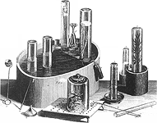
Priestley identified many other gases including hydrochloric acid, carbon monoxide, ammonia, sulfur dioxide but he of course did not know the chemical formulas of these gases. If the gas produced was soluble in water, Priestley collected it over mercury.
Fig. 36 Priestley’ equipment
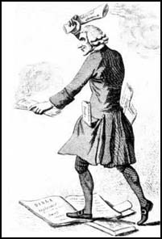

Fig. 37
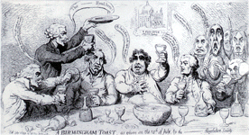
Cartoons of Priestley and revolution

www.chemheritage.org/EducationalServices/chemach/fore/jp.html

Priestley was a very radical figure, very unpopular for his support of the French and American revolutions. Publications like a ‘History of the Corruptions of Christianity’ did not improve his public image much! Note the cartoons above of him preaching that have been preserved from newspapers. In 1791 he was to attend a Bastille Day celebration with fellow supporters of the French revolution. He was warned a mob of dissenters were waiting at the venue so he hid at the house of a friend. The mob resorted to burning Priestley’s house and laboratory. Priestley decided to emigrate to America to escape this unwelcome attention.

The Phlogiston Debate

Priestley believed in the phlogiston theory. Phlogiston theory goes like this – when the calx was heated, it absorbed phlogiston from the air, leaving the remaining air more flammable. This is illustrated in Fig. 38

Fig. 38 a Priestley said that the calx absorbed phlogiston, leaving more flammable air behind. The mercury formed contains phlogiston.
b. The correct explanation is that the mercury oxide is reduced to mercury, releasing oxygen gas.

The phlogiston explanation held sway for several years. Careful measurement of the masses involved threw up a problem – the solid mercury product weighed less than the original calx. If it had gained phlogiston, why did it weigh less? Priestley had the answer – phlogiston had a negative mass! French chemist Antoine Lavoisier provided the correct explanation and he dubbed the gas involved oxygen (Greek for acid-former). Lavoisier explained that air had two components, one of which was oxygen. When heated the mercuric oxide (calx) was releasing oxygen, hence the mass loss. The mouse thrived on the oxygen enhanced air, for a while anyway!

Q.1 What are the listed ingredients on modern soda water?
Q.2 What is the reaction for forming ‘fixed air’ in fermentation?
Q.3 Explain how accurate mass readings made the phlogiston theory unlikely.
Q.4 What is the composition of air?
Q.5 Priestley supplied the name to a new product reaching Europe, the sap from a Brazilian tree. What was this material?
Q.6 Explain how mercury was significant to the collection of gases.
Q.7 Write an equation for the reaction of nitrogen dioxide, 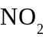 and water.
Q.8 Write an equation for the decomposition of mercury oxide when heated.
Q.9 Was Priestley sampling pure oxygen. Explain.
Q.10 Why was the gas Priestley formed from calx about five times better than normal air?

Extension
Fixed air was formed in the brewery from the fermentation of glucose

glucose → carbon dioxide and ethanol

Producing fixed air from sulfuric acid and chalk.

Gases like ammonia are very soluble in water. The displacement of water method of collecting gases does not work for ammonia. Priestley collected ammonia by displacing mercury.

Calx equation 2HgO(s) → 2Hg + O₂(g)

Experiment: Generating ‘fixed air’.

Aim: To use several different methods to produce the same gas, fixed air (carbon dioxide).

Materials
lime water solution for testing the gas
chalk or calcium carbonate
hydrochloric acid (2M)
test tubes with single holed stoppers and rubber tubing to collect gas
potatoes
dried yeast powder
drinking straws
gas jar and lid

Method
Priestley showed that the gas evolved from brewing vats was the same as the gas produced from reactions of acids on carbonates. There are several easy ways to produce a sample of carbon dioxide.

Blow through a straw into some lime-water in a test tube.
Observe the colour of the lime-water.

Add a spatula of chalk or calcium carbonate to a test tube.
Connect the test tube via rubber tubing to another test tube that contains lime-water.
Add some hydrochloric acid to the chalk and quickly put the stopper on so that the gas produced travels through the tube to the lime-water.
Observe the colour of the lime-water.

Add some chopped potato, sugar and dried yeast to a test tube. Cover with water.
Stopper the test tube with a stopper that has gas tubing through it.
Run the tubing into a beaker containing lime-water.
As the potatoes ferment, the gas produced over the next few days will pass through the lime-water.
Observe the colour of the lime-water.

To test other properties of carbon dioxide, use the chalk and acid method to fill a gas jar with carbon dioxide. Plunge a burning taper into the gas jar.
What happens?
Shake some universal indicator in another gas jar containing carbon dioxide. What colour does the indicator go?
Pour the gas from another gas jar of carbon dioxide onto the pan of a balance. The carbon dioxide is heavier than air and should show a mass reading.

Antoine Lavoisier

Name: Antoine Lavoisier Birth/Death: 1743 -1794

Country: French

Background: Middle class French bureaucrat.

Contribution to chemistry: Lavoisier solved the puzzle of combustion. Combustion is the reaction of a substance with oxygen. Lavoisier helped refine the systematic naming of chemicals and he formalized the Law of Conservation of Mass. As an aside, Lavoisier helped improve gunpowder formulations and the Paris street lighting.

Quote: ‘The Republic has no need of savants ( scientists)’ – the magistrate sentencing Lavoisier to death.

Impact of discovery: The correct explanation for combustion was a major step forward in the development of chemistry. Some analysts would consider Lavoisier the most significant of all chemists, not for his experimental ability but for his logical explanations.
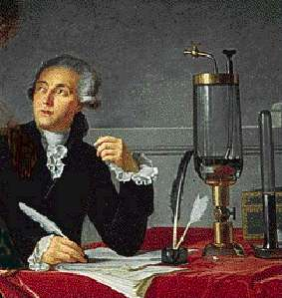
Fig. 39 Two images of Lavoisier
http://en.wikipedia.org/wiki/Antoine_Lavoisier
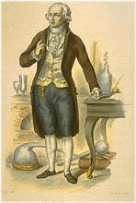

Odd spot: Lavoisier’s experiments included
- testing whether a candle will burn in a bell jar that a bird had been suffocated in! This was to test whether combustion required the same gas as breathing.
- wrapping an assistant in a varnished silk bag with his lips sealed with turpentine and pitch. He breathed through a tube into collecting flasks! The whole process was to test whether the mass of food consumed equaled the mass of water and carbon dioxide produced.

Lavoisier was a bachelor of law! He married a 13 year old, Marie-Anne Paulze. She worked as his assistant. His early discoveries included improved gunpowder formulations and street lights. His major contribution was to explain clearly and correctly many observations of contemporary chemists.
His book – Elementary Treatise of Chemistry – moved towards standard naming of chemicals and identification of elements.

Hydrogen: Lavoisier named inflammable air ‘hydrogen’, meaning ‘water former’. He explained that it must be a component of acids because it was always produced from the reaction of acids and metals. He confirmed that hydrogen produced water when reacted with air.

Conservation of mass: Lavoisier weighed sulfur carefully before burning it in a sealed container. The mass of the container was unchanged after the reaction.

Fig. 40 a Sulfur weighed in a sealed container. Sulfur is then burnt using a lens.
b The total mass of the container is unchanged.

Combustion: Lavoisier’s major contribution was to debunk phlogiston, as explained earlier. He was able to extend the role of oxygen to explain combustion in general. This was a major achievement. It is so complex to understand what happens when a candle burns.

Try this yourself. What do you think is happening to the candle wax when a candle burns?
Will a candle burn in a sealed container?
What happens to the volume of gas, if a candle is burnt in a sealed container?

With all the gases involved being clear, scientists struggled with this process for many years before Lavoisier conducted the following experiments.

Fig. 41 a Candle burning in air – what is actually happening? Prior to Lavoisier, scientists just assumed the candle was burning away. It weighed less because it was releasing phlogiston. There was no knowledge that carbon dioxide and water might be produced or that oxygen was required.
b Candle being burnt in a jar sitting in water. The volume change of water provides information about the gases. The air volume does drop, but the water is now acidic. Conclusion – fixed air, carbon dioxide, is produced during burning and some of it dissolves in water causing the volume of gas to decrease.
c Candle being burnt in a jar where a bird had suffocated. Burning does not occur. Conclusion – there is no oxygen left but other gas remains, the nitrogen and fixed air. Oxygen is essential for combustion. It is also essential for animals.
d Candle being burnt in a jar sitting in mercury. This time the gas volume hardly changed. Conclusion – the carbon dioxide does not dissolve in mercury. Combustion does not necessarily lead to a drop in the gas volume.

Combustion then is the reaction of the substances in the candle with the active component of air, oxygen. Oxygen is used up but the carbon in the candle and the oxygen form carbon dioxide gas. Steam or water is also produced. We know combustion now to be reactions like that of methane, CH₄

CH₄(g) + 2O₂(g) → CO₂(g) + 2H₂O(l)

Although Lavoisier was not able to put the whole picture together, mainly because the formulas of the substances were not known, the insight required for such conclusions has gained the respect of all scientists since.

Respiration: Lavoisier recognized that the human body ‘burns’ food in the same process as the food might burn in a flame. Respiration is a combustion reaction with products of carbon dioxide and water. He performed many experiments of sampling and weighing the breath exhaled by humans to verify this theory. He used a calorimeter to verify that both respiration and burning released the same amount of energy.

Chemical Nomenclature ( names )
Which name is more helpful, oil of vitriol or hydrogen sulfate?
Hopefully the latter is more informative. As many substances were made before chemists knew their composition, the names were confusing. Often, the one substance was named differently by chemists from different countries. Lavoisier tried to rectify problems naming chemicals. He suggested compounds should be named according the elements contained, i.e. a compound of copper and oxygen should be copper oxide.

The name iron sulfide is useful, it states that the compound is made from iron and sulfur. Names like oil of vitriol, calx etc were not useful.

On the 8th May 1794 Antoine Lavoisier was arrested, tried and guillotined all in the one day! ‘The Republic has no need of savants ( scientists)’, the magistrate said. ‘It took but a moment too cut off that head, though a hundred years perhaps will be required to produce another like it’, said mathematician M. LaGrange. So ended the life of one of the most respected chemists of all, executed for past history as a tax collector.

Q.1 What is the Law of Conservation of Mass?
Q.2 Give an example of a reaction between a metal and acid to form hydrogen.
Q.3 Explain how mass is conserved when you bake a cake.
Q.4 Write an equation for the burning of glucose C₆H₁₂O₆ in air.
Q.5 What is the equation for the respiration of glucose?
Q.6 Lavoisier tested whether a candle would burn in the air left after a bird had suffocated in a sealed container. Explain what he was doing and what he found.
Q.7 Do all acids contain hydrogen?

Extension

Formulas for several acids - HCl, H₂SO₄, HNO₃, CH₃COOH. Note that they all contain hydrogen and that his hydrogen is released in reactions with metals
Zn(s) + 2HCl(aq) → ZnCl₂(aq) + H₂(g)

The reaction of sufur with oxygen is
S(s) + O₂(g) → SO₂(g)

Experiment: Conservation of mass in chemical reactions.

Aim: To show that mass is conserved in chemical reactions.

Materials
snap lock bags
magnesium
hydrochloric acid (0.1M)

Method

Add about 15 mL of 0.1 M hydrochloric to a snaplock bag.
Sit a 1cm long piece of magnesium on the bag and weigh both bag and magnesium together.
Record the mass.
Add the magnesium carefully to the bag (without mixing the magnesium and acid until the bag is resealed) and quickly reseal it.
Shake the bag gently to make the magnesium mix with the acid.
Sit the bag back on the balance.
What happens to the mass of the bag as the reaction proceeds?
Is this the same with all reactions?
Write an equation for the reaction.
What gas is produced?

Experiment: Candle burning

Aim: To investigate the chemistry of a burning candle.

Materials
candles
blu-tack
pneumatic trough of 4 litre ice cream continer
gas jar or large beaker
lime-water
universal indicator

Method
Sit a candle on the bench supported by blu-tack if necessary.
Light the candle.
What can you see happening?
Where is the candle wax going?
Briefly hold a glass beaker a few cm above the flame. Can you see any moisture on the glass?
Where did the moisture come from?

1/3 fill the ice-cream container with water.
Sit the candle in blu-tack in the middle.
Light the candle and very quickly place the gas jar or beaker on it.
Observe the water level.
Watch closely also for any gas bubbles escaping the gas jar.
Is the water level changing?
When the candle goes out, what happens to the water level?
What is the final change in volume of gas?
What has caused this change.

Repeat the above procedure using universal indicator in the water.
What happens and why?

Repeat the above procedure using lime-water in the water.
When the candle goes ou, try and mix the water and the gas in the jar.
What happens?

Comment
Some students think the water rises because the oxygen is used up. Not true. The candle heats the air causing it to expand and bubble from the container. When the air cools, it contracts. Less gas is left so its volume is less. The products of combustion of candle wax are carbon dioxide and water. The lime-water and Universal indicator should show carbon dioxide is present. The water is seen as moisture on the glass at the start of the experiment.

Humphry Davy

Name: Humphry Davy Birth/Death: 1778 – 1829

Country: English

Background: Davy’s family was poor. At the age of 9, Davy went to live with his grandfather. He became an apprentice to a pharmacist but he also read widely on science subjects. His interest in science led to an offer of a position as a laboratory assistant in Bristol. His successful investigations with gases soon established Davy as a chemist in his own rite.

Contribution to chemistry: Davy isolated laughing gas and several other oxides of nitrogen. He invented a lamp for use in mines. His biggest contribution however, was the use of electrolysis to isolate reactive elements.
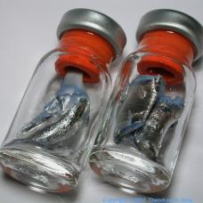
www.sciencephoto.com

Fig. 42 Davy was the first to isolate potassium. It is so reactive in air and water that it is stored in oil.

Quote: ‘When two elements combine and form more than one compound, the masses of one element that react with a fixed mass of the other are in the ratio of small whole numbers’. This was the type of information that helped Dalton formulate his principles of atomic theory. Davy arrived at this conclusion by preparing oxides of nitrogen.
Oxide 1 . 0.418 g of nitrogen reacts with 1 g of oxygen
Oxide 2. 0.787 g of nitrogen reacts with 1 g of oxygen
Oxide 3. 1.725 g of nitrogen reacts with 1 g of oxygen

Fig. 42.b The ratio of nitrogen to oxygen is close to whole number proportions – 1:2:4. It is this type of data that was leading to the notion of set chemical formulas for compounds.

Impact of discovery: Electrolysis is still the preferred method for the industrial production of aluminium, sodium and a range of other metals. The discovery by Davy of so many new elements made the development of a Periodic Table more likely.

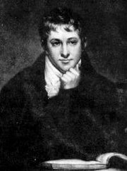
Fig. 43 Humphry Davy

http://www.woodrow.org/teachers/chemistry/institutes/1992/Davy.html

Davy’s first published work was with laughing gas. Nitrogen has several oxides, NO₂, NO, and N₂O. Davy studied the proportions of oxygen and nitrogen in each. Each gas has different properties but N₂O causes a high when inhaled. Davy’s discovery led to the use of laughing gas as a recreational drug but it was eventually used by dentists and doctors as an early anaesthetic.

Davy tried inhaling carbon monoxide but this was less successful – he nearly suffocated! In fact his death at a relatively early age is linked to practices like these.

The battery had been invented recently. Several scientists tried running electricity through ionic solutions.

Fig. 44 Electrolysis set up.

Electrolysis of copper sulfate provided copper metal, no big deal because copper was already known. Electrolysis of sodium chloride was confusing however, as hydrogen and oxygen gases were formed. This is because water reacts instead of sodium and chlorine. Solution - Davy eliminated the water by melting the ionic powders. This time potassium was extracted from potassium hydroxide and later sodium from sodium chloride. The Group 1 metals were extracted for the first time. Davy wrote

‘The potash began to fuse at both its points of electrolization. There was a violent effervescence at the upper surface, at the lower, or negative surface, there was no liberation of elastic fluid, but small globules having a high metallic lustre, and being precisely similar in visible characters to quicksilver, appeared, some of which burnt with explosion and bright flame, as soon as they were formed, and others remained, and were merely tarnished, and finally covered with a white film which formed at their surfaces’

Davy followed up with the isolation of magnesium, calcium and strontium. He used potassium to extract boron. That is a lot of new elements in a short period of time.

Questions
Q.1 Where on the Periodic Table do the elements that Davy discovered lie?
Q.2 Why were these elements not discovered earlier?
Q.3 Can seawater be electrolysed to form sodium and chlorine?

Extension

Fig. Electrolysis of a dilute salt solution leads to the decomposition of water into hydrogen and oxygen
2H₂O(l) → O₂(g) + 4H⁺(aq) + 4e positive electrode
4H₂O(l) + 4e → 4OH⁻(aq) + 2H₂(g) negative electrode
---------------------------------------------------
2H₂O(l) → 2H₂ (g) + O₂(g) overall equation

Fig. Electrolysis of molten salt leads to the production of sodium and chlorine. The industrial name for this process is the Downs Cell
2Na⁺ (l) + 2e → 2Na(l) negative electrode
2Cl⁻(l) → Cl₂(g) + 2e positive electrode
------------------------------
2Na⁺(l) + 2Cl⁻(l) → 2Na(l) + Cl₂(g) overall equation

The reaction of sodium with water that causes such a violent reaction is

2Na(s) + 2H₂O(l) → 2NaOH(aq) + H₂(g)

Experiment : Electrolysis

Aim: To investigate electrolysis

Materials
2 carbon electrodes
beaker
crucible
electrical leads
power supply or 6 volt battery
salt water
any copper solution i.e. copper sulfate
tin chloride powder
fume cupboard

Method

Electrolysis of salt water.
Half fill a beaker with a dilute salt solution
Sit two carbon rods in the beaker. Do not allow them to touch.
Connect the carbon rods to the power supply.
Turn the power supply on ( 4 - 6 volts )
What happens at each electrode?
Is the gas volume the same at both electrodes?

Electrolysis of copper sulfate.
Repeat the set up from the salt solution using a copper sulfate solution.
What happens at the electrodes?

Electrolysis of tin chloride – to be performed in a fume cupboard. Must be teacher supervised.
Add some powdered tin chloride to a crucible.
Heat the crucible on a Bunsen to melt the tin chloride
Use tongs to hold the electrodes in the crucible.
Turn the power supply on for a minute.
Turn power supply and Bunsen off.
Examine the electrodes.

The invention of the battery

Suppose that in a biology class you are dissecting a frog. You hang the frog leg up on a hook to inspect a little later. As the leg touches the hook it twitches. What significance, if any, do you attach to this? Has the frog been dead long? Do muscles contract after the animal dies? Is it a reflex?

If your response would be to shrug your shoulders and move on then you would be passing up one of the most significant discoveries of all time –the battery. Believe it or not, the whole world of batteries stemmed from this observation made by Italian professor, Luigi Galvani. Galvani experimented further to notice that the frog leg twitched the most when the hook and tongs were made from different metals. He concluded incorrectly, however that some form of electricity must be stored in the frog.

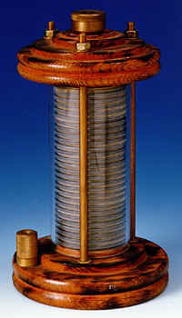
Another Italian scientist, Alessandro Volta, viewing Galvani’s research, argued that it was external electricity making the frog leg twitch. The electricity was coming from the interaction between the two different metals. Volta tried different metal combinations, touching them to his tongue to gauge the success or otherwise. He even tried placing separate electrodes in each ear but gave this away after complaining of headaches. In 1799, he displayed the first useful battery to the world. It was made from alternating zinc and silver discs separated by cardboard soaked in salt water. It was called Volta’s Pile.

For the first time scientists had a continuous source of electricity. It was this invention that enabled Davy to conduct his electrolysis experiments just a few years later. Electricity was also used to spark chemical reactions and to produce emission spectra of elements.
www.sparkmuseum.com/VOLTA.HTM Fig. 45 Volta pile

Experiment: Volta pile
Aim: To make a working model of the Volta Pile.

Materials
Metal disks or rectangles of similar size. Copper and zinc can be used if silver is unavailable.
Saturated salt solution. ( or potassium nitrate )
Filter paper
Electrical leads.
Galvanometer or voltmeter.

Method
Cut rectangular pieces of zinc and copper foil.
Also cut pieces of filter paper of the same size as the metals.
Alternate the layers of copper with paper soaked in salt solution with zinc layers.
Check the voltage or current as you progressively add more layers. The end piece of copper should be the positive electrode and the end piece of zinc the negative electrode.

Reactions: Cu²⁺ + 2e → Cu(s) Zn(s) → Zn²⁺ + 2e
The zinc electrodes will eventually be reacted away.

Lemon power
Lemons can be used as a similar source of a simple battery from natural materials.
Push a carbon rod into a lemon.
Push a magnesium strip or zinc strip into the same sector of the lemon.
Connect the two to a voltmeter. Like the frog legs, the lemon produces a current. Like the frog legs, it is not the lemon causing the current – it is the different materials used as electrodes. The lemon just completes the circuit.
Fig. photo of lemon battery.
John Dalton

Name: John Dalton Birth/Death: 1776 – 1844

Country: English

Background: Quaker family. 3 siblings died and the family lived in a two bedroom cottage. At the age of 12 he tried teaching at local school but found this too difficult. He then tried farming, but returned to run a school with his brother and sister. He was offered a job with maths in 1793 at the new Manchester College.

Contribution to chemistry: Dalton introduced atomic theory to the world. He realized chemicals had exact formulas and the atoms were preserved when they reacted. He was one of the first to represent chemicals with symbols.

Odd spot: Colour blindness: Dalton was the first to document this condition. He and his brother were both colour blind and supposedly the purchase of stockings for their mother led to a discussion on why their taste in colour was so bad! The answer – colour blindness! This condition was actually known as Daltonism for many years.

Impact of discovery: Modern chemistry texts abound with formulas and equations. These all stem from the lead provided by Dalton.

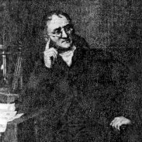
Dalton’s interest in meteorology led to his first research on the way that gases mix. In fact he proved that the particles mix but do not interact. His Law of Partial Pressures says that the pressure of each gas can be calculated as though it is the only gas present. The total pressure is then the sum of the pressures of the individual gases.
http://antoine.frostburg.edu/chem/senese/101/atoms/dalton.shtml

Fig. 47 Dalton’s law of partial pressures

Dalton’s main contribution to chemistry was to reintroduce atomic theory. All substances are made from some arrangement of elements. Each element has an atom that is unique to that element. It also has a unique mass. In chemical reactions, these elements are unchanged; they just mix in different combinations. A elements in a substance are present in a fixed arrangement. Dalton summarized the new atomic theory by stating that
- all substances are made from elements
- elements are neither created nor destroyed in chemical reactions
- elements have a unique mass
- elements are present in whole number ratios in compounds i.e. fixed air, or carbon dioxide, has a formula CO₂. Each molecule of carbon dioxide has one atom of carbon combining with two atoms of oxygen. This is a fixed ratio. A molecule of carbon dioxide can be formed from the reaction of one atom of carbon with two atoms of oxygen. This notion of explaining reactions in terms of the atoms and their combinations added enormous clarity to chemistry.

Interestingly, Dalton’s theory received a lukewarm reception from the scientific community. Scientists still could not accept that a solid object might in fact consist of small particles with space between them.

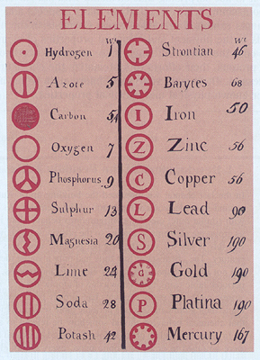
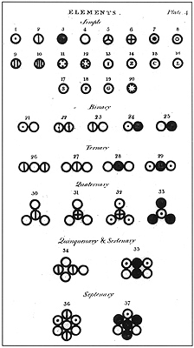
Fig. 48 Dalton’s symbols and masses
http://web.lemoyne.edu/~giunta/dalton.html http://www.uh.edu/engines/epi1411.htm
Dalton used symbols to simplify his equations. Some of the symbols for common substances are shown above. Dalton’s table of elements and their masses is also shown.

Q.1 Are the same symbols still used?
Q.2 What errors can you pick in this Table?
Some elements were not in fact elements. Magnesia was later shown to be a compound.

The mass of hydrogen is out by a factor of two. It was known that the ratio of hydrogen to oxygen was 1:8 in water. Dalton assumed water was HO. Therefore if hydrogen had a mass of 1 then oxygen must be 8. Since water is actually H₂O, then oxygen should be 16 times heavier than water.

Jons Berzelius

Name: Jons Berzelius Birth/Death: 1779 - 1835

Country: Swedish

Background: Berzelius was an exception to the run of chemists who lost one of their parents at an early age – he lost both! His father died when he was 4 and his mother died when he was 9. He paid his own way through medical school and then worked as an assistant at the Stockholm College of Medicine. He soon moved into chemistry instead of medicine.

Contribution to chemistry: Berzelius and colleagues discovered selenium, thorium, lithium and vanadium. He initiated the modern system of using symbols from our alphabet in place of element names. Berzelius methodically processed as many known substances as possible to work out their empirical formulas.

Fig. 49 Many substances have a positive component and a negative component. This process did not work for some molecules.

Impact of discovery: The new elements found by Berzelius have many uses. His work highlighted the usefulness of chemical symbols, formulas and equations.

Electrolysis: Berzelius experimented with electrolysis of aqueous solutions around the same time as Davy. He was the first chemist to point out that many substances had positive and negative parts. ( We now call these ionic substances.) Substances that did not separate when subjected to an electric current were often associated with living things. This was one of the first hints of covalent bonding.

Accurate masses: Berzelius’ meticulous experimenting allowed him to establish or correct the accepted masses of all known elements.

New elements: Berzelius discovered selenium, lithium, vanadium and thorium.

Nomenclature: Berzelius continued the work of Lavoisier in bringing order to the naming of chemicals. He insisted upon Latin or Greek names for the well known elements. He replaced the complex symbols used by Dalton with the initial letters of the element’s name i.e. H for hydrogen, N for nitrogen and Pb for lead ( the Latin for lead is plumbum ) as potassium and phosphorous also started with P. He also named many organic molecules like proteins. For the first time ever, chemical equations became part of chemistry documents.
The manufacture of zinc sulfide, for example, could be represented as
Zn(s) + S(s) → ZnS(s)

We have become blasé about the power of chemical equations like this but each one conveys very quickly a wealth of information. The equation above tells us that
- zinc and sulfur are elements that can combine to form a compound zinc sulfide.
- the reactants and products are solids.
- one atom of zinc is required for each atom of sulfur. If you have 2220 atoms of zinc, you will require 2220 atoms of sulfur. The mass of the sulfur and zinc required will be different even though the same number of each is required.
- if zinc has a relative atomic mass of 65.4 and sulfur a value of 32 (approximately 2:1), then an industry wishing to make large quantities of zinc sulfide needs to use twice the mass of zinc to sulfur to ensure little wastage. With compounds like ammonia, NH₃ this type of calculation is very important as the mass of nitrogen needs to be far greater than that of hydrogen. A simple glance at the formula would not suggest that.

Fig 50 The mass of zinc needed to react with 100 g of sulfur to have an equal number of atoms of each.

Q.1 Why do you think the symbols proposed by Berzelius were more accepted than those proposed by Dalton?
Q.2 What are the positive and negative components of table salt and chalk?
Q.3 Why do some substances not have obvious positive and negative components?
Q.4 When mercury oxide is heated, it decomposes to mercury and oxygen. Write a balanced equation for this process. What information is contained in this equation?
Q.5 What mass of magnesium is needed to react exactly with 32 grams of sulfur if the formula of magnesium sulfide is MgS?

Extension

Many substances are ionic. As solids, the ions are held in position and an electric current has no effect. When the substance is heated to a liquid, the ions can move. The negative ions move to the positive electrode and the positive ions move to the negative electrode.

MgS(solid) → Mg²⁺ and S²⁻
heat

negative electrode positive electrode

Chemical Names

The combination of Dalton, Berzelius and Lavoisier brought some system into the naming of chemicals. As scientists learnt the formulas for each chemical, they were able to give it a consistent name. Surely the title ‘carbon dioxide’ is more informative than ‘fixed air’. Some examples of the name changes for well known compounds are given in the table below.

Original title Modern name Chemical formula

fixed air carbon dioxide CO₂

reduced fixed air carbon monoxide CO

quicklime calcium oxide CaO

aqua fortis nitric acid HNO₃

aqua vitae alcohol C₂H₅OH

flammable air hydrogen H₂

spoiled air nitrogen N₂

fire air/phlogiston oxygen O₂

oil of vitriol sulfuric acid H₂SO₄

muriatic acid hydrochloric acid HCl

chalk calcium carbonate CaCO₃

potash potassium hydroxide KOH

magnesia magnesium oxide MgO

The Scientists

It is interesting that no single European country dominated the development of chemistry. Early Renaissance science came to Italy and Spain from scholars fleeing the advance of the muslim empire. From then on however, contributions came from many countries. The lack of instant media, like we have in the modern era, often caused disputes as to who was first to find something. Sometimes the dispute was even between two scientists from the same country, Isaac Newton and Robert Hooke both English scientists laying claim to developing our understanding of gravity. Some other well known conflicting releases were
- Lothar Meyer from Germany and Dmitri Mendeleev both released a similar Periodic Table in the same year.
- Karl Scheele discovered oxygen well before Joseph Priestley but he did not publish his result.
- Henry Cavendish isolated argon but could not test it or identify it because of its low reactivity.

Fig. 51 Map of Europe with scientists.

The existence in most countries of a ‘Royal Society’ was a positive influence on the sharing of knowledge. The Royal Societies helped encourage publication of research and the sharing of this research. In many instances, two countries were at war but their Royal Societies still communicated.

Joseph Gay-Lussac

Name: Joseph Gay-Lussac Birth/Death: 1778-1850

Country: French

Background: Wealthy upper class French noble before the revolution. Worked his way up again afterwards.

Contribution to chemistry: Gay-Lussac discovered the relationship between the volume and temperature of a gas. He realized the gases combine in simple numerical proportions of the volumes.
Gay-Lussac also helped to isolate the element boron.

Impact of discovery: Gay-Lussac improved the standard of gas measurements. His work, when combined with Avogadro’s, led to the analysis of the chemical formulas of many gases.

Odd spot: In 1805 Gay-Lussac was a balloonist! Using a hydrogen balloon, he was one of the first to leave the ground. Not only did he leave the ground, he reached altitudes of 7000 metres!

Gay-Lussac’s first published work was on the relationship between temperature and volume. If the temperature of a gas is doubled, its volume will double. This is known as Charles Law in honour of Jacques Charles who identified the relationship earlier but did not publish.

Gay-Lussac designed many new pieces of apparatus, including a portable barometer, the pipette and burette. He was famous for the standard of his experimental work. Gay-Lussac’s was able to isolate boron, nine days before Davy. Davy was first to publish. He also published his Law of Combining Volumes – The compounds of gaseous substances with each other are always formed in very simple ratios by volume. This Law was based on the work of Davy with oxides of nitrogen but Gay-Lussac concentrated on the volumes rather than the masses of the elements.

Oxide of nitrogen | Nitrogen proportion | Oxygen proportion | Now known as
Nitrous oxide | 100 | 50 | N₂O
Nitrous gas | 100 | 100 | NO
Nitrogen dioxide | 100 | 200 | NO₂

Fig 52. Gay-Lussac’s data for the volumes of nitrogen and oxygen in various oxides.
Davy was unable to find a simple relationship between the ratio of the masses of nitrogen and oxygen in nitrogen oxides but Gay-Lussac showed with the data above that the volumes were in simple ratios. This table works because the same volume of any gas should contain the same number of molecules (If pressure and temperature are the same)

Q.1 Gay-Lussac used a hydrogen balloon. How does this work? What disadvantages does it have over modern ballloons?

Extension

Charles Law V α T or V =kT. There is a linear relationship between temperature and volume. This is shown in the graph below.

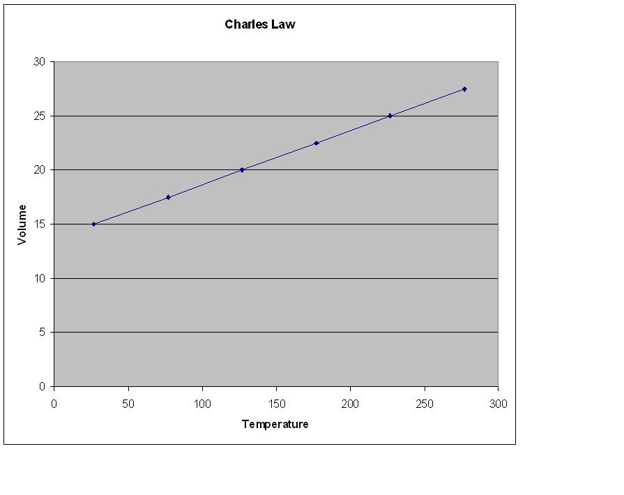
Another use for this graph is to extrapolate it until the volume is =0. A volume of 0, means that the particles have stopped moving. This temperature is called absolute zero and it has a value close to -273 C. The Kelvin temperature scale starts at this value to eliminate the silly idea of a negative temperature.

Amadeo Avogadro

Name: Amadeo Avogadro Birth/Death: 1776 – 1856

Country: Italian

Background: Avogadro was a wealthy professor in Turin, Italy. His work was rejected for nearly half a century so he did not receive due recognition for his work.

Contribution to chemistry: Avogadro proposed that equal volumes of gases (same temperature and pressure) had equal number of molecules. He also produced the insight that gaseous elements can exist as molecules.

Fig. 53 A molecule of hydrogen. Many gases exist as molecules.

Impact of discovery: Avogadro’s proposals above led to many discoveries of the properties of a range of gases. Avogadro did not find the value of Avogadro’s constant.

Avogadro built on the research of Gay-Lussac by proposing that an equal volume of any two gases, at the same temperature and pressure, will have an equal number of particles. Therefore this is an easy way to compare the masses of different gases – just weigh the contents of equal volumes.

Fig. 54 Two containers of equal volume will have an equal number of particles. It follows that the masses of the gases are in the ratio of the masses of the container.

Not content with this, Avogadro then solved a long standing puzzle. Scientists knew that water contained hydrogen and oxygen in the ratio of 2:1. Therefore the expected equation for the formation of water was

2H + O → H₂O
If the volumes used are
100 50 expect 50 of steam, but the volume found was 100.

From the equation, scientists expected that a volume of 100 for hydrogen would react with 50 of oxygen to form 50 of steam. What they found instead was that the volume of steam was 100.
Avagadro had the answer; gases existed as molecules i.e. H₂, O₂, Cl₂
The equation is therefore

2H₂ + O₂ → 2H₂O
100 50 100, this time 100 is expected
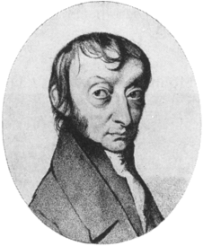
Fig. 55 Some common gas molecules.
Fig. 56 Amadeo Avogadro
This was a touch of genius, a simple subscript of a 2, made so many things simple.

Unfortunately, Avogadro’s work was rejected by other chemists like Berzelius and it was not revisited until around 1860.

By the way, Avogadro did not calculate Avogadro’s number – this was named after him after he had died.

www.chemheritage.org/classroom/chemach/periodic/avagadro.html

Q.1 What is a polyatomic molecule mean?
Q.2 Which gases are monatomic?
Q.3 Do all gases behave the same?
Q.4 Can you name any gaseous elements that have more than two atoms?

Extension

Some formulas for many common gaseous elements are

nitrogen N₂, oxygen O₂, fluorine F₂ , helium He , ozone O₃

The reason for this is that elements try to gain complete outer shells of electrons, eight electrons being a complete shell for many of the larger atoms. Oxygen has 6 outer shell electrons. By sharing two electrons with a neighbouring oxygen atom, both oxygens gain complete outer shells. This explains the distinction between an atom and a molecule.

Fig. 57 Oxygen atoms forming O₂ molecules. This leads to a complete outer shell of electrons.

Helium already has a complete outer shell (all of the Group VIII gases do) so it does not form a polyatomic molecule.

Stanislao Cannizarro

Name: Stanislao Cannizarro Birth/Death: 1826 - 1910

Country: Italian (Sicilian)

Background: Cannizarro’s research was interrupted by the Sicilian revolution. He served as an artillery officer during this war. He fled into exile in France at one point with a death sentence hanging over his head!

Contribution to chemistry: Cannizarro was a talented organic chemistry. The Cannizarro reaction is named after him. His biggest contribution however, was a feat of salesmanship. His support of Avogadro’s research finally led to its acceptance, many years after its proposal.

As an organic chemist, Cannizarro experimented successfully with many aromatic compounds like benzene. His moment of fame came in 1860 with the first ever international conference in chemistry at Karlsruhe, Germany. Cannizarro’s passion and flamboyance was the highlight of the conference and he inspired scientists from all over the world, including Russian Dmitri Mendeleev.

Cannizarro revived the theories of Avogadro that had been ignored for fifty years – that atoms and molecules both exist, that many atoms form diatomic molecules. He showed how consistent atomic mass values could be obtained once this premise was accepted.

Fig. 58 Stanislao Cannizarro http://www.chemheritage.org/classroom/chemach/periodic/cannizzaro.html
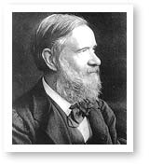

Friedrich Wohler

Name: Friedrich Wohler Birth/Death: 1800 - 1882

Country: German

Background:

Contribution to chemistry: Wohler was the first person to synthetically manufacture an organic chemical. This chemical was urea.

Quote: ‘I must tell you that I can make urea without the use of kidneys, either man or dog’.

Impact of discovery: The breakthrough by Wohler that organic chemicals could actually be made synthetically led to a whole new branch of chemistry – Organic Chemistry.

Organic chemicals are generally referred to as chemicals that contain both carbon and hydrogen. Glucose and citric acid are typical examples. Scheele had been able to isolate some organic chemicals by crystallizing them from strong solutions but he did not make the citric acid in the first place. This was obtained from oranges. No one thought it possible to synthetically make an organic molecule. Therefore interest in organic chemistry was minimal. It was assumed that a ‘vital force’ was necessary to make organic molecules and this vital force was only present in plants and animals.

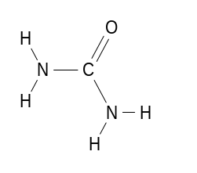
Urea has a structure

It is made in the human body
and eliminated in urine. French scientist H. M. Rouelle isolated urea from urine in 1773. German scientist Friedrich Wohler was attempting to manufacture ammonium cyanate in 1828 when he realised that one of the product had the same properties as urea – in fact it was urea. He wrote excitedly to his friend Berzelius –
‘I must tell you that I can make urea without the use of kidneys, either man or dog. Ammonium cyanate is urea’.

The last part of Wohler’s statement is in fact wrong. Ammnoium cyanate is different from urea but because no one had ever synthesized ammonium cyanate this was not evident.

The reaction Wohler was attempting was the production of ammonium cyanate from silver cyanate and ammonium chloride.

AgOCN(aq) + NH₄Cl(aq) → AgCl(s) + NH₄OCN(aq)
silver cyanate ammonium chloride ammonium cyanate

The product formed instead was urea, NH₂CONH₂. Wohler’s deduction that this was the same urea as isolated by Wohler was very good chemistry. He found the crystals were weakly acidic. They easily precipitated as nitrates and the odour from heating the crystals was similar that evident when urine is heated.

Q.1 How does the empirical formula of ammonium cyanate and urea compare?
Q.2 Can you think of any other organic chemicals that you could isolate i.e. alcohol from fruit

Some of the other notable organic chemists were
- Justus von Liebig (German). Liebig was considered the foremost teacher of organic chemistry in Europe. Many of the noted organic chemists to follow studied under him. The Liebig condenser is named after him.
- Friedrich Kekule (German). Kekule proposed correctly that carbon often formed four bonds and that it was capable of bonding to itself to form chains. The structure of butane can be used to illustrate these properties.
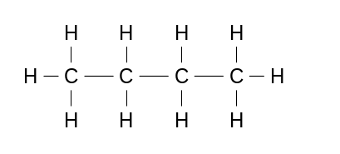
- Kekule also explained the puzzling structure of benzene. Benzene has a structure C₆H₆. This suggests a mixture of single and double bonds but experimental evidence suggests all the bonds were equal. Kekule explained that benzene has a cyclic structure where some of the electrons are delocalized.

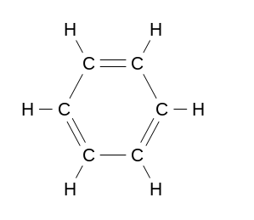
Benzene with its ringed structure and mobile double bonds. The structure is often simplified to the


second or third versions shown.

- William Perkin (English). Perkin was a laboratory assistant working for August von Hofmann. Hofmann wanted to try and synthesise quinine from aniline. This task is probably not feasible but Perkin did not know this so he took on this challenge at home. He mixed aniline with potassium dichromate. The result was a purple mess. Rather than throw this out, he left school, opened a factory and marketed a new dye, a ‘mauve’ dye. The colour was a hit and Perkins was able to retire a wealthy man at a very young age.
- Alfred Nobel (Swedish). Italian chemist Ascanio Sobrero discovered nitroglycerine in 1847. This is a powerful but unstable explosive. It was used for blasting in mines and roads. Alfred Nobel manufactured this nitroglycerine. An explosion killed Nobel’s brother so he researched a way of combining the explosive with an absorbent earth called ‘kieselguhr’. The product was more stable and was given the name dynamite. On seeing the destructive power of dynamite used in war, Nobel became a peace campaigner. The Nobel peace prize is named after him.
- James Hyatt (American). As ivory became scarce in the nineteenth century the wealthy people in the world had a problem – a shortage of billiard balls. A prize was offered for a suitable substitute material and Hyatt produced the first synthetic plastic, celluloid in 1869. This was also used for films and buttons and switches. Belgian American Leo Baekeland followed this up by mixing phenol and formaldehyde to form a completely synthetic plastic. This was called Bakelite.

Dmitri Mendeleev

Name: Dmitri Mendeleev Birth/Death: 1834

Country: Russian

Background: Medeleev was born to a very poor family in remote Siberia at a time when Russian science lagged a long way behind most of Europe. He had over thirteen brothers and sisters but the exact number was not recorded. Education in this part of Russia was very limited but Mendeleev still managed to develop a passion for science.

Contribution to chemistry: Mendeleev brought the Periodic Table to the world. Its arrival also helped the discovery of new elements and the correction of the data on some of the known elements.

Impact of discovery: The Periodic Table is one of the most universal symbols of science, usually covered early in every chemistry course.

Odd spot: Early in his career, Mendeleev was diagnosed with tuberculosis and given a few months to live.

Mendeleev was responsible for the writing of the first Russian chemistry text books. His encyclopedic memory and reputation for orderly analysis made the Periodic Table a logical task for him to work upon. He was however, famous for another reason – his tantrums and temper. He was a difficult man to get along with.

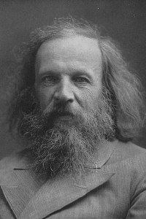
Fig. 59 Dmitri Mendeleev http://scienceworld.wolfram.com/biography/Mendeleev.html
There is not much point trying to make a jigsaw puzzle with only ¼ of the pieces. For the same reason, a Periodic Table was never going to be introduced until sufficient elements were known. As the 1800s progressed, the following factors made the search for patterns between the elements inevitable
- the number of known elements was climbing to over sixty.
- accurate masses were obtained for many of these elements.
- the discovery of reactive metals and non-metals provided a number of obvious groups of elements with very similar properties.
- accurate empirical formulas for a wide range of compounds provided data on the oxidation numbers of elements. Example - If sodium and chlorine reacted in the ratio 1:1, and sodium had a charge of +1, then chlorine must be -1. Chlorine is therefore likely to behave like iodine and bromine, which also have -1 charges.

Mendeleev was not the first to publish a table of the elements. Many scientists had noticed the repetition of properties amongst the elements. Attempts to find an arrangement that provided consistency were not forthcoming.

Fig. 60 Mendeleev’s table http://chemlab.pc.maricopa.edu/periodic/foldedtable.html
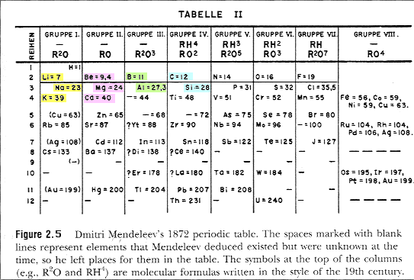
Mendeleev’s Periodic Table resembled earlier tables, in that the elements were arranged in order of increasing mass. The table recognizes that the properties of elements repeat themselves. What Mendeleev did differently, was to leave gaps where no element seemed to match the expected profile. He also suggested that the masses of some elements might be incorrect when they did not seem to fit where their mass suggested.

B boron | Al aluminium | Eka-aluminium
There must be an element like aluminium; Mendeleev called it eka-aluminium

Mendeleev’s table was not an overnight sensation. Many scientists were skeptical of the claims of there being unknown elements. These new elements would have to be discovered before the Periodic Table would be accepted. Eventually they were discovered.

Gallium, for example, was isolated in 1875 by French chemist Paul Lecoq de Boisbaudran. Mendeleev had not only predicted the existence of gallium but he had estimated its melting point, mass, valence and density. The new element found by Lecoq matched Mendeleev’s prediction in all respects except density. Mendeleev predicted 4.7 while Lecoq found 5.9. Mendeleev suggested Lecoq recheck his experiment and sure enough the value was found to be 4.7!

Mendeleev ordered the elements according to their mass. The modern version is ordered by the atomic number, the number of protons, of each element. This ordering eliminates confusion caused by the existence of isotopes.

Q.1 Why did Mendeleev not order the elements according to atomic number?
Q.2 Can you find examples on the Periodic Table where an element is lighter than the preceding element?

Tools

The link between inventions and progress in chemistry continued. Two of the more significant such inventions are listed below. Notice how these both of these inventions rely on previous inventions, electricity and vacuum pumps.

Emission Spectrum
German scientists Robert Bunsen and Gustav Kirchoff demonstrated in 1861 that many substances heated in a flame produced light of a unique colour. When this light was directed through a prism, it produced a unique set of spectral lines. This discovery helped scientists identify new elements. The presence of helium was suspected long before it isolated. Light from the sun contained a spectrum that did not match any known element. The spectra also helped scientists uncover the arrangement of electrons around the nucleus of an atom.
Fig. 61 Emission spectrum
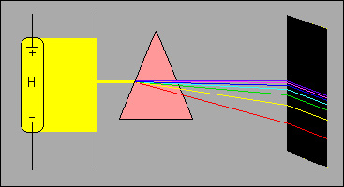
www.iun.edu/~cpanhd/C101webnotes/modern-atomic-theory/emission-spectrum
In this diagram, hydrogen is in a sealed glass tube. An electrode is moulded into each end of the tube. When a high voltage is applied to the tube it glows. The light emitted can be analysed by passing it through a prism or spectrograph. Each element produces a unique spectrum, like its own fingerprint.
The electricity causes electrons to jump to shells further from the nucleus than they would normally occupy. The atom is said to be in an excited state. When the electrons return to their normal position the extra energy is released as light. Each atom has a unique electron arrangement, therefore it has a unique spectrum.

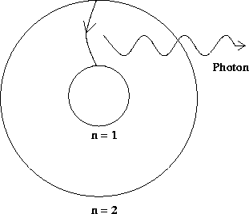

An electron returning from an outer shell releases
energy as light. Each element has an unique set of
electron jumps

Fig. 62

www.pbs.org/wgbh/aso/databank/entries/bpbohr

Vacuum tube

We have seen the impact of various discoveries, glass and electricity being two examples. Another contender for most important discovery might come as a surprise – the vacuum pump. van Guericke used one for his impressive demonstrations in the seventeenth century. Physicists used them to show that sound cannot travel through a vacuum and that all objects fall at the same rate in a vacuum. Michael Faraday and other scientists revisited vacuums when they found in the 1800s that gases sealed in vacuum tubes behaved strangely when electricity is passed through them. They frequently glowed or glowing rays were seen coming from the cathode. These rays were named ‘cathode rays’.

Fig. 63 Impact of the discovery of a vacuum
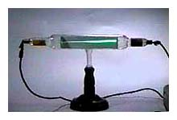
Fig.64 An early cathode ray tube. Note the electrodes at each end. www.aip.org/history/electron/jjhome.htm

The quality of the cathode rays obtained improved with the quality of the vacuum used. English scientist William Crookes (1832 – 1919) is usually recognized with perfecting vacuum tube experimenting. By placing a small paddle wheel in the path of the rays he demonstrated that the rays were particles and not radiation. Particles have momentum and can turn the paddle wheel. Radiation could not. What could these particles be?

Fig. 65 Crookes demonstrated the rays must have momentum

The modern television uses a refinement of the cathode ray tube like those used by Crookes.

Q.1 Why would carbon have a different emission spectra from nitrogen?
Q.2 How could helium have been discovered in light from the sun?

J.J Thomson

Name: Joseph John (J.J.) Thomson Birth/Death: 1856 - 1940

Country: English

Background: Middle class English education. 1906 Nobel Prize for physics and knighted in 1908.

Contribution to chemistry: Thomson discovered and named the electron. This proved that the atom was divisible. His laboratory was at the forefront of atomic research for many decades.

Anecdote: Thomson’s students liked to conduct their research without Thomson knowing it. Apparently he was an extremely clumsy experimenter, prone to ruining a complex experiment!

Impact of discovery: Thomson can lay claim to be the first person to prove that the atom is not the smallest possible particle. Thomson’s role of administering the most successful physics laboratory of the era was also very important.

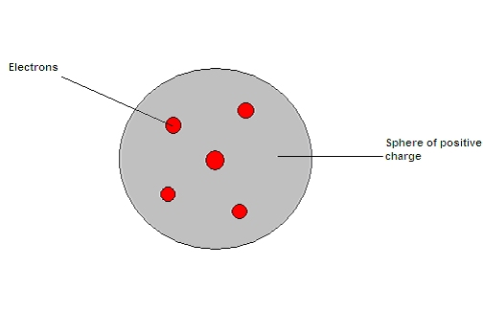
Fig.65 a Plum pudding model of the atom

Odd spot: Thomson became a physicist by default. His family could not raise the money needed to enroll him in engineering, his preferred profession.

Thomson was a graduate of Cambridge University. He stayed on there as a researcher after finishing his degree. Thomson did not discover cathode rays but his biggest contribution to science was the understanding of these new rays.

www.chemheritage.org/EducationalServices/chemach Fig. 66 J.J. Thomson
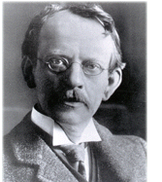
Scientists debated whether cathode rays were a wave like light or whether they were a beam of particles. Thomson’s research involved three stages.
1. Thomson built a variation of the cathode ray tube that allowed him to confirm that the cathode rays had a negative charge. If the rays were bent from the collector, no charge was registered at the collector. Therefore the charge and the rays cannot be separated – the rays had a negative charge.
2. Cathode rays did not seem to bend in an electric field like you would expect charged particles to do so. Thomson built a cathode ray tube that had a better vacuum in it. This tube is shown below. Notice that the cathode rays now had to pass through a pair of charged plates to see if their path was bent in an electric field. Now the cathode rays did bend in the electric field. They bent towards the positively charged plate, conforming they were negative.

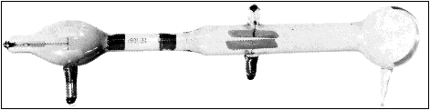

www.aip.org/history/electron/jj1897.htm Fig. 67 Thomson’s apparatus

3. The particles in the ray were too small to weigh but Thomson could tell that they were deflected over a thousand times more easily than the smallest atom, hydrogen. Therefore their mass was probably over one thousand times smaller than hydrogen.

Fig. 68 Explaining Thomson’s experiment

Think of the consequences of this release – Thomson was stating that he had found a negative particle far smaller than the smallest atom! This meant that particles smaller than atoms, subatomic particles, must exist. The word atom was first used by the ancient Greeks to describe a small indivisible particle. Now Thomson was saying that the atom was not indivisible. These new particles were called electrons.

Thomson assumed the atom was probably made from these particles so he put forward the ‘plum pudding’ model of an atom. This was soon proven to be wrong but the existence of sub atomic particles was not.

Q.1 Why were these rays called cathode rays?
Q.2 Explain how Thomson knew electrons must have a very small mass.
Q.3 Scientists later identified a second beam of particles in the vacuum tubes. They wer called canal rays. What do you think canal rays were?

William Ramsay and Lord Rayleigh

Name: William Ramsay Birth/Death: 1852 - 1916

Country: Scottish

Name: Lord Rayleigh Birth/Death:

Country: Scottish

These scientists are presented together because they collaborated so closely on the discovery of the inert or noble gases.

Quote: August 4th Ramsay wrote to Rayleigh ‘I have isolated the gas; Its density is 19.4, and it is not absorbed by magnesium ..’

Impact of discovery: Ramsay and Raleigh single handedly added a whole new column of elements to the Periodic Table.

Cavendish had noticed back in the 18th century that when he removed oxygen and nitrogen from air there still seemed to be some gas remaining. So meticulous was his experimenting that his estimate of 1/120th as the fraction was almost correct. He was not able to illicit any chemical response from this gas remnant, so he never found an answer to the identity of the gas. About 100 years later Lord Rayleigh found a puzzling discrepancy in the density of nitrogen produced from a chemical reaction and nitrogen isolated from air.

Fig. 69
using hot copper 2.3103g
using hot iron 2.3100g
using iron hydrate 2.3102g
from nitric oxide 2.3001g
from nitrous oxide 2.2990g
from urea 2.2985g

mass of 1 litre of nitrogen obtained from air mass of 1 litre of nitrogen obtained by reaction

note the difference in mass of about 11 milligrams between nitrogen obtained from air vs nitrogen obtained by chemical reaction. This is not a significant mass in some ways but it was enough to unsettle both Ramsay and Rayleigh.
It is interesting how one person’s valid guess can lead in a different direction to another person’s valid guess. Rayleigh assumed there was probably a lighter impurity in the chemically produced sample. Ramsay felt there was probably a heavier impurity in the sample of air. Initially they were working independently but, given the complexity of the task, they elected to collaborate.
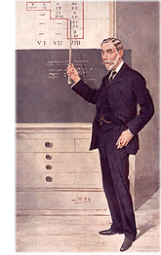
Fig. 70 To isolate the argon was a very difficult task. The oxygen, carbon dioxide and nitrogen that make up 119/120ths of the sample must be removed.

Isolating the argon was always going to be difficult. How do you find a reagent reactive enough to remove nitrogen but not produce troublesome nitrogen oxides or react with the argon.
Fig. 71 William Ramsay http://www.chemheritage.org/classroom/chemach/periodic/ramsay.html
Ramsay passed the air sample over hot magnesium to remove the nitrogen as magnesium nitride is a solid. Rayleigh pursued a different path of running electricity thorough the sample to deliberately react nitrogen and oxygen. The oxides were then removed. Using either method, some gas still remained after many passes. This gas might have been an isotope of nitrogen or another known gas. William Crookes was called in to examine the emission spectrum of the gas and it was found to not match any known gas. Ramsay called the gas argon, Greek for the ‘lazy one’, as it does not react easily.

Fig. 72. Apparatus used to isolate argon. www.chem.ucl.ac.uk/history/chemhistucl/hist14.html

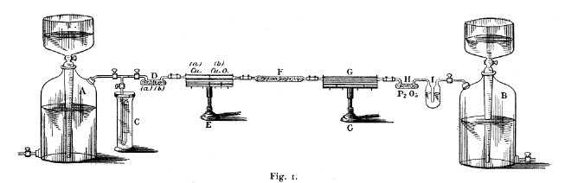
Helium had been suspected in 1865 in light arriving from the sun. Helios is the Greek word for sun. The isolation of helium was far more straight-forward. The British Museum reported to Ramsay that the mineral cleveite gave off a strange gas. Ramsay trapped this gas, examined its spectrum and matched it to the spectrum coming from the sun; end of story.
http://astro.u-strasbg.fr/~koppen/discharge/

Fig. 73
helium emission spectrum

The discovery of helium and argon raised a new issue. There was no room on the Periodic Table unless.. unless there was a whole column missing of similar elements. And there was.

Ramsay was able to isolate neon, krypton and xenon from air. They had also been present in air but in even smaller proportions. By freezing air to a liquid form, each of these gases can be distilled from it. The ability to freeze gases to temperatures below -150 ⁰C was a recent discovery. Neon has a characteristic crimson glow, when electricity is passed through it, hence its use in neon signs. These gases are referred to as the inert gases or noble gases due to their low reactivity.

Q.1 Ramsay removed oxygen, carbon dioxide and nitrogen from a sample of air.
Q.2 Can you suggest a reaction that would remove oxygen simply?
Q.3 Carbon dioxide can be reacted with sodium hydroxide solution.
Write a balanced equation for this reaction.
Q.4 Write a balanced chemical equation for the reaction of magnesium with nitrogen.
Hint: The formula of magnesium nitride is Mg₃N₂.

Extension

The electron configurations of helium and neon.
He 1s²
Ne 1s²2s²2p⁶
They both have complete outer shells and do not react easily with any other lements.

Wilhelm Roentgen

Name: Wilhelm Roentgen Birth/Death: 1845-1910

Country: German

Background: German physicist

Contribution to chemistry: Roentgen discovered X-rays

Quote: ‘I have discovered something interesting, but I do not know whether my observations are correct or not’.

Impact of discovery: X-rays provided scientists with a brand new toy. They have medical uses as well as scientific ones.

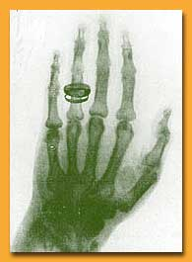
Fig. 74 Wilhelm Roentgen Fig. 75 X-ray of his wife’s hand
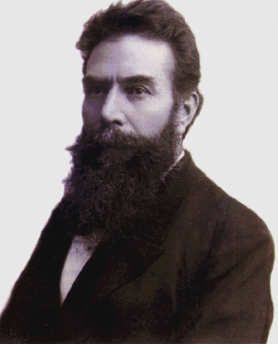

www.resonancepub.com/wroentgen.htm

Roentgen was using a cathode tube in 1895 when he noticed that a screen on the other side of the room was fluorescing. Some rays from the cathode tube must have been crossing the room to cause this. No particles were visible to Roentgen so he called the new rays, X-radiation, later shortened to X-rays.

Roentgen was kind enough to involve his wife, Bertha in his research – he X-rayed her!
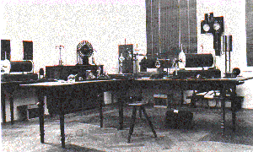

Fig. 76 Sketch of Roentgen’s apparatus www.xray.hmc.psu.edu/rci/ss1/ss1_2.html

French physicist Henri Becquerel (1852 – 1908) followed Roentgen’s announcement just a few months later with the news that uranium compounds could also give off radiation. Inspired by Roentgen, Becquerel tested other phosphorescent materials for radioactivity by leaving them near photographic plates wrapped in thick, black paper. The phosphorescent materials did work but Becquerel also accidentally found some of the plates exposed when they were sitting in the dark near uranium ore.
High energy was involved in Roentgen’s experiments but here was an ore sitting on a desk giving off radiation.

Fig. 77. Photographic plates exposed by uranium
Becquerel did not put this new discovery to any use and the science community just assumed that the radiation was the same as the X-rays. The radiation was, however, quite different and later scientists put it to many uses.

Maria Sklodowska (Marie Curie)

Name: Maria Sklodowska Birth/Death: 1867 – 1934

Country: Polish

Background: Curie’s family in Poland were very poor. Most Polish families were as the Russian rule of Poland was very oppressive. Her education included illegal night school. Her marriage to the respected researcher, Pierre Curie enabled her to escape from this background.

Contribution to chemistry: Curie isolated two new radioactive elements, radium and pollonium

Quote: ‘I easily learned mathematics and physics, as far as these sciences were taken in consideration in the school. I found in this ready help from my father, who loved science… Unhappily he had no laboratory and could not perform experiments.

Impact of discovery: Curie showed radiation was not limited to uranium. Her persistence in isolating such scarce elements has been much admired.

Odd spot: Marie’s husband, Pierre worked with her. In 1906 he stumbled on the road and was run over and killed by a horse drawn carriage. There was a road toll before cars! It is thought the effects of radiation might have impaired his balance.
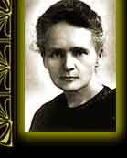
Fig. 78 Marie Curie http://www.aip.org/history/curie/
At last, a female scientist! But don’t be fooled into thinking things had changed – much of her research had to be conducted in a small shed at the rear of the university.
The Curies first advance was to develop a device to measure radiation levels. This device measured the electric current that radiation produced in gas. The greater the radiation, the higher the current. Curie tested all possible elements to see if it was only uranium that was radioactive. Thorium also proved to be radioactive. observed in 1898 that the radiation emitted from a pitchblende ore seemed different from the radiation emitted from a uranium ore.. She and her husband tried to isolate the source of the radiation in pitchblende. The proportions of the elements present were extremely low, so it took the Curie’s several years to isolate samples of sufficient size to study.. Curie called the two elements that she isolated polonium and radium.

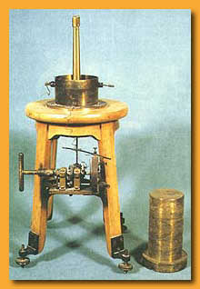

Fig. 79a Curie’s device for measuring radiation

www.aip.org/history/curie/resbr1.htm

b. Radiation from pitchblende is not the same as from uranium

We now know that radioactive elements are ones that have an unstable nucleus. The nucleus gives off small particles.

Curie observed in 1898 that the radiation emitted from a pitchblende ore seemed different from the radiation emitted from a uranium ore. The rate of particle emission was higher. She and her husband tried to isolate the source of the radiation in pitchblende. The proportions of the elements present were extremely low, so it took the Curie’s about four years of painstaking experimenting to isolate samples of sufficient size to study. Curie actually found two elements in the pitchblende. She named these new elements polonium and radium.
Marie Curie died of radiation sickness in 1934.

Q.1 Marie Curie measured radioactivity by the conductivity it caused in a gas.
Q.2 How do you think this works?
Q.3 What instrument do modern scientists use for measuring radiation levels?
Q.4 Who was this instrument named after?

Completion of the Periodic Table ( Perhaps!)

Given the contributions of Scheele, Davy, Mendeleev and Ramsay amongst others, and the advent of particle accelerators, it is an appropriate point to stop and look at the completion of the Periodic Table. By completion I refer to the isolation of the first 92 elements up to uranium. All of these elements have now been found or artificially prepared. Research continues into the synthetic production of elements heavier than uranium.

The Periodic Table has been like a giant jigsaw, where the pieces are hidden. Some of the pieces have been found easily, others have been very well hidden. All in all, it is a fascinating story in itself.

Fig. 80 Early elements

Which elements were known to the ancients? The easy to find ones of course! Very abundant ones and very non-reactive ones. Carbon, or charcoal, is produced whenever wood is burnt. Sulfur is found around volcanoes and gold is found as nuggets. More reactive elements will do just that, react and form a compound and therefore be harder to find. The next elements to be found were some of the abundant, low reactivity metals. As mentioned in the alchemy section, the Egyptians and Middle Eastern scientists were able to extract copper, tin, lead and zinc from their ores. Zinc sulfide, ZnS and lead sulfide, PbS are common ores that the metal can be fairly easily extracted from.

Fig. 81 Year of discovery

By 1790 there were twenty seven known elements. Although scientists had samples of these substances, they did not necessarily know they were elements. Confused? If you see a yellow powder it could be sufur or it could be a compound like lead nitrate. You would have to test it to see. There were no easy tests in 1800 for this. It was only with the publications of Dalton and Berzelius that anyone was even aware of the definition of an element. As late as 1900, many chemists still did not accept atomic theory.

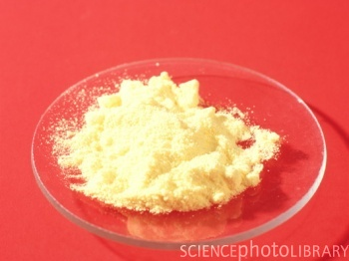
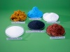
www.sciencephoto.com
Fig. a. 82 Element or compound? – photo of powders.
b. Elements known 1800
It did not help that many elements can exist in alternate forms or allotropes. Carbon is a perfect example. It can exist as charcoal, graphite or diamond, each of which has quite different properties. Diamond is the hardest natural substance while graphite is one of the softest. Each form of carbon has many important uses
- Diamond. Extremely hard material used for jewellery and the cutting edges of drills. It is made deep in the Earth’s crust where extreme heat and pressure act on carbon. A synthetic diamond industry now exits.
- Graphite. Soft, layered structure. Used as a lubricant and in pencils. It is one of the few non metals that conducts, hence its use in electrodes. In 1564 an usually pure deposit of graphite was found in England. Pieces of it could be sawn off and wrapped in string to make the first pencils ever. Pencils were a technology breakthrough in warfare! The ability to write fast, legible messages in battle gave the English a real edge.
- Charcoal. Used as reinforcement in rubber, pigment in paint and dye. If it is heated with steam it becomes very porous, activated charcoal. This absorbs odors and impurities.

In recent years, scientists have produced more versions of carbon. The carbon nanotube has a cylinder shape and it is a very small diameter fibre. It offers great strength to plastics. Scientists have also isolated large spherical structures of carbon known as buckyballs (buckminsterfullerenes ). Buckyballs are produced in high technology equipment being used at high temperatures. These molecules have carbon atoms arranged in pentagons and hexagons to form a shape like a soccer ball. Their discovery is too recent for these molecules to be in practical use but scientists are very excited about their possibilities in medical fields and as industrial catalysts.

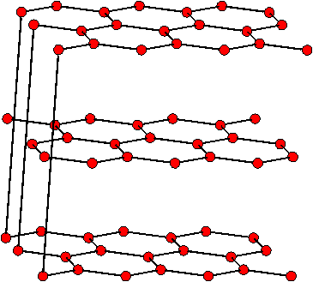

Fig. 82 a. graphite nanotube www.cnanotech.com/pages/resources_and_news

New elements came with a rush in the 1800s. Electrolysis produced most of the Group I and VII elements, while Ramsay isolated the Group VIII elements. This is why Mendeleev was able to publish a Periodic Table – the number of known elements was higher. Still however, some elements presented their own challenges.

Scheele produced fluoric acid, HF in 1771 but he was not able to isolate the fluorine. Fluorine is the most reactive non metal. It is extremely dangerous to handle. Even fluoric acid is dangerous - it attacks glass vigorously and causes extraordinary burns. By 1824 Berzelius had prepared a range of fluoride compounds, potassium fluoride, magnesium fluoride etc but no pure fluorine. It was not until 1886 that French chemist Henri Moissan succeeded in isolating fluorine through the electrolysis of a water free liquid mixture of hydrogen fluoride and potassium bifluoride.

Fig. 83 Discovery of further elements

Some other elements were difficult because their abundance in the Earth’s crust is so low. Many of the heavy metals are like this. Scientists had to process mammoth volumes of ore for minute samples of the metals. The polonium and radium isolated by Marie Curie were examples of this.

Artificial elements

By 1935, four gaps only remained in the Periodic Table. All other elements up to uranium had been found. Scientists decided to try making these elements themselves.

Element 43: Produced in a cyclotron in 1937 at the University of California. Technetium.

Element 61: Identified in 1945 as a byproduct of uranium fission. Promethium.

Element 85: Produced in 1940 from the bombardment of bismuth with alpha particles.

Elements 87: Francium identified in 1939 at the Curie Institute in Paris. It is a decay product of actinium.

Transuranium elements

With very few gaps in the Periodic Table, why not try and make heavier elements than the known ones? Scientists chose uranium as an obvious target and bombarded it with a variety of particles. Neptunium, element 93, was the first to be produced in 1940 at Berkeley by Edwin McMillan and Philip Abelson. The research team bombarded uranium with neutrons. Neptunium, like most of these large atoms, has many different isotopes.
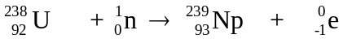

Glenn Seaborg took over at the University of California and his team was able to produce plutonium, element 94 by bombarding uranium with protons. A large quantity of plutonium was manufactured for the atomic bomb that was dropped on Nagasaki in 1945. Seaborg’s team then produced elements 95, americium, 96 curium, 97 berkelium and 98 californium. Most of these names are self-explanatory. Often the next element was obtained by bombarding the previous element discovered.

Research is continuing into these heavy elements. In many instances the quantity formed is minute and it lasts for a very small period of time.

Q.1 Which elements were easy to find?
Q.2 What reasons were there for some elements being difficult to isolate?
Q.3 What are artificial elements?
Q.4 Are there likely to be more unknown elements?
Q.5 Research the latest elements to be discovered.

Naming the elements

K Potassium

Na Sodium

Students can be forgiven at times for finding the language of chemistry difficult. Surely giving potassium the symbol P would make more sense. P of course is assigned to phosphorous. In the case of

Tin and
Titanium,

even the use of Ti would not help. The naming of elements was never going to be simple or consistent. They were found over a 5000 year span and they were found in a variety of countries. It is probably easier to explain the problems through the use of some examples.

Gold
As gold is found in nature, and it is easy to work, its use originated in many different countries. Each country had its own name for the metal, most names referring to its yellow colour or to its source.
Egyptian – nub – as the gold was found in Nubia
Babylonian – hurasu – region of Mesopotamia
Indian – ayas - ?
Etruscan - aurum – yellow
Germanic - gold - yellow
Slavic - zoloto – colour of the sun
With so many different names, it is no wonder chemistry nomenclature was an issue. As Berzelius relied heavily on Latin or Greek names, the symbol Au was chosen from the Italian name aurum. The English language however, persisted with the German name gold.

Potassium
Potassium is known in many countries as Kalium. We have a universal symbol for it but not a universal name. Many elements have different names in other countries.

Potash, K₂CO₃ is obtained from the ashes of plant material. As the ashes were often found in pots, the name potash was formed. The Arabs did not distinguish between potash and soda ash, Na₂CO₃. They were both called ‘alkali’ and they were the original source of base. In Europe they were called natron. German scientist Martin Klaproth distinguished the two carbonates in 1797, calling potash ‘kali’ (from alkali) and soda ‘natron’. Now the symbols K and Na are more understandable.

All of this happened before either element was isolated. Davy did form both in 1807 and he gave them the names potassium and sodium. German scientist Ludwig Gilbert chose instead the names kalium and natronium.

The ending -ium was part of the systematic naming that continued the practice of shunning of women in science. The original name for platinum was platina. Platinum was found in lumps of grey clay on a beach in Columbia, South America. A sample sent back to France was captured by the British. The British navy eventually decided this grey metal was useless and they returned it. French scientists worked out how to mould the metal and they found that it was more tarnish resistant than gold. In Latin, feminine items end in - a and masculine ones end in -ium. Humphry Davy changed its name to platinum to be consistent with barium, calcium and all other things male in science. Even the element named after Marie Curie was given the masculine ending, curium!

The above examples illustrate that
- the naming of elements has been a complex process.
- many elements are named from their colour or source
- different countries may have different names
- symbols of many elements were derived from the Roman or Greek names.

Other examples
Fluorine is found in highly coloured ores. These ores were called fluorspars, which means ‘false emeralds’. Scientists knew these ores contained a new element but it took over 100 years of research, between 1770 and 1870, before anyone succeeded in isolating fluorine. It is the most reactive non metal and many scientists were seriously injured or killed using heat trying to extract it.

Francium. Synthetically produced by French scientists, hence the name. Francium is unstable and decays rapidly. It is estimated that about 10 g of francium exists in the world at any one point in time. As more is produced, other atoms decay.

An unusual dense, black mineral was found near Ytterby, a small village in Sweden. This mineral yielded all of the following elements - Yttrium, Erbium, Terbium, Ytterbium and Holmium. It is fascinating that one mineral might supply so many elements. The element names of the first four of these contains some part of Ytterby.

Our naming system is still evolving. Twenty years ago, iron compounds were called ferrous or ferric compounds, depending upon whether they were Fe²⁺ or Fe³⁺ ions i.e.
ferrous sulfate FeSO₄
ferric sulfate Fe₂(SO₄) ₃
Now these two compounds are distinguished as iron (II) sulfate and iron (III) sulfate. Similarly, tin compounds were referred to as stannous or stannic.

Q.1 Where do you think the following elements were first found or made?
Germanium, Californium, Berkelium, Polonium, Gallium and Scandium
Q.2 Name four elements named after famous scientists.
Q.3 How many elements are named after planets?
Q.4 Which other element has a name linked to our solar system.
Q.5 What will the formulas of stannous chloride and stannic chloride be?

Fig. 84 Lavoisier’s list of elements

Ernest Rutherford

Name: Ernest Rutherford Birth/Death: 1871 - 1937

Country: New Zealand

Background: Potato farm background. New Zealand did not really have post graduate science happening at all in this era. Winning a scholarship to study in Britain was the launching pad for his career.

Contribution to chemistry: An extraordinary sequence of research from discovering the nucleus of the atom to identifying types of radiation to producing the first nuclear reaction.

Quote: All science is either physics or stamp collecting.

Odd Spot: Rutherford won the 1908 Nobel Prize for chemistry. He was quite put out by this as he saw himself as a physicist!

Impact of discovery: Rutherford’s picture of the atomic with a small positive nucleus is still valid today. His work bombarding targets with radiation was the fore runner of particle accelerators. Rutherford was the first successful alchemist! He was able to change nitrogen to oxygen.

Rutherford's story is a compelling one. New Zealand had only 14 post graduate students in 1893, Rutherford being one of them. He could not find a job in New Zealand, even as a teacher. He applied for a scholarship to study in England but came second. As luck would have it, the winner did not accept the prize and Rutherford was on his way to England. He soon became a student of Thomson.

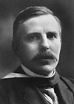
Fig. 85 Ernest Rutherford
The discovery of radiation provided Rutherford with a new tool to use in the investigation of the atom. In 1898 he reported that all radiation was not equal, it contained at least alpha and beta particles. These particles had quite different properties.

Fig. 86 Picture of alpha and beta particles being emitted. Decay of nucleus

www.nobel.se/chemistry/laureates/1908/rutherford-bio.html

Rutherford’s most famous experiment was his bombardment of gold foil. See Fig. In this experiment he directed alpha particles at a thin film of gold. Alpha particles have a positive charge. The first surprise was that most particles passed through the foil. They were deflected slightly. The second surprise was that an occasional particle rebounded almost straight back towards the source.

Rutherford’s conclusions from this experiment are stunning;
- the atom is mostly space. Therefore most of the alpha particles passed through the gold foil.
- the atom has a nucleus. The nucleus is small and positively charged. The positive particles he called protons.
- electrons surround the nucleus.
Firstly, Thomson has shown the atom to be divisible, now Rutherford demonstrates that the atom is mainly space!

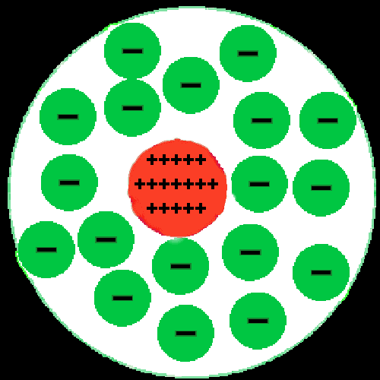

Fig. 87 The new, radical view of the atom.

Rutherford did not know how the electrons were arranged but Bohr consulted with him as he solved this question.

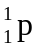In 1919, Rutherford's team continued its successful experimentation by performing the first artificial transmutation of any element. They bombarded nitrogen atoms with alpha particles resulting in the formation of oxygen atoms. A stream of protons ( symbol) was also generated. This reaction is shown as

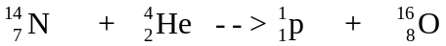
The alchemist's dream of converting one element to another was finally realized, although gold was not the end product!

Niels Bohr

Name: Niels Bohr Birth/Death: 1885 - 1962

Country: Danish

Background: Bohr was born, worked and died in Copenhagen. He did travel to England to work under Thomson for a short period.

Contribution to chemistry: Bohr is best known for his proposal that electrons are in shells around the nucleus. He also helped Rutherford and others with their research into the nucleus of the atom.

Quote: Never express yourself more clearly than you can think.

Odd spot: When Germany occupied Denmark, Bohr and his family were smuggled to Sweden in a fishing boat. He then traveled to the US in a military plane and assisted with the Manhattan Project. He angered the British government by recommending that they share atomic secrets with the Soviets.

Impact of discovery: Nobel Prize winner 1922. The explanation of electron configuration has been modified but it was a huge step forward.

After Rutherford determined that the atom had a nucleus, Bohr proposed that the electrons existed in shells around the nucleus. This explained why the electrons did not crash into the nucleus. The inner shells fill first but they do not hold as many electrons as the outer shells.

Fig, 88 Bohr’s atom

Bohr’s model also helped explain emission spectrums. Energy can cause electrons to jump to shells further from the nucleus. When the electrons return, light is emitted. The light is characteristic of the element – it is the unique emission spectrum of the element.

Bohr’s model was modified by American Erwin Schrodinger over the next years.

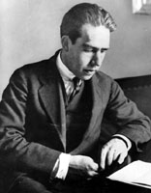
Bohr and his son fled Europe during World War II and worked on the Manhattan Project. He was not comfortable with the consequences of this research.
Fig. 89 Niels Bohr
Extension
The electron configuration of
- N 2 5 2 electrons in inner shell, 5 in next
- Cl 2 8 7 2 inner shell, 8 next and 7 in third
www.pbs.org/wgbh/aso/databank/entries/bpbohr

More tools

Two further new tools were to have such a significant impact on research that they are summarized here.

Mass spectrometer

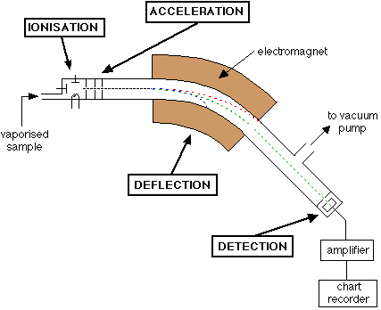
www.chemguide.co.uk/analysis/masspec/howitworks.html Fig. 90 Mass spectrometer

The mass spectrometer is a device that provides scientists with very accurate masses of elements and compounds. It was invented around 1919 by Francis Aston, one of Thomson’s students. It works by charging each element and firing it into a magnetic field. The heavier the element, the greater the field required to bend the path of the element. For the same reason, it is more difficult to deflect a solid rugby player from their path than it is to deflect a small child from their path! The deflection also depends upon the charge. Carbon was chosen as a standard and given a value of 12. The mass of the other elements was ascertained relative to carbon, hence the name relative atomic mass.

Carbon has a relative atomic mass of 12, magnesium 24.3. This means that a magnesium atom weighs just over twice as much as carbon atom. Most uranium has a relative atomic mass of 238. It is obviously a very heavy atom, weighing about twenty times carbon. This instrument also helps to identify the structure of unknown molecules.

Q. 1 What information can be obtained from a mass spectrometer?
Q.2 Carbon dioxide, CO₂ and propane, C₃H₈ both have a mass of 44. A mass spectrometer can distinguish these two molecules. How do you think it does this?
Q.3 Why are the masses obtained called ‘relative’ atomic masses?
Q.4 Why was carbon given a value of 12?

Particle accelerators

Scientists of the twentieth century have used a range of particle accelerators to produce high speed particles. These particles can then be collided with each other or with other targets. The collisions may lead to new atoms forming or smaller particles being emitted. Rutherford’s early work relied on particles being released from radioactive elements. The energy levels on these were too low however to penetrate the nucleus itself. Rutherford wanted particles with a much greater energy.

The first particle accelerator was constructed by Ernest Lawrence at the University of California in 1931. Lawrence called his five inch diameter machine a ‘proton merry-go-round’ because it accelerated positive hydrogen ions to an energy level of 80000 electron volts. The hydrogen ions were accelerated in a circular path and then directed at a target atom. The success of the first machine caused the quest for ever increasing diameter machines. The increasing diameter promises higher energy levels. The CERN (Council for European Nuclear Research ) research facility on the French/Swiss border features a 27 km long tunnel that is set 100 metres below the ground

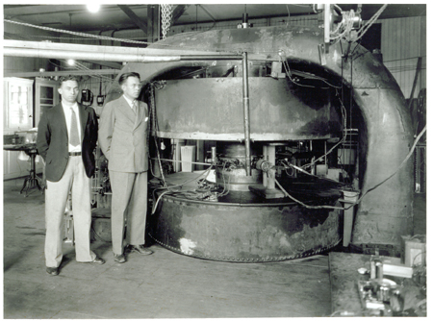
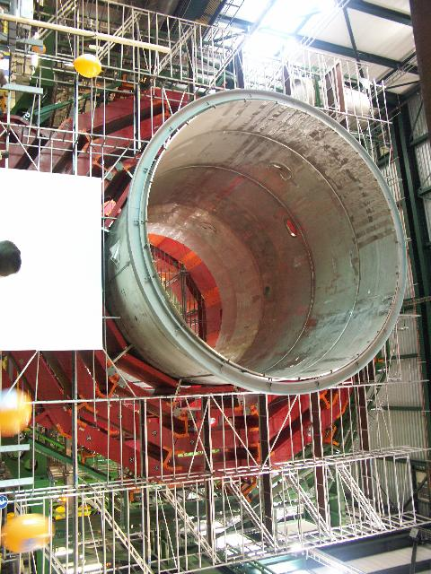

Fig. 91 Early cyclotron

Fig. 92. Construction in the CERN cyclotron

www.physics.rutgers.edu/cyclotron/cyc_hist_album.shtml
www.met.ed.ac.uk/~bc/cern.html

By 1936, cycltrons could be used to accelerate protons, deuterons and alpha particles. Lawrence’s team was able to produce the element technetium. This does not exist naturally on Earth.

Q.1 Why was it popular to use neutrons as the particles accelerated?
Q.2 Why do synchrotrons get increasingly bigger?

Females in Chemistry

Britain set up a Royal Society in the seventeenth century. This was an organization to provide a forum for scientists to share research. To this end the Royal Society was extremely successful. It also helped generate interest in science amongst the general population. Even more useful was the way in which scientists from different countries frequently shared research. The charter of the Royal Society however, had one huge negative impact – it was male only! Scientists like Isaac Newton, one of the early Presidents of the Royal Society, were not able to communicate with women at all. Newton would not allow female lab assistants or cleaners into his building. Science historian Londa Schiebinger observed ‘For nearly 300 years the only female presence in the Royal Society was a skeleton preserved in the Society’s anatomical section.

As reported earlier in this book, Marie Curie, as late as 1900, had to work in a shed at the back of the university. Lisa Meitner only found her opportunity because so many male German scientists died, or were involved in, the World Wars. So, despite all this, who were the ground breaking females?

Marie-Anne Paulze Fig. 93
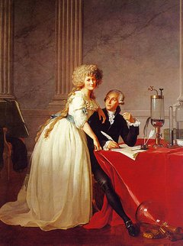

When Antoine Lavoisier married Marie-Anne Paulze he was 29 years old and she was 13. Pretty young! There has been much conjecture about the role that Marie-Anne played in the relationship. Was she a doting wife, doing the housework while her husband busied himself with science or was she actually sharing and contributing with the research? No-one is sure of the answer to this question but what is known is that Marie-Anne translated English documents for her husband and she helped with the recording of Antoine’s discoveries.

Marie-Anne was to remain in science after Antoine was executed. She married Count Rumford (Lord Kelvin).

http://homepage.mac.com/dtrapp/periodic.f/lavoisier.html

Ellen Swallow Richards 1842 – 1911

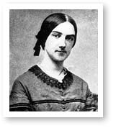
www.chemheritage.org/classroom/chemach/environment/richards.html
Fig. 94 Ellen Swallow Richards
While women were never going to be accepted as scientists in Europe, the emerging United States did offer a little more opportunity. Ellen Swallow Richards was always a determined and talented student. She paid her way through College but was not accepted as a researcher. She then became the first female to ever be accepted at the prestigious Massachusetts Institute of Technology (MIT). After her degree, Richards stayed researching iron and other minerals at the Institute. She contributed money to support the acceptance of other women to MIT. Although a lecturer, she was not entitled to pay.

Richards’ department took on the first major sanitary engineering project of the United States. They sampled and tested the water in the lakes and rivers of Massachusetts. As a result of their research, water standards and sewage treatment plants were introduced. There are probably advantages to being one of the first female scientist – you can bring a female perspective to where to apply science. Richards set up model kitchens and published books on the chemistry of cleaning and clothing.

Marie Curie 1867 – 1934

As reported earlier in the text, Marie Curie isolated the elements polonium and radium, two radioactive elements. Keep in mind that Curie had to work out the back of the university due to her gender.

Ellen Gleditsch 1879 - 1968

Gleditsch was an outstanding student in her native Norway. However, she was not allowed to enter university for the familiar reason that she was female. As a pharmacist she learnt as much chemistry as a normal university student. Her enthusiasm enabled her to join Marie Curie’s team as a researcher where she established the ratio of radium to uranium in radioactive ores.

Gleditsch studied in the US for a period and then returned to Norway where she was eventually appointed as Professor of Chemistry. Her discoveries included the measurement of the half life of radium and the isolation of radioactive lead. The existence of radioactive lead was proof of the existence of isotopes.

Irene Joliot-Curie 1897 – 1956

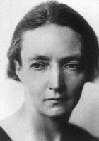
Fig. 95 Irene Joliot-Curie
As the name suggests, Irene was the daughter of Marie and Pierre Curie. Inevitably, she also was drawn towards radiation. She served during the first world war as a radiographer, then became a Doctor of Science in 1925. She worked as a lab assistant for her famous mother and later married another lab assistant, Frederic Joliot. Irene and Frederic did not rest on the laurels of their famous parents. Their research on radioactivity and their generation of radioactive elements saw them perform the experiment that led James Chadwick to identify the neutron. They were awarded the 1935 Nobel Prize for Chemistry when they documented processes for converting stable elements to radioactive elements. She moved into atomic physics after World War II and helped the construction of the first French nuclear pile.
http://nobelprize.org/chemistry/laureates/1935/joliot-curie-bio.html

Rosalind Franklin 1920 – 1958

Rosalind Franklin was a British physical chemist. She was involved in a number of famous research teams, in particular the team that unravelled the structure of DNA. In her early years at Cambridge the percentage of female students was kept under 10% of the total student body and women were not entitled to a degree. As late as 1950 she was not allowed to dine with her male colleagues. Her early work centred on the derivation of products like carbon fibres from coal. While working in France she learnt the principles of X-ray diffraction. She was able to combine her experience with chains of carbon and X-ray diffraction to perform X-ray diffraction on DNA molecules. Her ‘photographs’ of the molecule were crucial to the understanding of its structure. Franklin might have solved the DNA puzzle herself if male scientists had shared their information with her.
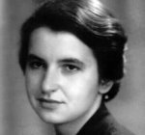
Fig. 96 Rosalind Franklin
http://en.wikipedia.org/wiki/Rosalind_Franklin

Franklin died of ovarian cancer in 1958, probably as a result of over exposure to X-rays.

Lisa Meitner

Lisa Meitner’s contributions to the understanding of the atomic fission are reported on later in this text. Meitner’s work was interrupted by World War II.

Stephanie Kwolek 1923 –

www.chemheritage.org/classroom/chemach/plastics/kwolek.html

Kwolek was born in Pennsylvania in the United States in 1923. She obtained a position as a chemist with the plastics company Du Pont. Her task was to investigate the processing of a new type of polymer, polyamides. Kwolek found that the molecules in these polymers had a unique ability to orient themselves in parallel chains. The fibres formed had unusual strength. They are still used for just this reason – sails for racing yachts, bullet proof clothing and light weight sporting equipment. Kwolek is also the first scientist to publish the procedure for drawing nylon rope from a solution. This experiment is performed in just about every chemistry class in Australia.
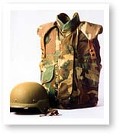

Fig. 97
Kevlar helmet and vest.

Frederick Soddy

Name: Frederick Soddy Birth/Death: 1877 – 1956

Country: English

Contribution to chemistry: Explanation of isotopes.

Impact of discovery: This was an important step in completing the picture of the nucleus of the atom.

Soddy worked with both William Ramsay and Ernest Rutherford. With Rutherford, he was able to show that when an atom gives off the radiation that Bequerel discovered, it becomes an atom of a different element.

Fig. 98. An element emitting an alpha particle or a beta particle is changed to a new element.

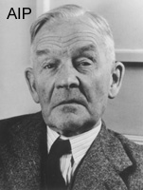
Rutherford and Soddy also explained that radioactive elements have a half life. This means that they lose half of their radioactivity during this period.
Fig. 99 Frederick Soddy
Fig. 100 Half life
http://pubs.acs.org/cen/80th/protactinium.html
Soddy is best known for his suggestion in 1913 that elements can have isotopes. The recently developed mass spectrometer was putting forward some puzzles. Some chlorine atoms for example, seemed to weigh 35 while others weighed 37. The chemical properties of the two chlorine atoms seemed identical so there was no suggestion that the two types of chlorine were actually different elements. Soddy said the two chlorine atoms were isotopes; they were both chlorine but had different masses. There are many atoms with isotopes and as particle accelerators became more common many artificial isotopes were formed.

Fig. 101. Chlorine isotopes

³⁵Cl mass 34.969 ³⁷Cl mass 36.966

The reason for isotopes was still not clear until the work of 1930s.

Q.1 Plutonium is dangerous to store because of its long half life. What does this mean?
Q.2 Can any elements have more than two isotopes?
Q.3 Isotopes can be useful. Research some examples.

Extension
Since the neutron was not known when Rutherford identified alpha particles, he did not know they were helium nuclei.

α alpha particles helium nucleus 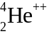
β beta particles electrons 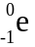
γ gamma particles electromagnetic waves

Rutherford’s bombardment of nitrogen can now be shown as
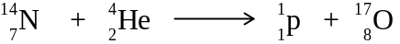

This was the first transmutation. The oxygen produced had a different mass to normal oxygen.

James Chadwick

Name: James Chadwick Birth/Death: 1891 - 1974

Country: English

Contribution to chemistry: Proof of the existence of the neutron.

Anecdote: Chadwick was a prisoner of war for four years during World War I.

Impact of discovery: The identification of the neutron completed the picture of the structure of the atom.

After Soddy formulated the notion of isotopes, Rutherford and other researchers suspected a neutral particle was present in the nucleus. Its lack of charge however, made it very elusive to researchers.

Fig. 102. The masses of hydrogen and helium suggested the presence of another particle.

The existence of this neutral particle, the neutron, was confirmed by Chadwick in 1932. The experiment that led to this discovery was the bombardment of beryllium by alpha particles. Radiation without a charge was produced. The experiment was conducted by Marie Curie’s daughter, Irene and her husband Frederic.
Chadwick explained that the neutral radiation was neutrons.

Fig. 103 Finally scientists had a complete picture of the structure of the atom. Carbon can be used as an example.

Fig. 104 James Chadwick http://www.britannica.com/nobel/micro/114_22.html
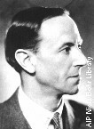

Extension

The notation that scientists use for elements is 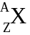

where z= atomic number = number of protons in the nucleus
A= mass number = total number of protons and neutrons in the nucleus

For example, a particular atom of iron may be represented as Fe.
This atom contains 26 protons, therefore it is the element iron.
The number of neutrons is 56 – 26 = 30.
The number of electrons equals the number of protons = 26

The existence of the neutron explained the isotopes of chlorine and other elements. The two isotopes of chlorine are 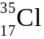 and 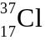 . One has 18 neutrons, the other 20.
The existence of isotopes also explains a problem that Mendeleev faced. He had some instances where a heavier element came before a lighter element on the Periodic Table, tellurium and iodine being examples. Now we know this is just the imbalance of neutrons causing this.

Lisa Meitner

Name: Lisa Meitner Birth/Death: 1878 - 1968

Country: German

Background: Jewish scientist

Contribution to chemistry: Meitner was the first to realise that uranium could be split apart.

Impact of discovery: The discovery of nuclear fission was the launching pad of nuclear science and the atomic industry.
Fig. 105 Apparatus for splitting the atom www.users.bigpond.com/Sinclair/fission/Work3.html

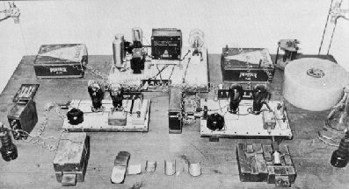

Lisa Meitner started working for Max Plank as a physicist in Berlin in 1908. Her close colleague was a chemist Otto Hahn. The two were to work together very closely over the next 60 years. She had to work in a shed at the back of the university because women were still not allowed to work in university posts. Meitner and Hahn were responsible for the first production of the element protractium. The loss of so many German males during World War I finally created opportunities for females after the war. Meitner became head of physics at the Kaiser Wilhelm Institute in Berlin. She worked with Hahn on the nature of alpha and beta radiation. She was also the first to formalize the use of Geiger counters in radiation research.

The discovery of the neutron in 1932 led to a frenzy of activity using this new particle to bombard large atoms. The hope was that new, larger elements would be formed. Italian physicist Enrico Fermi claimed to have done this with uranium. He was awarded the 1938 Nobel Prize for his work. When he left Italy to accept the prize he chose to stay in the US to avoid the forthcoming war. Meitner, a Jew and a pacifist, also fled Germany but she continued her studies in Sweden. Meanwhile Hahn and another physicist, Fritz Strassmann tried to repeat Fermi’s bombardment of uranium with neutrons but they were puzzled with the results. Instead of a larger atom they seemed to have traces of the smaller barium evident. He mailed the experimental data to Meitner in Sweden. She realized that uranium had in fact been split – the first successful example of nuclear fission. She identified krypton and neutrons as the other products of fission. She also used Einstein’s E=mc² equation to predict the massive amounts of energy that such a reaction might produce.
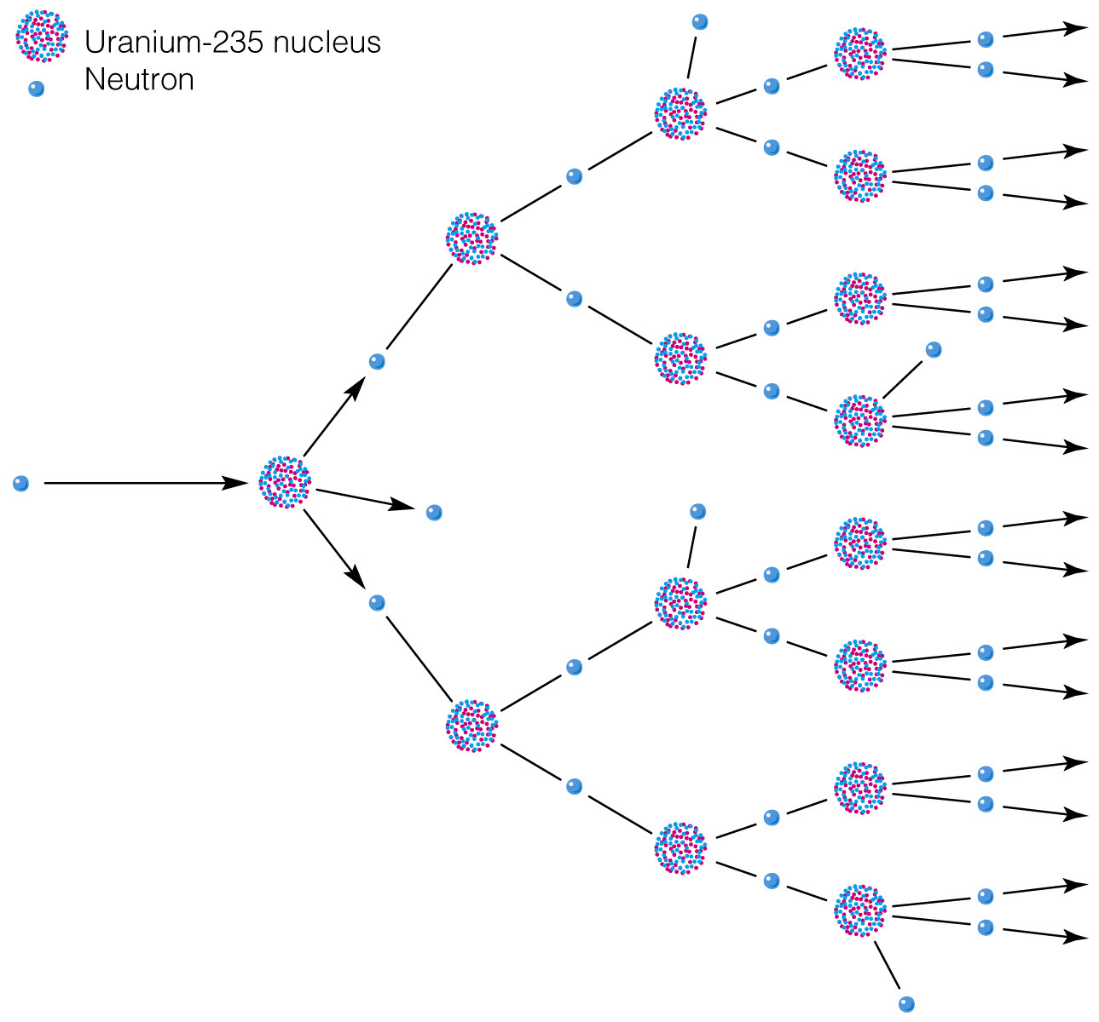
Fig. 106. Splitting the atom
http://wps.prenhall.com/wps/media/objects/439/449969/Media_Portfolio/ch18.html
The discovery of nuclear fission in 1938 was a sensation. Perhaps it could provide a super weapon to be used during the long war to follow. German research into a nuclear weapon started almost immediately. The US responded by initiating the Manhattan Project to develop a weapon of its own. Meitner was invited to join this team but, being a pacifist, she declined.

A sense of the excitement caused by the discovery of fission can be gained from this excerpt from a speech by Italian physicist Enrico Fermi when he retired in 1954
I remember very vividly the first month, January 1939, that I started working at Pupin Laboratories because things began happening very fast. In that period, Niels Bohr was on a lecture engagement in Princeton and I remember one afternoon that Willis Lamb came back very excited and said that Bohr had leaked out great news. The great news that had leaked out was Hahn’s and Meitner’s discovery of fission and at least the outline of its interpretation. Then, somewhat later that month, there was a meeting in Washington where the possible importance of the newly discovered phenomenon of fission was first discussed, in semi-jocular earnest, as a possible source of nuclear power.

Enrico Fermi (1901 – 1954) was an Italian physicist who emigrated to the US because his wife was Jewish.

The equation for the fission reaction is

Reactions where the nucleus breaks up into smaller nuclei are called nuclear fission reactions. Notice from the equation that the reaction of each atom released two extra neutrons (symbol ¹₀n). These neutrons could in turn cause two further atoms of uranium to react, releasing four neutrons this time to continue the process. Scientists realised for the first time that a chain reaction might result. Any chain reaction was likely to release very large amounts of energy. The chain reaction does in fact happen if a sufficient mass of uranium is present. This minimum mass is referred to as a critical mass.

Werner Karl Heisenberg and German Atomic Research

Name: Werner Karl Heisenberg Birth/Death: 1901 - 1976

Country: German

Background: Well respected German physicist, middle class background.

Contribution to chemistry: Heisenberg’s Uncertainty Principle is still used in physics. In chemistry, Heisenberg led German research for a bomb

Impact of discovery: Heisenberg’s team did not succeed with a bomb. Hopefully, this is an example of a popular failure?

Heisenberg’s research into quantum mechanics made him one of Germany’s leading physicists. The Heisenberg Uncertainty Principle, published in 1927, is still valid today. When World War II broke out, Heisenberg was summoned to Berlin to the Army Weapons Bureau to head a team researching the potential for practical utilization of nuclear fission. He was separated from his family for the duration of the war, the secrecy of the reactor experimentation being paramount.
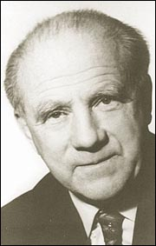
Fig. 107 Werner Heisenberg www.aip.org/history/heisenberg/p11.htm
Despite being the first country to split the atom, despite having good supplies of uranium and heavy water, Heisenberg’s team failed to produce an atomic weapon. Speculation as to why varies. Some critics view Heisenberg as a good theoretician but a poor experimenter. His arrogant manner did not encourage a collaborative approach from his team. Other critics blame the lack of real financial support from the German hierarchy as a greater problem. Germany’s resources were spread too thinly by the war on so many fronts.

Heisenberg’s team was captured near the end of the war and interrogated in England for over 6 months. A special Allied team had been used to capture as many German rocket scientists and weapons scientists as possible. While the scientists were imprisoned, their conversations were taped. They have recently been released and are called the Farm Hall Transcripts.

The raid on Telemark

Germany’s supply of heavy water was coming from a plant located at Rjukan in Telemark, a remote part of Norway. Heavy water is needed in large quantities to control nuclear fission. The British government felt it was crucial to destroy this plant if Germany was to be prevented from developing a bomb. The plant, Norsk Hydro was a hydroelectricity facility producing heavy water as a byproduct.

Heavy water, or deuterium, has a formula D₂O or ²H₂O. The hydrogen used is an isotope of normal hydrogen. Its nucleus contains a neutron as well as a proton. The physical properties of heavy water are not greatly different but heavy water slows neutrons differently during uranium fission. For this reason, heavy water is required for control of nuclear fission reactions.

The plant was heavily guarded and virtually surrounded by snow and ice covered cliffs. There was only one access road into the plant. The first attempt to sabotage the facility saw the glider used crash with all the British paratroopers killed in the crash or shot by the Germans. With the Germans alerted to such missions, the next attempt involved parachuting 12 Norwegians onto a nearby mountain plateau. The men survived several winter months living on reindeer and whatever else they could catch before they made their move. They could not use the suspension bridge access, so they crossed the gorge and scaled the icy cliffs below the plant. They crossed a mined area, cut through metal fencing and forced their way in through a window. The explosives were successfully laid and the saboteurs made their escape on skis. Despite a full scale search by the Germans, all of the Norwegians escaped.

As a follow up campaign, the facility was bombed by aeroplane. After that, the Germans decided to ship most of the remaining heavy water to Germany. The cargo was guarded heavily but the ferry to transport it over Lake Tinnsjo was not. Timed charges were placed on the boat. Unfortunately the boat was delayed and fourteen locals were also killed in the explosion.
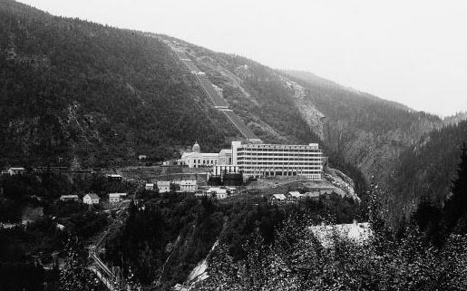
Fig. 108 Heavy water plant
www.hydro.com/en/about/history

Manhattan Project

The Manhattan Project was the United States’ response to fears of Germany or Japan developing an atomic bomb. In1939, three noted scientists, all Hungarian Jewish refugees, persuaded Albert Einstein to write to the US President Franklin D. Roosevelt warning him of the dangers of the German research. Lyman Briggs received this letter and, not understanding the urgency involved, filed it in a safe. It was not until late 1941 that enough pressure was brought to bear on the US government to take the project seriously.

The project was massive. The total cost at the time was over $2 billion dollars and the project employed 130000 workers. It involved over thirty locations, but the main ones were

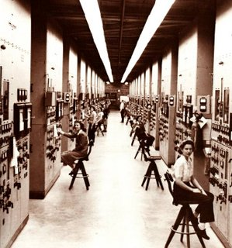
- The University of Chicago researched the theoretical aspects of designing and initiating a fission reaction. Chief physicist was Dr Robert Oppenheimer. Research was conducted on two different fuels, ²³⁵U and plutonium. They knew a critical mass of fuel was required to bring about a chain reaction so they planned to implode two subcritical masses into each other, making a critical mass. There was a lingering concern that the whole atmosphere might be ignited by this reaction! Fortunately, this was proven to not be possible. On December 2, 1942 Fermi’s team, working in a basement below the university oval initiated the first self-sustaining nuclear chain reaction. The famous coded message sent from the team was ‘The Italian navigator has landed in the new world, the natives are friendly’.
- Hanford Washington. Plutonium was produced here from bombarding ²³⁵U with relatively slow neutrons.
- Ames Laboratory. Uranium was extracted here from uranium ores.
- Oak Ridge Tennessee. Scientists here had to enrich uranium. The unstable isotope, ²³⁵U is needed for a chain reaction. This is however only 0.7% of natural uranium which is itself quite scarce. It is very difficult to separate ²³⁵U from ²³⁸U because their chemical properties are almost identical. The successful method chosen was to diffuse the isotopes through a porous tube lined wit silver. The isotopes diffused at different speeds. The US’s huge reserves of silver were depleted significantly by this process.
- Los Alamos, New Mexico. Scientists here designed the weapon itself.
Fig. 109 Oak Ridge control panel

http://en.wikipedia.org/wiki/Manhattan_Project control panel operators at Oak Ridge

Absolute secrecy surrounded each of these sites. All communication in and out was monitored and scientists were not allowed to discuss their work with their wives and families.

Uranium was used in the Hiroshima bomb, nicknamed Little Boy. Conventional explosive was used to shoot one piece of uranium into another.
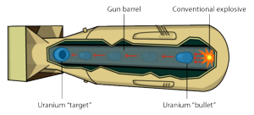
Fig. 110 Little Boy
http://en.wikipedia.org/wiki/Manhattan_Project

http://en.wikipedia.org/wiki/Manhattan_Project

The Nagasaki bomb and the first trial bomb were both made from plutonium. The gun barrel technique used for uranium was not suitable for plutonium. Instead a core of plutonium was compressed by a shock wave. Under compression, a chain reaction could occur. This caused the plutonium bomb to be a more spherical one.

The first test took place on July 16, 1945 near Alamagordo, New Mexico. The test site was called ‘Trinity’. The blast was estimated to have an explosive effect equivalent to that of 20000 tonnes of TNT. This was the first time that the characteristic mushroom cloud of an atomic bomb was ever seen. The cloud was over 12 kilometres high. Many soldiers and military observers watched the explosion through dark glasses from distances as close as 10 kilometres.

Little Boy was dropped from the B-29 bomber Enola Gay on Hiroshima on August 6th 1945. Fat Boy was dropped on Nagasaki three days later on August 9th. The blast from each bomb killed over 80000 people immediately. Many more were to die from the effects of radiation over the following weeks and years. The Japanese surrendered unconditionally on August 15th, 1945.

From a technical point of view, the detonation of two atomic bombs was an amazing achievement.

Marcus Oliphant

Name: Mark Oliphant Birth/Death: 1901 - 2000

Country: Australian!
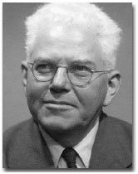
Background: Born in Adelaide, he studied physics at Adelaide University. He won a scholarship in 1929 to England and worked with Rutherford’s team.

Contribution to chemistry: Working with Rutherford, Oliphant helped identify isotopes of hydrogen. He helped to improve the resolution of British radar and he was a high level manager in the separation of uranium isotopes in the Manhattan project.

Fig. 111 Marcus Oliphant www.physicstoday.org/pt/vol-54/iss-7/p73b.html

Impact of discovery: Oliphant was one of the few Australian scientists to ever play such a significant role in atomic science.

Oliphant’s research included the identification and naming of ‘tritium’. Tritium is formed by bombarding deuterium with protons. Both deuterium and tritium are isotopes of hydrogen. They are important in nuclear fusion and fission reactions.

Fig. 112 dueterium (1 proton, 2 neutrons) tritium ( 1 proton, 3 neutrons)

Early in World War II, he helped improve the resolution of British radar. He also started the construction of one of Britain’s first cyclotrons. He then traveled to the US to see why warnings of a nuclear weapon were not being taken seriously. His visit helped motivate the Americans to initiate the Manhattan project and he soon became an important part of venture.

The Manhattan Project was to be the last military research that Oliphant conducted. He was appalled by the destruction that occurred. He returned to Australia where he was always a leader in particle research at the Australian National University. He retired in 1967 but still managed to serve as Governor of South Australia for 5 years.

Post World War II

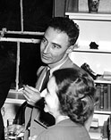
Fig. 113 Julius Rosenberg and his wife, Ethel.
http://www.law.umkc.edu/faculty/projects/ftrials/rosenb/ROS_IMAG.HTM
http://en.wikipedia.org/wiki/Ethel_and_Julius_Rosenberg
After the war, the Soviet Union developed is own atomic bomb amid much controversy. Many scientists struggled to cope with the reality of the devastation that their bomb had unleashed. Einstein was to comment ‘I could burn my fingers that I wrote that first letter to Roosevelt… but perhaps I can be forgiven because we all felt there was a high probability that the Germans were working on this problem and would use the atomic bomb’. Other scientists sold or passed on valuable information to Soviet scientists. By the early 1950s both the United States and the Soviet Union had progressed to the testing of hydrogen bombs. Hydrogen is a more abundant fuel than uranium and the energy produced is greater. The hydrogen bomb uses nuclear fusion instead of nuclear fission. Nuclear fusion is the combining of nuclei to make larger nuclei. In this bomb, hydrogen atoms are combined to form helium.

Julius Rosenberg was arrested on June 16, 1950. He and his wife Ethel were charged with treason and accused of selling atomic secrets to the Soviet Union. Julius Rosenberg’s brother-in-law worked at Los Alamos as part of the Manhattan Project. Julius was accused of passing information learnt from his brother-in-law to Soviet spies. British physicist, Klaus Fuchs was also tried in a separate case. Julius and his wife were both found guilty and sentenced to death. Despite several appeals, the sentence was carried out in 1953.

Nuclear reactions are also used to generate electrical energy. The Soviet Union trialled the first nuclear power generating plant as early as 1954. Many other countries now have nuclear power generating facilities. These plants are all nuclear fission reactions. As yet, scientists have not been able to harness nuclear fusion for electrical energy because the reaction is too energetic. A consortium of six countries is investigating the establishment of a trial reactor using hydrogen as a fuel but this plant is still on the drawing board.

Albert Ghiorso became director in place of Seaborg and elements 99 to 106 were produced. The names of several of these latter elements were questioned however because a Soviet team claimed to have produced elements 104 and 105 before the Berkeley team did. It is not unusual to see element 105 labelled as hahnium or dubnium or as the Latin number for 105 depending upon the year and origin of the publication that you are reading. All of these elements are radioactive, hence unstable. Their properties are not well established because many of them only exist for a fraction of a second. German researchers have also been prominent in the recent search for elements from number 107 onwards.

Synchrotron

One of the modern particle accelerators that is particularly relevant to Australian scientists is the synchrotron. This is because Australia’s first synchrotron is being built near Monash University in Melbourne. It will be over 60 metres in diameter and it is due to open in 2007.

Fig. 114 synchrotron http://www.synchrotron.vic.gov.au/content.asp?Document_ID=95


The particles accelerated in a synchrotron are electrons. Once the electrons are moving at high speeds, they are stored in the large ring of the synchrotron. When the path of the electrons is bent by a magnetic field light is emitted. The light is in the form of high energy X-rays. The intensity of these X-rays is far greater than that of normal X-rays. The X-rays are directed at targets and information is gleaned about the target from the interaction.

There are four major areas in which the synchrotron light is applied. These are

1. Diffraction/scattering. When X-rays strike a crystal they are scattered or diffracted. The scattering that occurs helps tell the scientist the position of the particles in the crystal. In this way the structure of particles in a crystal can be learnt

2. Spectroscopy. When some atoms are hit be X-rays they emit light. The light emitted can identify the atoms present.

3. Polarimetry. Here X-rays are used to help study the complex structures of molecules like proteins and how they function. There are many medical uses for this type of technology.

4. Imaging – improved x-rays. Conventional x-rays can distinguish between bone and tissue but synchrotron imaging can distinguish between different soft tissues, body organs and cartilage.

Fig. 115 a x-ray of a finger by synchrotron light
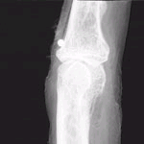

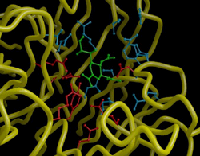
b synchrotron being used to develop an influenza drug.
http://www.synchrotron.vic.gov.au/content.asp?document_id=1152
- The Australian synchrotron could be used to study a diverse range of processes, from drug synthesis and materials science to food processing and forensics.

Glossary:

absolute zero – the lowest possible temperature. Particles come to rest at this temperature.
acid- substance that can donate hydrogen ions when it reacts
acid/base indicator – liquid that has a different colour in the presence of acid to the colour it has in base
alkali – base – substance that can accept a hydrogen ion when it reacts.
atom – basic particle that elements are made from
cathode rays – beams of particles generated in a cathode tube.
cathode tube – sealed glass tube that allows high voltages to be passed through the gas trapped inside.
combustion – burning – reaction of a substance with oxygen
critical mass – minimum amount of a substance needed for a sustainable reaction.
cyclotron – circular machine used to accelerate particles to high speeds
diffraction – bending of light as it passes objects
distillation – heating liquid mixture to boil one or more of the components off
electrolysis – passing of an electric current through a liquid
emission spectrum – wavelengths of light given off by atoms placed in a hot flame
empirical formula –ratio of atoms present in a substance
half life – time taken for a radioactive substance to lose half of its radioactivity
ion – atom that has lost or gained electrons. Charged atom.
isotopes – atoms of the same element that have different numbers of neutrons.
mass spectrometer – instrument for measuring accurate masses of atoms and molecules
molecule – group of atoms bonded together that can exist as a separate entity
noble gases – unreactive gases in Group VIII of the periodic table
nuclear fission – splitting of a larger nucleus into smaller ones
nuclear fusion – joining of small nuclei to form a larger one
nucleus – centre of an atom containing protons and neutrons.
ore – metals are found in the Earth’s crust combined with non metals. These minerals are referred to as ores.
pneumatic trough – large dish with water used for capturing gases
quantum mechanics – mathematical modelling of the paths of the electrons in an atom
radiation – invisible particles released from unstable atoms
synchrotron – particle accelerator that accelerates electrons, producing high intensity X-rays
transmutation – conversion of one element into another
vacuum – container with a high percentage of the air removed from it
X-ray – one of the types of radiation that exists

