Units 1 and 2 assessment task example: problem-solving – antacids
Information for teachers:
The ‘problem-solving’ assessment task may involve students developing a practical or theoretical solution to a given problem.
In this sample assessment task, students will be involved in a practical activity where they will formulate and test a new antacid. This relates to content in Unit 2 Area of Study 1. A lead-up activity involves students testing the effectiveness of different commercial antacid tablets.
The task could also be used as the basis of a ‘report of an application of chemical concepts to a real-life context’ and could be used as a template for a Units 3 and 4 ‘problem-solving, including calculations, using chemistry concepts and skills applied to real-world contexts’ assessment task.
Teachers should ensure that risk assessment is completed for all practical activities.

Formulation of an antacid

Background information for teachers
Hydrochloric acid (HCl) is secreted by the parietal cells in the stomach at a concentration of about 0.16 M. The flow of HCl increases when food enters the stomach. If you eat or drink too much, you may develop heartburn or indigestion.
Antacids are a class of medicines that neutralise the acid in the stomach. They contain ingredients such as aluminum, calcium, magnesium, or sodium bicarbonate which act as bases (alkalis) to neutralise the stomach acid and therefore help to relieve any heartburn or indigestion. The longer an antacid stays in the stomach, the longer it works. Having some food in your stomach may prolong the effects of an antacid. Available without a prescription, antacids are available as tablets or liquids.
The two main differences between antacids are the ingredients they contain and their formulation. The different active ingredients - aluminum, calcium, magnesium, or sodium bicarbonate – all have differences in how long they take to start working, how long they keep working, what other medications they may interact with, and who they are suitable for. Other ingredients may be added to improve the taste or for other purposes, for example, aspirin is contained in some antacids.

Table 1 shows the benefits and side effects of the components of different antacids.
Table 1 Benefits and side effects of components of antacids
Active ingredient | Chemical formula | Benefits | Side effects
Calcium carbonate | CaCO₃ | - strong and fast-acting antacid  - may work longer than antacids containing sodium bicarbonate or magnesium  - completely neutralises stomach acid | - only one-third of the dosage is absorbed by the body  - slight risk of developing kidney stones  - systemic alkalosis from prolonged use  - gastric acid secretion may rebound (i.e., stomach produces even more acid after eating or drinking)  - may cause nausea and vomiting
Sodium bicarbonate | NaHCO₃ | - works quickly to relieve heartburn symptoms  - weak, short-acting antacid  - generally a safe household remedy  - effervescent property, so avoids the chalky taste of carbonates | - quickly eliminated from your stomach—so relief may not last as long  - may cause bloating, belching, or flatulence due to the production of CO₂  - high sodium content is not appropriate for people who are on salt-restricted diets or have congestive heart failure, high blood pressure, or kidney problems
Aluminium hydroxide | Al(OH)₃ | - dissolves slowly in the stomach, gradually relieving heartburn symptoms | - may cause constipation  - may weaken bones
Magnesium salts: magnesium hydroxide; magnesium trisilicate | Mg(OH)₂  Mg₂O₈Si₃ | - acts quickly to neutralise acid | - may cause diarrhoea  - may cause heartburn
Other common added ingredients

Peppermint flavouring
- relaxes the lower oesophageal sphincter to release gas, peppermint encourages the release of a belch after a meal
Simethicone
- helps disperse gas in people prone to bloating
Alginic acid (alginate)
- gum-like substances that coats your oesophagus with a protective layer in gastroesophageal reflux

Most commercial antacids contain two or more components. The active ingredients vary significantly between different brands. Some widely advertised brands, those with additional components and those containing greater concentrations of the active ingredients, tend to cost more. Some antacids may also sacrifice efficacy for the sake of taste and acceptability.
Tables 2 and 3 show the formulations of different antacids.

Table 2 Examples of the formulations of three different antacid tablets
Antacid tablet formulations
Brand A | Brand B | Brand C
Active ingredients (per tablet) | Active ingredients (per tablet) | Active ingredients (per tablet)
- Aluminium hydroxide, 400 mg  - Magnesium hydroxide, 400 mg  - Simethicone, 40 mg | - Calcium carbonate, 780 mg  - Magnesium carbonate hydrate, 130 mg  - Magnesium trisilicate, 130 mg | - Sodium alginate, 500 mg  - Potassium bicarbonate, 267 mg  - Calcium carbonate, 160 mg
Other listed ingredients:
- Hydroxybenzoates
- Saccharin
- Sodium

Table 3 Examples of the formulations of three different antacid tablets
Liquid antacid formulations
Brand A | Brand B
Active ingredients (per 10 mL) | Active ingredients (per 10 mL)
- Sodium alginate, 1000 mg  - Potassium bicarbonate, 200 mg  - Calcium carbonate, 200 mg | - Sodium alginate, 500 mg  - Calcium carbonate, 325 mg  - Sodium bicarbonate, 213 mg
Other listed ingredients:  - Hydroxybenzoates  - Saccharin  - Sodium | Other listed ingredients:  - Peppermint flavour

Scope of the assessment task
Students will be introduced to the action of antacids in neutralising stomach acid by conducting a laboratory experiment to compare the action of different commercial antacid tablets. They will then be provided with information about different antacid formulations (Table 1) and a comparison of the benefits and side effects of different antacid formulations (Tables 2 and 3) to develop and test a new antacid formulation involving a mixture of two bases. They will present a report that outlines a justification for their choice of two bases and summarises the results of their antacid tests using different proportions of their selected bases.

pH paper versus a pH meter
The experiments related to the assessment task involve the use of a pH meter since this is more sensitive than pH paper.
However, teachers may want to explore the concept of ‘resolution’ by comparing the use of pH paper with a pH probe. This can be done by using both pH paper as well as a pH probe when two different commercial antacids are dropped into water. Most carbonates and bicarbonates will form solutions with a pH of about 8 when dissolved in water.
The two photographs below were taken after two different antacid tablets were dropped into water. Universal indicator paper was used in both solutions.

Figure 1 Experimental set-up for the testing of two commercial antacid tablets using universal indicator paper. (Photograph by author – Pat O’Shea)
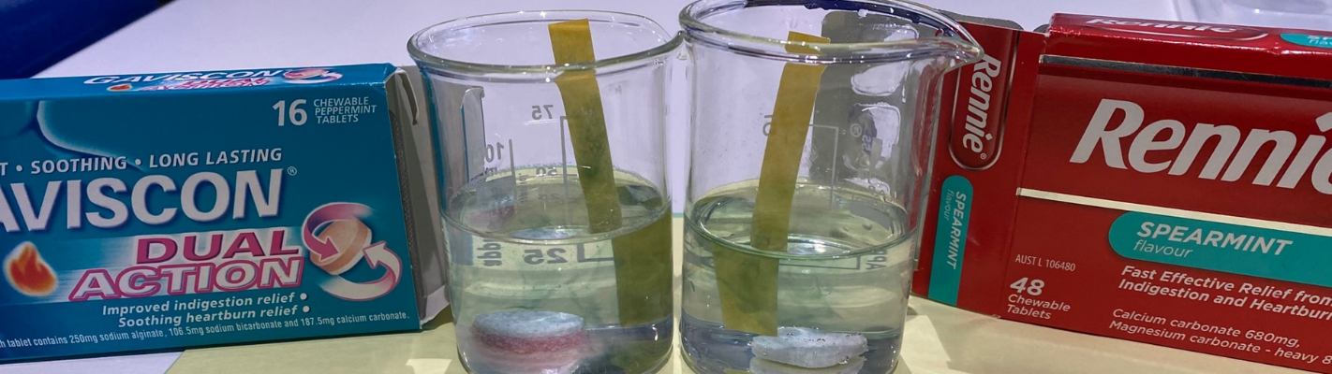

Figure 2 After adding acid, the pH dropped quickly but then backed off slowly. (Photograph by author – Pat O’Shea)
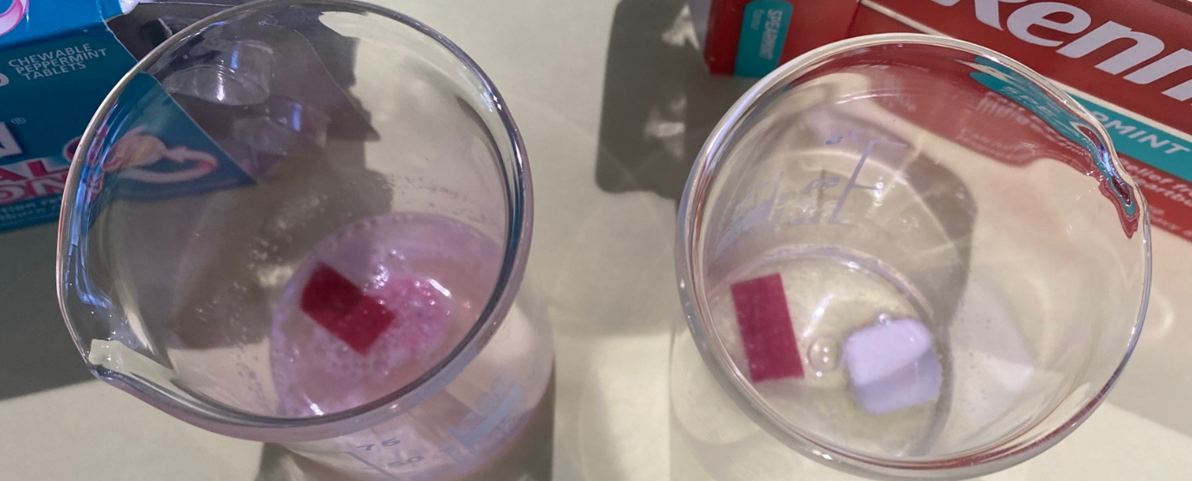
The use of pH probes enables monitoring of pH with greater resolution than is possible with various pH papers.

Instructions for students
Introduction
Hydrochloric acid (HCl) is secreted by the parietal cells in your stomach at a concentration of about 0.16 M. The flow of HCl increases when food enters the stomach. If you eat or drink too much, you may develop heartburn or indigestion.
Antacids are a class of medicines that neutralise the acid in the stomach. They contain bases (alkalis) to neutralise the stomach acid and therefore help to relieve any heartburn or indigestion. Most antacids have a mixture of bases in their formulation.
Scope of the task
You will conduct a laboratory experiment to investigate the effectiveness of different commercial antacid tablets. Your teacher will then provide you with information about the formulation of different antacids and a comparison of the benefits and side effects of the active ingredients that are used in antacids. You will use the results of your investigation and the provided information about antacid formulations to:
- select two different bases that could be used in an antacid formulation.
- test the effectiveness of five different antacid formulations in neutralising an acid. The formulations will be made up of different proportions of your two selected bases.
Record your results in your logbook.
Your assessment task will involve you writing a report that:
- outlines a justification for your choice of the two bases in your antacid formulation.
- summarises the results of your tests using different proportions of your selected bases.
Title: Formulating antacids
Aims:
Part A: To investigate the amount of hydrochloric acid that is neutralised by different antacid tablets, as one measure of the effectiveness of the tablets.
Part B: To investigate the effects of different formulations of an antacid on an acid.

Procedure:
Part A Comparing the effectiveness of antacid tablets
- Crush one indigestion tablet using a mortar and pestle.
- Add 50 mL of distilled water and mix.
- Measure the pH using a pH probe; start recording the pH after about 1 minute (when the pH has stabilised). Note that some reactions may be slow.
- When the pH has stabilised, add 1 mL of dilute hydrochloric acid.
- Monitor the change in pH as you keep adding 1 mL volumes of the dilute hydrochloric acid, waiting for the pH to stabilise each time, until the pH is neutral.
- Record all results in your logbook.

Part B Testing antacid formulations
- Use the information provided by your teacher about antacid formulations to select two bases that could be used in an antacid formulation.
- Mix different proportions of the bases to form five (5) different antacid formulations.
- Test the effects of different antacid formulations on an acid by adapting the procedure in Part A of this investigation.
- Record all results in your logbook.
- Hand your logbook in to your teacher. This will be returned to you when you are given the assessment task which requires you to write a report of your investigations.

