Did you know?
Some of Australia’s greatest scientists are indigenous Australians.
Topics
1. Woven reeds: These reeds grow on the school grounds and around the Darebin.
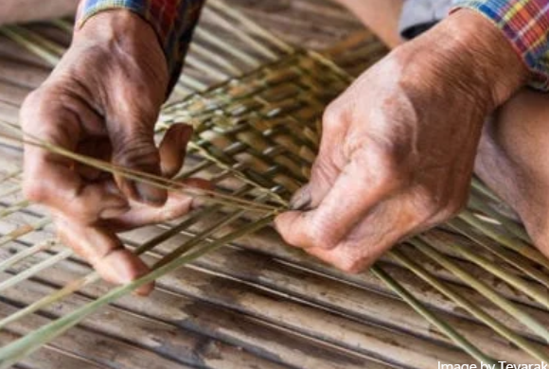
Find out how First Nation’s People weave these reeds and see if you can weave them yourself.

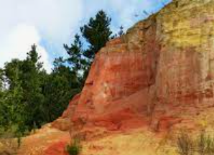
2. Paint: Indigenous paint can be made from clay.
Find out how this works and make some paint yourself.

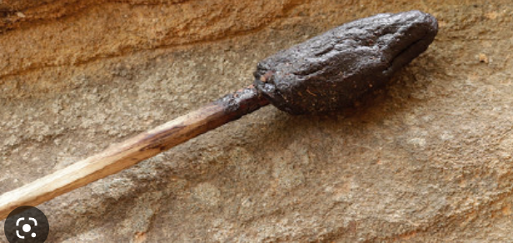
3. Indigenous glue recipes:
Indigenous people made glue from tree sap.
How did they do this?
Can we do this ourselves?
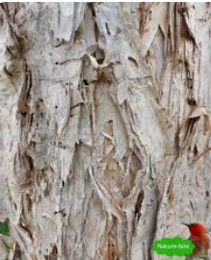
4. Paperbark tree
The paperbark tree had many indigenous uses.
What were they?
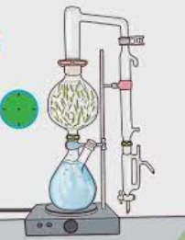
Can we make a shelter from paperbark?

5. Tea-tree oil: How do you extract this and what is it good for?
We can set this up in the lab
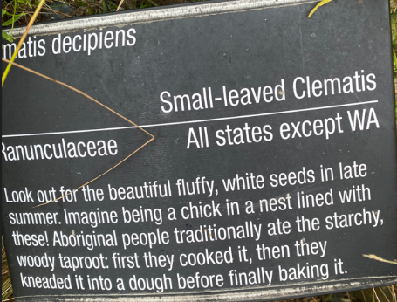
6. Royal Melbourne Gardens
Has a trail for indigenous plants.
Report back on this trail.
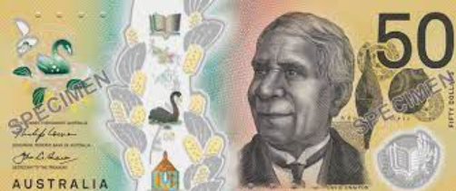
7. Who is this man and why is he on these notes?

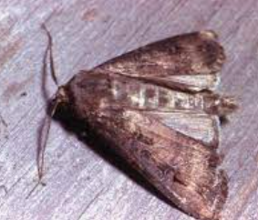
8. This is a Bogong moth. It is important to indigenous people.
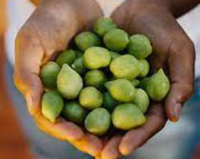
Why?
9. Kakadu plums
These have unique properties and
their kernels are also nutritious.
Explore this theme.
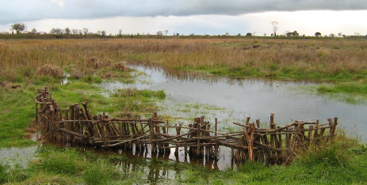
10. Budj Bim: Eel traps.
These are the first fish traps in the world.
Explain how they work.
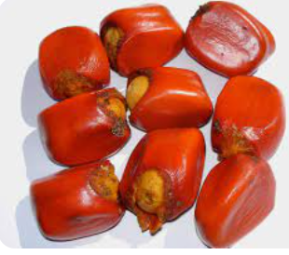

11. Macrozamia nuts: Eat them at your own peril! Find out what I mean by this
12. Fire-stick vegetation control. What is this and how does it work?
13. Medicinal plants. Explain which plants indigenous Australians valued as medicines.

