Chemistry Unit 4 Outcome 2
Food SAC Experiment
Title: Invertase in action.
Aim: To investigate the behaviour of the enzyme invertase
Background
Invertase (sucrase) is an enzyme that catalyses the hydrolysis of sucrose into fructose and glucose.

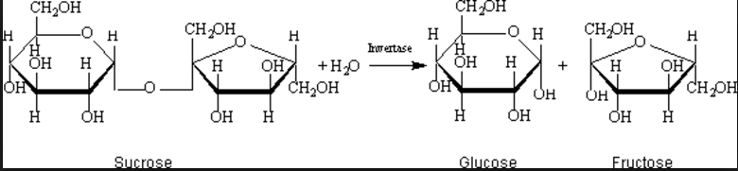
The progress of this reaction can be monitored through the use of the Benedict’s reagent. Benedict’s reagent produces a brownish colour in the presence of reducing sugar. Sucrose is not a reducing sugar but glucose and fructose are. Therefore a sucrose solution produces no colour change but a glucose or fructose solution will.
Materials
Yeast sachet
Water baths
Test tubes
  - M sucrose solution ( 9 g of table sugar to 250 mL tap water)
Benedict’s reagent
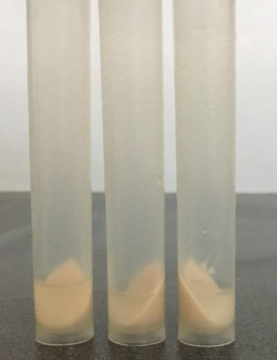
- M NaOH
Buffer solutions: pH 1, pH 5, pH 7, pH 9, pH 11

Invertase preparation
Add a sachet of yeast to 175 mL of tap water in a flask.
Place in a 40 ⁰C water bath for 30 minutes.
Centrifuge for 10 minutes.
Pipette off the supernatant liquid – this is the enzyme stock

Part A: Enzyme functionality and pH

Aim: To investigate the effect of pH on the activity of invertase
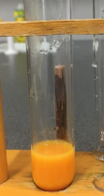
Method
A hot water bath set to 70 ⁰C should be set up for the latter steps.
Add 2mL of each buffer to 5 separate test tubes. Label each test tube
Add 2 mL of sucrose and 2 mL of invertase to each tube. Leave for approximately 5 minutes.
Add 10 drops of 1.0 M NaOH solution to each test tube to establish an alkaline environment.
Add 2 mL of Benedict’s reagent to each test tube and add each test tube to the water bath
Time how long it takes for each test tube to reach a particular intensity of brown solution.

Part B: Enzyme functionality and temperature
Aim: To investigate the effect of temperature on the activity of invertase

Method
Set water baths at temperatures of 20 ⁰C, 30 ⁰C, 40 ⁰C, 50 ⁰C and 60 ⁰C.
Place 2 mL of buffer 5 into each test tube and 2 mL of invertase.
Place one test tube in each water bath and leave 25 mins.
Add 2 mL of sucrose to each test tube.
Place back in the water bath in each test tube.
Take each test tube out and cool in an iced water bath (about 4 mins)
Add 2 mL of Benedict’s solution to each test tube.
Return the test tubes to the 70 ⁰C water bath and time how long it takes for the brown colour to form.

Results
Appropriate presentation of results 4 marks

Graphs
For Part A draw a graph of time for brown formation vs pH of buffer.
For Part B draw a graph of time for brown formation vs pH of buffer. 6 marks

Questions
Part A

1. Put into your own words how Part A is designed to work. 3 marks

2. Identify the independent variable, the dependent variable and any controlled variables. 4 marks

3. What conclusion can you draw from your graph about the performance of invertase? 2 marks

4. Explain what is happening to invertase at a pH of 13. 2 marks

5. The equations below show the reactions occurring when Benedict’s reagent is added.
a. What type of reaction is this?
b. What is happening to the copper ions during this reaction?
c. Why is there a colour change?
d. Refer to the equations to explain why NaOH was added to the mixture. 5 marks

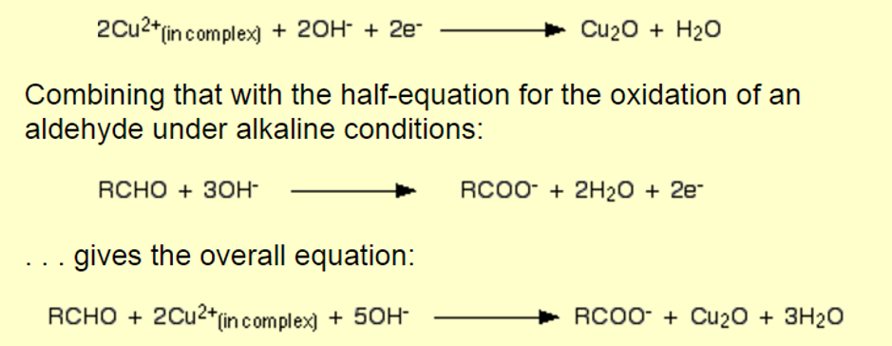

6. Glucose is a reducing sugar, sucrose is not. Glucose can form an open chain molecule with an aldehyde group. Sucose does not.
Explain what Benedict’s reagent is showing. 3 marks

Part B

7. Identify the independent variable, the dependent variable and any controlled variables. 4 marks

8. Discuss what your graph is showing about the impact of temperature on enzyme activity. 3 marks

9. a. Explain why the reaction rate increases from 20 ⁰C to 40 ⁰C.
b. Explain why the reaction rate decreases from 40 ⁰C to 60 ⁰C. 4 marks

Teacher notes
The preparation of invertase is simple and a fresh batch leads to better results.
There is an assumption that the action of invertase stops when the NaOH is added to the test tubes.

