Learning Journal
Unit 4 covers several aspects of food calorimetry. I feel the introduction of this topic to the students would be easy to adapt to a learning journal. I would envisage introducing a concept at a time and asking the student to submit their reflection on each new part straight after its introduction.
Sequence: A cycle of (next bit of theory – submit a response). Possible topics and submissions in this document.
This task might be completed in stages over a fortnight.
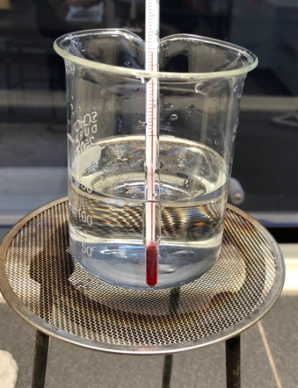
Unit 4 AOS2: Food calorimetry
The energy content of foods can be determined by burning the food under
a container of water and measuring the temperature change.
This process is known as calorimetry.
The formula used is
q = 4.18 x m_{w} x ΔT

1. What do each of these symbols stand for and what units should be
use for each variable?

2. a. You burn a biscuit under 100 g of water and the temperature changes by 28 ⁰C. You then burn a similar biscuit under 400 g of water. What is the expected temperature change?
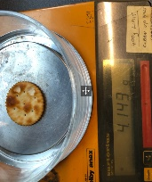
b. You burn the same biscuit under 100 g of ethanol. Will the temperature change be the same as for water?

Savoy biscuit
3. Why did we weigh the biscuit?

4. a. Use the data from the video to calculate the energy released by the biscuit. (150 g of water was used)
b. Calculate the energy per g for the biscuit and the energy per 100 g since the label uses that measure.

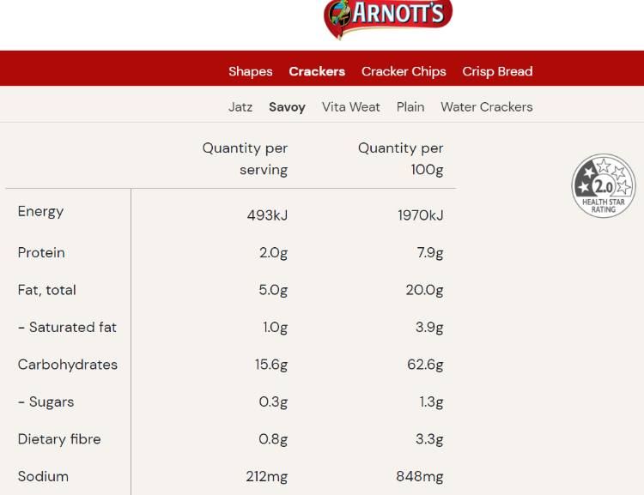

The label from a Savoy pack is shown above.
5. a. How does the energy value you obtained compare to the packet value?
b. Why is your value low?
6. What % is your answer of the value on the label?
7. Suppose this process always loses the same % of heat and you allowed for that.
a. Calculate the heat evolved per gram for the cashew burnt in the video.
b. Now adjust your estimate to allow for the % efficiency of this process.
8. a. What design changes were trialled on the video?
b. Discuss the reasons for the modification and its effectiveness.
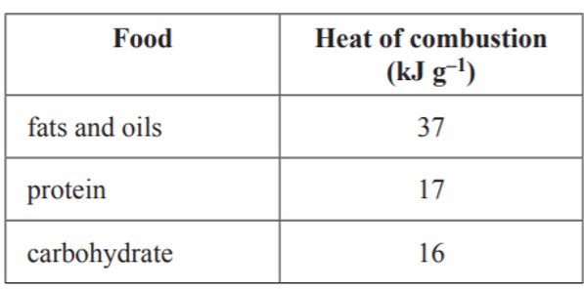
9. The table shown here is from your data book.
Use it and the Savoy label to make another estimate
of the energy content of a Savoy biscuit.
How does this estimate compare to the energy value on the
label? Why might this method give a different answer?

10. Research the composition of a cashew and what its energy content is likely to be.

11. Reflection: Give a concise explanation of the purpose of calorimetry and a commentary on how to obtain valid
results.

Calorimeter

11. Describe the features of a calorimeter that should enhance the energy readings obtained.

12. In a bomb calorimeter, how is the food ignited?
Why is oxygen pumped in under pressure?

13. What is the formula for calibration of a calorimeter?
Determine the calibration factor of the calorimeter on the video.

14. An experiment is performed in the same calorimeter and the temperature increases by 7.2 °C. Calculate the
energy released.
An experiment is performed in the same calorimeter and the temperature decreases by 2.6 °C.
Can you still use this value even though the temperature dropped?

Calorimeter experiment

15. Calculate the enthalpy change for this reaction.

16. Write a balanced thermochemical equation for the reaction occurring.

17. Why was the ammeter and power supply not attached for this reaction?

18. Would you recalibrate between each experiment?

19. Could you calculate the enthalpy change using the 4.18 specific heat capacity of water?

