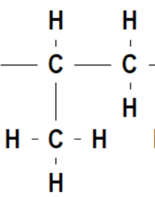 **Organic pathways**

**PROPENE**



***+ itself***

**n**

**polypropene**

**1-chloropropane**



***HCl***

***H2O/H3PO4***

***addition***

***substitution***

**1-chloropropane**

**PROPANEpropane**



**propan-1-ol**



**propan-2-ol**

***KOH***



**©poshea**

**propan-1-amine**

***oxidation***

***esterification***

***H2SO4(l)***

***Cr2O72-/H+***

***Cr2O72-/H+***

***NH3***

***Cl2/uv***

**propanal**

**propanoic acid**

**propyl propanoate**

**propanone**