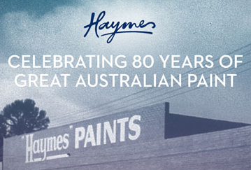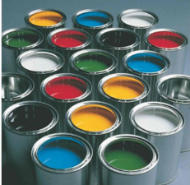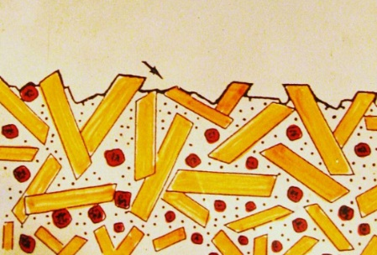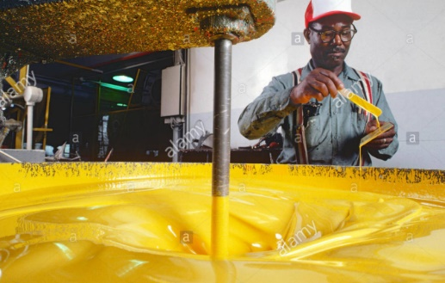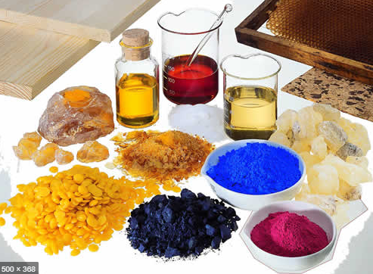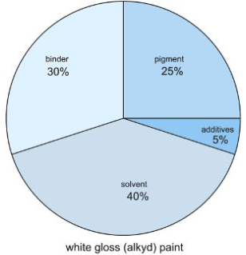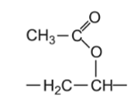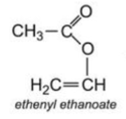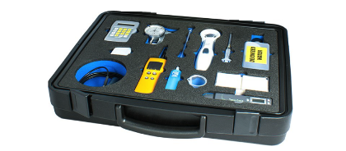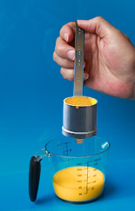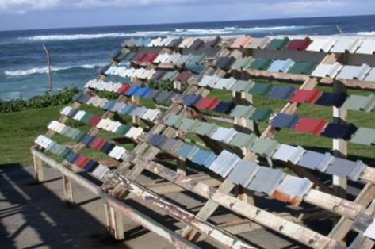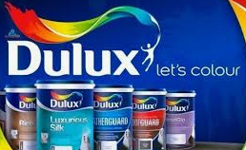

**© POShea**

**Microscope view - paint**

**Raw materials **

**mixing**

**Composition:**

**Binder – oil or acrylate for film.**

**Pigments: colour and body – talc, titanium dioxide.**

**Solvent: water, enables drying.**

**Surfactants, adhesives, fungicides**

**Oil base: linseed oil used as binder, it oxidises as it dries.**

**Acrylic paint: emulsion of PMMA in water.**

***Monomer*: Polymer: polymethylmethacrylate**

***Methylmethacrylate* (Perspex!)**

**Paint: Is a polymer film like cling wrap but pigments added to make it opaque and surfactants added to allow adhesion to surface.**

**Paint testing: adhesion, opaque**

**Viscosity: liquid flow**

**Weathering**

**Paint Industry: Dulux Dandenong, Haymes Ballarat**