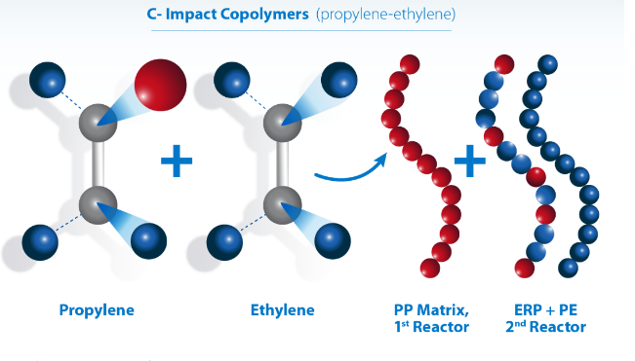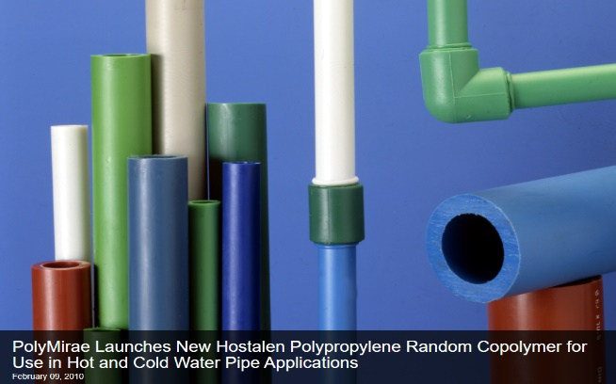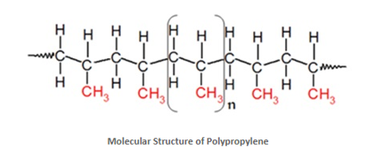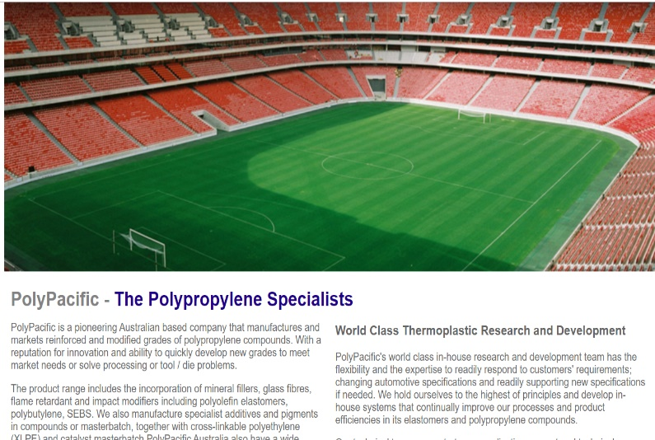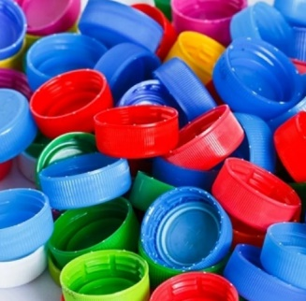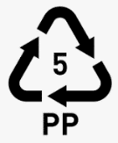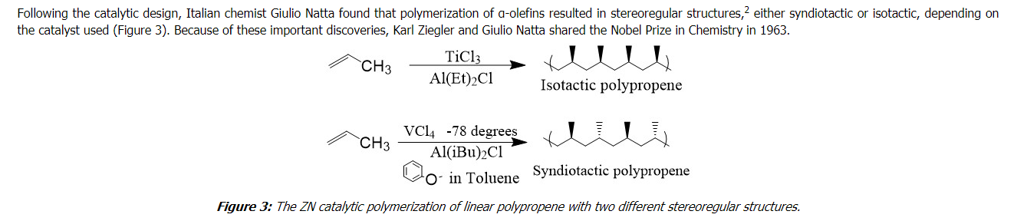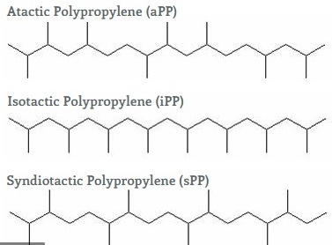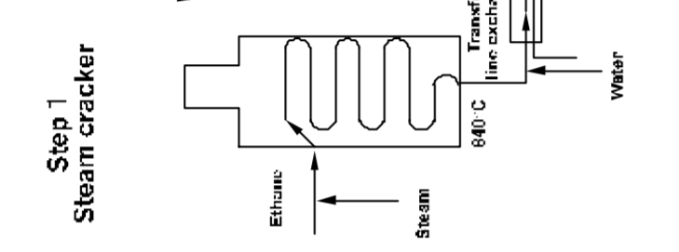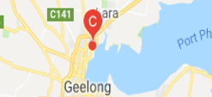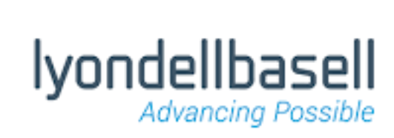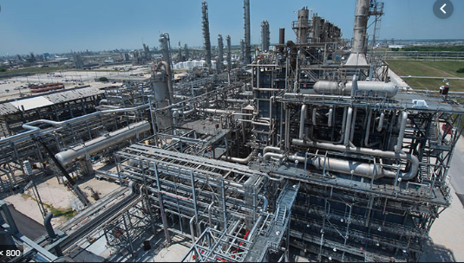

**Copolymers.**

**Better properties are achieved by blending propene with other monomers**

**© POShea**

**Polypropene**: three arrangements:

Atactic – random

Isotactic – methyl group same side

Syndiotactic – methyl group alternating.

The more regular the arrangement, the higher the density and melting point. Atactic has the lower melting point but is more transparent as it is less crystalline.

**Steam cracking of alkanes to alkenes**, very high pressure and temperature.

**Lyondellbasell takes propene from Qenos and produces polystyrene in Geelong. I**t has many uses including fake grass, furniture, packaging and microwave material.

**Ziegler-Natta catalysts: used to arrange the position of the methyl groups.**: ethane to ethene,

**Propene**: byproduct of Qenos cracking ethane to ethene,

Polypropene (Polypropylene)