**Proteins**: Polymers of amino acids

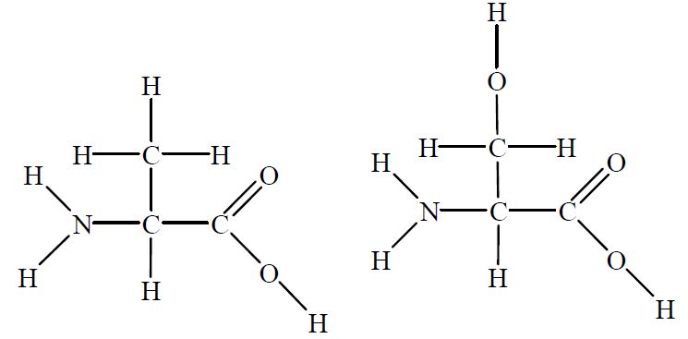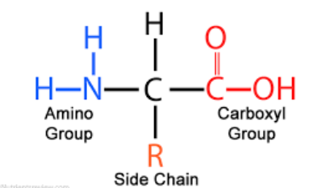

**2-amino acid structure**:

alanine serine

1. Explain what a 2-amino acid is.
2. Explain the difference in solubility in water between the two amino acids shown.

_____________________________________________________________________

_____________________________________________________________________

1. Draw the three products that can be formed when alanine and serine react.
2. Draw the zwitter-ion of glycine and the structure it will have in acid solution and the structure it will have in alkaline solution.
3. Use the diagram provided to explain the secondary structure of proteins.

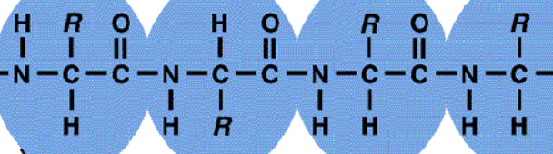

1. 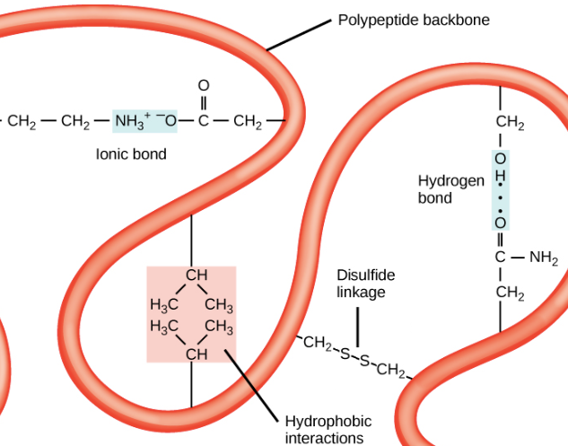Use the diagram attached to explain the

tertiary structure of proteins.

**Solutions**

1. 2-amino acids have an amine group and a carboxyl group attached to a common carbon atom.
2. The nature of the R group dictates the solubility. Electronegative atoms like oxygen and nitrogen enable hydrogen bonds to form with water.



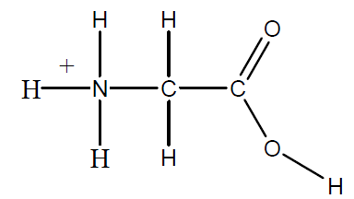

1. 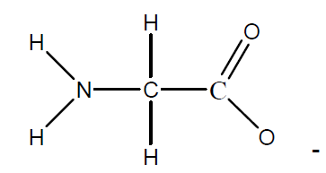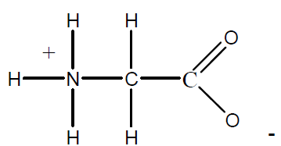

Zwitter acid base conditions

1. Secondary structure is caused by the dipoles on the nitrogen and oxygen atoms attracting other parts of the molecule. The R groups do not cause secondary structure.

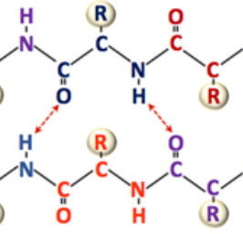

1. Tertiary structure is the result of a variety of types of interactions between R groups. These interactions include covalent disulfide links, ionic bonds, dipoles and dispersion forces.