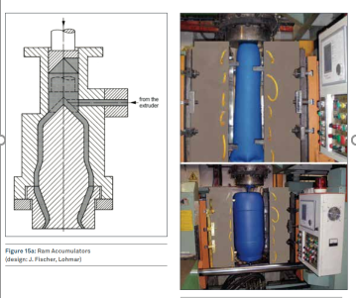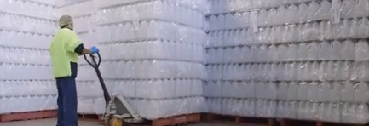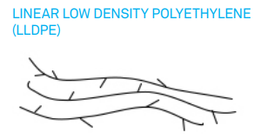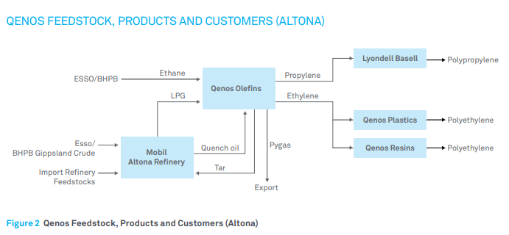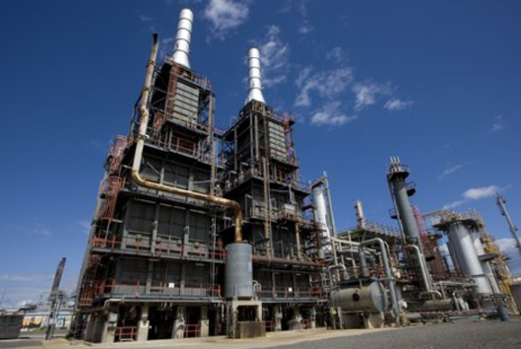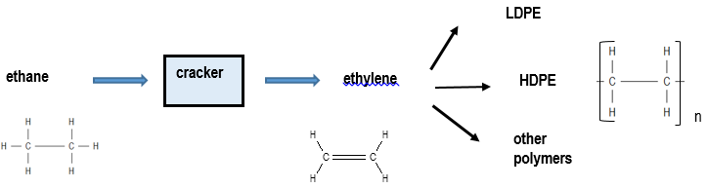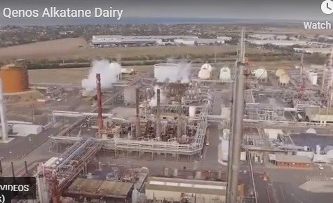

**Rotational mould**

**Specialty LLDPE used for 2L milk cartons**

**Co-polymer with but-1-ene or hex-1-ene**

**Twin cracking units**

**Altona petrochemical companies are linked**

**Cracker**

**C2H6(g) ⇌ C2H4(g) + H2(g) endothermic**

**A difficult reaction – harsh conditions used.**

* temperatures up to 9000C
* a very short reaction time
* low hydrocarbon concentrations
* rapid cooling of products to prevent their decomposition.

**Qenos plant in Altona**

**Qenos: Ethane to ethene to polyethene**