**Chemistry: Outcome 3: Research project (Poster)**

**Outcome 3**

Design and undertake a practical investigation related to energy and/or food and present methodologies, findings and conclusion in a scientific poster.

**Other VCAA requirements**

* 7-10 hours of class time
* Logbook to be used to record progress, results and design
* Poster to be submitted (not exceeding 1000 words)
* Correct citation of resources used
* Risk assessment conducted
* Hypothesis must be tested
* Students can conduct experiments in pairs but must submit individual posters.

**Further details**

Unit 3 investigations have to relate to energy. I have restricted your investigation further to investigate some aspect of reaction rates.

The investigation requires the student to

* identify an aim, develop a question, formulate a hypothesis and plan a course of action to answer the question and that complies with safety and ethical requirements.
* undertake an experiment that involves the collection of primary quantitative data
* analyse and evaluate the data
* identify limitations of data and methods
* link experimental results to theory
* reach a conclusion in response to the question and suggests further investigations
* communicate findings in a scientific poster
* maintain a logbook

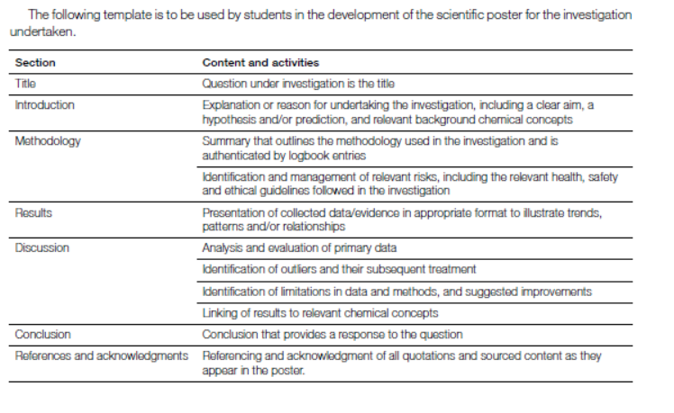

**Background**

Reactions proceed at different rates. This can be important for many reasons and typically chemists will seek to manipulate these rates, either speeding a reaction up or slowing it down if needed.

A challenge is to find an aspect of a particular reaction that allows its rate to be measured, be it a colour change or a change in pH.

The rate of a chemical reaction is usually discussed in terms of collision theory.

**Introductory experiment** : Reaction rates

Potassium permanganate is a purple solution. The manganese atom has a high oxidation state in this compound. There are a range of reductants that can reduce the manganese and one of these is oxalic acid found in rhubarb and chocolate.

Oxalic acid – C2H2O4

Potassium permanganate is KMnO4

As the MnO4- is reduced, it forms the colourless Mn2+.

Note: In this experiment trends are evident but is difficult to draw precise quantitative results because there is more than one reaction occurring. There is also the complication that the Mn2+ produced in the reaction also acts as a catalyst for the reaction.

**Materials**

Rhubarb – from the fruit and vegetable shop!

(**Remove the leaves of the rhubarb plant – they are toxic if eaten)

* 1. 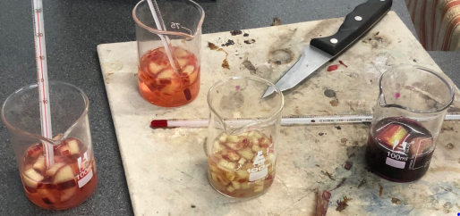M potassium permanganate

1. M sulfuric acid

hot plate

knife

thermometer

**Part A:** Rate and temperature

**Procedure**

**1.** Add 30 mL of acidified permanganate to a 100 mL beaker.

**2**. Cut a 6 cm piece of rhubarb stalk. Cut this piece into 10 pieces.

**3.** Record the temperature of the permanganate

**4**. Add the rhubarb to the permanganate and time how long it takes for the permanganate to

go colourless. Stir gently.

**5**. Repeat the procedure but this time heat the solution to 40 °C before adding the rhubarb

**6**. Repeat the procedure but heat the solution to 60 °C before starting.

**Part B: Rate and surface area**

**Procedure**

**1.** You already have one reading for this section – it is the first reading in Part A when you

used a 6cm piece of rhubarb cut into 10 pieces

**2.** Repeat this procedure (30 mL of acidified permanganate) but cut the 6 cm piece of rhubarb

into about 30 pieces

**3.** Repeat this procedure (30 mL of acidified permanganate) but cut the 6 cm piece of rhubarb

into 2 pieces only.

**Student investigation**

Select a reaction and to investigate its rate.

Possible reactions include

* marble chips in acid
* magnesium in acid
* thiosulfate solutions and acid
* iron solutions
* enzymes
* rhubarb

**Designing and planning your task**

You need to show me evidence that you have a valid hypothesis and plan for testing the hypothesis.

|  |  |
| --- | --- |
| Topic |  |
| State the aspect you are studying |  |
| Why is this a relevant topic? |  |
| What is your hypothesis? |  |
| Outline the procedure you will follow | __________________________________________________________  __________________________________________________________  __________________________________________________________  __________________________________________________________  __________________________________________________________  __________________________________________________________ |
|  |  |

**Experimentation**

Use the headings below to outline the experiment you will conduct and your requirements.

Description of your experiment

__________________________________________________________________________________________

__________________________________________________________________________________________

__________________________________________________________________________________________

__________________________________________________________________________________________

__________________________________________________________________________________________

__________________________________________________________________________________________

Materials required

__________________________________________________________________________________________

__________________________________________________________________________________________

Risk assessment

__________________________________________________________________________________________

__________________________________________________________________________________________

__________________________________________________________________________________________

Variables

__________________________________________________________________________________________

__________________________________________________________________________________________

__________________________________________________________________________________________

**Results and analysis**

During your experiment you collected data. Outline this data and analyse it.

**Results**

**Graphing of data**

**Conclusions**

__________________________________________________________________________________________

__________________________________________________________________________________________

__________________________________________________________________________________________

__________________________________________________________________________________________

__________________________________________________________________________________________

__________________________________________________________________________________________

**Final experiment**: Reaction rate investigation

Your class has investigated different aspects of reaction rates. Combine the conclusions of the class to inform your hypothesis testing and conclusion.

**Question**: Has the quality of your data obtained improved?

__________________________________________________________________________________________

__________________________________________________________________________________________

__________________________________________________________________________________________

__________________________________________________________________________________________

__________________________________________________________________________________________

**POSTER**

You have 1 hour in class under exam conditions to construct a poster summarising your investigation.

You will be supplied with an A3 sheet of paper for your poster.

You may bring results table, resource citations and graphs already prepared to this session.