Chemistry: Outcome 3: Research project (Poster)

Outcome 3
Design and undertake a practical investigation related to energy and/or food and present methodologies, findings and conclusion in a scientific poster.

Other VCAA requirements
- 7-10 hours of class time
- Logbook to be used to record progress, results and design
- Poster to be submitted (not exceeding 1000 words)
- Correct citation of resources used
- Risk assessment conducted
- Hypothesis must be tested
- Students can conduct experiments in pairs but must submit individual posters.

Further details
Unit 3 investigations have to relate to energy. I have restricted your investigation further to investigate some aspect of galvanic cells.

The investigation requires the student to
- identify an aim, develop a question, formulate a hypothesis and plan a course of action to answer the question and that complies with safety and ethical requirements.
- undertake an experiment that involves the collection of primary quantitative data
- analyse and evaluate the data
- identify limitations of data and methods
- link experimental results to theory
- reach a conclusion in response to the question and suggests further investigations
- communicate findings in a scientific poster
- maintain a logbook

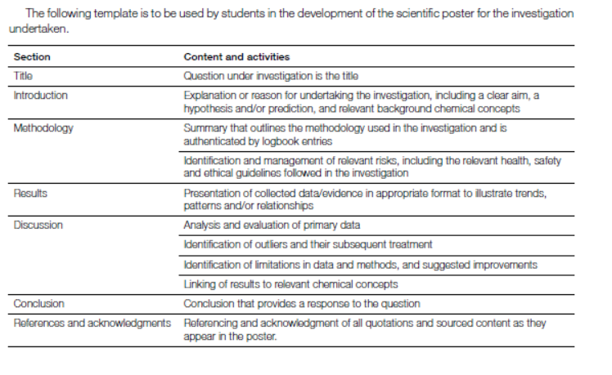

Background
What society calls batteries, chemists call galvanic cells. Galvanic cells convert chemical potential energy directly to electrical energy. They are used to power the wide range of portable devices that we rely on so heavily.
In a competitive market place, the performance and the efficiency of the cell needs to be maximised. In this task you will select one aspect of cell design to investigate. You will propose a hypothesis and design an experiment to test your hypothesis. The data you obtain will form the basis of your conclusion. Your findings are presented as a poster.
It is assumed you have a sound understanding of galvanic cell theory before commencing this task.

Introductory experiment 1: Reactivity of metals and the electrochemical series

Aim: To compare the chemical reactivity of metals with their position on the electrochemical series.

Materials
Samples of the following metals
- zinc, magnesium, iron (nails), copper, lead
0.5 M HCl
3.0 M HCl
Test-tubes

Procedure
Add a sample of copper to 0.5 M HCl in a test-tube
Repeat in a separate test-tube for each metal
Compare the rate of reaction for each metal.

For the metals that were difficult to discern, repeat the procedure with 3.0 M HCl.

Rank the metals tested in order of reactivity.

Introductory experiment 2 (Teacher demonstration): Making a galvanic cell
Your teacher will demonstrate the construction of a basic galvanic cell using a copper half-cell and a zinc half-cell.
This design of this cell will be deliberately poor.
Record the voltage.
Compare the voltage and polarity obtained with theoretical values.

Student investigation
Select an aspect (a variable) of galvanic cells to investigate.
Possible variables include
- impact of solution concentration
- impact of solution temperature
- salt bridge concentration
- electrode separation
- electrode surface area
- measuring current instead of voltage
- choice of salt bridge solution
- performance of cell over time

Designing and planning your task
You need to show me evidence that you have a valid hypothesis and plan for testing the hypothesis.
Topic

State the aspect you are studying
Why is this a relevant topic?
What is your hypothesis?
Outline the procedure you will follow | __________________________________________________________  __________________________________________________________  __________________________________________________________  __________________________________________________________  __________________________________________________________  __________________________________________________________

Experimentation
Use the headings below to outline the experiment you will conduct and your requirements.

Description of your experiment

__________________________________________________________________________________________

__________________________________________________________________________________________

__________________________________________________________________________________________

__________________________________________________________________________________________

__________________________________________________________________________________________

__________________________________________________________________________________________

Materials required

__________________________________________________________________________________________

__________________________________________________________________________________________

Risk assessment

__________________________________________________________________________________________

__________________________________________________________________________________________

__________________________________________________________________________________________

Variables

__________________________________________________________________________________________

__________________________________________________________________________________________

__________________________________________________________________________________________

Results and analysis
During your experiment you collected data. Outline this data and analyse it.

Results

Graphing of data

Conclusions

__________________________________________________________________________________________

__________________________________________________________________________________________

__________________________________________________________________________________________

__________________________________________________________________________________________

__________________________________________________________________________________________

__________________________________________________________________________________________

Final experiment: Forming an electrochemical series
Your class has investigated different aspects of galvanic cells. Combine the conclusions of the class to set guidelines for obtaining accurate values for a range of galvanic cells. Combinations to try should be –
- magnesium, zinc, iron and lead to all be tested against copper.

Compare your data to the position and voltage of the electrochemical series.

Question: Has the quality of your data obtained improved?

__________________________________________________________________________________________

__________________________________________________________________________________________

__________________________________________________________________________________________

__________________________________________________________________________________________

__________________________________________________________________________________________

POSTER
You have 1 hour in class under exam conditions to construct a poster summarising your investigation.
You will be supplied with an A3 sheet of paper for your poster.
You may bring results table, resource citations and graphs already prepared to this session.

