Redox topic test solutions

SECTION A: Multiple-choice questions (1 mark each)
Question 1

Answer: C

Explanation:
Assume oxygen is -2 to work out the oxidation number of bromine.

Question 2

Answer: B

Explanation:
Sulfur in sulfuric acid is +6 and in SO₂ it is +4.

Question 3

Answer: D

Explanation:
The reaction at the cathode will be reduction. Option D shows the reduction of sulfur.

Question 4

Answer: D

Explanation:
The efficiency of a modern fuel cell should be higher than that of a gas-fired power station.

Question 5

Answer: B

Explanation:
The oxidation state of nitrogen in NO₃⁻ is +5, while in NO it is +2.

Question 6

Answer: D

Explanation:
Aluminium metal is oxidised and chlorine gas is reduced. The electrons flow from the aluminium to the chlorine electrode.

Question 7

Answer: A

Explanation:
Experiment 1 shows gallium is more reactive than cadmium and experiment 2 shows rubidium is more reactive than gallium. A discussion of oxidants will be a comparison of the ions of eac metal.

Question 8

Answer: A

Explanation:
Zinc metal is oxidised in tis reaction and silver ions are reduced.

Question 9

Answer: A

Explanation:
Alternative A shows a balanced equation for the reaction of zinc with silver oxide.

Question 10

Answer: D

Explanation:
The anode reaction needs to be oxidation so it will be the reaction of ethane not oxygen. Alternative B is correctly balanced.

SECTION B: Short-answer questions

Question 1 (7 marks)
a. i. C₂O₄²⁻ +3 ii. NH₄⁺ -3 iii. NO₂⁻ +3 3 marks

b. i. O₂ + 4e⁻ 2O²⁻ 2 marks
ii. Sn²⁺ Sn⁴⁺ + 2e⁻

c. i. SO₃²⁻(aq) + H₂O(l) SO₄²⁻(aq) + 2H⁺(aq) + 2e⁻ 2 marks
ii. IO₃⁻(aq) + 6H⁺(aq) + 5e⁻ I₂(aq) + 3H₂O(l)

Question 2 (6 marks)
a. Fe²⁺(aq) Fe³⁺(aq) + e⁻ reducing agent 3 marks
Cl₂(g) + 2e⁻ 2Cl⁻(aq) oxidizing agent
b. K(s) K⁺(aq) + e⁻ reducing agent 3 marks
Al³⁺(aq) + 3e⁻ Al(s) oxidizing agent

Question 3 (8 marks)

+ e -
Platinum electrode with Cl₂ in NaCl Magnesium electrode in Mg(NO₃)₂
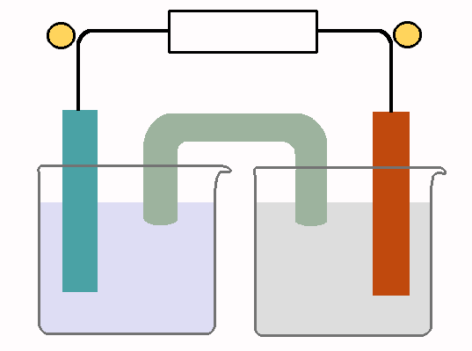

Voltage 3.63 V

½ equations Cl₂(g) + 2e⁻ 2Cl⁻(aq) Mg(s) Mg²⁺(aq) + 2e⁻
Mg(s) + Cl₂(g) Mg²⁺(aq) + 2Cl⁻(aq)

Question 4 (6 marks)
a. FeCl₃(aq) + Ni(s) 1 mark

b. Fe³⁺(aq) + e⁻ Fe²⁺(aq)
Ni(s) Ni²⁺(aq) + 2e⁻
2FeCl₃(aq) + Ni(s) 2FeCl₂(aq) + NiCl₂(aq) 3 marks

c. Fe³⁺(aq) 1 mark

Question 5 (6 marks)
a. i. A secondary cell is a cell that can be recharged. The products of the reaction stay in contact with the
electrodes to facilitate this. 2 marks

ii. A secondary cell has a set amount of reactant while a fuel cell has a continuous supply of reactants.

b. Anode: Cd(s) + 2OH⁻(aq) Cd(OH)₂(s) + 2e⁻ 2 marks
Cathode: 2NiO(OH)(s) + 2H₂O(l) + 2e⁻ 2Ni(OH)₂(s) + 2OH⁻(aq)

c. i. 2Ni(OH)₂(s) + Cd(OH)₂(s) Cd(s) + 2NiO(OH)(s) + 2H₂O(l) 2 marks
ii. Nickel electrode

Question 6 (7 marks)
a. anode: CH₄(g) + 2H₂O(l) CO₂(g) + 8H⁺(aq) + 8e⁻
cathode: O₂(g) + 4H⁺(aq) + 4e⁻ 2H₂O(l)

overall equation: CH₄(g) + 2O₂(g) CO₂(g) + 2H₂O(l) 3 marks

b. i. CH₄ will react at the negative anode. 1 mark

ii. -4 to +4 1 mark

c. Renewability will depend upon the source of methane. If it is obtained as a fossil fuel the process is non-
renewable. If it is sourced as biogas it could be renewable. 2 marks

