**Reaction Rate Experiment**

**(This sheet accompanies the video experiment)**

**Aim:** To investigate the factors that affect the rate of a reaction.

**Background**

Rhubarb is a vegetable that is sometimes cooked and added to desserts or muffins. It is not particularly popular and has a very sharp taste. The sharp taste is due to the oxalic acid it contains. The reddish stalks are used for cooking as the leaves are toxic.

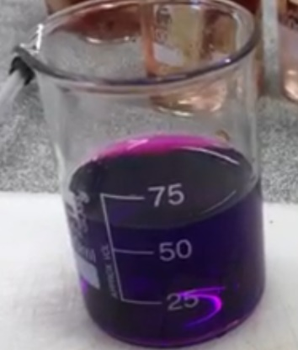

**Part A**: Reaction rate

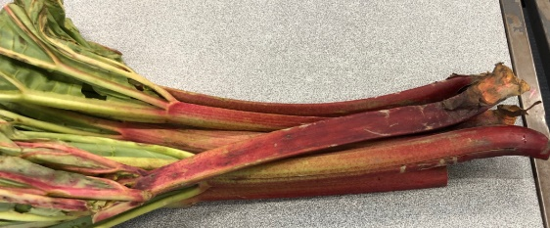

*oxalic acid*

rhubarb potassium KMnO4

permanganate

The oxalic acid in rhubarb can reduce the permanganate ions from MnO4- to Mn2+.

Mn2+ solutions are colourless so the rate of reaction can be judged by how quickly the solution goes colourless.

1. a. Write a molecular formula for the oxalic acid. _________________________

b. Write a balanced half-equation for the oxidation of oxalic acid to CO2 and H+ ions.

_____________________________________________________________________

PAUSE

2. a. Write a balanced equation for the reduction of MnO4- to Mn2+.

_____________________________________________________________________

b. What is the oxidation number change of the manganese ions during this reaction?

______________________________

3. Write a balanced overall equation for the reaction between oxalic acid and potassium

permanganate.

______________________________________________________________________

**Part A: Rate and temperature**

4. Use the video data to record the time for each solution to clear at each temperature.

Leave column 3 blank at this stage.

|  |  |  |
| --- | --- | --- |
| Temperature 0C | Time (sec) | Reciprocal of time |
|  |  |  |
|  |  |  |
|  |  |  |
|  |  |  |
|  |  |  |

PAUSE

5. Draw a graph of your results.

6. What conclusion can you draw from this graph?

_____________________________________________________________________

7. The time for the solution to go colourless is not really the **rate** of the reaction.

Calculate the reciprocal of each value of time and the second column and put the reciprocal

value in the third column.

Draw a graph of reciprocal of time on the vertical axis and temperature on the horizontal axis,

8. Explain why this graph is a better representation of how rate and temperature are linked.

___________________________________________________________________________

___________________________________________________________________________

9. Explain why the rate will change with temperature.

__________________________________________________________________________

**Part B: Surface area**

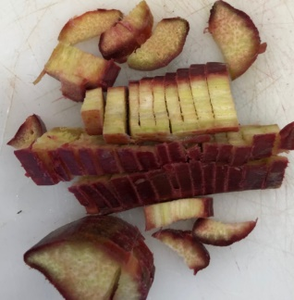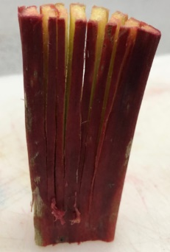

In part A, you sliced the rhubarb 10 times across the circumference.

Would it have made any difference if the slices had been longitudinal as in the diagram above?

10. Assume the rhubarb piece is a perfect cylinder of diameter 2 cm and length 10 cm.

Calculate the surface area of

* the original piece ______________________________________________________

_____________________________________________________________________

* the two pieces formed if the rhubarb is cut across the middle __________________

____________________________________________________________________

* the two pieces formed if the rhubarb is cut longitudinally. ______________________

______________________________________________________________________

11. a. Which form of cutting would lead to the faster reaction rate?

_____________________________________________________________________

b. Explain why reaction rate depends upon surface area.

______________________________________________________________________

**Part C: Concentration**

A student boils several stalks of rhubarb in 500 mL of water to extract the oxalic acid. He filters the water and rhubarb to get a clear solution of oxalic acid.

Design an experiment that will use the solution prepared above to test the impact of concentration changes on the rate of reaction.

In your experiment design

* outline how you will form solutions of other concentration
* how you will compare the solutions
* the result you expect to get
* the dependent, independent and controlled variables in your experiment.

________________________________________________________________________

_________________________________________________________________________

________________________________________________________________________

_________________________________________________________________________

________________________________________________________________________

_________________________________________________________________________

________________________________________________________________________

_________________________________________________________________________