**SACs**

* Should not be tests.
* Don’t assess any content from other units eg. Revisit Unit 1 concepts in Unit 2
* Don’t have to address all Key Skills
* Should be varied.
* It will be difficult to decide which category a task belongs to but that does not matter eg a set of experiments on acids and bases could lead to an annotated report, a reflective journal or an investigation
* Don’t use commercial work without adaptation.
* Give the students clear details beforehand.
* Assessment must be transparent.
* Do things that are useful and interesting.
* Unit 1-2 SACs

Can be assessed as S/N => infographics are fine

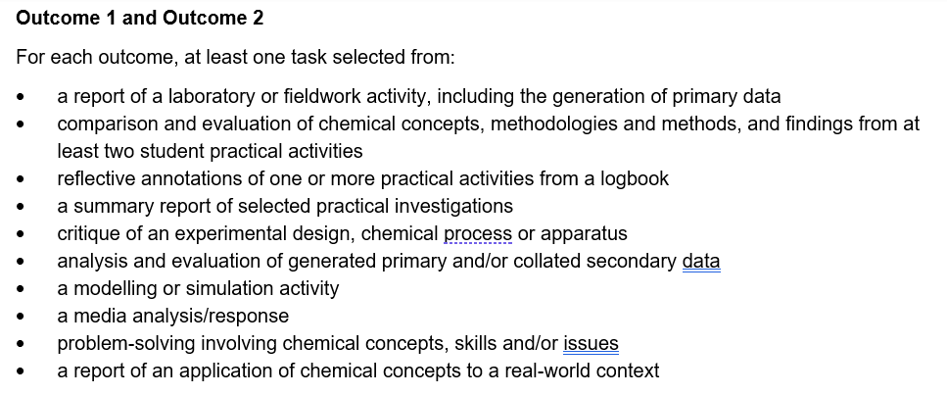

**Production of Green Steel: Which category? Could be any of the categories below**

Infographic, poster, media response, a report of an application, analysis of an innovation.

Media file: need some articles to refer to, looking at how students interpret the information

Poster: Steps in the production of steel vs green steel.

**Critique of an experiment**

**(critique an experiment performed poorly and redo it more carefully)**

**Procedure**

* Set up the cell as shown in Figure 1.
* Record the voltage produced by the cell in your logbook.

Low solution concentration

Low salt bridge concentration

Long, narrow salt bridge

Shallow solution

Figure 1 Experimental set-up

**Design changes**

Consider each facet of this cell. Changes can be made to improve the voltage obtained.

* List four possible changes to the cell.
* For each suggested change, explain why you are anticipating a better performance from the cell.
* Set the cell up again, instituting some of your suggested changes.
* Record the voltage obtained.
* What conclusion can you draw on the changes you have made?

**Report**

You must submit a practical report on this task. Your report should include:

* the voltage you obtained from the initial cell
* analysis of this cell, the half-equations occurring, the direction of electron flow and the polarity of the electrodes
* each proposed change and the explanation as to why you have suggested that change
* the voltage you obtained from the second cell
* the conclusion you have made about the effectiveness of your changes

**Assessment**

|  |  |
| --- | --- |
| **Aspect of critique** | **Number of marks** |
| Voltage and polarity recorded from the initial cell | 2 |
| Analysis of the cell, half-equations, electron flow, polarity | 2 |
| First suggested changes and the justification | 4 |
| Second suggested changes and the justification | 4 |
| Third suggested changes and the justification | 4 |
| Fourth suggested changes and the justification | 4 |
| Voltage from redesigned cell | 4 |
| Conclusion | 6 |
| **Total marks** | **30 marks** |

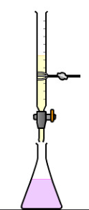**Titration critique**

Aim: To critique and improve the design of a titration experiment.

**Conduct an initial experiment** – poorly designed. Wrong indicator.

Use an acid 4 times the concentration of the base.

Measurements and calculations in logbook.

Pool class results

Discussion of limitations

Statement of modifications you will make and why.

**Second experiment**, measurements added to logbook.

**Report under test conditions**

1. State the limitations of your initial experiment.

2. Evidence of poor methodology.

3. List the changes you made to the design.

4. Calculation of new results. Results pooled.

5. Conclusion on effectiveness of the changes made.

**Analysis of an innovation/sustainability case study**

Chemistry related Sustainability Goals listed in the Study Design

Investigation topic 4: The sustainability of a commercial product or material: AOS3

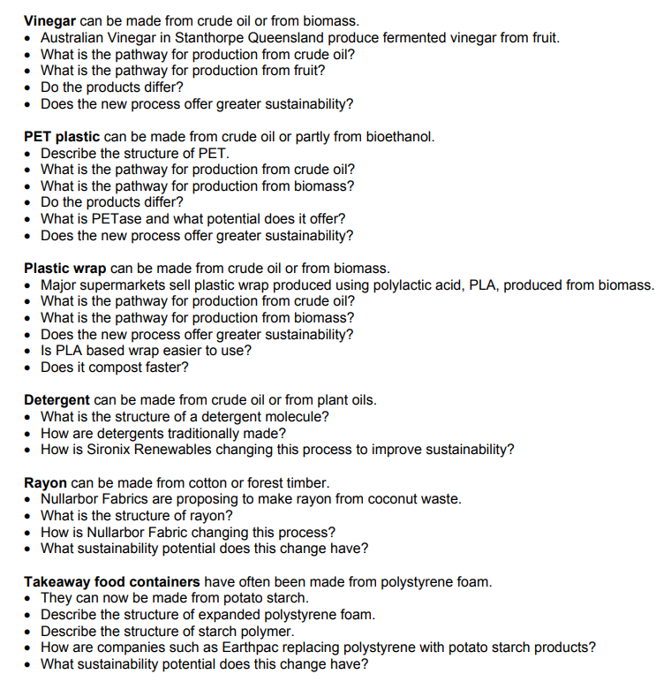

**Title**: Modelling organic molecules: Area of Study 2 How are materials quantified and classified?

**Task**

Students will have one week to prepare to model some organic structures through a series of structured questions. In the week beforehand you should

* review the bonding in hydrocarbons and organic functional groups.
* review the structure of different types of isomers.
* select how you will model the molecules (eg Minit bonding kit, plasticene and toothpicks, lollies and toothpicks)
* ensure you have the raw materials required to show your models

On the day of the SAC task you will be supplied with a large piece of poster paper on which to sit your models and to write your explanations on as to what the models are showing.

**SAC**

Draw a grid on your poster paper, matching the grid below – use the whole of an A3 sheet.

Choose any **four** of the questions below and build a model to address the question. Use the third column to explain what your model shows.

|  |  |  |
| --- | --- | --- |
| Molecule and  formula | Model | What your model shows |
|  |  |  |
|  |  |  |
|  |  |  |
|  |  |  |

**Questions**

* alkane series and their shapes. This type of drawing does not do justice to the

shape and length of a hydrocarbon. Provide a model to improve on this.

* melting points of alcohols differ significantly from those of alkanes. Model why this is so.
* structural isomers. There are several structural isomers of C4H10O. Model these.
* melting points in a homologous series. Model why the melting points change with molecule length.
* solubility in water. Water and methanol are very miscible liquids. Model why this is the case.
* compare the structures of the alkane, alkene and alkyne that has three carbon atoms.
* construct all the structural isomers of hexane
* construct some models that you can use to explain IUPAC nomenclature.
* construct models of the molecules of useful organic compounds.

**Information for teachers**

**Title**: Modelling organic structures.

**Suited to**: Unit 1: Area of Study 2 - How are materials quantified and classified?

**Student design reference**: *Students may construct models to visualise the similarities and differences between families of organic compounds*

**Key knowledge**: To be selected from

* the grouping of hydrocarbon compounds into families based upon similarities in physical and chemical properties.
* representations of organic compounds (structural and semi-structural formulas)
* naming according to IUPAC guidelines, including structural isomers up to C5
* materials and products used in everyday life that are made from organic compounds.

**Key Skill:** Analyse, evaluate and communicate scientific ideas, in particular

* analyse and explain how models and theories are used to organise and understand observed phenomena and concepts related to chemistry, identifying limitations of selected models/theories

**Scope**: Inform students 2-3 weeks before the task, that

* students will need to choose the style of their models and the materials that this choice will entail. Possible choices include plasticene, polystyrene foam balls, toothpicks, straws, lollies, clay, modelling kits.
* the task will be completed under test conditions.
* Students will need to choose the questions they intend to answer.
* They will need to explain and annotate their models.

**Possible marking scheme**: 5 marks per question, allocated as

* 3 marks for the models (accuracy, usefulness and innovtiveness)
* 2 marks for annotations and explanations of the chemistry of the models.

**Unit 1-2 Chemistry SAC task: Application of chemical concepts to a real-life context**

**Title:** Green steel production

**Background**

Iron is the most used metal on Earth and Australia is the world’s leading exporter of iron ore, the raw material used in the production of iron and steel. In 2021 world iron production was 2.5 x 109 tonnes.

Iron is found in the Earth’s crust as a variety of ores but the two most abundant ones are

* haematite, Fe2O3 and
* magnetite, Fe2O4.

To obtain relatively pure iron, the oxygen in the ore must be removed. This is usually done by heating the ore with carbon (coal) in a blast furnace. The oxygen and the carbon combine to form CO2. There are several problems with this technology, such as the large quantity of coal required, the greenhouse gases produced and the energy required for the process.

**Blast furnace**

**Green steel**

The steel industry is very focused on the move to ‘green steel’ production, to lower the environmental impact of steel production. There are two important areas of focus in green steel research-

1. use of hydrogen gas generated by renewable energy to provide the energy needed by the steel industry.
2. use of alternatives to coal as the reductant to lower CO2 emissions and to lower the dependence of society on coal.

The focus of this task is on the latter area of research following the research of Professor Veena Sahajwalla and the University of NSW (UNSW).

**Task**

Your teacher will supply you with reading material on the trials UNSW is making with used car tyres as the source of carbon, rather than coal. You will have a week to read these articles and to prepare for a set of questions relating to

* the importance and uses of iron
* the structure of metal alloys (since steels are a range of alloys of iron
* the role of carbon in a blast furnace
* how tyres can replace carbon
* environmental gains offered by this process.

You may bring a double-sided set of notes to the SAC. The SAC will consist of a series of questions relating to the source material.

Possible questions

**Metals**

1. List the properties of most metals.

2. a. Compared to other metals,

* how do you think the durability of iron ranks?
* how do you think the strength of iron ranks?
* how do you think the melting point of iron ranks?

b. Considering your answers to part a. why do you think iron is the most used metal in the

world?

3. Why is iron not found pure in the Earth’s crust?

**Blast furnace**

4. Write an equation for the most important reaction taking place in a blast furnace.

5. Explain why carbon is added in large quantities to a blast furnace?

6. What gases are emitted in a blast furnace and why are emission levels so high?

**University of New South Wales: Green steel**

The University of New South Wales considers the use of car tyres in a blast furnace to be a very exciting innovation.

7. What are the car tyres replacing in the blast furnace?

8. What are car tyres made from?

9. Explain in detail how this innovation impacts-

a. total levels of greenhouse emissions

b. levels of landfill

c. the depletion of fossil fuel reserves

10. Car tyres burn easily, releasing significant amounts of energy.

Does this help or hinder a blast furnace?

**Alloys**

Steel is an alloy of iron

11. Explain what an alloy is.

12. Why add small amounts of elements such as carbon and chromium to iron?

* reflective annotations of one or more practical activities from a logbook
* a summary report of selected practical investigations

**Potato plastic**

(Adaptation of RSC method)

**Aim**: To make a bioplastic from the starch in potatoes. Glycerol is added to improve the performance of the plastic.

**Materials**

Clean potato! (100 g per group)

(I guess older potatoes might produce more starch but have not tested this)

Glycerol

0.1 M HCl 0.1 M NaOH pH paper

Food grater

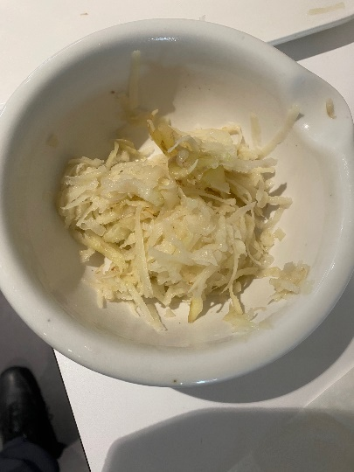Hot plate

Petrie dish

Large beakers

10 and 100 mL measuring cylinders

Large mortar and pestle

**Procedure**

**Extracting the starch Fig.1**

1. Grate about 100 g of potato Fig. 1. The potato does not need to be peeled, but it should be clean. Put the potato into the mortar.
2. Add about 100 cm3 of distilled water to the mortar, and grind the potato carefully. Fig.2
3. 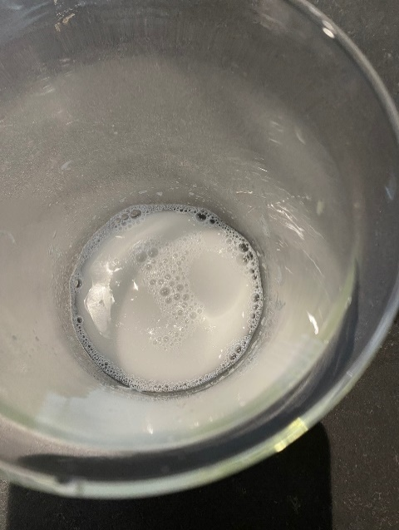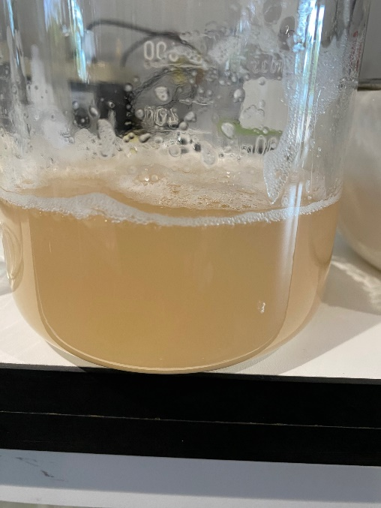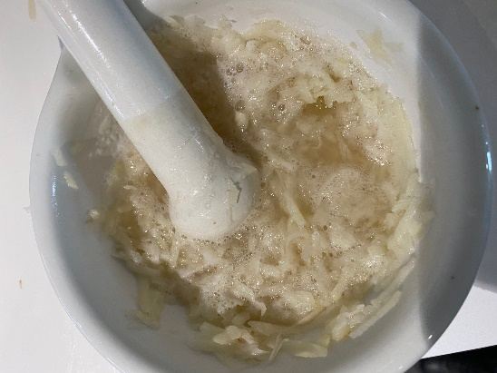Pour the liquid off through the tea strainer (Fig 3) into the beaker, leaving the potato behind in the mortar.

Fig. 2 Fig. 3 Fig. 4

1. Repeat steps 2 and 3 twice more.
2. Leave the mixture to settle in the beaker for five minutes.
3. Decant the water from the beaker, leaving behind the white starch which should have settled in the bottom. Fig. 4. Put about 100 cm3 of distilled water in with the starch and stir gently. Leave to settle again and then decant the water, leaving the starch behind.

**Making the plastic film**

1. Put 22 mL of water into the beaker and add 4 g of the potato starch slurry from the previous step , 3 mL of hydrochloric acid and 2 mL of glycerol).
2. 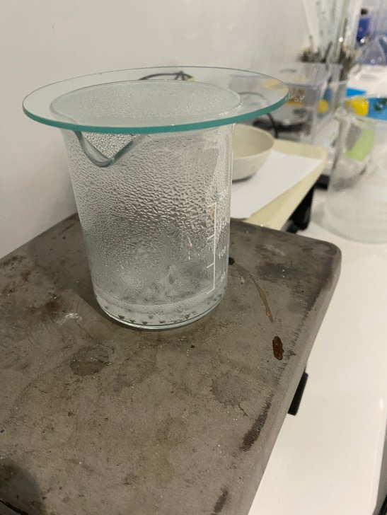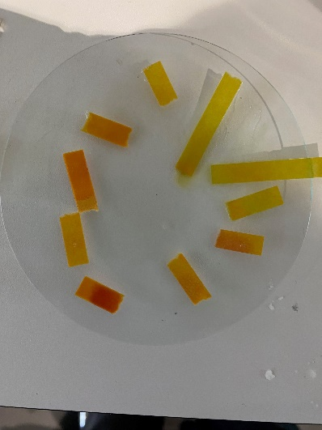Put the watch glass on the beaker and heat the mixture on a hot plate. Fig. 5 Bring it carefully to the boil and then boil it gently for 15 mins. Do not boil it dry. If it looks like it might, stop heating.

Fig. 5 Fig. 6

1. Dip the glass rod into the mixture and dot it onto the indicator paper to measure the pH. Add enough sodium hydroxide solution to neutralise the mixture, testing after each addition with indicator paper. Fig. 6) You will probably need to add about the same amount as you did of acid at the beginning (3 mL).
2. You can then add a drop of food colouring and mix thoroughly. Fig. 7
3. Pour the mixture onto a labelled petri dish or white tile and push it around with the glass rod so that there is an even covering.
4. Repeat the process, but leave out the glycerol. (Left side of Fig 8)
5. 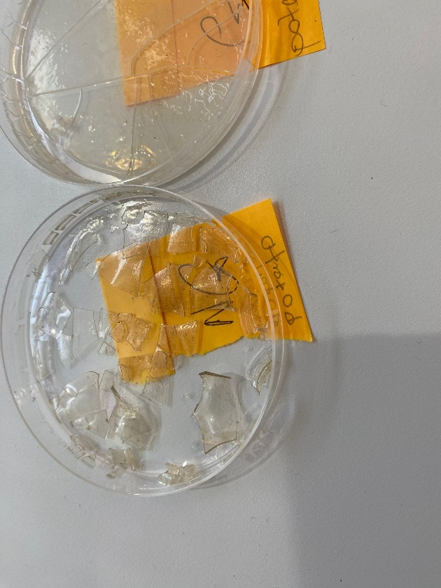Label the mixtures and leave them to dry out. It takes about one day on a radiator or sunny windowsill, or two days at room temperature. Alternatively, use a drying cabinet. It takes about 90 mins at 100 °C.

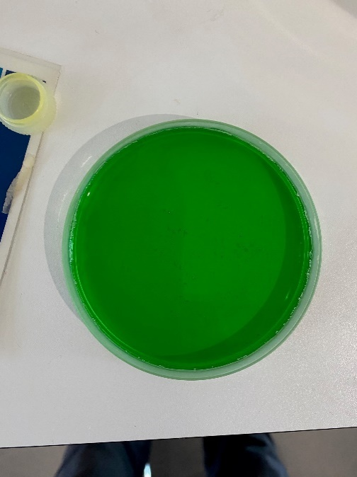

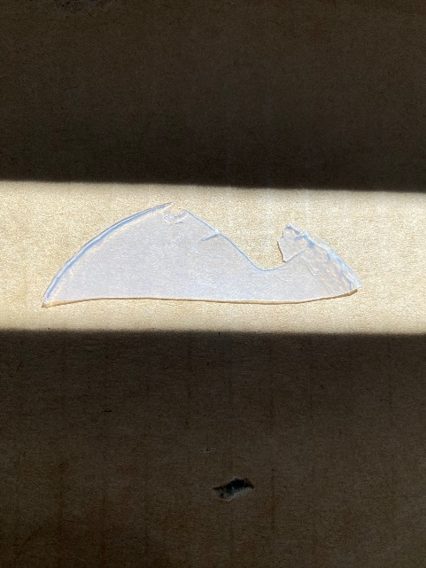

Fig. 7 no glycerol glycerol glycerol

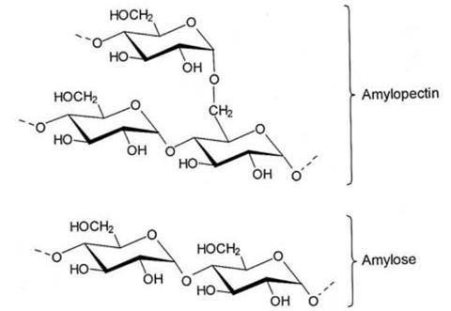**Discussion**

The polymer you are extracting is of course starch. Potato starch is a

blend of the branched amylopectin and the linear amylose. The linear

amylose forms the better film.

The HCl added in the experiment breaks some of the crosslinks in

amylopectin, increasing the amylose content.

The glycerol acts as a plasticiser. It holds water in the starch structure

so the structure is less likely to crack.

This experiment could be done as an investigation. Would basmati rice with its high amylose content form a good film? Does citric acid also act as a plasticizer as other texts suggest? Does the age of the spuds matter?

The photos below are from testing normal rice in the same way as the potatoes above. The sample on the left has no glycerol and is hard and brittle, the same on the right has glycerol and is flexible like a latex glove.

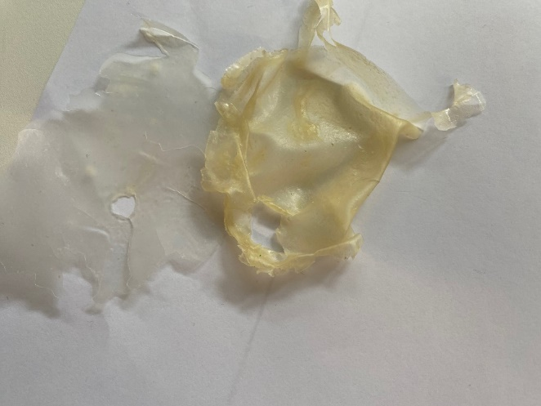

**Unit 1-2 Chemistry SAC task: Media File**

**Topic**: Innovations in plastic recycling

**Task**

You are presented with two related articles on the innovations on plastics recycling of Licella and other companies.

* Article 1: Licella’s proposal to develop the plastic recycling capacity of Timor Leste. The technology proposed is new in that it does not remould the plastic, instead it breaks it down to a synthetic oil.
* Article 2: The use of this same technology to recycle waste plastic to new, food-grade polymers.

You will have one week between receiving these articles and completing your SAC task during a class,

Comment for teachers: Articles like these should enable students to respond using the chemical concepts they are studying so the response is not just ‘opinion’. Good students should be able to explain why thlis form or recycling is very different from more common forms where a plastic is remoulded to a product with inferior properties. Students should also be able to draw the structures of propene and polypropene to further demonstrate their understanding. They can also reflect on the sustainability impact of this technology.

You need to read both articles and to respond to the information presented.

Your response should

* demonstrate an understanding of the chemistry of this new form of recycling
* show structures of relevant materials mentioned
* explain how this new process differs from conventional recycling
* discuss the sustainability impact of this technology
* incorporate a conclusion as to your opinion on the importance of this technology.

Your response might take the form of a written report or poster or slideshow or other form negotiated with the teacher.

A possible rubric that could be used to assess student responses might utilise the following five criteria:

* Clarity of communication
* Explanation of the sustainability impact
* Understanding of the chemistry of the processes
* Analyse, evaluate and communicate scientific ideas
* Construct evidence-based arguments and draw conclusions

<https://www.foodanddrinkbusiness.com.au/news/aussie-first-soft-plastic-food-wrapper-made-from-recycled-material>

**Chemistry SAC task: Summary report of practical investigations**

Summary report of selected practical investigations into the properties of acids and bases

**Scope**

Students conduct a series of investigative learning tasks on acids and bases. They then answer directed questions to explain the links between acids and bases theory and experimental behaviour.

**Part A: Acids and Bases Introduction**

You might already have some notions about what acids and bases are. With your partner complete the following tasks.

**Task One (Prior Knowledge)** – List as many examples of acids and bases as you can (name and/or formula)

**ACIDS BASES**

**What makes something an acid?**

________________________________________________________________

________________________________________________________________

**Properties of acids and bases**

You are provided with 5 samples of liquids, labelled from 1 to 5.

Add a small piece of magnesium to a dimple tray.

Add about 1 mL of liquid 1. Record your observations.

Repeat for all 5 liquids.

Add a small piece of blue litmus paper to liquid 1. Record your observations.

Repeat for all 5 liquids.

Repeat using red litmus.

What conclusion can you draw bout the properties of acids?

What conclusion can you draw bout the properties of acids?

Are there liquids that are neither acid nor base?

The liquids you used were:

1. NaOH 2. H2SO4 3. Water 4. HCl 5. KOH

Complete the following table

|  |  |  |
| --- | --- | --- |
| Acid and its formula | Neutral and its formula | Base and its formula |
|  |  |  |
|  |  |  |
|  |  |  |
|  |  |  |
|  |  |  |

**Acids/bases and their formulas**. Is there a way of using the chemical formula to define an acid?

________________________________________________________________

________________________________________________________________

**Part B: pH**

pH is a measure of how strong an acid or a base is. We can test pH by adding an indicator, either a paper strip or a few drops of universal indicator solution.

Activity for the front bench of the class. The class has a set of liquids on the front bench. (vinegar, lemon juice, milk, baking soda, dilute caustic soda etc) Test the pH of each and line the liquids up in order of pH.

Use the large paper provided to make a pH line and place the liquids on the line.

Do the results match what you would expect?

Make a summary of how pH works – what is the pH of acids? Bases? What happens to pH as the acid gets stronger?

**Part C: Reactions of acids**

**Acids plus carbonate**

Add a spatula of sodium carbonate to a test tube. Add some HCl. Test the gas produced with a match.

What happened to the match? _____________________________

Which gas is produced? ________________________

Write a balanced equation for the reaction.

________________________________________________________________

Repeat the reaction using calcium carbonate.

Write an equation for the reaction.

________________________________________________________________

Write a general equation for the reaction occurring between an acid and a carbonate.

________________________________________________________________

**Acids plus metals**

Add a small piece of magnesium to some hydrochloric acid in a test tube. Test the gas.

Identify the gas. ___________________________

Write a balanced equation for the reaction occurring when a pop test occurs.

________________________________________________________________

Write a balanced equation for the reaction occurring between the magnesium and the hydrochloric acid.

________________________________________________________________

Add a small piece of zinc to sulphuric acid.

Write a balanced equation for this reaction.

________________________________________________________________

Write a general equation for the reaction occurring between an acid and a metal

________________________________________________________________

**Acids and bases**

Add a few mL of hydrochloric acid to a test tube.

Add a few drops of indicator.

Add sodium hydroxide until there is a colour change.

Is there a gas produced? ____________________________

Write a balanced equation for the reaction occurring.

________________________________________________________________

Repeat this procedure using sulphuric acid and potassium hydroxide.

Write a general equation for the reaction between an acid and a base.

**Similar task for reactivity of metals**

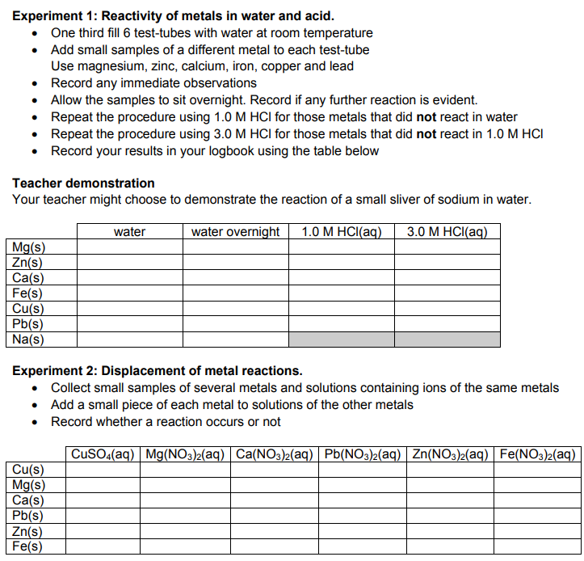

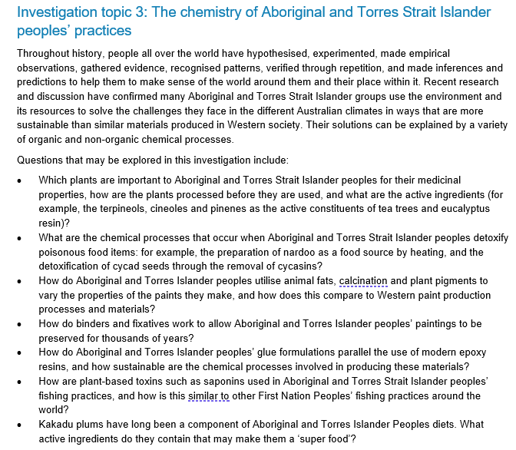

**Primary data: colorimeter**

**Unit 1-2 Chemistry SAC task**: Analysis and evaluation of generated primary data

**Title**: Colorimeter and concentration

**Background**

A colorimeter (UV-visible spectrophotometer) can be used to determine the concentration of a coloured solution. An essential part of this process is the construction of a calibration curve from standard solutions.

This task also provides students with experience in diluting solutions accurately.

You will be supplied with a 0.500 M CuSO4 solution. You will prepare several dilutions of this solution, test their absorbance in a colorimeter and use the data to prepare a calibration curve. You will then use the calibration curve to determine the concentration of an unlabelled CuSO4 solution.

**Method**

You need to dilute the 0.50 M CuSO4 solution to prepare 100 mL solutions of the other concentrations shown in the table. Complete the table to determine the volume of 0.500 M solution you require and the volume of water you require for each solution.

|  |  |  |  |
| --- | --- | --- | --- |
| Concentration CuSO4 | Volume 0.50 M CuSO4 | Volume water | Absorbance |
| 0.5 | 100 | 0 |  |
| 0.4 |  |  |  |
| 0.3 |  |  |  |
| 0.2 |  |  |  |
| 0.1 |  |  |  |

Test one of your solutions in a colorimeter or spectrophotometer to determine the appropriate wavelength to maximise absorption (red light).

Record the absorbance of each solution.

Construct a calibration curve.

Your teacher will supply you with a solution of unknown concentration. Use your calibration curve to determine its concentration.

**Commentary for teachers**

The emphasis in this task is on collecting, graphing and analysing data so the student report should focus on these aspects.

Student report to include

* Table above completed
* Calibration curve with appropriate scales and line of best fit
* Commentary on the linearity and accuracy of the calibration curve.
* Concentration of unknown solution determined.

This task offers the opportunity for the results of each group to be collated for further commentary on the accuracy of this technique.

**Unit 2 Investigation: Electrical conductivity of salt solutions**

*This task could be adapted to be a typical prac or it could be used as the Investigation where students selected different aspects of the data to investigate. Sample questions are provided.*

**Electrical conductivity of salt solutions**

Electrical conductivity can be used to determine the concentration of salt solutions. The apparatus will include a power supply, electrodes and an ammeter.

**Initial testing** : to show that conductivity does change with concentration.

Have different groups measure the electrical conductivity of a salt solution. Use different volumes, different size beakers and ask one group to heat their sample to 40 0C before testing.

What do you observe at the electrodes?

Ask each group to write the conductivity value they obtained on the board.

How do the values compare?

If you measure the conductivity of a solution of unknown concentration, how will you find the concentration from the conductivity reading?

Conclusion: Student results are likely to be all over the place due to a lack of control of variables – electrode depth, size, separation, temperature etc. What variables are there to take into account in this experiment?

**Your task is to investigate** this process to improve the consistency of the results obtained. It should be that each group can take a solution and obtain the same result when testing conductivity.

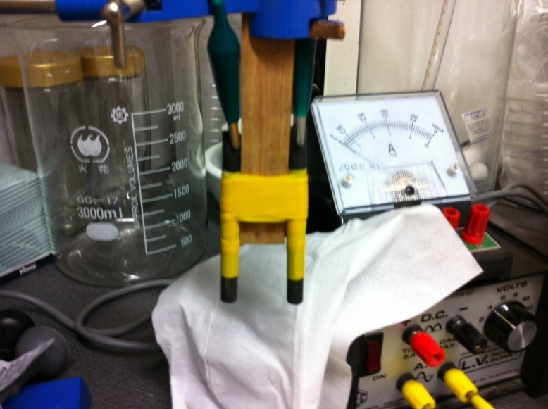You need to develop a question and a hypothesis and to outline the course of action you will follow to conduct your investigation.

Note:

To get good results,

* Always use 25 0C
* Keep electrodes fixed depth and separation
* Use calibration curve
* Use AC current and equipment

**Other questions that could be used.**

1. a. Explain why salt solutions conduct but pure water does not.

b. Do you think this process will work with sea-water? Explain your answer.

c. Do you think this process will work for all ionic substances? Explain your answer.

2. Explain why the experiment design has to be more complex than just putting electrodes into the solution and turning the current on.

3. a. Explain what the issue is with electrode depth.

b. Why would this affect the conductivity?

c. Suggest two ways of controlling this problem.

4. a. Explain what the issue is with electrode separation.

b. Why would this affect the conductivity?

c. Suggest two ways of controlling this problem.

5. a. Why do gases form at the electrodes?

b. What are the gases?

c. Why might this affect testing?

6. Why was a series of standard solutions prepared?

7. a. Draw a calibration curve and line of best fit for the data – conductivity vs concentration.

b. What does your graph show?

8. What was the concentration of the solution that was teste next?

9. a. How does conductivity change with temperature?

b. Suggest a reason for this observation.

10 . How did conductivity change with electrode separation?