This task could be adapted to be a typical prac or it could be used as the Investigation where students selected different aspects of the data to investigate. Sample questions are provided.
Unit 2: Electrical conductivity of salt solutions
Electrical conductivity can be used to determine the concentration of salt solutions. The apparatus will include a power supply, electrodes and an ammeter.
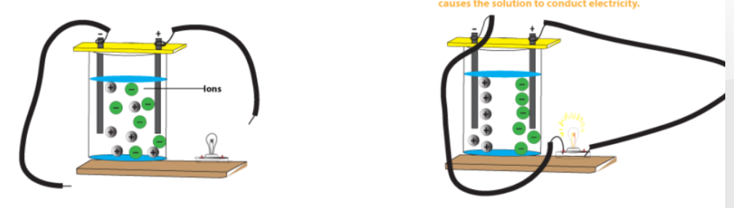
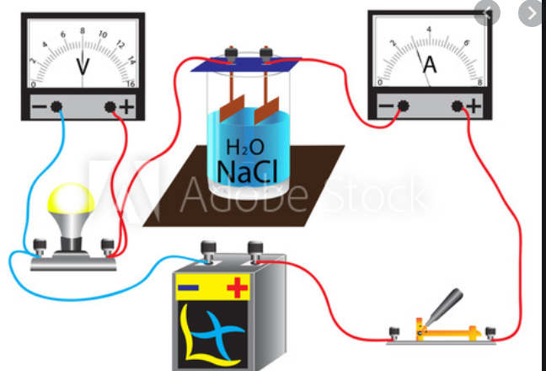
The ions in the solution move to the electrodes. The more ions, the higher the conductivity.
1. a. Explain why salt solutions conduct but pure water does not.
b. Do you think this process will work with sea-water? Explain your answer.
c. Do you think this process will work for all ionic substances? Explain your answer.

2. Explain why the experiment design has to be more complex than just putting electrodes into the solution and turning the current on.
3. a. Explain what the issue is with electrode depth.
b. Why would this affect the conductivity?
c. Suggest two ways of controlling this problem.

4. a. Explain what the issue is with electrode separation.
b. Why would this affect the conductivity?
c. Suggest two ways of controlling this problem.

5. a. Why do gases form at the electrodes?
b. What are the gases?
c. Why might this affect testing?

6. Why was a series of standard solutions prepared?
7. a. Draw a calibration curve and line of best fit for the data – conductivity vs concentration.
b. What does your graph show?
8. What was the concentration of the solution that was teste next?
9. a. How does conductivity change with temperature?
b. Suggest a reason for this observation.

10 . How did conductivity change with electrode separation?

