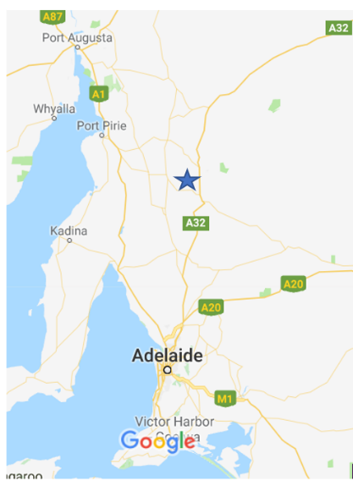
South Australian Tesla project
This project is known as the Hornsdale Power Reserve located at Jamestown,
above Adelaide. Neoen is the company operating the plant.

The battery complex is linked to a wind farm so that renewable energy is used to
charge the batteries.

Size: 100 MW: Capable of powering 50000 homes for over an hour.
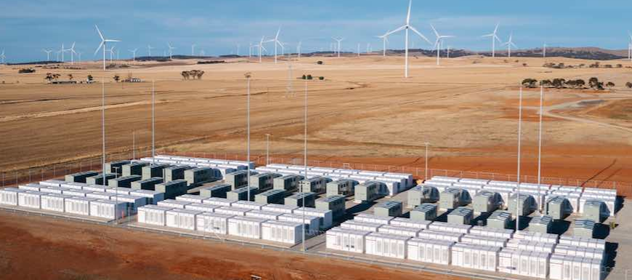

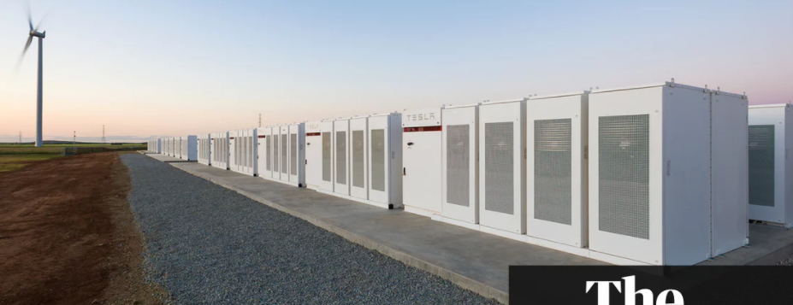
It is NOT 1 big battery. It is thousands of small batteries like the ones in your phone all connected together. This is shown in the cross-section diagram below.

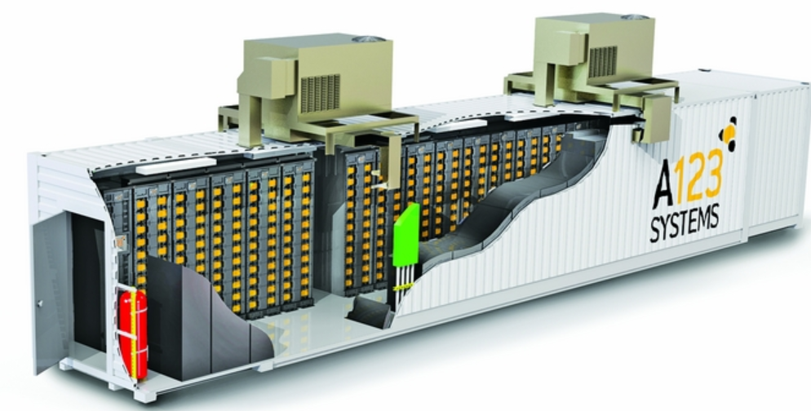

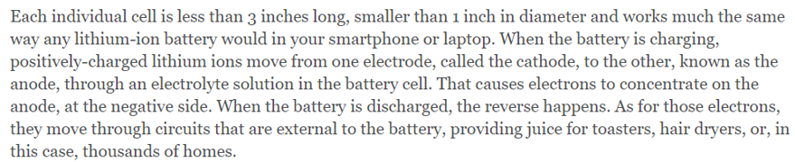

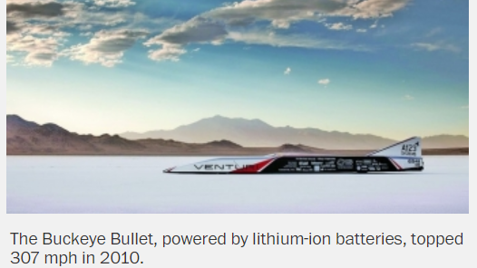
Lithium-ion batteries have been prominent for several years now.

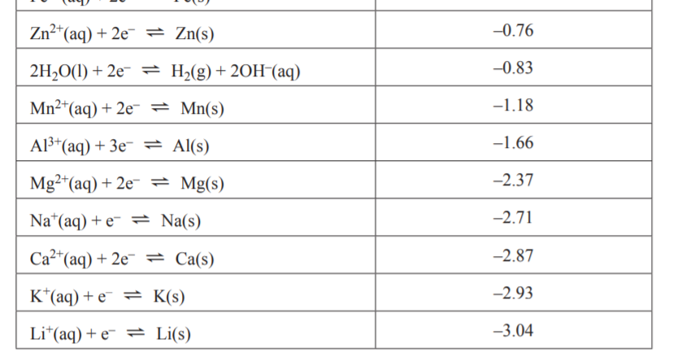
Why lithium? As the lowest metal on the electrochemical series it offers the highest potential voltages. It is also the lightest metal of all.

Battery Chemistry: Very complex – require conducting polymers as lithium reacts violently with aqueous solutions. Electrode materials are also very high tech.
