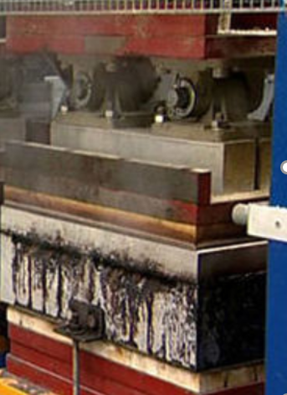

Tray formed

**Biodegradable plastic from potatoes**

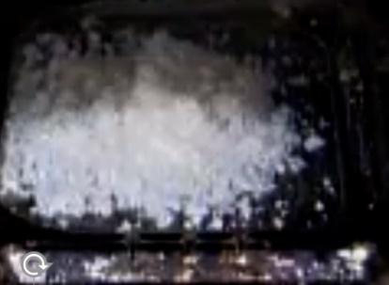

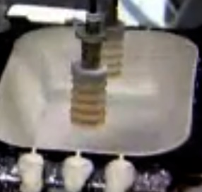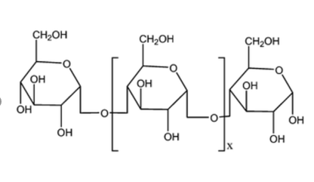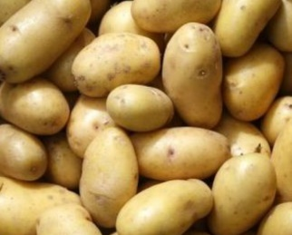

As potatoes are processed for chips, significant amounts of starch are washed off. This can be added to cellulose and a polymer produced.

Starch is a natural polymer, the cellulose adds strength to it.

Powdered mixture of starch, cellulose and wax added to a mould.

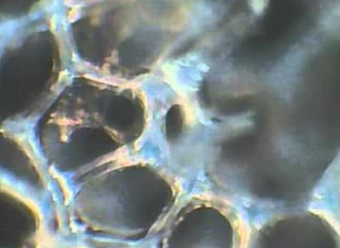

Under a microscope, the product can be seen to be a porous foam

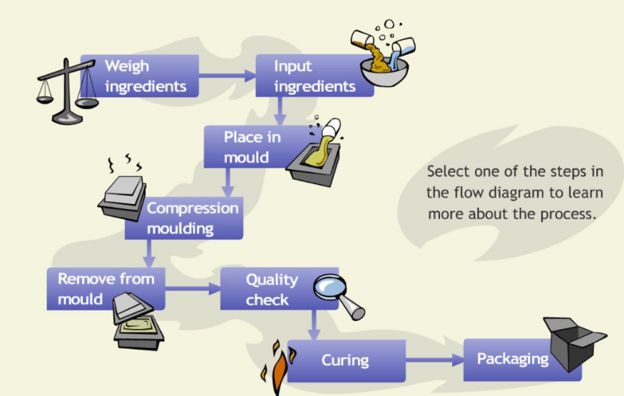

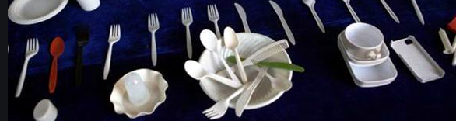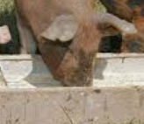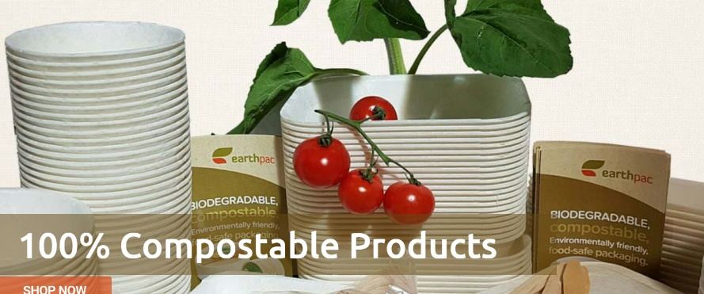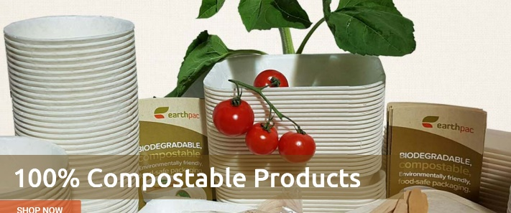

Waste is fed to the pigs!