Titrations: The concentration of an acid is determined from its reaction with a base of known concentration and vice versa.

The concentration of a sample of oxalic acid (HOOCCOOH) is determined by a titration against 0.150 M NaOH.

- Explain what a primary standard is.

_____________________________________________________________________________

- Describe how you would prepare a 250 mL standard solution of 0.05 M Na₂CO₃.

_____________________________________________________________________________

_____________________________________________________________________________

- Use an equation to explain why NaOH is not suitable as a primary standard.

_____________________________________________________________________________

If oxalic acid is a weak acid, explain how you would choose a suitable indicator for this reaction. Refer to the diagrams below.
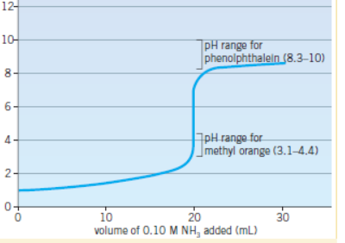
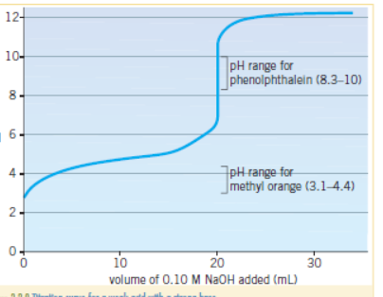

________________________________________________________________________________

- Oxalic acid is a diprotic acid. Write a balanced equation for its reaction with NaOH.

____________________________________________________________________________

Titration data: 20 mL of oxalic acid added to a 250 mL volumetric flask and made up to the mark with
de-ionised water. The diluted solution is added to the burette.

20 mL aliquots of 0.15 M NaOH used.

Titres 21.95 21.10 20.90 21.05 mL

Calculate the concentration of the undiluted oxalic acid.

____________________________________________________________________________

____________________________________________________________________________

____________________________________________________________________________

- What will each of the following be rinsed with?
volumetric flask ______________ pipette _____________

burette ___________________ conical flasks ________________

- Give an example in a titration of a

Random error ______________________________________________________

Systematic error ______________________________________________________

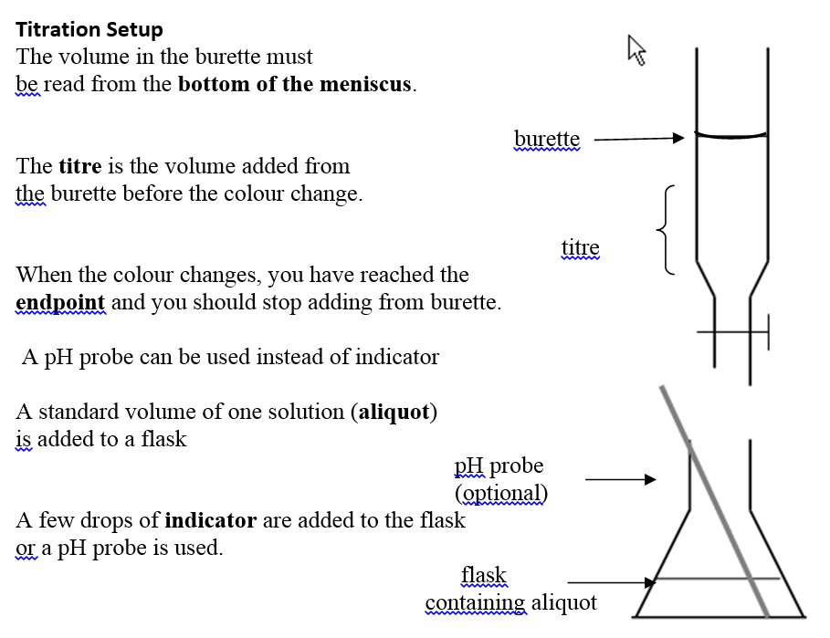
Other

Solutions
1. Solution you have prepared yourself (or purchased) that you are confident of an accurate
concentration – made from stable compound of known formula and purity.
2. Calculate and weigh required mass of Na₂CO₃. Add to volumetric flask and half-fill with de-ionised
water. Shake to dissolve, make up to the mark with de-ionised water.
3. NaOH reacts with both CO₂ and H₂O from the air eg. 2NaOH + CO₂(g) Na₂CO₃(aq) + H₂O(l)
4. C₂O₄H₂(aq) + 2NaOH Na₂C₂O₄(aq) + 2H₂O(l)
5. volumetric – water: pipette – solution: burette – solution: conical - water
6. random – judging the colour change systematic – volumetric flask not accurate

Concentration: Concordant titres 21.10 20.90 21.05 gives mean titre of 21.02 mL

n(NaOH) = c x V = 0.15 x 0.02 = 0.00300 mol
n(oxalic) = ½ n(NaOH) = 0.0015 mol

c(oxalic diluted) = 0.0015/0.02102 = 0.0714 M c(undiluted) = 0.0714 x 250/20 = 0.892 M

