**Titrations of organic acids**

Acid/base titrations are a traditional method of analysis used to determine the concentration of acid or base solutions. This technique can be applied to organic acids like ethanoic acid in the same way it is used for inorganic acids such as hydrochloric acid. Most organic acids are weak acids so this must be taken into account in the experiment design.

The equivalence point is likely to be in the range of pH 8-10, suiting phenolphthalein as an indicator.

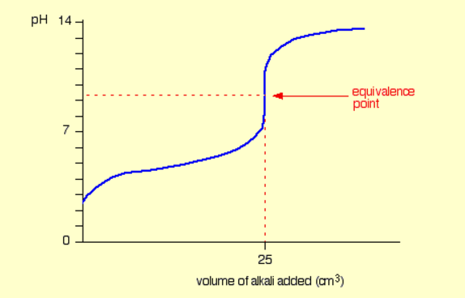

**Ethanoic acid**

**Experiment 1: Titration**

**Aim:** To determine the acid concentration in commercial vinegar.

**Materials**

Ethanoic acid

0.10 M NaOH

Burettes

Pipettes

Volumetric flasks

**Procedure**

1. Add 20.0 mL of commercial vinegar to a 250 mL volumetric flask

2. Make up to the mark with distilled water.

3. Use this solution to fill a burette.

4. Pipette 20.0 mL aliquots of NaOH solution into flasks.

5. Add a few drops of phenolphthalein indicator to each flask.

6. Perform titrations between the two solutions until concordant results are obtained.

**Titration of other organic acids**

**Propanoic acid (Propionic acid is the old name for this):** Titration for propanoic acid concentration using NaOH will work with phenolphthalein as easily as for ethanoic acid.

**Benzoic acid**. Can be titrated but is interesting as it is not highly soluble in water. Can be dissolved in ethanol then water added.

0.1 M solution requires 1.2 g of benzoic acid in 100 mL of solution.

Weigh benzoic acid. Add it to a 100 mL volumetric flask.

Add 40 mL of ethanol.

Make up to the mark with water.

Titrate using beakers on a magnetic stirrer as shown below.

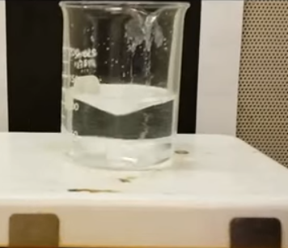

Benzoic acid reaction with NaOH

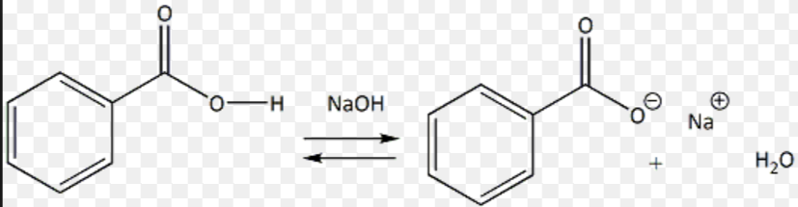

**Citric acid**: Can be titrated. Citric acid is triprotic so ratio of citric acid to NaOH will be 1:3.

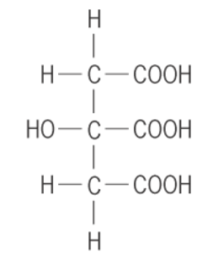

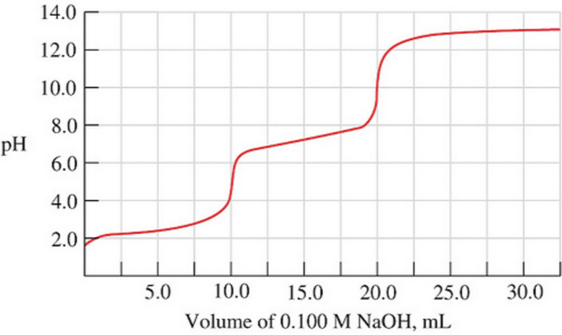

Diprotic acid. Expect to just detect the final equivalence point using phenolphthalein.

**Oxalic acid: Diprotic**.



Purity of citric acid.

Prepare mixtures of sugar and citric acid. Make a calibration curve. Test an unknown

Conductometric titration of ethanoic acid