SECTION A – Multiple-choice questions

Instructions for Section A
Answer all questions.
Choose the response that is correct or best answers the question.
A correct answer scores 1, an incorrect answer scores 0.
No mark will be given if more than one answer is completed for any question.
Marks will not be deducted for incorrect answers.

Question 1
The mass of calcium that has the same number of atoms as 20 g of helium will be closest to, in g,
- 2
- 40
- 100
- 200

Question 2
Which of the following is not 1.0 mole of the substance?
A. 31 g of phosphorous
B. 6.02 × 10²³ atoms of oxygen
C. 16 g of water, H₂O
D. 16 g of methane, CH₄

Question 3
42 g of nitrogen reacts exactly with 96 g of oxygen. The compound formed will be
A. NO
B. NO₂
C. N₂O
D. N₂O₅

Question 4
The principle behind the operation of a mass spectrometer is that
A. the larger the atom, the faster it moves.
B. the heavier an atom, the harder it to deflect.
C. faster atoms will deflect more than slower ones.
D. the heavier an atom is, the more its path will bend in a magnetic field.

SECTION A – continued
TURN OVER

Question 5
Select the alternative that gives the best explanation of a mole
A. amount of an element that has the same number of particles as 12 g. of carbon-12
B. amount of substance that has the same number of particles as 12 g of carbon-12
C. amount of a substance that has the same number of particles as 12 g of natural carbon
D. 12 grams of any substance

Question 6
The formula of glucose is C₆H₁₂O₆. The mass of 1 mole of glucose will be, in gram,
A. 30
B. 72
C. 144
D. 180

Question 7
The relative formula mass of ammonium sulfate, (NH₄)₂SO₄ is closest to
A. 114
B. 114 g
C. 132
D. 132 g

Question 8
A sample of NO₂ contains 5.4 × 10²⁴ atoms. The number of mole of NO₂ will be
A. 3
B. 4
C. 6
D. 9

Question 9
In a 1.0 kg sample of methane, the mass of hydrogen will be, in g,
A. 250
B. 500
C. 750
D. 800

SECTION A – continued

Question 10
Which of the following represents the greatest number of mole of oxygen atoms?
A. 96 g of oxygen atoms
B. 2.5 mole of ozone, O₃
C. 2.4 × 10²⁴ atoms of oxygen
D. 72 g of water

SECTION B- Short-answer questions

Instructions for Section B
Questions must be answered in the spaces provided in this book. To obtain full marks for your responses you should
- Give simplified answers with an appropriate number of significant figures to all numerical questions; unsimplified answers will not be given full marks.
- Show all workings in your answers to numerical questions. No credit will be given for an incorrect answer unless it is accompanied by details of the working.
Make sure chemical equations are balanced and that the formulas for individual substances include an indication of state; for example, H2(g); NaCl(s)

Question 1 (8 marks)
A schematic diagram of a mass spectrometer is shown below.

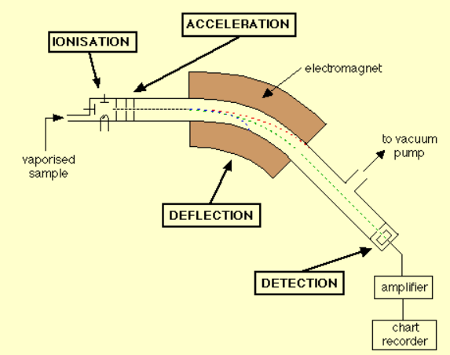

a. Elements can be passed into a mass spectrometer where they become charged.
i. What process is used to charge atoms in a mass spectrometer? 1 mark

______________________________________________________________________

ii. What two variables determine the degree to which an ion is deflected? 1 mark

______________________________________________________________________

SECTION B – continued

iii. When a sample of tin is passed into a mass spectrometer, there are ten different peaks
shown on its spectrum. What does this tell you about the element tin? 1 mark

________________________________________________________________________

________________________________________________________________________

b. A mass spectrum of magnesium is shown below.
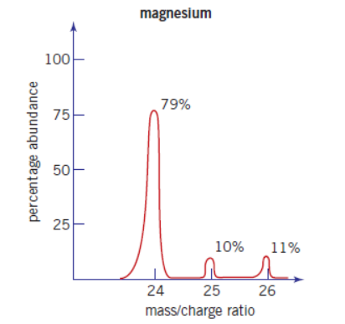

i. Use the mass spectrum to complete the table below for magnesium 3 marks
Isotope | Relative isotopic mass | Percentage abundance

ii. Use the data provided to determine the relative atomic mass of magnesium. 2 marks

___________________________________________________________________________

___________________________________________________________________________

SECTION B – continued
TURN OVER

Question 2 (8 marks)
The following questions refer to carbon dioxide, CO₂.

a. i. Calculate the relative molecular mass of carbon dioxide ______________ 1 mark

ii. Calculate the molar mass of carbon dioxide. _____________________ 1 mark

b. Calculate the percentage oxygen in carbon dioxide. 2 marks

___________________________________________________________________________

c. In 132 g of carbon dioxide,
i. how many molecules of carbon dioxide are there? 2 marks

__________________________________________________________________________

__________________________________________________________________________

ii. how many atoms are there? 2 marks

__________________________________________________________________________

Question 3 (4 marks)

a. Determine the number of mole of sulfur in 200 g 1 mark
___________________________________________________________________________

b. How many mole of sulfur is 1.28 x 10²⁵ atoms of sulfur? 1 mark
___________________________________________________________________________

c. Determine the number of mole of sulfur in 128 g of sulfur dioxide 1 mark

__________________________________________________________________________

d. How many atoms of sulfur in 128 g of sulfur dioxide? 1 mark

__________________________________________________________________________

Question 4 (5 marks)
A 5.232 g sample of a compound contains 1.392 gram of potassium, 1.992 g of oxygen and the remainder is chromium.
a. Calculate the empirical formula of this compound. 3 marks

___________________________________________________________________________

___________________________________________________________________________

___________________________________________________________________________

b. What is the percentage mass of oxygen in this compound? 2 marks

___________________________________________________________________________

___________________________________________________________________________

Question 5 (5 marks)
The molar mass of calcium phosphate, Ca₃(PO₄)₂, is 310.3 gmol⁻¹.

In 500 g, what is the

a. number of mole ____________________________ 1 mark

b. number of mole of phosphorous atoms ___________________________ 1 mark

c. number of mole of calcium ions ___________________________ 1 mark

d. number of mole of oxygen atoms ___________________________ 1 mark

e. number of oxygen atoms _____________________________ 1 mark

Question 6 (5 marks)
Calculate the mass of
a. 3.56 mole of copper

__________________________________________________________________ 1 mark

b. 0.50 mole of sulfur dioxide, SO₂ 2 marks

________________________________________________________________________

________________________________________________________________________

c. 0.380 mole of barium chloride, BaCl₂ 2 marks

________________________________________________________________________

________________________________________________________________________

Question 7 (5 marks)
Calculate the number of mole in
a. 68.0 g of aluminium

________________________________________________________________ 1 mark

b. 28.4 g of sulfur dioxide, SO₂ 2 mark

_________________________________________________________________________

__________________________________________________________________________

c. 4.50 tonne ( 1 tonne = 10⁶ g) of carbon dioxide, CO₂ 2 marks
_________________________________________________________________________

_________________________________________________________________________

