Triglycerides: Formed from the reaction of glycerol with 3 fatty acid molecules.

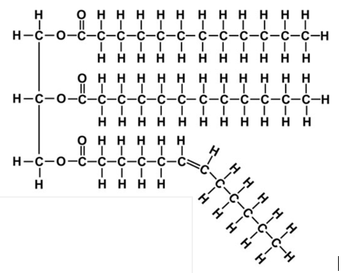
Use the molecule shown to answer the following questions.

- Circle the ester bonds on the molecule.

- Draw the structures of the three different products

formed when this molecule undergoes hydrolysis.

- Write a balanced equation for the complete combustion of the unsaturated fatty acid.

___________________________________________________________________

- Draw the structure of the methyl ester that could be formed from the saturated fatty acid.

- Which fatty acid will have the lowest melting point? Explain your answer.

________________________________________________________________

________________________________________________________________

- Explain how the original triglyceride is digested in the body.

________________________________________________________________

________________________________________________________________

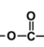
Solutions

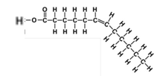
- There are 3 ester bonds.
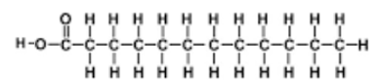
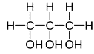
- Glycerol

- C₁₂H₂₄O₂(l) + 17O₂(g) 12CO₂(g) + 12H₂O(l)

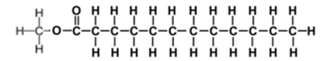

- The unsaturated fatty acid has the lower melting point. The C=C double bond makes bends in the long chain preventing the molecules packing together tightly. The dispersion forces between molecules will be weaker if they cannot pack together well.
- Triglycerides are digested mainly in the small intestine. Bile acts an emulsifier to break up large blobs of fat into smaller ones that lipase can hydrolyse much faster. Once hydrolysis occurs the fatty acids can be transported in the blood to body cells where they can be reassembled or stored in adipose tissue.

