Unit 2 TT3 Redox reactions Solns

SECTION A: Multiple-choice questions (1 mark each)
Question 1

Answer: D

Explanation:
Ag⁺(aq) + e⁻ Ag(s). This is reduction and silver ions will be the oxidant

Question 2

Answer: B

Explanation:
Br₂(l) + 2e⁻ 2Br⁻(aq) This is reduction.

Question 3

Answer: D

Explanation:
The reaction represented is Mg(s) Mg²⁺(aq) + 2e⁻ which is oxidation

Question 4

Answer: C

Explanation:
The oxidation state of both hydrogen and oxygen gases is zero. When they form a compound they form ions and electrons are transferred.

Question 5

Answer: B

Explanation:
Zn(s) Zn²⁺(aq) + 2e is oxidation

Question 6

Answer: C

Explanation:
2H⁺(aq) + 2e⁻ H₂(g) is reduction

Question 7

Answer: A

Explanation:
The half cell is for the reaction Fe³⁺(aq) + e⁻ Fe²⁺(aq). Platinum is inert and will not react. There is no iron electrode for iron metal to be the reactant.

Question 8

Answer: A

Explanation:
Oxidation is a loss of electrons so the electrode at which this occurs will be negative

Question 9

Answer: D

Explanation:
When aluminium corrodes it forms ions; Al(s) Al³⁺(aq) + 3e⁻

Question 10

Answer: D

Explanation:
The more reactive metal can replace the less reactive metal in solution. Option D is the only combination suitable.

SECTION B: Short-answer questions

Question 1
a. Complete and balance the following half equations;
i. Al(s) Al³⁺(aq) + 3e⁻ oxidation

ii. Fe³⁺(aq) + e⁻ Fe²⁺(aq) reduction

iii. I₂(s) +2e⁻ 2I⁻(aq) reduction
1 + 1 + 1 = 3 marks
b. see above
3 marks
Total 6 marks

Question 2
a. Mg(s) + Pb²⁺(aq) Mg²⁺(aq) + Pb(s) Mg= reductant, Pb²⁺ oxidant

b. 2Li(s) + MgBr₂(aq) 2LiBr(aq) + Mg(s) Li = reductant Mg²⁺ oxidant

c. Cl₂(g) + 2KBr(aq) 2KCl(aq) + Br₂(l) Cl₂ = oxidant Br⁻ = reductant
2 + 2 + 2 = 6 marks

Question 3
a. The second one will occur spontaneously
i. Cu(s) + LiBr(aq) _____________________________________

ii. 2Li(s) + CuBr₂(aq) 2LiBr(aq) + Cu(aq)

b. see above

c. Li reductant Cu²⁺ oxidant
2 + 1 + 2 = 5 marks

Question 4
a. sodium
1 mark
b. i. Ca 1s²2s²2p⁶3s²3p⁶4s²

ii. Ca²⁺ 1s²2s²2p⁶3s²3p⁶

iii. Calcium ions are accepting two electrons to form calcium atoms

iv. Ca²⁺(aq) + 2e⁻ Ca(s)

v. Reduced as electrons are being gained
1 + 1 + 1 + 1 + 1 = 5 marks

c. i. Na(s) Na⁺(aq) + e⁻

ii. Reductant
1 + 1 = 2 marks
Total 8 marks
Question 5
electron flow*
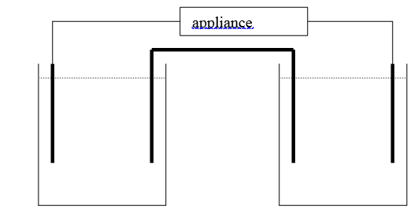
- *

zinc* nickel *
*Zn(NO₃)₂(aq) NiSO₄(aq)

*anode: Zn(s) Zn²⁺(aq) + 2e⁻ *cathode: Ni²⁺(aq) + 2e⁻ Ni(s)
* overall equation: Zn(s) + Ni²⁺(aq) Zn²⁺(aq) + Ni(s)

a.
8 marks
b. i. the level of nickel on it will build up

ii. it will gradually decay away
1 + 1 = 2 marks
Total 10 marks

Question 6
a. i. Fe to Fe³⁺

ii. oxygen gas
1 + 1 = 2 marks
b. water is a reactant in this process – it facilities the flow of electrons
1 mark

c. i. paint is a physical barrier that prevents oxygen and water contacting the iron

ii. cover in other materials such as bitumen or a more reactive metal. Use a sacrificial anode
1 + 1 = 2 marks
Total 5 marks

