Unit 2 Topic test 4: Concentration & volumetric analysis Student name: __________________

SECTION A – Multiple-choice questions

Instructions for Section A
Answer all questions.
Choose the response that is correct or best answers the question.
A correct answer scores 1, an incorrect answer scores 0.
No mark will be given if more than one answer is completed for any question.
Marks will not be deducted for incorrect answers.

Question 1
A supersaturated solution can be prepared by
A. adding the solute and stirring it vigorously until no further solid dissolves.
B. forming a saturated solution at 70 ⁰C and slowly adding a small volume of water.
C. forming a saturated solution at 60 ⁰C and heating it slowly to 70 ⁰C.
D. forming a saturated solution at 70 ⁰C and allowing to cool slowly to 60 ⁰C.

Question 2
Calculate the volume of water that needs to be added to 50 mL of 2.0 M KCl to lower the concentration to 0.40 M.
A. 10 mL
B. 50 mL
C. 200 mL
D. 250 mL

Question 3
The label of a 500 mL hand sanitiser lists the contents at 74%(v/v) propan-2-ol. The amount of propan-2-ol required to prepare this container is
A. 74 g
B. 148 mL
C. 370 mL
D. 370 g

Question 4
What mass of NaCl is required to prepare a 100 mL solution of concentration 0.50 M?
A. 2.93 g
B. 5.00 g
C. 7.93 g
D. 50.0 g
Question 5
Which of the following solutions contains the greatest mass of NaOH? (M = 40.0 g mol⁻¹)
A. 500 mL of 2.0 M NaOH
B. 500 mL of NaOH solution of concentration 20 g L⁻¹
C. 50 mL of 0.1 M NaOH
D. 1.0 L of 0.05 M NaOH

Use the following information to answer Questions 6 to 8
A titration is conducted to determine the concentration of an oxalic acid (C₂H₂O₄) solution. The oxalic acid is titrated against a 0.12 M KOH solution. The oxalic acid is added to the burette and 20.0 mL aliquots of KOH are used in the flasks under the burette. The mean titre obtained is
The equation for the reaction is 15.0 mL

C₂H₂O₄(aq) + 2KOH(aq) K₂C₂O₄(aq) + 2H₂O(l)

Question 6
The concentration of the oxalic solution is, in M,
A. 0.080
B. 0.16
C. 0.32
D. 0.64

Question 7
Oxalic acid is a weak acid that does not fully ionise when added to water. In a titration
A. this will make the method invalid as weak acids will react too quickly.
B. the titre will be very low.
C. the fact that oxalic acid is a weak acid will not impact the calculations.
D. the base used must also be a weak base to compensate for the acid being weak.

Question 8
In this titration
A. any indicator used should lead to the same mean titre.
B. the indicator will change colour when the equivalence point is reached.
C. the endpoint is when the acid and base are in the required mole ratio.
D. the equivalence point is when the acid and base are in the required mole ratio

Question 9
Underground water in many parts of Australia has a high calcium ion concentration. The calcium ions in the dam
A. cannot be removed through precipitation as all calcium compounds are soluble in water.
B. could be precipitated if a more reactive metal is added to the water.
C. could be precipitated from the water through the addition of sodium carbonate.
D. could be precipitated from the water through the addition of sodium nitrate.

Question 10
The arsenic level in a water supply is measured as 8 ppm. This is equivalent to
A. 8 mg of arsenic in every litre of water.
B. 8 mg of arsenic in 1.0 kg of water.
C. 8 mg of arsenic in every g of water.
D. 8 g of arsenic in every kg of water.

SECTION B- Short-answer questions

Instructions for Section B
Questions must be answered in the spaces provided in this book. To obtain full marks for your responses you should
- Give simplified answers with an appropriate number of significant figures to all numerical questions; unsimplified answers will not be given full marks.
- Show all workings in your answers to numerical questions. No credit will be given for an incorrect answer unless it is accompanied by details of the working.
Make sure chemical equations are balanced and that the formulas for individual substances include an indication of state; for example, H2(g); NaCl(s)

Question 1 (7 marks)
15 g of sodium hydroxide is dissolved in water, forming a 100 mL solution.

a. Determine the concentration of the sodium hydroxide in

i. g L⁻¹ __________________________________________________________ 1 mark

ii. %(m/v) _________________________________________________________ 1 mark

iii. molarity, M ____________________________________________________ 1 mark

b. 5 mL of the above solution is added to a 250 mL volumetric flask and deionised water is
added to make the volume 250 mL.
Calculation the molar concentration of the diluted solution. 2 marks

__________________________________________________________________________

__________________________________________________________________________

c. Calculate the mass of sodium hydroxide required to prepare 600 mL of 3.0 M NaOH. 2 marks

__________________________________________________________________________

__________________________________________________________________________

Question 2 (10 marks)
The graph below shows the solubility curves for three ionic substances.
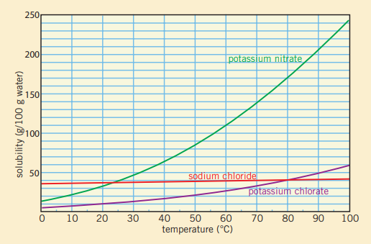

a. i. State two conclusions you can draw from the shape of the graphs provided. 2 marks

__________________________________________________________________________

__________________________________________________________________________

___________________________________________________________________________

ii. Explain how the solubility curve for potassium chlorate could be obtained. 3 marks

___________________________________________________________________________

___________________________________________________________________________

__________________________________________________________________________

___________________________________________________________________________

iii. Describe how you could prepare a supersaturated solution of potassium nitrate. (Include
the amounts you would use) 2 marks

__________________________________________________________________________

___________________________________________________________________________

b. i. Determine the mass of sodium chloride that will dissolve in 40 g of water at 60 ⁰C. 1mark

__________________________________________________________________________

___________________________________________________________________________

ii. After considerable stirring, a student is able to dissolve 10 g of potassium chlorate in 50 g
of water. Determine the likely temperature of the water. 2 marks

__________________________________________________________________________

___________________________________________________________________________

Question 3 (11 marks)
Water supplies near lead smelters usually contain elevated levels of lead ions. The lead ions can be removed from a water sample by adding sodium sulfate to precipitate the lead ions.

a. i. Write an equation for the reaction between lead ions and sodium sulfate solution. 2 marks

__________________________________________________________________________________

ii. Explain how this reaction can be used to purify a water sample. 3 marks

__________________________________________________________________________

___________________________________________________________________________

__________________________________________________________________________

___________________________________________________________________________

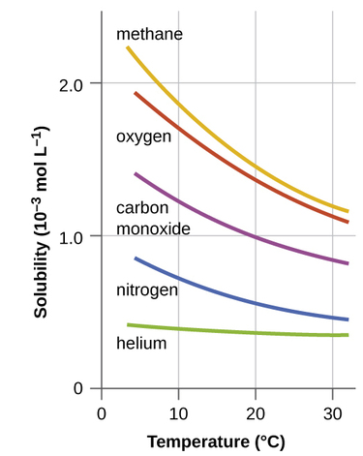
b. The graph below is taken from a university chemistry textbook.

i. Explain what this graph is showing. 2 marks

__________________________________________________________________________

___________________________________________________________________________

ii. How is the trend in this graph different from the trend in solubility of most ionic compounds? 2 marks

__________________________________________________________________________

___________________________________________________________________________

__________________________________________________________________________

iii. Global warming is leading to increased temperatures of our water supplies. Use this graph to explain one
reason why this temperature increase will add challenge to the survival of various marine species.
2 marks
__________________________________________________________________________

___________________________________________________________________________

__________________________________________________________________________

Question 4 (12 marks)
Ethanoic acid is the main active ingredient in vinegar. It is a weak acid with a chemical formula of CH₃COOH.
A student prepares a 0.15 M solution of sodium hydroxide to use in a titration to determine the concentration of ethanoic acid in a commercial vinegar solution.

a. i. Describe how the student could prepare a 250 mL of 0.100 M NaOH solution. 3 marks

__________________________________________________________________________

___________________________________________________________________________

__________________________________________________________________________

ii. What is the likely pH of the solution at the equivalence point of this titration? 1 mark

___________________________________________________________________________

iii. Suggest a suitable indicator for this titration. _____________________________________ 1 mark

iv. NaOH is used for this titration but it is not normally considered a suitable solution to use as a primary
standard. Explain what this statement means. 2 marks

___________________________________________________________________________

__________________________________________________________________________

b. The vinegar solution is added to the burette and 20.0 mL aliquots of NaOH are added to several flasks to be
placed under the burette. The titres obtained are 13.9 mL, 13.1 mL, 12.9 mL and 13.0 mL.

i. What should each of these pieces of equipment be rinsed with before the titration? 2 marks

burette ____________________________________________________

conical flasks ______________________________________________

ii. Use appropriate titres to determine the concentration of the ethanoic acid in M. 3 marks

___________________________________________________________________________

__________________________________________________________________________

___________________________________________________________________________

__________________________________________________________________________

END OF KEY TOPIC TEST

