Unit 2 Topic Test 5: Gases Student name: ________________

Section A: Multiple choice

Question 1
Kinetic molecular theory of gases suggests that
A. the volume of the particles in a gas sample is much smaller than the volume of the container.
B. the particles continually lose energy to the surroundings.
C. the forces acting between gas particles cause the particles to collide.
D. all particles in a gas sample have the same speed.

Question 2
Select the alternative that contains only one value for pressure.
A. 1.1 atm, 110 kPa, 1100 Pa
B. 1.2 atm, 130 kPa, 130000 Pa
C. 1.48 atm, 150 kPa, 0.150 kPa
D. 1.48 atm, 150 kPa, 150000 Pa

Question 3
A sample of hydrogen gas and a sample of helium gas are compared. The containers used have the same volume and the temperature and pressure of both gases is the same. The helium atoms will
A. have the same average velocity as the hydrogen molecules.
B. be the same number as there are hydrogen atoms.
C. have a lower average velocity than the hydrogen molecules.
D. have a lower kinetic energy than the hydrogen molecules.

Question 4
The principal greenhouse gases produced by human activities are:
A. CO₂ and methane only.
B. CO₂, methane and H₂O.
C. CO₂, CO and methane.
D. CO₂, methane and SO₂.

Question 5
A value for absolute zero temperature can be obtained by
A. placing a gas sample in your freezer.
B. extrapolating a volume vs temperature graph.
C. taking a gas sample to the Antarctic.
D. extrapolating a pressure vs volume graph.
Question 6
A sample of gas has a volume of 60 L and a pressure of 80 kPa. The temperature is held constant and the pressure is increased to 320 kPa. The volume will now be
A. 15 L
B. 30 L
C. 120 L
D. 240 L

Question 7
The volume of an 8.0 g sample of gas at SLC is 12.4 L. The gas could be
A. hydrogen.
B. helium.
C. methane.
D. oxygen.

Question 8
A 64 g sample of oxygen gas is at 26⁰ C and it has a pressure of 3 atm.
The values of pressure, number of mole and temperature that could be substituted into the general gas equation to give a volume in L would be:
A. n = 2, T = 26, P = 300
B. n = 2, T = 299, P = 300
C. n = 2, T = 299, P = 304
D. n = 4, T = 299, P = 304

Use the following information to answer Questions 9 and 10.
The reaction between hydrogen and chlorine gases is

H₂(g) + Cl₂(g) 2HCl(g)

A reaction produces 6.0 L of HCl gas. Assume all volumes in the question are measured at the same temperature and pressure.

Question 9
The volume of hydrogen gas required for this reaction was, in L,
A. 3
B. 6
C. 9
D. 12

Question 10
10 L of Cl₂ gas was used for the above reaction.
A. 10 L of H₂ must have been used also.
B. 7 L of Cl₂ remained after the reaction.
C. 4 L of Cl₂ remained after the reaction.
D. 12 L of reactants was consumed by the reaction.

SECTION B- Short-answer questions

Instructions for Section B
Questions must be answered in the spaces provided in this book. To obtain full marks for your responses you should
- Give simplified answers with an appropriate number of significant figures to all numerical questions; unsimplified answers will not be given full marks.
- Show all workings in your answers to numerical questions. No credit will be given for an incorrect answer unless it is accompanied by details of the working.
Make sure chemical equations are balanced and that the formulas for individual substances include an indication of state; for example, H2(g); NaCl(s)

Question 1 (10 marks)
The diagram below is a representation of the particles of gas in a container.
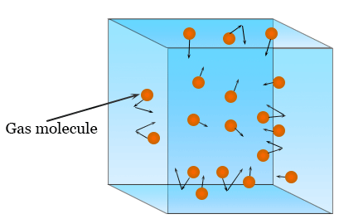
a. i. Describe the motion of an individual particle. 2 marks

_____________________________________________________________________________

______________________________________________________________________________

ii. Do all particles have the same velocity? Explain your answer. 2 marks

_____________________________________________________________________________

______________________________________________________________________________

iii. Describe the impact of an increase in temperature on this gas sample. 2 marks

_____________________________________________________________________________

______________________________________________________________________________
b. Hydrochloric acid, HCl, is a gas at room temperature. It contains significant dipoles. Will the dipoles affect
the motion of the HCl gas particles? Explain your answer. 2 marks

_____________________________________________________________________________

______________________________________________________________________________

ii. If the number of gas particles in the sample is doubled, is it likely that the volume of the particles will be
greater than the volume of the container? 1 mark

_____________________________________________________________________________

______________________________________________________________________________

c. Use the diagram provided to explain what ‘pressure’ means. 1 mark

__________________________________________________________________________

Question 2 (9 marks)
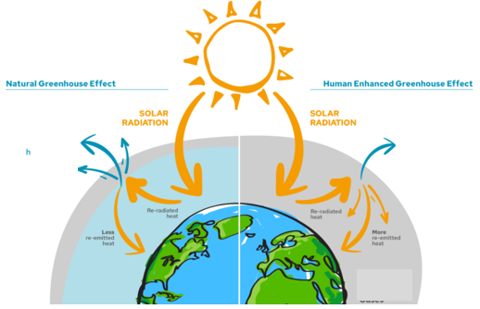
The diagram below contrasts the greenhouse effect on the left with the enhanced greenhouse effect, shown on the right.

a. i. Name three greenhouse gases. ____________________________________________ 2 marks

ii. Write an equation for a reaction that leads to significant CO₂ emissions. 2 marks

_______________________________________________________________________________

iii. State an example of a natural activity that is adding to emission levels. 1 marks

______________________________________________________________________________

b. Refer to the diagram provided to explain how human activity is causing an enhanced greenhouse effect. In
your answer, explain the impact on the Earth of changes in greenhouse gas emissions. 4 marks

_____________________________________________________________________________

______________________________________________________________________________

_____________________________________________________________________________

______________________________________________________________________________

Question 3 (6 marks)
a. i. A sample of gas has a volume of 4.8 L and a pressure of 0.80 atm. The volume of the container is reduced
to 1.2 L. Determine the new pressure in the container. (The temperature is fixed). 1 mark

____________________________________________________________________________________

ii. A sample of gas at 150 K has a volume of 36 L. The temperature is increased to 450 K. Calculate the
volume of the gas at the new temperature. (Pressure is held constant) 1 mark

___________________________________________________________________________________

b. Scientists use the Kelvin scale in preference to the Celsius scale in many applications. Explain why. 2 marks

_____________________________________________________________________________

______________________________________________________________________________

c. i. Convert to kPa: 0.85 atm __________________________________________________ 1 mark

ii. Convert to K: -120 ⁰C __________________________________________________ 1 mark

Question 4 (6 marks)
a. 50.0 g of nitrogen gas is added to a 35.0 L container at 28.4 ⁰C. Calculate the pressure the gas will reach in
the container. 4 marks

_____________________________________________________________________________

______________________________________________________________________________

_____________________________________________________________________________

______________________________________________________________________________

b. 96 g of hydrogen gas is added to a reactor and the conditions are adjusted to SLC.
Calculate the volume of the container. 2 marks

______________________________________________________________________________

_____________________________________________________________________________

______________________________________________________________________________

Question 5 (9 marks)
The equation for the complete combustion of ethane is

2C₂H₆(g) + 7O₂(g) 4CO₂(g) + 6H₂O(g)

a. i. If conditions are held constant and 30 L of ethane gas reacts, calculate the

volume of oxygen gas required for the reaction _______________________________ 1 mark

- volume of product gas formed. ____________________________________________ 1 mark

ii. If 25 L of ethane reacts with 40 L of oxygen gas, calculate the volume of the products formed.
(Assume conditions are held constant) 2 marks

______________________________________________________________________________

b. i. Determine the mass of CO₂ that could be formed from the complete combustion of 80 g of ethane?
3 marks
_______________________________________________________________________________

_________________________________________________________________________________

_________________________________________________________________________________

ii. Calculate the volume of the CO₂ gas, if the pressure is 125 kPa and the temperature is 22 ⁰C. 2 marks

_________________________________________________________________________________

_________________________________________________________________________________

END OF KEY TOPIC TEST

