Unit 2: Topic test
SECTION A – Multiple-choice questions

Instructions for Section A
Answer all questions.
Choose the response that is correct or best answers the question.
A correct answer scores 1, an incorrect answer scores 0.
No mark will be given if more than one answer is completed for any question.
Marks will not be deducted for incorrect answers.

Question 1
In the context of soil and water, the term ‘salt’ best refers to
A. any compound that has been added to the soil or water.
B. the sodium chloride that is present.
C. any traces of metals found as elements.
D. any ionic compounds present.

Question 2
Which of the following human activities is likely to have the most impact on salt levels in water supplies?
A. Farmers spreading fertilizer on crops.
B. Industries using high temperature incinerators to dispose of waste.
C. Fruit growers spraying pesticide onto orchards.
D. Emissions from cars.

Question 3
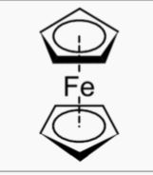
The sketch above is of ferrocene, a substance that has unusual magnetic properties and some pharmaceutical uses. Ferrocene is an example of
A. an ionic compound, as evident from the presence of iron.
B. an organometallic compound.
C. an organic compound as it contains non-metals only.
D. a dioxin molecule.

Use the following information to answer Questions 4 and 5
The sketch below is a diagram of a sample of water being tested.
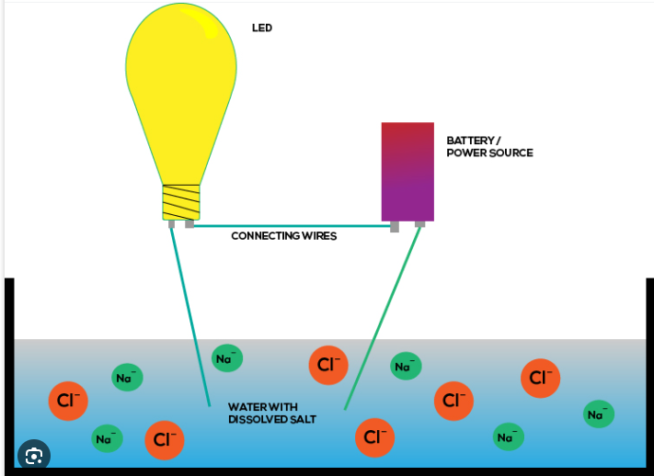
Question 4
The diagram demonstrates that
A. electrical energy can be generated from a salt solution.
B. water goes from a poor conductor of electricity to a good conductor if any salt is added.
C. the light globe intensity provides an indicator of salt concentration.
D. NaCl solutions are unusual as they are the only ionic solution that conduct electricity.

Question 5
If the light globe is glowing, it is because
A. electrons are flowing through the solution from the positive to the negative electrode.
B. electrons are flowing through the solution from the negative to the positive electrode.
C. sodium ions are flowing to the negative electrode and chloride ions to the positive electrode.
D. the sodium ions flow, while the chloride ions are fixed in position.

Question 6
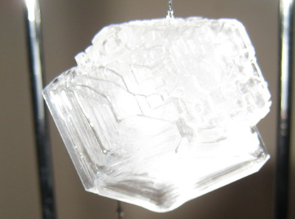
The diagram shows a crystal of sodium carbonate. If this crystal is heated, gently at first, but then strongly, it will be observed that

A. the crystal will melt at a low temperature.
B. the crystal structure collapses at low heat but the substance does not melt without a hot
flame.
C. the crystal with melt at high temperatures, releasing water as well.
D. no change will occur until a very hot flame causes the crystal to melt to a clear liquid.
Question 7
In gravimetric analysis, the concentration on an ionic solution is determined by
A. adding a compound to precipitate the metal and non-metal ions present.
B. adding a set volume of another liquid until a colour change occurs.
C. adding a solid to displace one of the ions present.
D. measuring the mass of precipitate formed when one of the ions is precipitated.

Question 8
A precipitate of barium sulfate is obtained by filtration. The two solutions mixed to produce this precipitate could be
A. barium nitrate and magnesium sulfate.
B. barium carbonate and lead sulfate.
C. barium nitrate and barium chloride.
D. barium nitrate and sodium nitrate.

Question 9
Silver nitrate solution is to be added to a water sample to determine the concentration of magnesium iodide in the sample. For this analysis,
A. the mass of magnesium nitrate precipitated will need to be determined.
B. an excess of silver nitrate needs to be used.
C. the mole ratio of silver nitrate to magnesium bromide will be 1:1.
D. an excess of magnesium iodide needs to be used.

Question 10
FeSCN²⁺(aq) solutions have a characteristic red colour. To use a colorimeter to analyse these solutions, the light source used should be
A. green, to ensure the solution reflects light.
B. green, to ensure the solution absorbs light.
C. red, to ensure the solution reflects light.
D. red, to ensure the solution absorbs light.

SECTION B- Short-answer questions

Instructions for Section B
Questions must be answered in the spaces provided in this book. To obtain full marks for your responses you should
- Give simplified answers with an appropriate number of significant figures to all numerical questions; unsimplified answers will not be given full marks.
- Show all workings in your answers to numerical questions. No credit will be given for an incorrect answer unless it is accompanied by details of the working.
Make sure chemical equations are balanced and that the formulas for individual substances include an indication of state; for example, H2(g); NaCl(s)

Question 1 (8 marks)
The salinity levels of soils and waterways varies across different regions of Australia. The nature of the salts present also varies.

a. State two ways in which various salts enter the soil or water systems. 2 marks

__________________________________________________________________________

_________________________________________________________________________

__________________________________________________________________________

b. Water in some regions is described as ‘hard’.
i. What is ‘hard’ water? 1 mark

__________________________________________________________________________

ii. Describe one solution for treating hard water. 1 mark

__________________________________________________________________________

__________________________________________________________________________

c. Tetraethyl lead, Pb(C₂H₅)₄, is an example of an organometallic compound. Use this compound
to explain this term. 2 marks

________________________________________________________________________

________________________________________________________________________

d. The presence of heavy metal salts in soil and water is usually a source of concern. Give an
example of a ‘heavy metal’ and why these metals are a problem. 2 marks

________________________________________________________________________

_________________________________________________________________________

_________________________________________________________________________

Question 2 (15 marks)
Salinity levels in many Victorian rivers and lakes are relatively high.
a. Give two guidelines to follow to ensure a water sample for testing is a representative one.
2 marks

___________________________________________________________________________

___________________________________________________________________________

b. Explain why electrical conductivity of a solution varies with salt concentration. 2 marks

___________________________________________________________________________

___________________________________________________________________________

c. You are asked to test the salinity levels of salt solutions in your school laboratory.
i. Describe the experimental set-up you will use. 3 marks

___________________________________________________________________________

___________________________________________________________________________

___________________________________________________________________________

___________________________________________________________________________

ii. State two steps you will take to ensure your procedure is repeatable. 2 marks

_________________________________________________________________________

_________________________________________________________________________
d. i. Use the data provided to draw a graph of conductivity versus concentration for a series of
standard salt solutions. 2 marks

Concentration M | electrical conductivity (amps cm⁻¹)
0.01 | 21
0.02 | 41
0.05 | 100
0.10 | 205

ii. Water samples from two separate salt lakes are now tested and their electrical conductivity
recorded.
Lake A: 34.2
Lake B: 54.3
Use your graph to determine the concentration of salt in both lakes. 2 marks

________________________________________________________________________
________________________________________________________________________
iii. Assuming that all of the salt is sodium chloride, how many gram of sodium chloride is
present in a 10 mL sample of water from Lake A? 2 marks

________________________________________________________________________

Question 3 (8 marks)
A series of blue copper sulfate solutions of known concentration are shown below.
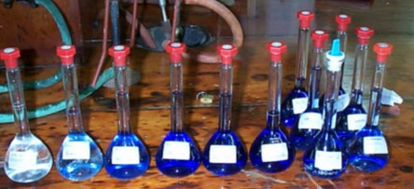
These solutions can be tested in a colorimeter as shown below.
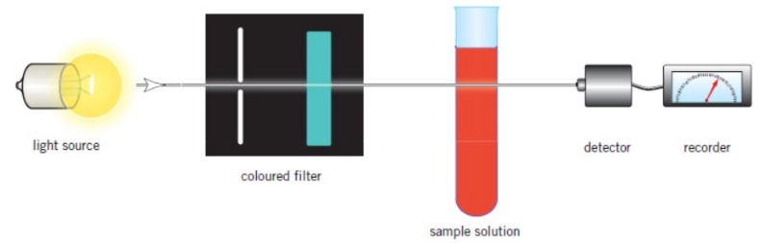
a. i. How is the radiation chosen for this analysis? 2 marks

______________________________________________________________________

_______________________________________________________________________

ii. How is a UV-visible spectrophotometer different from this colorimeter? 1 mark

___________________________________________________________________________

iii. How will the intensity of light arriving at the detector change with concentration? 1 mark

__________________________________________________________________________

b. The data obtained by testing the standard solutions is shown in the table below.

concentration of copper  mg L⁻¹ | absorbance
10 | 12
20 | 24
30 | 35
40 | 46
50 | 57
Use the axes provided to draw a calibration curve for copper solutions.
2 marks

c. A 10 mL sample from a hot water system is tested and its absorbance recorded as 40.
i. What is the copper concentration of this solution? _________________ 1 mark

ii. How many gram of copper is in this sample? 1 mark

_________________________________________________________________________

Question 4 (4 marks)
A 32.30 g sample of hydrated iron (III) nitrate is heated until the mass remains constant at 19.34 g.
Calculate the molar ratio of water of hydration of the iron nitrate. 4 marks

___________________________________________________________________________

___________________________________________________________________________

___________________________________________________________________________

___________________________________________________________________________

Question 5 (5 marks)
A 50.0 mL sample of water is known to contain lead ions (Pb²⁺). An excess of sodium chloride solution is added to the sample to produce a precipitate.
Initial mass of the filter paper: 0.923 g
Mass of filter paper and dried precipitate: 1.556 g

a. Write a balanced equation for the reaction occurring. 1 mark

___________________________________________________________________________

b. Use the data provided to determine the concentration of lead in the original sample in g mL⁻¹.
4 marks
___________________________________________________________________________

___________________________________________________________________________

___________________________________________________________________________

___________________________________________________________________________

END OF KEY TOPIC TEST

