Unit 3&4 Chemistry Trial Exam Solutions
Section A
1. D. South Australia does not use coal. Its % renewable energy is higher than that of Victoria.
2. D. The amount of energy from butane is 50 × 49.7 = 2485 kJ. The mass of ethanol required is
2485/29.6 = 83.9 g
3. B. Mass of methane = =1.07 × 10¹⁷ g = 1.07 × 10¹⁴ kg
4. D. Biodiesel molecules typically have higher viscosity and melting points than petrodiesel. The
presence of two oxygen atoms in each biodiesel molecule will add a little solubility in water.
5. B. n(CO₂) = = 6 mol. By trial and error, if ethane is the fuel the n(ethane) will be half
n(CO₂) = 3 mol. 3 mol of ethane = 90 g so ethane works.
6. D. Silver ions are being reduced to silver metal in this cell. This is reduction and reduction occurs
at the cathode. The cathode will be positive.
7. B. Electrons flow from the anode to the cathode in all cells.
8. A. The half equations in acidic conditions are different from alkaline conditions but the overall
equation is the same.
9. C. The molecular formula of ethanol is C₂H₆O and of ethanoic acid is C₂H₄O₂.
10. C. The standard definition of a catalyst is that it lowers the activation energy required by offering
an alternative pathway for a reaction.
11. B. Increasing oxygen concentration pushes the first reaction in the forward direction while the
mask serves as a barrier to lower CO concentration favouring the reverse equation of reaction 2.
12. B. The amount of N₂O₄ drops by 0.2 mol, therefore the amount of NO₂ increases by 0.4 mol. (1:2
ratio)
13. D. The concentration was halved – this was caused by the volume being doubled. This change will
favour the forward reaction (1:2 particle ratio) so the concentration of N₂O₄ drops further.
14. D. The strongest oxidant is copper ions and the strongest reductant is copper metal. Copper metal
reacts at the anode and copper ions react at the cathode.
15. A. Since copper ions enter the solution at the anode and leave at the cathode the net concentration
of copper ions is unchanged.
16. B. Numbering needs to start from the right-hand end and the longest chain has 7 carbons – hence
it is a heptane derivative.
17. A. Butan-2-ol could be formed from a hydroxyl group bonding to either but-1-ene or but-2-ene.
18. C. Alkanes have much lower boiling points than functional group equivalents. Alcohols have
higher boiling points than aldehyde or ketone equivalents.
19. C. With a polar stationary phase, a polar molecule will be slow emerging. Butan-1-ol is highly
polar.
20. A. Ethanoic acid is a weak acid and ethanamine a weak base. One of the reasons for not titrating
weak acids and bases is the difficulty of judging an endpoint.
21. D. Molecule will be propanoic acid. Propanoic should have 3 sets of peaks and the acid group is
responsible for the large shift value. The splitting pattern also matches.
22. D. n(NaOH) = 0.02 × 0.12 = 0.0024 mol = n(diluted ethanoic) c= 0.0024/0.0148 =0.162 M.
Undiluted = 0.162 × 250/10 = 4.05 M
23. B. Molecule is propan-1-ol. The molar mass is 60 matching the spectrum, the peak at 31 suggests
a primary alcohol and a peak at 29 could be an alkyl group.
24. D. CH₃CH₂NH₂(aq) + HCl(aq) CH₃CH₂NH₃Cl(aq) (HCl acts as an acid)
25. D. The Data book can be used to identify the amino acids as valine, glycine and alanine.
26. C. As the temperature approaches 40⁰C the enzyme functions very well and the reaction rate
increases. A fast reaction means a low time for a colour change.
27. A. The formula of glucose is C₆H₁₂O₆. When glucose molecules join, water is formed, leaving
C₆H₁₂O₆.
28. D. Folic acid has several -OH groups. This will lead to its solubility in water. Vitamin A is fat
soluble.
29. C. Q = 4.18 x 60 x 80 = 20060 J = 20.1 kJ; energy per gram = 350/30 = 11.6 kJ g⁻¹. M = 20.1/11.6
30. C. The duration is an independent variable. The mass obtained will depend upon the time the cell
runs for.

Section B Short answer
Question 1 (11 marks)

a. i. C₆H₁₂O₆(aq) 2C₂H₆O(aq) + 2CO₂(g) (1 mark)

ii. Bioethanol is renewable whereas petrol is not. Although bioethanol produces CO₂
when used, the production of the bioethanol source absorbs CO₂. The net production of
CO₂ is less for bioethanol than petrol. (2 marks)

b. i. Cellulose is a natural polymer, made from many glucose monomers. To obtain glucose
from cellulose, the glycosidic bonds between glucose monomers needs to broken.
Enzymes such as cellulase increase the rate of hydrolysis reactions. (2 marks)

ii. Cellulose could be obtained from forest waste or wheat husks – sources that are
generally considered waste. When food crops like sugar or corn are used to produce fuel,
the amount of food present to the world is lowered. (1 mark)

c. i. C₂H₆O(l) + 3O₂(g) 2CO₂(g) + 3H₂O(l) (1 mark)

ii. n(ethanol) = = 21700 mol
n(CO₂) =2 n(ethanol) = 43500 mol

V = = 2.27 × 10⁶ L (3 marks)

iii. E = 29.6 × 1000000 = 2.96 × 10⁷ kJ (1 mark)

Question 2 (11 marks)
a. i. 2Li + O₂ Li₂O₂ (1 mark)

ii. -1 (1 mark)

b. Li₂O₂ 2Li⁺ + 2e⁻ + O₂ (1 mark)

c. The cell does not run in an aqueous environment, it uses a conducting polymer
electrolyte. This is an expensive material, as are the high tech electrode. (2 marks)

d. n(Li) = = 0.841 mol
n(e) = n(Li) = 0.841 mol
Q = n(e) × 96500 = 0.841 × 96500 = 81100 C
E = VQ = 3.5 × 81100 = 284000 J (3 marks)

e. cathode: Li⁺(l) + e⁻ Li(l) (3 marks)
anode: 2Cl⁻(l) Cl₂(g) + 2e⁻
overall: 2Li⁺(l) + 2Cl⁻(l) Cl₂(g) + 2Li(l)

Question 3 (9 marks)
a. i. N₂(g) + 3H₂(g) ⇌ 2NH₃(g) (1 mark)

ii. From the graph, [H₂] = 2 M, [N₂] = 0.66, [NH₃] = 0.66 M

K = = 0.083 M⁻² (3 marks)

iii. K for this reaction = = 12 M² (1 mark)

b. i. Some NH₃ has been removed from the system. The system partially opposes this
change and moves in the forward direction to replace some of the NH₃. The concentrations
of N₂ and H₂ will drop. (2 marks)

ii. K will be the same as the temperature has not changed. It is only temperature that
changes K. (2 marks)

Question 4 (8 marks)
a. i. propane and chlorine or propene and HCl. (2 marks)

ii. C₃H₈(g) + Cl₂(g) C₃H₇Cl(g) + HCl(g) (1 mark)
or C₃H₆(g) + HCl(g) C₃H₇Cl(g)

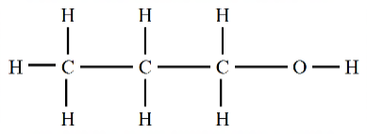
b. (1 mark)

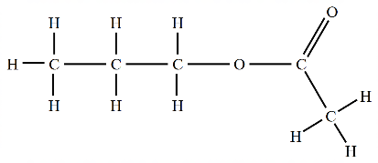
c. i. (1 mark)

ii. ethanoic acid (1 mark)

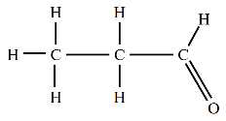
d.
i.
(1 mark)
ii. Cr₂O₇²⁻ (aq) + 14H⁺(aq) + 6e⁻ 2Cr³⁺(aq) + 7H₂O(l) (1 mark)

Question 5 (10 marks)
a. Sucrose is a disaccharide formed from the reaction between glucose and fructose. The
purple structure shown is the enzyme invertase (sucrase). Sucrose fits nicely onto the
enzyme, weakening the glycosidic linkage between glucose and fructose. The diagram is
illustrating the way the shape of an enzyme facilitates a particular reaction. The
glycosidic linkage breaks, forming fructose and glucose. (3 marks)

b. i. glycosidic (or ether) (1 mark)

ii. glucose and fructose (1 mark)

iii. Yes. Once one disaccharide is hydrolysed, the site becomes vacant for the process to
be repeated. (1 mark)

c. A pH of 1 is a very acidic environment. It is likely that the enzyme will be denatured,
losing its shape. It will not be effective once denatured. (2 marks)

d. The Glycaemic Index refers to the influence of a food on the glucose concentration in the
blood. The higher the value, the faster glucose is being released into the blood during
digestion. Sucrose has to only undergo one simple reaction to produce glucose, therefore
it is considered high GI (2 marks)

Question 6 (9 marks)
a. (4 marks)
C₁₄H₂₈O₂

C₁₂H₂₄O₂

C₁₆H₃₂O₂

C₃H₈O₃
b. C_{n}H_{2n+1}COOH or C_{n}H_{2n}O₂ (1 mark)

c. Triglycerides and fatty acids contain long hydrocarbon chains. These chains are non-polar
and the molecule as a whole is non-polar. It will not mix readily with the aqueous
contents of the stomach so digestion usually starts in the small intestine. (2 marks)

d. Bile acts as an emulsifier. It contains molecules that contain both polar and non-polar
segments. The emulsifiers break the large blobs of fats into much smaller drops. The
lipase enzymes can contact the triglycerides better due to the increased surface area.
(2 marks)

Question 7 (8 marks)
a. (3 marks)
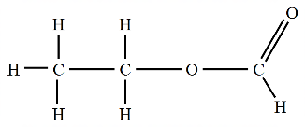
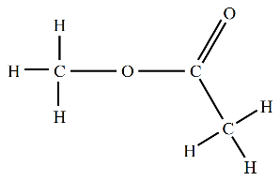
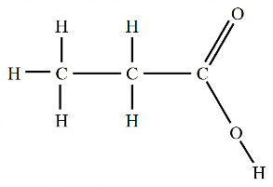

propanoic acid methyl ethanoate ethyl methanoate
molecule 1 molecule 2 molecule 3

b. Molecule will not be propanoic acid as there is no broad absorption around 3000 cm⁻¹.
Nor will the molecule be an alcohol – it could be one of the esters. (2 marks)

c. The molecule could be methyl ethanoate but not ethyl methanoate (ethyl methanoate
would have 3 hydrogen environments and some splitting). Methyl ethanoate however
has only two hydrogen environments and no splitting as each environment has no
neighbouring hydrogen atoms. (3 marks)

Question 8 (9 marks)

a. i. C₂H₂O₄(aq) 2CO₂(g) + 2H⁺(aq) + 2e⁻ (1 mark)

ii. MnO₄⁻(aq) + 8H⁺(aq) + 5e⁻ Mn²⁺ + 4H₂O(l) (1 mark)

iii. 5C₂H₂O₄(aq) + 2MnO₄⁻(aq) + 6H⁺(aq) 10CO₂ + 8H₂O(l) (1 mark)

iv. n(MnO₄⁻) = c × V = 0.120 × 0.025 = 0.003 mol
n(oxalic acid) = 0.003 × 5/2 = 0.0075 mol
c = = 0.507 M (2 marks)

b. i. C₂H₂O₄(aq) + 2NaOH(aq) Na₂C₂O₄(aq) + 2H₂O(l) (1 mark)

ii. n(NaOH) = c × V = 0.50 × 0.020 = 0.010 mol
n(oxalic acid) = 0.01 × ½ = 0.005 mol
c = = 0.368 M (3 marks)

Question 9 (7 marks)
a. i. The heating apparatus is used to calibrate the calorimeter. Electrical energy is used to
heat the calorimeter during calibration. (1 mark)

ii. For complete combustion of the food sample excess oxygen must be provided. Adding
the oxygen under pressure ensures the oxygen is in excess. (1 mark)

b. Burning food items under a solution calorimeter often provides poor results as a
significant percentage of the thermal energy is lost to the surroundings. Burning the food
in a bomb calorimeter limits heat losses. (1 mark)

c. i. CF = =553 J ⁰C⁻¹ (2 marks)

ii. E = CF ×ΔT = 553 × 5.8 = 3210 J = 3.12 kJ
ΔH = 3.12/0.873 = 3.68 kJ g⁻¹ (2 marks)

Question 10 (9 marks)
a. i. mass of magnesium (1 mark)

ii. time (or temperature) (1 mark)

iii. volume HCl, concentration (1 mark)

b. (1 mark)
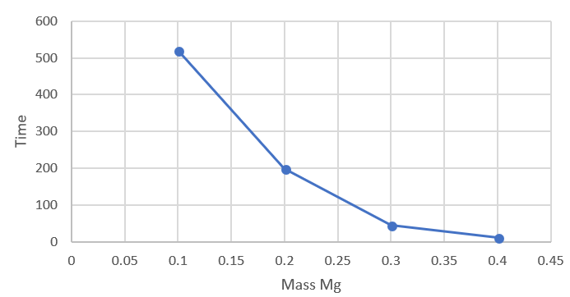

c. i. The time drops (1 mark)

ii. No, the rate of the reaction is increasing. Rate and the time taken to produce 80 mL are
not the same thing, they are virtually the reciprocal of each other. A low time means a fast
rate (1 mark)

d. The temperature readings indicate the reaction must be very exothermic. This introduces
an unexpected complication – the heat produced in the experiment will be affecting the
rate. The student had assumed the temperature was controlled. This may be the reason a
linear relationship was not found. (3 marks)

