**Unit 3&4 Chemistry 2019 Trial Exam Solutions**

**Section A**

1. D. The only non fossil fuel on the list is renewables at 2.1%. Therefore the % fossil fuel is

100 – 2.1 = 97.9%

2. B. Energy from natural gas is 3396.6 ×1015 J = 3.40 ×1018 J

From Data book, energy per gram of methane is 55600 J

mass methane = = = 6.12 × 1013 g = 6.12 × 1010 kg

3. B. *n*(CO2) =  = 6 mol ratio fuel: CO2 is 3:6 or 1:2: this would match ethane.

4. D. The question asks for the bonding within the molecule, not between molecules, making

covalent the answer.

5. C. The most likely product to form from sugars is ethanol using fermentation. This process

would provide a better yield than biogas.

6. A. The zinc is being oxidized to Zn2+ ions, so the reaction will involvea loss of 2 electrons. The

hydroxide ions are included as the product is a solid. Zn(s) + 2OH-(aq) 🡪 Zn(OH)2(s) + 2e

7. D. The pH and the mass will remain constant. The pH is constant as one reaction produces OH-

ions while the other uses them.

8. A. Mercury is considered a dangerous heavy metal. It has been phased out of many common uses.

9. A. The half-equation balances easily without the need for acid conditions.

10. C. The question asks for the reverse reaction. The activation energy is always positive and the

enthalpy change for the reverse reaction is a positive one.

11. A. 2HI ⇌ H2 + I2

start 3 0 0

equilibrium 2.6 0.2 0.2

*K* = = 0.0059

12. D. Dilution will lower the red intensity. The reaction will move in the reverse direction as well,

also reducing the red intensity.

13. B. The addition of AgNO3 lowers the concentration of SCN-. The reverse reaction is favoured

but it only partially replaces the SCN- ions lost in the precipitate.

14. C. The NaCl must be fairly concentrated for chlorine to form at the anode instead of the

expected oxygen gas.

15. B. *Q* = *It* = 2.8 × 5 × 60 = 840 C

*n*(e) = = 0.00870 mol *n*(H2) = 0.00435 mol

*V* = *n* × 24.8 = 0.00435 × 24.8 = 0.108 L

16. A. The 2 bromine atoms are on carbons 3 and 4. They are named first as bromo is alphabetically

before methyl (the prefix di- is not counted).

17. B. Amines can be formed from the reaction between chloroalkanes and ammonia.

18. D. Isomers of all types can be formed from this molecular formula.



 *Structural geometric*

*Could have optical isomer*

19. C. There are several significant peaks with low retention times. This would suggest they are

non-polar molecules that are not absorbed much on the stationary phase.

20. D. Butan-2-ol is drawn below. It has 5 hydrogen environments and 4 carbon environments.

21. D. Butanone will be the only alternative with 4 carbon environments and the large shift value on the left.

22. B. *n*(NaOH) = 0.0294 × 0.25 = 0.00735 mol

*n*(oxalic acid) = ½ *n*(NaOH) = 0.00368 mol

mass = 0.00368 × 90 = 0.331 g %(m/m) = 0.331×100/3 = 11.03 %

23. A. The molecule will be 2-chloropropane. The two parent molecular ion peaks suggest the

presence of chlorine and the relative molecular mass of 78.5 matches.

24. C. Half-equations are C2H6O(aq) + H2O(l) 🡪 C2H4O2(aq) + 4H+(aq) + 4e-

Cr2O72-(aq) + 14H+(aq) + 6e- 🡪 2Cr3+(aq) + 7H2O(l)

25. D. Glycogen is a polysaccharide and will have far more hydroxyl groups than the other

smaller molecules.

26. D. The general formula for a saturated fatty acid is CnH2nO2. This would require 40 H atoms for

20 C atoms. As there are only 32 C atoms, there must be 4 double bonds.

27. A. The pH of saliva is relatively neutral. Saliva contains amylase. The pH of the stomach is

very low – pepsin works in this environment and the pH of the small intestine is alkaline to assit

 the breakdown of triglycerides.

28. B. The structure of an amine and alcohol functional group

can be seen when examining the molecule.

29. C. The carbohydrate heats the water by 80C. The fat heats the water by 8 × 37/16 = 18.50C.

30. A. The acid is diluted in the dirty burette so the titre will be high. This will make the base appear to be more

concentrated than it really is.

**Section B Short answer**

**Question 1** (9 marks)

**a. i**. 2 marks

**ii**. C20H38O2(l) + 28.5O2(g) 🡪 20CO2(g) + 19H2O(l)

2 marks

**b.** **i.** monounsaturated 1 mark

**ii**. Stearic acid will have the higher melting point. It is a longer molecule, so will have

more dispersion forces. Oleic acid also has a carbon-to-carbon double bond so the bends

in its molecules will lower its melting point. 2 marks

**c**. Canola is also a food item so competing demand for its use.

Growing crops requires resources and arable land – limits to this. 2 marks

**Question** **2** (10 marks)

**a**. anode: Zn(s) + 2OH-(aq) 🡪 Zn(OH)2(s) + 2e- 2 marks

cathode: 2MnO2(s) + H2O(l) + 2e- 🡪 Mn2O3(s) + 2OH-(aq)

**b**. x - (-1.28) = 1.43 => voltage = 0.15 V 1 mark

**c**. In dry cells, the zinc is often the outer casing so the reaction of Zn(s) to Zn2+ ions means

the zinc metal casing is oxidising. In this cell, the zinc is not the outer casing so this is

not a problem. 2 marks

**d**. anode: O2(g) + 2H2O(l) + 4e 🡪 4OH-(aq) 3 marks

cathode: CH4(g) + 8OH-(aq) 🡪 CO2(g) + 6H2O(l) + 8e

overall: CH4(g) + 2O2(g) 🡪 CO2(g) + 2H2O(l)

**Question 3** (8 marks)

a. 4 marks

A: chloroethane



B: ethanol



C: ethanamine

D: ethanoic acid

**b. i**. C2H4(g) + HCl(g) 🡪 CH3CH2Cl(g) 1 mark

**ii**. CH3CH2Cl(g) + NH3(g) 🡪 CH3CH2NH2(g) + HCl(g) 1 mark

**c**. CH3CH2OH(l) + H2O(l) 🡪 CH3COOH(l) + 4H+(aq) + 4e- 1 mark

**d**. The addition reactions of ethene to chloroethane or to ethanol are 100% atom efficient as

there is only one product. 1 mark

**Question 4** (11 marks)

**a**. **i**. The value of the equilibrium constant will not change as the temperature has not

been changed. 1 mark

**ii**. the decrease in volume will favour the back reaction to convert 3 particles to 2. The

net change in the concentration of SO2 gas, however, will be an increase. The initial

volume drop increased the concentration more than the subsequent reverse reaction lowers

it. 2 marks

**iii**. the amount of SO2 gas drops as the reverse reaction was favoured. 1 mark

**b**. i. 2 marks

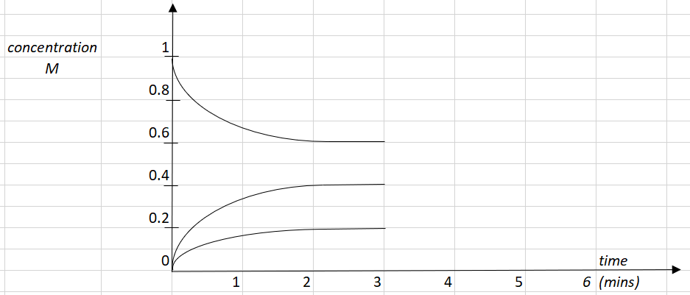

**ii**. *K* =  = = 0.088 M 2 marks

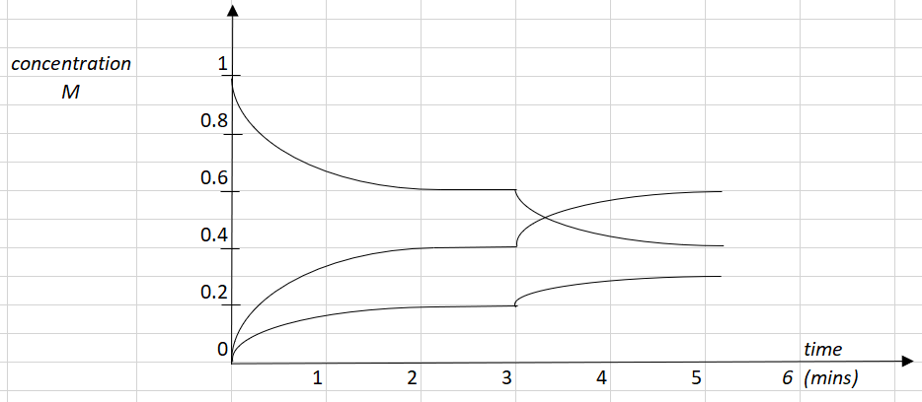 **iii**. 3 marks

**Question 5** (9 marks)

**a**. **i**. C3H6O: propanal is consistent with being an aldehyde and having a molecular mass

of 58 as shown on the mass spectrum. 1 mark

**ii**. propanal 1 mark



**b**. propanoic acid 2 marks

**c**. 1 mark

|  |  |
| --- | --- |
| Wave number (cm-1) | Bond |
| 3000 | C - H |
| 1750 | C=O |

**d**. 3 marks

|  |  |  |
| --- | --- | --- |
| Shift | Likely structure | Splitting pattern |
| 1.1 |  | Triplet as 2 neighbouring H atoms |
| 2.4 |  | Quartet as 3 neighbouring H atoms |
| 9.8 |  | Triplet as 2 neighbouring H atoms |

**e**. Aldehydes can be formed when fats go rancid, so perhaps this molecule could be formed from the reaction of oxygen and unsaturated fat. 1 mark

**Question 6** (8 marks)

**a. i**. Aqueous CuSO4 or CuCl2 would work. CuBr2 would not work. 1 mark

**ii**. anode: 2H2O(l) 🡪 O2(g) + 4H+(aq) + 4e 3 marks

cathode: Cu2+(aq) + 2e 🡪 Cu(s)

overall equation: 2Cu2+(aq) + 2H2O(l) 🡪 2Cu(s) + O2(g) + 4H+(aq)

**b.** *Q*= *It* = 6.6 × 140 = 924 C

*n*e =  = 9.58 ×10-3 mol *n*O2 = ¼ × *n*e = 2.39 ×10-3 mol

*V* =  =  = 0.061 L 4 marks

**Question 7** (10 marks)

**a. i**. Thermal energy can easily pass around the calorimeter if a biscuit is burnt under a

beaker of water. Combustion might be more complete in a bomb calorimeter and the

initial heat is not lost as you light the biscuit. 2 marks

**ii**. To ensure there is sufficient oxygen for complete combustion to occur. 1 mark

**iii**. To pass an electric current through the food to get it burning. 1 mark

**b**. 3 marks

*CF* = = 547 J0C-1

Energy = *CF* × Δ*T* = 547 × 4.5 = 2460 J

Heat of combustion = 2460/0.962 = 2.58 kJ g-1

**c. i**. The heat of combustion will drop as the energy per gram of carbohydrate is less than

that of fat. 1 mark

**ii**. - energy content: little change as energy of aspartame and sugar are similar

- taste: biscuit will taste horrible as this is a massive dose of aspartame 2 marks

**Question 8** (7 marks)

**a**. **i**. Amylase enzyme is causing the hydrolysis of starch polysaccharide molecules to

smaller, sweeter saccharides. 1 mark

**ii**. Chewing your food is serving to break the food into smaller particles, increasing the

surface area and enabling the reaction to proceed at a faster rate. 1 mark

**b**. People who are lactose intolerant often do not naturally produce lactase. They might take

tablets so their body has the lactase required to break lactose into glucose and

galactose. 1 mark

**c**. **i**. Liver contains an enzyme that can serve as a catalyst for the decomposition of H2O2.

The shape of the enzyme complements the H2O2, providing an alternative reaction

pathway. 2 marks

**ii**. Potassium iodide is also a catalyst that provides an alternative reaction pathway. It is

however, not an enzyme, it is an inorganic catalyst. 2 marks

**Question 9** (10 marks)

**a**. **i**. independent variable: the half-cell combination 1 mark

**ii**. dependent variable: the voltage produced 1 mark

**b**. 3 marks

Cu2+(aq) + 2e ⇌ Cu(s) 0.82 V

Pb2+(aq) + 2e ⇌ Pb(s) 0.54 V

Fe2+(aq) + 2e ⇌ Fe(s) 0.29 V

Zn2+(aq) + 2e ⇌ Zn(s) 0.00 V

Mg2+(aq) + 2e ⇌ Mg(s) - 1.10 V

**c**. The student’s conclusion is harsh. Her experiments do show the same order of reactivity of metals as the electrochemical series does. Her voltages are lower than those of the table but are still fairly proportional to the accepted values. 2 marks

**d**. The student should have used 1.0 M concentrations and 25 0C to match standard conditions. The choice of sodium sulfate for a salt bridge is a poor one as it will form precipitates with solutions such as lead. 3 marks

**Question 10** (8 marks)

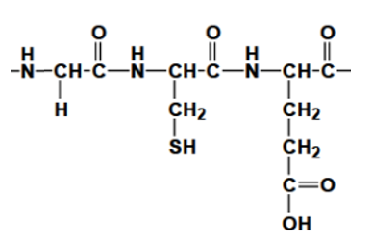**a**. 5 marks

Primary structure: covalent N – C peptide links between neighbouring amino acids, formed by condensation polymerisation reactions between amino acids. Strong bonds.

Secondary structure: Hydrogen bonding between different parts of the protein chain formed as a result of the dipoles on the nitrogen, hydrogen and oxygen atoms of the peptide link. Causes coils and pleats.

Tertiary structure: bonding between – R groups that gives proteins their unique shape. May be dispersion forces, covalent bonds, dipole bonds or hydrogen bonds

**b**. Digestion of proteins starts mainly in the stomach where enzymes such as pepsin break the protein to smaller peptides. Digestion continues in the small intestine where other enzymes such as trypsin complete hydrolysis to amino acids. Amino acids dissolve in the blood and are transported to other parts of the body to be reassembled as new proteins or converted to energy. 3 marks