Unit 3 Chemistry Name: ________________
2018 Trial exam

SECTION A – Multiple-choice questions

Instructions for Section A
Answer all questions.
Choose the response that is correct or best answers the question.
A correct answer scores 1, an incorrect answer scores 0.
No mark will be given if more than one answer is completed for any question.
Marks will not be deducted for incorrect answers.

Question 1
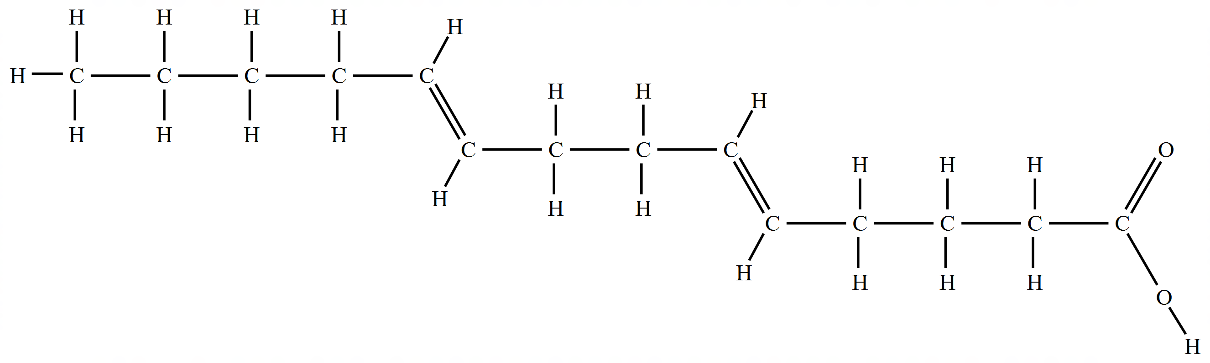
The molecule shown is
A. an example of a biodiesel molecule.
B. a fatty acid.
C. a triglyceride.
D. a typical component of petrodiesel.

Question 2
What is the total amount of energy released, in kilojoules, when 20 g of ethanol and 20 g of butane undergo complete combustion?
A. 994
B. 1038
C. 1586
D. 2032

Question 3
The products of a combustion reaction are shown below.

8CO₂(g) + 10H₂O(l)

The reaction is
A. the complete combustion of butane.
B. the incomplete combustion of butane.
C. the complete combustion of octane.
D. the incomplete combustion of octane.

Question 4
1.50 g of ethane undergoes complete combustion. What volume of CO₂, in litres, is produced at SLC from this combustion?
A. 1.24
B. 2.48
C. 4.96
D. 24.8

Question 5
McCain Foods has set up a plant to produce a fuel from the peel of the many thousands of potatoes they use each year. This fuel is most likely to be
A. ethanol
B. natural gas
C. biodiesel
D. petrodiesel

Question 6
A sketch of a cell is provided below.
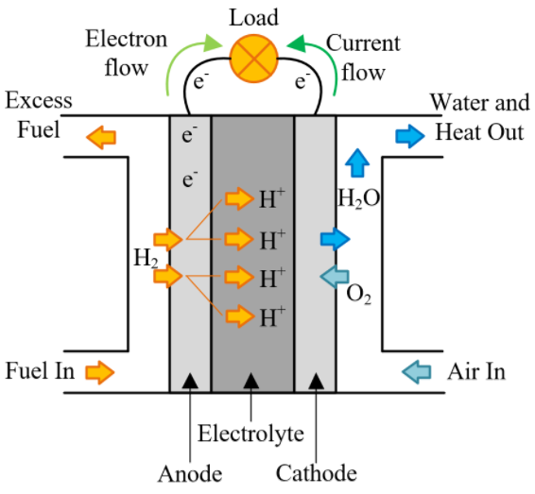

In this cell,
A. the reaction occurring at the cathode will be 2H₂(g) + O₂(g) 2H₂O(l)
B. the reaction occurring at the cathode will be O₂(g) + 2H₂O(l) + 4e⁻ 4OH⁻(aq)
C. the reaction occurring at the cathode will be H₂(g) 2H⁺(aq) + 2e⁻
D. the reaction occurring at the cathode will be O₂(g) + 4H⁺(aq) + 4e⁻ 2H₂O(l)

Question 7
The energy profile diagram for a chemical reaction is shown below.
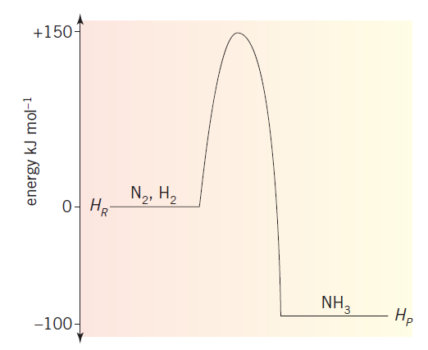
The activation energy, and the value of ΔH for the reverse reaction of the one shown will be, respectively,
A. +150 kJ mol⁻¹ and -100 kJ mol⁻¹
B. +150 kJ mol⁻¹ and +100 kJ mol⁻¹
C. +250 kJ mol⁻¹ and +100 kJ mol⁻¹
D. +250 kJ mol⁻¹ and -100 kJ mol⁻¹

Question 8
Which of the following alternatives is not a balanced half equation?
A. Br₂(l) + 2e⁻ 2Br⁻(aq)
B. SO₄²⁻(aq) + 4H⁺(aq) + 2e⁻ SO₂(g) + 2H₂O(l)
C. CH₃CH₂OH(aq) + H₂(g) CH₃COOH(aq) + 4H⁺(aq) + 2e⁻
D. NO₂(g) + H₂O(l) NO₃⁻(aq) + 2H⁺(aq) + e⁻

Questions 9 and 10 refer to the following information
One of the types of lithium battery now in production is the lithium-iron cell. It has the same voltage as a typical alkaline cell but it copes better in high current demand uses. The overall equation for one version of this cell is

FeS + 2Li Fe + Li₂S (note: phases not shown for polymer electrolytes)

Question 9
The half equations occurring during discharge in the lithium-iron cell are
 | Anode | Cathode
A. | Li Li⁺ + e⁻ | Fe²⁺ + 2e⁻ Fe
B. | Fe Fe²⁺ + 2e⁻ | Li Li⁺ + e⁻
C. | Li⁺ + e⁻ Li | Fe Fe²⁺ + 2e⁻
D. | S + 2e⁻ S²⁻ | Fe²⁺ + 2e⁻ Fe

Question 10
When this cell is being recharged, the
A. reduction reaction will occur at the same electrode as during discharge
B. oxidation reaction will be at the negative electrode as an external power source is used
C. iron electrode will be connected to the positive terminal of the recharger
D. lithium electrode will be connected to the positive terminal of the recharger
Question 11
The concentrations of the species present in an equilibrium mixture are shown on the graph below.
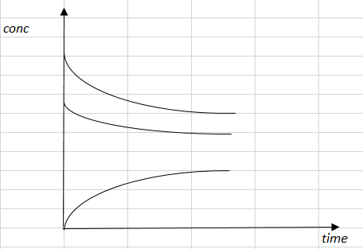

A reaction that matches the concentrations shown is
A. PCl₅(g) ⇋ PCl₃(g) + Cl₂(g)
B. H₂(g) + I₂(g) ⇋ 2HI(g)
C. N₂O₄(g) ⇋ 2NO₂(g)
D. 2SO₂(g) + O₂(g) ⇋ 2SO₃(g)

Question 12
Nitrosyl chloride can decompose to nitrogen monoxide and chlorine gas. The equation for the reaction is

2NOCl(g) ⇋ 2NO(g) + Cl₂(g)

1.8 mole of NOCl is added to an empty reactor. When equilibrium is reached, the amount of NOCl has dropped to 1.2 mole. The total number of mole of substances in the reactor at equilibrium will be
A. 1.8
B. 2.1
C. 2.7
D. 3.6

Question 13
The equation for the decomposition of ammonia gas is shown below

2NH₃(g) ⇋ N₂(g) + 3H₂(g) K = 2.8 × 10⁻⁶ M at 40⁰C.

A sample of ammonia is added to an empty reactor at 40⁰C. When equilibrium is reached, the
A. [NH₃] will be greater than [H₂]
B. [N₂] will be half the [NH₃]
C. [N₂] will be three times [H₂]
D. [H₂] will be greater [NH₃]

Question 14
Select the alternative that can be deduced from the graph below.
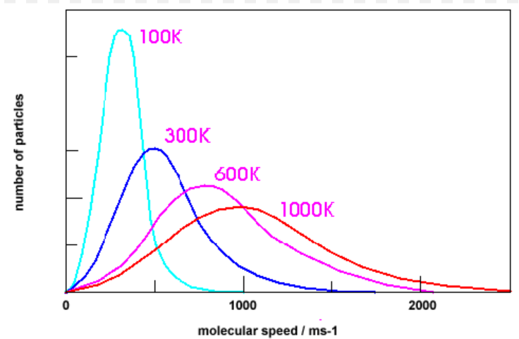
A. As the temperature increases, the activation energy for a reaction decreases.
B. At 1000K an alternative pathway for a reaction will lower the activation energy.
C. More particles at 1000K have the energy required to react than at 300K.
D. All particles in a reaction at 1000K are moving faster than particles in a reaction at 100K

Question 15
A series of experiments is conducted where the mass change is measured when magnesium ribbon is added to HCl solution. Graph C represents the addition of magnesium ribbon to a 1.0 M solution containing excess HCl.

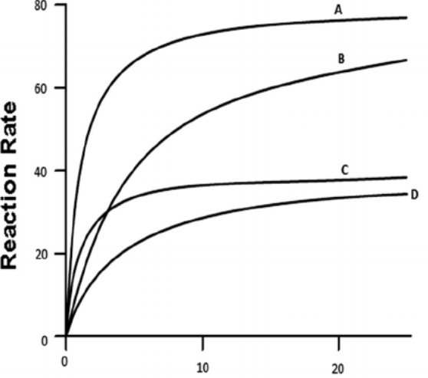
A solid ball of magnesium is now added to a separate flask containing the same volume of the same HCl solution. The mass of the magnesium ball is double that of the magnesium ribbon used to produce Graph C.
Which graph(s) could represent the mass change occurring in the flask?
A. Graph A only.
B. Graph B only.
C. Either graph A or graph B.
D. Graph D only.

Question 16
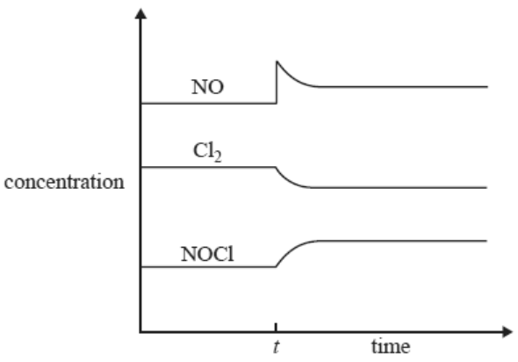
The change made to the system at time t represented in the graph could be
A. the addition of NO gas to an empty reactor.
B. the addition of NO to an equilibrium mixture.
C. removal of some NO gas from an equilibrium mixture.
D. an increase in temperature as the reaction is exothermic.

Question 17
An electrolytic cell produces a pungent gas at the anode and a brown deposit at the cathode. The cell could be
A. dilute CuCl₂(aq) with platinum electrodes.
B. CuCl₂(l) with copper electrodes.
C. CuCl₂(l) with platinum electrodes.
D. dilute CuSO₄(aq) with platinum electrodes.

Use the following information to answer Questions 18 to 20
Electrolysis is conducted on an aqueous solution of silver nitrate, with inert electrodes.
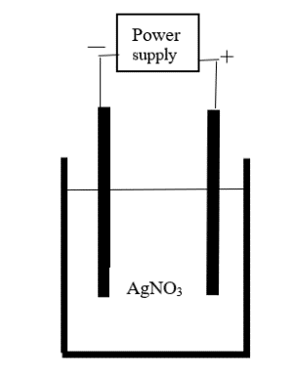

Question 18
In this cell
A. silver metal will be deposited at the anode
B. hydrogen gas will be produced at the cathode
C. oxygen gas will be produced at the cathode
D. oxygen gas will be produced at the positive electrode

Question 19
In this cell
A. oxygen gas is produced at the negative electrode
B. silver metal will be deposited at the negative electrode which is the anode
C. silver metal will be deposited at the negative electrode which is the cathode
D. silver ions will be produced at the cathode

Question 20
A current of 8.4 amps runs through the circuit for 12 minutes. The mass of silver deposited will be, in g,
A. 0.112
B. 3.38
C. 5.12
D. 6.77

Section A 20 marks ____
Total Section B 63marks ____
Total exam 83 marks ____

SECTION B - Short-answer questions

Instructions for Section B
Questions must be answered in the spaces provided in this book.
To obtain full marks for your responses you should
- give simplified answers with an appropriate number of significant figures to all numerical questions; unsimplified answers will not be given full marks.
- show all workings in your answers to numerical questions. No credit will be given for an incorrect answer unless it is accompanied by details of the working.
- make sure chemical equations are balanced and that the formulas for individual substances include an indication of state; for example, H₂(g); NaCl(s)

Question 1 (13 marks)
The flowchart below outlines the process of biodiesel manufacture. (Glycerin is a commercial name for glycerol)
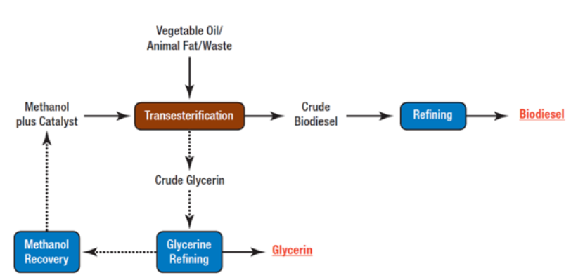
a. i. List two common sources of oil or fat in Australia. (2 marks)

____________________________________________________________________

ii. If ethanol is used in place of methanol, the environmental credentials of this process
can be improved. Explain why. (2 marks)

_______________________________________________________________________

_______________________________________________________________________

b. Glycerol (glycerine) is relatively easy to separate from biodiesel. Explain, with reference
to the bonding involved, why this is the case. (2 marks)

_____________________________________________________________________

_____________________________________________________________________

c. On a particular day, 12.6 mol of biodiesel is produced. Complete the table below to show
the amounts of each species required, or produced, for this process. (2 marks)
triglyceride | methanol | glycerol | biodiesel
 |  |  | 12.6 mol

d. The molecular formula of one form of biodiesel is C₁₉H₃₄O₂. (2 marks)
i. Write a balanced equation for the complete combustion of this molecule.

______________________________________________________________________

ii. Calculate the volume of CO₂ produced at 350⁰C and 100 kPa pressure from the
combustion of 1.80 mole of this fuel. (3 marks)

Question 2 ( 9 marks)
The equation for the exothermic reaction between sulfur dioxide and oxygen gases is:

2SO₂(g) + O₂(g) ⇋ 2SO₃(g)

a. The temperature in an equilibrium mixture of the above gases is increased.
i. Explain the impact of this change on the amount of SO₃ gas. (1 mark)

_____________________________________________________________________

ii. Explain the impact of this change on the rate of the forward reaction in this process.
(1 mark)
____________________________________________________________________

_____________________________________________________________________

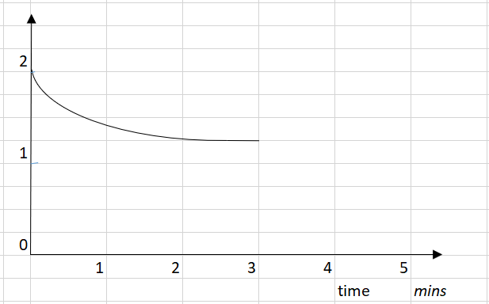
b. A sample of SO₃ is added to an empty reactor. The concentration of the SO₃ is
monitored over time and is displayed on the graph below.

concentration

i. Use the axes provided to draw in the concentrations of the SO₂ and O₂ gases.
(2 marks)
ii. Use the graph to determine the value of the equilibrium constant K for the reaction as
it is expressed in the introduction to this question. (3 marks)

_____________________________________________________________________

____________________________________________________________________

_____________________________________________________________________

c. The volume of an equilibrium mixture of the above gases is halved. Explain clearly how
the SO₂ concentration will have changed after equilibrium is re-established. (2 marks)

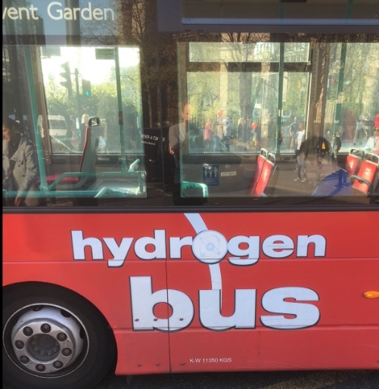
Question 3 (10 marks)
Buses like the one shown are a common sight in London.
The bus uses a fuel cell that runs in alkaline conditions
to generate the electrical energy it requires.

a. Use the template below to show the equations occurring in the fuel cell used by the bus.

anode: _________________________________________________ (3 marks)

cathode: __________________________________________________

overall: __________________________________________________

b. What voltage does this cell produce? _____________________ (1 mark)

c. The cells used to power this bus are very expensive. Give two reasons for this expense.
(2 marks)
_____________________________________________________________________

_____________________________________________________________________

d. The bus does not produce any CO₂ emissions yet the use of hydrogen for transport is not
considered carbon neutral. Explain why such buses are not carbon neutral. (1 mark)

_____________________________________________________________________

e. i. List one similarity between a fuel cell and an electrolytic cell. (1 mark)

_______________________________________________________________________

ii. List one similarity between a fuel cell and a secondary cell. (1 mark)

_______________________________________________________________________

iii. Explain how the same reactants as the bus uses could be used to produce electrical
energy from thermal energy. (1 mark)

_______________________________________________________________________

_______________________________________________________________________

Question 4 (10 marks)
Potassium permanganate (KMnO₄) solution has a purple colour. When an acidified solution is added to an Fe²⁺ solution, the purple colour disappears at first until the KMnO₄ is in excess. The reaction occurring is a redox reaction where the permanganate ions form Mn²⁺ ions and the Fe²⁺ ions are oxidised.

a. i. Write a balanced half-equation for the reduction of MnO₄⁻ ions to Mn²⁺ ions.
(Assume acid conditions) (1 mark)

___________________________________________________________________

ii. Write a balanced half-equation for the oxidation of Fe²⁺ ions. (1 mark)

____________________________________________________________________

iii. Write a balanced overall equation for this reaction. (1 mark)

_____________________________________________________________________

iv. What is the oxidation number change of manganese atoms in this reaction? (1 mark)

_____________________________________________________________________
b. A galvanic cell is constructed from a half-cell containing 1.0 M KMnO₄ and a half-cell
made from 1.0 M Fe(NO₃)₂. The KMnO₄ is found to be the positive electrode and the
voltage of the cell is 0.74 V.
i. Suggest a suitable material to use for the (2 marks)

cathode _____________________ anode ____________________

ii. What will be the standard electrode potential of the MnO₄⁻ half-equation? (1 mark)

___________________________________________________________________

c. A lead-acid accumulator uses Pb at one electrode and PbO₂ at the other. The same
product is formed at both electrodes, PbSO₄.
i. Write a balanced half-equation for the reduction of acidified PbO₂. (1 mark)

___________________________________________________________________

ii. Write a balanced half-equation for the oxidation of Pb metal. (1 mark)

____________________________________________________________________

iii. Write a balanced overall equation for this reaction. (1 mark)

_____________________________________________________________________

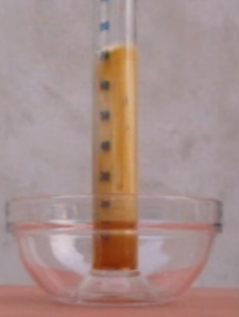
Question 5 (11 marks)
Hydrogen peroxide, H₂O₂, can decompose slowly. If a catalyst
such as potassium iodide is added, the decomposition can be
quite rapid. The addition of detergent to the reaction mixture
leads to the production of a foam.

A student uses measuring cylinders and detergent to
investigate the rate of this reaction. The faster the rate of reaction,
the higher up the measuring cylinder the foam moves.
The student uses the same concentration solution, the same mass
of catalyst but conducts the experiment at a range of
temperatures. Her results are shown in the table below.

Temperature ⁰C | Height of foam in cm
20 | 8.1
30 | 11.0
40 | 14.2
50 | 17.1
a. i. The decomposition of H₂O₂ is a redox reaction. Use the electrochemical series, and the
diagram provided, to complete the template below. (3 marks)

oxidation: _________________________________________________

reduction: __________________________________________________

overall: __________________________________________________

ii. Explain why a foam forms. (1 mark)

____________________________________________________________________

b. For the student’s experiment, identify (3 marks)
i. the dependent variable _____________________________________

ii. the independent variable _____________________________________

iii. a controlled variable. _____________________________________

c. i. Use the axes provided to graph the student’s results. (1 mark)

ii. What conclusion can you draw from the data? (1 mark)

___________________________________________________________________

iii. Explain how temperature impacts on the rate of the reaction. (2 marks)

____________________________________________________________________

____________________________________________________________________
Question 6 (10 marks)
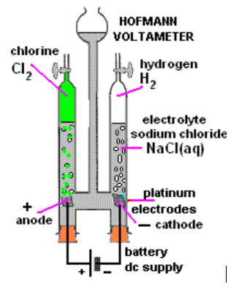
The apparatus shown below is known as a Hofmann voltameter. It is used to capture gaseous products of electrolysis reactions. In the diagram shown, the solution used is brine, a very concentrated NaCl solution.

(3 marks)
a. Use your knowledge of electrochemical series, and the information provided on the
diagram to show the half-equations and overall equation for the reactions occurring.

anode: _________________________________________________

cathode: __________________________________________________

overall: __________________________________________________

b. The electrolysis of brine does not provide the products predicted from the
electrochemical series. Suggest a valid reason why the usual rules you apply to the
electrochemical series are not providing the expected result. (1 mark)

___________________________________________________________________

c. The diagram shows an equal volume of gases being produced. Discuss whether this is an
accurate representation of this process. (2 marks)

___________________________________________________________________

___________________________________________________________________

d. Calculate the total volume of gas that will be produced at SLC from a current of 3.80
amps running for 4.00 hours. (4 marks)

____________________________________________________________________

_____________________________________________________________________

____________________________________________________________________

_____________________________________________________________________

