Unit 3 Chemistry 2020 Trial Exam Solutions
Section A

1. B: Molecule is heptane. A C₇ is a common component of petrol. Page 5 column

2. C: Mass in 1 litre is 850 g. Data book gives diesel as 45 kJ g⁻¹. Q = 45 x 850 = 38250 density of a sample
of petrodiesel is 0.85 g mL⁻¹. Be aware of every table in the data book

3. D: Fermentation of glucose to form bioethanol page 16

4. C: ratio of fuel to CO₂ is 1:4 matching the equation for the combustion of butane page 47

5. A: n(S) = 3.2/32 = 0.1 = n(SO₂). V = = 5 L worked examples in 3.5
6. D: Slicing lengthwise will increase the surface area more than slicing across. Page 180

7. C: As the reaction proceeds, acid is used up, so the pH rises. Page 173

8. B page 44

9: C: Take note that the question asks for the reverse reaction.

10. A: From electrochemical series, H⁺ will react with Zn(s). The zinc is oxidised.
Pages 131 to 34
11. D: Zinc is oxidised – this will be at the anode. Hydrogen ions are reduced – at the cathode.

12. A: Add option A to the half-equation on the diagram and it will simplify to the required overall equation.
13. B: The presence of OH⁻ ions indicate an alkaline environment. The presence of electrons shows it is a
half-equation and the loss of electrons is oxidation. Page 153 – note the alkaline environment

14. A: For an endothermic reaction, K increases as temperature increases. This favours the blue colour.
Page 226
15. C: The precipitate is AgCl. Its formation lowers the Cl⁻ concentration so the system moves in the
reverse direction, favouring the pink colour. Page 217

16. D: This reaction has a very low K value- which can only happen if the amount of products is much lower
than the amount of reactant.
Understanding of E0 table required page 243
17. B: The only metal more reactive than water is manganese. Refer to electrochemical series in Data Book.
18. B: n(Mg) = 2.43/24.3 = 0.1 mol n(e) = 0.2 Q = 0.2 x 96500 = 19300 C
I = Q/t = 19300/3600 = 5.36 amp page 253
19. D: The products are hydrogen and oxygen. The production of oxygen is oxidation and will occur at the positive
anode. Page 243
20. A: The number of mole of hydrogen is half the number of mole of electrons. The number of mole of oxygen is a
quarter. Altogether this is ¾ of the number of mole of electron. Page 253
Section B Short answer
Question

Question 1 (9 marks)
a. i. Density of a gas is low- more compact if condensed to a liquid 1 mark
ii. Fractional distillation. Natural gas heated, added to a column. The hot gas rises until each component
condenses at different levels of the tower. Propane and ethane will condense before methane.
Page 5 fractional distillation
b. Natrual gas is absorbed on the surface of the coal. A well is drilled into the coal and water, sand or gas is used to
shake it free. Page 7 2 marks

c. Waste is added to a digestor containing bacteria. The bacteria operate in anaerobic conditions to produce
methane. Page 9 1 mark
d. i. CH₄(g) + 2O₂(g) CO₂(g) + 2H₂O(l) 1 mark
ii. chemical thermal gas thermal steam mechanical electrical 1 mark page 13
iii. S(s) + O₂(g) SO₂(g) 1 mark page 19 – several pollutant gases produced

Question 2 (7 marks)
a. i. C₂H₆(g) + 3.5O₂(g) 2CO₂(g) + 3H₂O(l) ΔH = -1560 kJ mol⁻¹ 2 marks page 42 thermochemical equations include vakues of ΔH

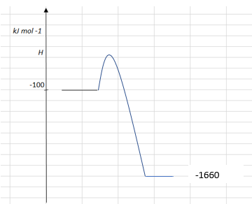
ii. 2 marks

iii. q= 4.18 × 1000 × 10 = 4.18 × 10⁴ J mass = 4.18×10⁴/51900 = 0.81 g 2 marks
diagram and formula p57

b. C₂H₆(g) + 2.5O₂(g) 2CO(g) + 3H₂O(l) 1 mark

Question 3 (9 marks)
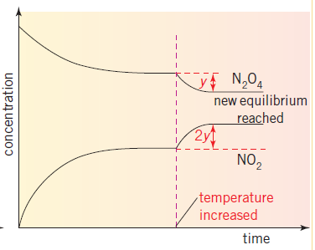
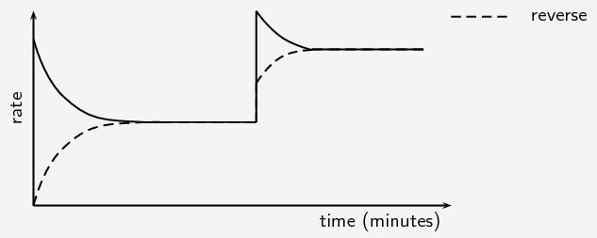
rate

Page 218 has a similar graph
a. i. N₂O₄(g) ⇌ 2NO₂(g). 1 mark

ii. K_{c} = 1 mark
iii. The y and 2y reflect the stoichiometry of the equation. The NO₂ will change by twice the N₂O₄.
1 mark
iv. brown intensity will increase with extra NO₂ forming. 1 mark
page 226 refers to the same reaction
b. endothermic – an increase in K when the temperature rises is consistent with an endothermic reaction.
2 marks
c. see graph 3 marks

Question 4 (10 marks)
a. Anode: Al(s) + 3OH⁻(aq) Al³⁺(aq) + 3e⁻ 4 marks
Cathode: O₂(g) + 2H₂O(l) + 4e⁻ 4OH⁻(aq)
Not covered in text but it is a reminder to use your Data Book as the equations only need slight changes
Overall: 4Al(s) + 3O₂(g) + 6H₂O(l) 4Al(OH)₃(s)

Approximate cell voltage: 0.4 - ⁻ 1.66 = 2.04 V

b. Oxygen is plentiful – replace the aluminium sheet whenever the cell slows 2 marks

c. Anode: H₂(g) + 2e⁻ 2H⁺(aq) + 2e⁻ 4 marks
Cathode: O₂(g) + 4H⁺ (aq) + 4e⁻ 2H₂O(l)
Hydrogen fuel cell page 153
Overall: 2H₂(g) + O₂(g) 2H₂O(l)

Approximate cell voltage: 1.23 V

Question 5 (10 marks)
a. Anode: 2Cl⁻(aq) Cl₂(g) + 2e⁻ 4 marks
Cathode: 2H₂O(l) + 2e⁻ H₂(g) + 2OH⁻(aq)
This is the membrane cell page 247 – note the exception to the E0 rules of Cl2
Overall equation: 2H₂O(l) + 2Cl⁻(aq) Cl₂(g) + H₂(g) + 2OH⁻(aq)
Products of this process: H₂, Cl₂, NaOH

b. Q = It = 49 × 4× 3600 = 7.06 × 10⁶ C
n(e) = /96500 = 7.31 mol
n(Cl₂) = 3.66 mol worked examples like 9.3.1
V = 127 L 4 marks

c. i. Na⁺(l) + e⁻ Na(l) 1 mark

ii. 2H₂O(l) + 2e⁻ O₂(g) + 4H⁺(aq) + 4e⁻ 1 mark

Question 6 (8 marks)
a. Reactants: Mg/HCl or CaCO₃/HCl 2 marks

Equation: Mg(s) + 2HCl(aq) MgCl₂(aq) + H₂(g)
Page 180 but linked to the Investigation you have to do
b. Possible hypothesis: The reaction rate will increase with temperature.
Procedure:
Add 50 mL of 1.0 M HCl to the flask
Heat contents to 20 C.
Add 0.1 g of Mg
Record time taken to produce 50 mL of gas
Repeat procedure with the HCl at 25 ⁰C, then 30, then 35 ⁰C etc
Graph of time taken (y axis) vs temperature. 6 marks

Question 7 (7 marks)
a. i. independent variable separation distance 3 marks
ii. dependent variable current or voltage
iii. a controlled variable temp or soln concentration

b. Zn(s) + Cu²⁺(aq) Zn²⁺(aq) + Cu(s) 1 mark
the data is provided for a reason – look very carefully at what it is saying
c. The separation is not affecting the voltage greatly, but it is affecting the current. The manufacturer
should make long, skinny batteries rather than wide ones where the electrodes are a long way apart.
The higher the current the more flexible the cell is in applications it is suitable for. 3 marks

