2024 chemistry Unit 3 exam solutions
Section A: Multiple choice

Question 1
B: Fermentation produces a dilute ethanol solution. Distillation is used to concentrate this.

Question 2
C: Water reacts at the anode to produce oxygen and is the source of the H ions travelling to the cathode.

Question 3
A: Green hydrogen is produced using renewable energy.

Question 4
C:
A. 49.6 L of methane at SLC. 2 mol = 1780
B. 30 g of methane. 30 g is just less than 2 mol of option A
C. 50 L of ethane at SLC. Just over 2 mol = > 3120 making it the highest
D. 20 g of hydrogen gas. 10 mol H₂ = 2820

Question 5
C. The digestor forms biogas which is then burnt in a generator to produce electrical energy.

Question 6
D. The combustion of biogas will produce CO₂ but at least the manure is renewable.

Question 7
B: As spelt out in the data book

Question 8
D. Option D is an acidic environment and is correctly balanced.

Question 9
C. Keep in mind this is the reverse reaction so the activation energy is only 75 kJ.

Question 10
D: Aluminium is more reactive than nickel and can replace it in solution.

Question 11
A. Aluminium is being oxidised at the anode, making it the negative electrode,

Question 12
D. Copper ions are reduced to copper and hydrogen gas forms hydrogen ions causing the pH to drop.

Question 13
D. Each change in option D will increase the reaction rate lowering the time required.

Question 14
B. 0.6 mole of NOCl is used so 0.6 mole of NO forms and 0.3 mole of Cl₂. Total 1.4 + 0.6 + 0.3 = 2.3 mole

Question 15
B. The equation is 1/3 of the original so K_{c} will be the cube root of 729.

Question 16
D. If the volume is halved, all three concentrations are doubled. The system will move forwards but the concentration will still be higher than the original. The amount of hydrogen will have dropped.

Question 17
B. The strongest oxidant will be Fe²⁺ and the strongest reductant Fe, so iron will oxidise at the anode and reduce at the cathode.

Question 18
C. A and D can be ruled out straightaway as A will be half of B and no calcium will form. Silver has a charge of +1 and a high relative atomic mass.

Question 19
A. Neither calcium nor aluminium will be formed from aqueous solutions, water would react instead

Question 20
C. The electrochemical series shows the result should be higher. The values are however precise.

Section B: Short answer questions

Question 1 (9 marks)
a. C₂H₆O(l) + 3O₂(g) 2CO₂(g) + 3H₂O(l) 1 mark

b. q = 0.74 × 29.6 = 21.9 kJ = 21900 J *
21900 = 4.18 × 105 × ∆T => ∆T = 49.9 ^{º}C * 2 marks

c. i. Lower* – this type of experiment will always provide quite low results due to heat losses to the environment.*
2 marks
ii. Making a lid for the container, putting foil around the apparatus, making the flame closer to the beaker,
using copper metal 2 marks

d. This could still work if you have a specific heat capacity value for the olive oil. The oil will increase in temperature more* than the water but the lower specific heat capacity will counter this*. 2 marks

Question 2 (8 marks)
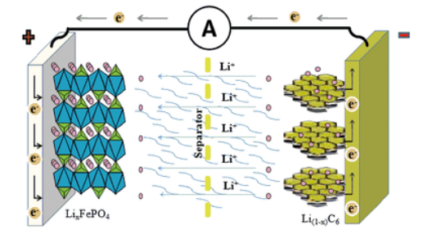

cathode anode

cathode anode

a. i. see diagram 1 mark
ii. see diagram 1 mark
iii. see diagram 1 mark

b. i. Discharge: LiC₆ + FePO₄ C₆ + LiFePO₄ 1 mark
ii. Recharge: C₆ + LiFePO₄ LiC₆ + FePO₄ 1 mark

c. Fe³⁺ Fe²⁺ 1 mark

d. Low mass* and high potential* 2 marks

Question 3 (10 marks)
a. i. C₈H₁₈(s) + 12.5O₂(g) 8CO₂(g) + 9H₂O(l) 1 mark

ii. C(s) + O₂(g) CO₂(g) 1 mark

iii. This cell is of interest for the potential it offers for lowering CO₂ emissions. Firstly, it requires CO₂, therefore it can be used to reduce CO₂ levels. It produces hydrogen, a fuel. Therefore less fossil fuels are used, another improvement. The hydrogen has many potential uses. 3 marks

b. i. anode 2O²⁻ O₂(g) + 4e 1 mark

ii. CO₂(g) + 2e CO(g) + O²⁻ 1 mark
H₂O(l) + 2e H₂(g) + O²⁻ 1 mark

c. i. Hydrogen could be used in a fuel cell in a vehicle for electrical energy. 1 mark

ii. 2H₂(g) + O₂(g) 2H₂O(l) ∆H = -282 kJ mol⁻¹ 1 mark

Question 4 (11 marks)
a. i. The presence of water in the cell allows hydrogen to form at the cathode instead of sodium. 1 mark
ii. As the NaCl is concentrated, the Cl⁻ reacts at the anode instead of water*. The small difference in potential and the high concentration of the Cl allows this*. 2 marks

b. Anode: 2Cl⁻(aq) Cl₂(g) + 2e⁻ 3 marks
Cathode: 2H₂O(l) + 2e H₂(g) + 2OH⁻(aq)
Overall: 2Cl⁻(aq) + 2H₂O(l) H₂(g) + 2OH⁻(aq) + Cl₂(g)

c. From an inexpensive raw material, you get three useful products – hydrogen, chlorine and NaOH 2 marks

d. Q = It = 240 × 60 × 60 = 864000 C
n(e) = 864000/96500 = 8.95 mol *
n(Cl₂) = ½ n(e) = 4.48 mol: n(H₂) also = 4.48 mol
total mole of gas = 8.95 mol *
V = n x 24.8 = 8.95 x 24.8 = 222 L* 3 marks

Question 5 (5 marks)
a. i. C₆H₁₂O₆(s) + 6O₂(g) 6CO₂(g) + 6H₂O(l) 1 mark

ii. C₆H₁₂O₆(aq) + 6O₂(g) 6CO₂(g) + 6H₂O(l) 1 mark

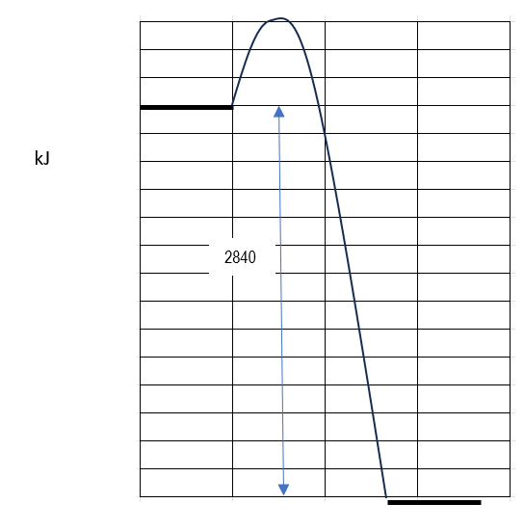
b. i.

kJ

ii. see graph 1 mark

Question 6 (8 marks)
a. ∆H = - 8.05 kJ mol⁻¹ and K_{c} = 0.11 M^{-0.5} 2 marks

b. ∆H = + 8.05 kJ mol⁻¹ and K_{c} = 8.77 M^{0.5} 2 marks

c. i. the concentration of NOBr will decrease. It is an exothermic reaction. The increase in temperature will favour the reverse reaction. 1 mark
ii. the rate of the forward reaction will increase. If the temperature is higher the rate of reaction will be higher.
1 mark

d. [NO] = [Br₂] = 0.50/2 = 0.25 M

K = 0.013 = => X = 0.0142 M 2 marks

Question 7 (10 marks)
a. Diagram 1 is showing the impact of an increase in temperature*. More particles will be moving faster so a higher proportion of particles will have sufficient energy for a reaction to occur.* In an example like magnesium pieces being dropped into HCl solution, many of the HCl particles will be moving faster at the higher temperature. 3 marks

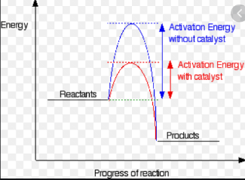
b. Diagram 2 is showing the impact of a catalyst*. It lowers the activation energy so a higher proportion of particles have the energy required for a reaction to occur*.

3 marks

c. 2H₂O₂(aq) 2H₂O(l) + O₂(g) *
Line up several test-tubes with the same volume of H₂O₂ at the same temperature.*
Attach each test-tube to a gas syringe ready to capture the oxygen gas formed.*
Add the same mass of catalyst to each test-tube and time how long it takes for a set volume of oxygen gas to be
released.*
( a hard to solve problem would be the difference in surface area of each catalyst)
4 marks

End of exam

Section A: 20 marks
Section B: 63 marks

