Unit 3: Topic Test -Introduction to fuels Name:____________________

Mark out of 50: ____________

SECTION A – Multiple-choice questions

Instructions for Section A
Answer all questions.
Choose the response that is correct for the question.
A correct answer scores 1, an incorrect answer scores 0.
Marks are not deducted for incorrect answers.
If more than one answer is completed for any question, no mark will be given.

Question 1
The best definition of a fuel is
A. a reactant in an exothermic reaction.
B. a carbon compound or an alkane.
C. a compound that releases significant amounts of energy easily.
D. a compound with a high level of stored energy.

Question 2
Which of the following pie charts is the best representation of Australia’s electricity generation mix in 2023?
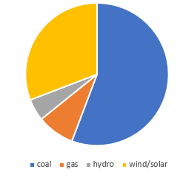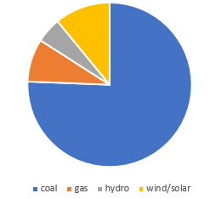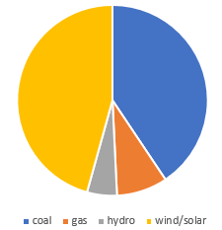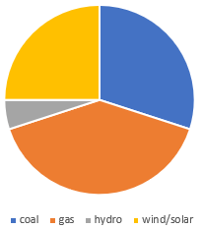
gas
wind/solar
coal
A. B. C. D.
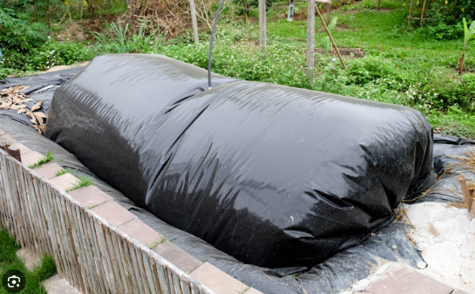
Question 3
The photo on the right shows a large collection bag used
at a waste treatment plant.

The fuel collected at the site is best described as
A. natural gas
B. biogas
C. bioethanol
D. coal seam gas

Question 4
Which of the following is a correct thermochemical equation?
A. C₂H₆(g) + 3.5O₂(g) 2CO₂(g) + 3H₂O(l) ∆H= -1560 kJ mol⁻¹
B. 2C₂H₆(g) + 7O₂(g) 4CO₂(g) + 6H₂O(g) ∆H= -1560 kJ mol⁻¹
C. 2C₂H₆(g) + 7O₂(g) 4CO₂(g) + 6H₂O(g) ∆H= -3120 kJ mol⁻¹
D. 2C₂H₆(g) + 7O₂(g) 4CO₂(g) + 6H₂O(l) ∆H= -3120 kJ

Question 5
An energy profile diagram is drawn below.
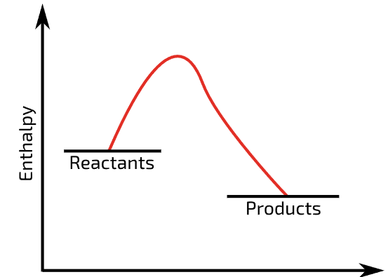

In the reaction represented by the diagram, the
A. enthalpy of the products is less than that of the reactants and energy is released to the surroundings.
B. enthalpy of the products is greater than that of the reactants and energy is released to the surroundings.
C. enthalpy of the products is less than that of the reactants and energy is absorbed from the surroundings.
D. enthalpy of the products is greater than that of the reactants and energy is absorbed from the surroundings.

Question 6
Which of the following food sources can provide the body with the greatest amount of energy?
A. 10 g of sugar and 5 g of peanut oil
B. 5 g of sugar, 5 g of protein and 5 g of peanut oil
C. 24 g of sugar
D. 12 g of peanut oil

Question 7
Which of the following is represented with a negative value?
A. the enthalpy of 2 mole of ethane undergoing combustion
B. the heat of combustion of 2 mole of ethane
C. the heat of combustion of 1 g of ethane
D. the amount of energy released when 2 mole of ethane undergoes combustion

Question 8
Select the correct statement about fermentation.
A. Fermentation converts any sugar into ethanol.
B. Fermentation will produce pure ethanol if the reaction is allowed to continue long enough.
C. Fermentation usually produces an ethanol solution of concentration around 12 (%v/v).
D. Fermentation requires oxygen gas.

Question 9
Compared to petrol, E10 fuel
A. has a higher energy density.
B. is more likely to absorb traces of water.
C. leads to more rapid engine deterioration.
D. emits a lower volume of gas per kilometre during combustion.

Question 10
Which of the following reactions produces the greatest amount of energy per mole of methane?
A. CH₄(g) + O₂(g) CO(g) + H₂O(g)
B. CH₄(g) + 2O₂(g) CO₂(g) + H₂O(g)
C. CH₄(g) + 2O₂(g) CO₂(g) + H₂O(l)
D. CH₄(l) + 2O₂(g) CO₂(g) + H₂O(g)

SECTION B- Short-answer questions

Instructions for Section B
Questions must be answered in the spaces provided in this book.
To obtain full marks for your responses you should
- Give simplified answers with an appropriate number of significant figures to all numerical questions; unsimplified answers will not be given full marks.
- Show all workings in your answers to numerical questions. No credit will be given for an incorrect answer unless it is accompanied by details of the working.
Make sure chemical equations are balanced and that the formulas for individual substances include an indication of state; for example, H₂(g); NaCl(s)

Question 1 (15 marks)
The flowchart below refers to the production of bioethanol from timber industry waste. The timber contains a high cellulose content, cellulose being a natural polymer formed from glucose monomers.
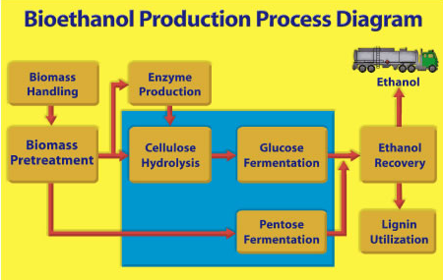
a. i. Write a thermochemical equation for the complete combustion of ethanol. 1 mark

__________________________________________________________________________

ii. Calculate the amount of energy released by the complete combustion of 92 g of ethanol. 2 marks

_________________________________________________________________________________

_________________________________________________________________________________

ii. Write a balanced equation for the incomplete combustion of ethanol to form carbon monoxide and water.
1 mark
__________________________________________________________________________

b. i. Draw the structure of a bioethanol molecule. 1 mark

ii. Will a molecule of ethanol produced from crude oil have the same structure and properties as a molecule
of biodiesel. Justify your answer. 2 marks

_________________________________________________________________________________

_________________________________________________________________________________

c. i. The flowchart above shows biomass pretreatment and cellulose hydrolysis as the first steps.
Explain the purpose of these steps. 2 marks

_________________________________________________________________________________

_________________________________________________________________________________

ii. Pentose is not a molecule you are likely to be familiar with. What conclusions can you draw about pentose
from this diagram? 2 marks

_________________________________________________________________________________

_________________________________________________________________________________

d. i. Write a balanced equation for the fermentation of glucose. 1 mark

_________________________________________________________________________________

ii. Once fermentation has occurred, bioethanol plants will run the solution into tall columns like the ones
shown here. Explain the purpose and principle behind these columns. 3 marks
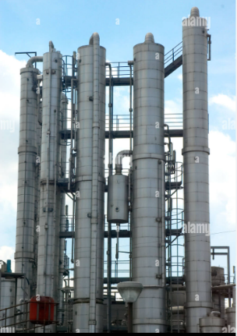
_________________________________________________________________________________

_________________________________________________________________________________

_________________________________________________________________________________

_________________________________________________________________________________

Question 2 (6 marks)
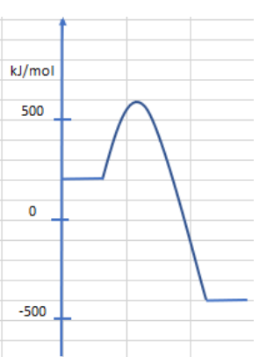
The energy profile diagram below is for the reaction between phosphorus, P₄, and oxygen gas to form phosphorous pentoxide, P₄O₁₀.

a. In this reaction

i. the bonds broken are ______________________________________________________ 1 mark

ii. the bonds formed are ______________________________________________________ 1 mark

iii. the temperature of the surroundings will ______________ 1 mark

iv. the activation energy is __________________________ 1 mark

b. Write a thermochemical equation for the formation of phosphorus pentoxide. 2 marks

____________________________________________________________________________________

Question 3 (8 marks)
The diagram below shows some important processes in living things.
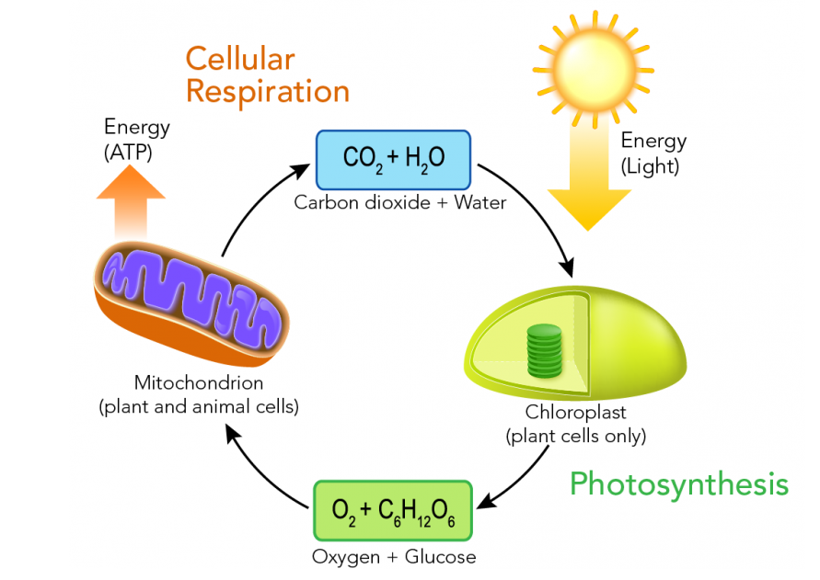

a. i. Write a balanced equation for the photosynthesis process. 1 mark

________________________________________________________________________________

ii. What is the energy transformation occurring in this reaction? 1 mark

_______________________________________________________________________________

iii. State two uses in the human body for glucose. 2 marks

_______________________________________________________________________________

________________________________________________________________________________

b. i. Write a balanced equation for the respiration process. 1 mark

_______________________________________________________________________________

ii. What is the energy transformation in this reaction? 1 mark

_______________________________________________________________________________

iii. Calculate the amount of energy released when 4 mole of glucose reacts. 1 mark

_______________________________________________________________________________

c. Why does the combustion of 1.0 g of fats release more energy than the combustion of 1.0 g of sugar?
1 mark
_______________________________________________________________________________

Question 4 (11 marks)
a. i. Identify a potential source of biogas and explain how biogas is produced from this source. 2 marks

__________________________________________________________________________

__________________________________________________________________________

ii. List three major components of biogas and their typical proportions. 2 marks

__________________________________________________________________________

__________________________________________________________________________

iii. How is useful energy obtained from biogas? 1 mark

__________________________________________________________________________

__________________________________________________________________________

b. Canola is grown in Australia, Canada and Europe and its oil is used as a source of biodiesel.
i. Describe the structure of a lipid molecule. 2 marks

__________________________________________________________________________

__________________________________________________________________________

__________________________________________________________________________

__________________________________________________________________________

ii. What processing of plant oil is needed to convert it to biodiesel? 2 marks

__________________________________________________________________________

__________________________________________________________________________

__________________________________________________________________________

iii. The combustion of biodiesel produces CO₂ emissions, yet biodiesel is considered a better option than
petrol or diesel. Discuss the impact upon the environment of a shift from fossil fuels to biodiesel.
2 marks

__________________________________________________________________________

__________________________________________________________________________

__________________________________________________________________________

__________________________________________________________________________

__________________________________________________________________________

END OF KEY TOPIC TEST

